

CAPSTONE PROJECT REPORT
Report 3 – Software Requirement Specification

– Hanoi, Aug 2026 –

Table of Contents
Change Log 10
Definition and Acronyms 11
I. Overall Requirements 16
1. Context Diagram 16
2. Main Business Flow 18
2.1 End-to-End Core Business Flow (BF-01) 18
2.2 Worker Rejection or Dispatch Timeout (BF-02) 19
2.3 Worker No-Show & Emergency Dispatch (BF-04) 20
2.4 Dispute & Escalation Handling (BF-05) 21
3. Conceptual Data Model 22
3.1 Entity Relationship Diagram 22
3.2 Entity Descriptions 22
3.3 Data Business Rules 29
4. User Requirements 30
4.1 Actors 30
4.2 Use Cases (UC) 31
4.3 Use Case Diagrams 48
4.4 Permission Matrix 52
5. System Functionalities 57
5.1 Screen Inventory 57
5.2 External API Inventory 65
5.3 Background Job Inventory 65
II. Use Case Specifications 66
1. Platform Administration & User Support (SUP) 66
1.1 UC-01: Register Account 66
1.2 UC-02: Login 67
1.3 UC-03: Logout 69
1.4 UC-04: Reset Password 69
1.5 UC-05: View Own Profile 70
1.6 UC-06: Edit Own Profile 71
1.7 UC-07: Manage Notifications 72
2. Event & Shift Management (FE-01) 73
2.1 UC-08: Search Events 73
2.2 UC-09: Create Event 74
2.3 UC-10: View Event Details 75
2.4 UC-11: Edit Event 76
2.5 UC-12: Cancel Event 77
2.6 UC-13: Activate Event 78
2.7 UC-14: Clone Event 79
2.8 UC-15: Archive Event 80
2.9 UC-16: Create Shift 81
2.10 UC-17: Create Bulk Shifts 82
2.11 UC-18: Edit Shift 83
2.12 UC-19: Cancel Shift 84
2.13 UC-20: View Staffing Progress 85
3. Worker Profile & Availability (FE-02) 85
3.1 UC-21: Manage Skills 86
3.2 UC-22: Manage Experience 86
3.3 UC-23: Upload CCCD 87
3.4 UC-24: Submit Verification 88
3.5 UC-25: Declare Availability 89
3.6 UC-26: Set Working Area 90
3.7 UC-27: Block Event Organizer 91
3.8 UC-28: Manage Blocked List 92
4. Worker Matching & Dispatch (FE-03) 92
4.1 UC-29: View Shift Proposals 92
4.2 UC-30: Filter Shift Proposals 93
4.3 UC-31: View Proposal Details 94
4.4 UC-32: Accept Shift 95
4.5 UC-33: Reject Shift 96
4.6 UC-34: Configure Matching Preferences 97
4.7 UC-35: Toggle Online Status 98
4.8 UC-36: Enter Invite Code 99
4.9 UC-37: Monitor Readiness 100
4.10 UC-38: Calculate Match Score 101
4.11 UC-39: Calculate Shift Metrics 102
5. Assignment & Workforce Tracking (FE-04) 103
5.1 UC-40: View Assignment List 103
5.2 UC-41: View Assignment Details 104
5.3 UC-42: Filter Assignments 105
6. Attendance & Completion (FE-05) 106
6.1 UC-43: Check-in at Shift 106
6.2 UC-44: Check-out from Shift 107
6.3 UC-45: Update Checklist 107
6.4 UC-46: Submit Work Evidence 108
6.5 UC-47: Create Job Checklist 109
6.6 UC-48: View Checklist 110
6.7 UC-49: Confirm Completion 110
6.8 UC-50: Report Incomplete 111
6.9 UC-51: Request Early Checkout 112
6.10 UC-52: Generate Attendance QR 113
7. Cancellation & Replacement (FE-06) 114
7.1 UC-53: Cancel Assignment 114
7.2 UC-54: Handle No-show 115
7.3 UC-55: Trigger Emergency Dispatch 116
7.4 UC-56: Confirm No-show 117
7.5 UC-57: Request Replacement 118
8. Payment & Escrow (FE-07) 119
8.1 UC-58: Deposit Escrow 119
8.2 UC-59: Transfer to Platform Escrow 120
8.3 UC-60: View Payment History 121
8.4 UC-61: Request Withdrawal 122
8.5 UC-62: Confirm Payment 123
8.6 UC-63: Process Partial Payment 124
8.7 UC-64: View Worker Income 125
8.8 UC-65: Configure Payment Methods 126
8.9 UC-66: View Escrow Status 127
8.10 UC-67: Auto-Payment 127
8.11 UC-68: Request Refund 128
9. Reputation & Disputes (FE-08) 129
9.1 UC-69: Rate 129
9.2 UC-70: View Ratings 130
9.3 UC-71: Submit Dispute 131
9.4 UC-72: Handle Dispute 132
10. Reliability Score (FE-09) 133
10.1 UC-73: View Reliability Score 133
10.2 UC-74: Appeal Penalty 134
10.3 UC-75: Request Reliability Unlock 135
11. AI Wage Recommendation (FE-10) 136
11.1 UC-76: View Wage Recommendation 136
11.2 UC-77: Set Shift Wage 137
11.3 UC-78: Configure Pricing Rules 138
12. AI Shift Planning (FE-11) 139
12.1 UC-79: Create Event with AI 139
12.2 UC-80: Review AI Draft 140
13. Fairness Guardrails (FE-12) 141
13.1 UC-81: View Fairness Report 141
13.2 UC-82: Configure Fairness Rules 142
13.3 UC-83: View Opportunity Statistics 143
14. EO Registration & Verification (FE-13) 144
14.1 UC-84: Manage EO Registration 144
15. Worker Verification & Dispute Resolution (FE-14) 145
15.1 UC-85: Verify and Handle Cases 145
16. System Administration (FE-15) 147
16.1 UC-86: Dashboard 147
16.2 UC-87: User Management 148
16.3 UC-88: Configure AI Features 149
16.4 UC-89: View AI Logs 150
17. Financial Operations (FE-16) 151
17.1 UC-90: View Finance Dashboard 151
17.2 UC-91: Approve Withdrawal 152
17.3 UC-92: Process Refund 153
17.4 UC-93: Perform Reconciliation 154
17.5 UC-94: Financial Reports 155
III. Functional Requirements 156
1. CANi Admin, Customer Care & Finance Web Portal Screens 156
1.1 SCR-01: User Login 156
1.2 SCR-02: Password Reset 157
1.3 SCR-03: Set New Password 158
1.4 SCR-04: Password Change 159
1.5 SCR-05: Admin Dashboard 160
1.6 SCR-06: Customer Care Dashboard 161
1.7 SCR-07: Finance Dashboard 162
1.8 SCR-08: My Profile 163
1.9 SCR-09: Edit Profile 164
1.10 SCR-10: Notifications 165
1.11 SCR-11: User Management 166
1.12 SCR-12: User Details 167
1.13 SCR-13: Event Management 168
1.14 SCR-14: Event Details 169
1.15 SCR-15: Event Organizer Registrations 170
1.16 SCR-16: Event Organizer Registration Details 171
1.17 SCR-17: Worker Verification 172
1.18 SCR-18: Verification Details 173
1.19 SCR-19: Dispute Management 174
1.20 SCR-20: Dispute Details 175
1.21 SCR-21: Penalty Appeals 176
1.22 SCR-22: Appeal Details 177
1.23 SCR-23: No-show Cases 178
1.24 SCR-24: No-show Details 179
1.25 SCR-25: Support Tickets 180
1.26 SCR-26: Ticket Details 181
1.27 SCR-27: User Lookup 183
1.28 SCR-28: User Support Details 184
1.29 SCR-29: My Activity 185
1.30 SCR-30: Withdrawal Requests 186
1.31 SCR-31: Withdrawal Details 187
1.32 SCR-32: Refund Requests 188
1.33 SCR-33: Refund Details 190
1.34 SCR-34: Financial Cases 191
1.35 SCR-35: Financial Case Details 192
1.36 SCR-36: Transactions 193
1.37 SCR-37: Transaction Details 194
1.38 SCR-38: Reconciliation 195
1.39 SCR-39: Financial Reports 197
1.40 SCR-40: Financial Alerts 198
1.41 SCR-41: Financial Audit Trail 199
1.42 SCR-42: Pricing Rules 200
1.43 SCR-43: AI Configuration 201
1.44 SCR-44: AI Logs 202
1.45 SCR-45: Fairness Rules 203
1.46 SCR-46: Fairness Report 204
1.47 SCR-47: Platform Reports 206
1.48 SCR-48: System Alerts 207
1.49 SCR-49: Audit Logs 208
2. Event Organizer (EO) Web Portal Screens 210
2.1 SCR-50: Login 210
2.2 SCR-51: User Register 212
2.3 SCR-52: Email Verification 214
2.4 SCR-53: Password Reset 216
2.5 SCR-54: Set New Password 218
2.6 SCR-55: Password Change 219
2.7 SCR-56: Event Organizer Dashboard 220
2.8 SCR-57: My Profile 220
2.9 SCR-58: Notifications 221
2.10 SCR-59: Create Event 222
2.11 SCR-60: Event Details 223
2.12 SCR-61: Edit Event 224
2.13 SCR-62: Create Shift 225
2.14 SCR-63: Edit Shift 226
2.15 SCR-64: Shift Details 227
2.16 SCR-65: Wage Recommendation 228
2.17 SCR-66: Create Job Checklist 229
2.18 SCR-67: Assigned Workers 230
2.19 SCR-68: View Worker Ratings 231
2.20 SCR-69: Attendance Management 232
2.21 SCR-70: Rate Worker 233
2.22 SCR-71: Submit Dispute 234
2.23 SCR-72: Dispute Details (EO) 235
2.24 SCR-73: Dispute Response 236
2.25 SCR-74: EO Payment Account 237
2.26 SCR-75: Payment History 238
2.27 SCR-76: Payment Status 239
3. CANi Partner Mobile App Screens (Worker App) 240
3.1 SCR-77: User Login 240
3.2 SCR-78: User Register 242
3.3 SCR-79: Email Verification 244
3.4 SCR-80: Password Reset 246
3.5 SCR-81: Set New Password 247
3.6 SCR-82: Password Change 249
3.7 SCR-83: Worker Home 251
3.8 SCR-84: Notifications 253
3.9 SCR-85: Worker Profile 255
3.10 SCR-86: Edit Profile 256
3.11 SCR-87: Availability Calendar 258
3.12 SCR-88: Matching Preferences 260
3.13 SCR-89: Identity Verification 262
3.14 SCR-90: Shift Proposals 264
3.15 SCR-91: Proposal Details 266
3.16 SCR-92: Enter Invite Code 268
3.17 SCR-93: Invitation Details 270
3.18 SCR-94: View EO Ratings 272
3.19 SCR-95: Blocked Event Organizers 274
3.20 SCR-96: My Assignments 276
3.21 SCR-97: Assignment Details 278
3.22 SCR-98: QR Scanner 279
3.23 SCR-99: Job Checklist & Evidence 281
3.24 SCR-100: Shift Completion Request 282
3.25 SCR-101: Attendance History 283
3.26 SCR-102: Rate Event Organizer 284
3.27 SCR-103: Worker Wallet 285
3.28 SCR-104: Income History 286
3.29 SCR-105: Request Withdrawal 287
3.30 SCR-106: Withdrawal History 288
3.31 SCR-107: Withdrawal Details 289
3.32 SCR-108: Bank Account Details 290
3.33 SCR-109: My Disputes 291
3.34 SCR-110: Dispute Details 292
3.35 SCR-111: Submit Dispute 293
3.36 SCR-112: Reliability Score 295
3.37 SCR-113: Penalty Appeal 296
4. Background Job Inventory 297
5.1 Shift Proposal Expiry (JOB-01) 297
5.2 Soft-Hold Release (JOB-02) 297
5.3 Event Readiness Check & Alert (JOB-03) 298
5.4 Worker Reliability Score Recalculation (JOB-04) 298
5.5 Unlock Expired Locked Accounts (JOB-05) 299
5. External API Inventory 299
5.1 VnPay Payment Webhook (API-01) 299
5.2 SePay Bank Transfer Webhook (API-02) 300
5.3 Firebase Cloud Messaging Push API (API-03) 300
5.4 SMTP Email Notification Service (API-04) 300
IV. Non-Functional Requirements 300
1. External Interfaces 300
1.1 User Interfaces (UI) 300
1.2 Hardware Interfaces 301
1.3 Software & Communications Interfaces 301
2. Quality Attributes 302
2.1 Usability Requirements 302
2.2 Performance Requirements 302
2.3 Security Requirements 303
2.4 Reliability, Availability & Maintainability 304
V. Requirement Appendix 304
1. Business Rules 304
2. System Messages 318
3. Other Requirements 325

Change Log
Date | A*  M, D | In charge | Change Description
15/09/2026 | A | HungPD, KhanhDT, MinhTB, DuongMH, QuyTH | Initial draft of Report 3 - Software Requirement Specification.
18/09/2026 | A | DuongMH | Added Section I: Overall Requirements, Context Diagram, and Core Business Flows (BF-01 to BF-05).
20/09/2026 | A | KhanhDT | Added Section I.4: User Requirements, Actors catalog and Use Case Diagrams.
22/09/2026 | A | QuyTH | Added Section II: Detailed Use Case Specifications for 87 Use Cases across 14 major system features.
25/09/2026 | A | HungPD, KhanhDT,  MinhTB, DuongMH, QuyTH | Added Section III: Functional Requirements, 69 Screen Mockups (44 Web & 25 Mobile), and UI User Actions.
26/09/2026 | A | KhanhDT, QuyTH | Added Section III: Screen Elements Dictionary and Field-level Validation Rules tables for all 69 screens.
28/09/2026 | A | HungPD, MinhTB | Added Section IV: Non-Functional Requirements, Architecture, Quality Attributes, and Security constraints.
29/09/2026 | A | HungPD, KhanhDT, MinhTB, DuongMH, QuyTH | Added Section V: Business Rules Inventory (265 BRs) and Background Jobs Specifications.
30/09/2026 | M | HungPD | Updated Section II: Refined Use Case Specifications with distinct Alternative Flows and Exception Flows per supervisor review.
01/10/2026 | M | HungPD | Standardized document styling: 100% Times New Roman, two-side justification, and updated Table of Contents.
17/10/2026 | M | MinhTB | Update Use Case List and Use Case Specifications base to new update of project scope
*A - Added M - Modified D - Deleted

Definition and Acronyms
This section provides a consolidated glossary of core definitions, business terms, system actors, and technical acronyms utilized throughout this Software Requirements Specification (SRS) for the CANi (Candidate Allocation Network for Events) platform. It serves as the authoritative single source of truth (Ubiquitous Language) ensuring semantic consistency across system models, business rules, and interface specifications.
Acronym / Term | Definition and Scope in CANi Platform
Admin (System Administrator) | A privileged internal platform operator holding administrative credentials authorized to configure global system parameters (matching weights, commission rates, geofence radiuses), manage user account lifecycles (ban, unban, credential audits), oversee system health, and inspect end-to-end operational and financial audit logs.
AF (Alternative Flow) | A secondary or exceptional execution sequence within a Use Case specification that documents system responses to non-nominal conditions, user input validation errors, external API timeouts, or rule violations (e.g., worker cancellation, insufficient escrow balance).
API (Application Programming Interface) | A defined set of HTTP RESTful endpoints and data contracts facilitating communication between client applications (CANi Web/Mobile) and backend core microservices, as well as external integrations (payment gateways, mapping providers, SMS/FCM gateways).
Assignment | A formalized, binding operational agreement between an Event Organizer and a Candidate Worker for a designated Shift. An assignment is instantiated only after a matched candidate explicitly accepts a dispatch proposal within the permitted timeout window.
Attendance | The immutable verification and timesheet log tracking a Worker's physical presence, punctuality, and actual hours worked on-site during a Shift, validated cryptographically via GPS geofencing and dynamic two-factor QR code scanning at Check-in and Check-out.
Availability | The operational schedule and geographic boundary declared by a Worker indicating specific calendar time windows and transit distances during which they are willing, active, and eligible to receive Shift dispatch offers.
BR (Business Rule) | A formal, enumerable policy, formula, or constraint governing platform operations and data transitions within the CANi platform (e.g., matching score weighting, no-show penalties, cancellation refund ratios, and escrow deposit formulas).
CANi (Candidate Allocation Network for Events) | The on-demand workforce mobilization and coordination platform designed for event operations. CANi automates short-term event labor sourcing, multi-criteria candidate matching, automated dispatching, fraud-resistant QR attendance tracking, escrow payment protection, and post-event settlement.
CCCD (Căn cước công dân) | The Vietnamese National Citizen Identity Card required from both Workers and Event Organizers during onboarding. Physical identity cards are parsed via automated OCR and validated through eKYC to ensure legal compliance and identity accountability.
Customer Care (Customer Support / Care Specialist) | An operational platform specialist acting as a tier-2 customer support agent and formal dispute arbitrator. Customer Care oversees manual identity verification (eKYC review), investigates attendance disputes, adjudicates wage disagreements between EOs and Workers, and authorizes penalty adjustments or escrow refunds.
DFD (Data Flow Diagram) | A structured graphical modeling technique (Level 0 Context, Level 1 Functional Decomposition, Level 2 Detailed Process) illustrating external entities, automated processes, data stores, and information flows across the CANi platform architecture.
Disbursement | The automated batch financial payout transferring earned shift remuneration from the CANi Escrow account directly into the verified bank account or digital wallet of a Worker upon successful shift checkout and supervisor completion sign-off.
Dispatch / Dispatching Engine | The automated operational mechanism that pushes Shift assignments and notifications to pre-filtered candidate Workers in prioritized tiers. The engine enforces strict response timers (e.g., 60-minute window for standard dispatches, 15-minute window for urgent/live dispatches) before rotating to the next eligible candidate in the pool.
Dispute | A formal grievance submitted via the platform by an EO or a Worker regarding discrepancies in recorded attendance hours, unauthorized wage deductions, incomplete task delivery, on-site property damage, or walkout allegations, requiring evidence-backed Customer Care mediation.
Dynamic QR Code | A cryptographically signed, time-expiring (rotating every 30 to 60 seconds) Quick Response code rendered exclusively on the authorized supervisor/EO terminal. Workers scan this code using their mobile camera to authenticate on-site Check-in and Check-out, preventing proxy attendance and remote GPS spoofing.
eKYC (Electronic Know Your Customer) | A paperless, automated digital identity verification workflow combining OCR data extraction from government-issued identity cards (CCCD) with biometric liveness and facial matching to establish verified user trust before dispatch participation.
EO (Event Organizer / Customer) | The primary demand-side stakeholder representing corporate event hosts, event production agencies, or independent coordinators who publish labor demands on CANi. EOs define Event schedules, configure Shifts, fund Escrow payroll balances, manage on-site staff, and approve timesheets.
Escrow Deposit (Ký quỹ sự kiện) | A mandatory financial guarantee whereby the Event Organizer deposits 100% of the total estimated shift wages plus platform service fees into CANi's secured platform holding account prior to shift publication and dispatch, ensuring guaranteed compensation for workers upon task completion.
Event | A planned temporary corporate, cultural, or commercial gathering declared by an EO on CANi, characterized by a designated venue, start/end calendar dates, logistical instructions, and comprising one or more operational Shifts across multiple specialized labor roles.
ERS (Event Readiness Score) | A real-time aggregated analytical metric (expressed as a percentage from 0% to 100%) measuring the recruitment fulfillment, confirmed worker headcount, and staffing reliability risk across all Shifts within an Event relative to time remaining until event launch.
Fairness Rotation (Gini Balance) | An algorithmic allocation policy embedded within the matching scoring pipeline that awards bonus priority points to qualified workers with low recent shift counts (e.g., idle > 7 days or < 3 shifts in the current week) to prevent labor monopolization by a small elite tier and maintain platform-wide Gini equality.
FCM (Firebase Cloud Messaging) | Google's cross-platform push notification infrastructure utilized by CANi to deliver high-priority, real-time alerts (urgent shift offers, 15-minute response timeouts, check-in prompts, emergency replacements) to mobile client devices.
FE (Feature / Functional Element) | A standardized functional module identifier within the CANi requirement traceability matrix (e.g., FE-01 User Authentication, FE-06 Candidate Matching & Dispatch, FE-10 QR Attendance & Timesheet).
GPS / Geofencing | Global Positioning System coordinate tracking and radius boundary verification used by CANi to validate that a Worker is physically present within the designated venue boundary (e.g., within 200 meters) before permitting dynamic QR attendance check-in.
JWT (JSON Web Token) | An open standard (RFC 7519) compact, digitally signed authentication token carrying user claims (user ID, roles, session validity) passed in HTTP headers to secure stateless client-server API interactions.
Matching / Matching Engine | The multi-criteria algorithmic evaluation pipeline that evaluates candidate Workers against Shift criteria. The engine applies Hard Filters (exact role, distance ≤ 15 km, schedule overlap, RS ≥ 60) followed by a Weighted Soft Scoring model (0.4×Distance + 0.3×Rating + 0.2×Experience + 0.1×RS + Fairness Bonus) to rank candidate suitability.
NFR (Non-Functional Requirement) | Enforceable technical constraints and quality standards governing CANi platform performance, scalability, security, availability, regulatory compliance, and usability (e.g., API response times < 500ms, 99.9% uptime).
No-Show | A critical operational violation where a confirmed, assigned Worker fails to appear and check in at the Event venue within the allowed grace period (e.g., 15–30 minutes past shift start) without authorized cancellation, resulting in punitive RS penalties, temporary account suspension, and triggering immediate urgent replacement dispatch.
OCR (Optical Character Recognition) | Computer vision technology integrated into the CANi onboarding subsystem to automatically detect and transcribe textual information (ID number, full name, date of birth, address) from scanned images of national identity cards (CCCD).
OTP (One-Time Password) | A dynamically generated, cryptographically random 6-digit numeric token with a brief validity window (typically 3–5 minutes) transmitted via SMS or Email for phone number verification, two-factor authentication, and sensitive transaction approvals.
PostGIS | An open-source spatial database extender for the PostgreSQL relational database enabling spatial indexing (R-Tree / GiST), distance matrix calculations, and geographic bounding queries utilized heavily by CANi's geofencing and dispatching modules.
RS (Reliability Score / Điểm Uy tín) | A dynamic, multi-factor numerical reputation index (initial baseline: 100 points, range: 0–100) quantifying a Worker's historical dependability on CANi. RS decreases upon late cancellations, no-shows, and dispute penalties, and increases through successful, highly rated shift completions. Dropping below 20 points suspends dispatch eligibility.
SCR (Screen Identifier) | A standardized specification reference ID (e.g., SCR-W01 Worker Home, SCR-E05 Shift Creation) mapping Use Case functional flows to UI/UX wireframes, mobile screens, and web dashboard layouts.
Shift | An atomic unit of labor demand within an Event, defined by an operational role (e.g., Usher, Check-in Crew, Logistics Assistant), precise calendar start/end times, venue location, required worker quota, assigned supervisor, subtask checklist, and set wage rate.
SLA (Service Level Agreement) | Contractually enforced operational benchmarks defining maximum allowable response and resolution times across CANi support workflows (e.g., dispute adjudication within 24 hours, urgent replacement dispatch initiated within 5 minutes).
SMS (Short Message Service) | Telecommunications protocol used as a secondary communication channel to deliver mission-critical transactional OTPs, emergency shift notices, and account security notifications to mobile devices.
SRS (Software Requirements Specification) | The authoritative IEEE 830 / ISO/IEC/IEEE 29148 compliant software engineering document establishing the complete functional and non-functional requirements, data models, business rules, and interface designs of the CANi system.
SUP (Supervisor / On-site Coordinator) | An operational representative appointed by an Event Organizer to manage on-site event execution. Supervisors possess permissions to display attendance dynamic QR codes, monitor worker check-ins in real time, delegate shift tasks, verify work completion, and submit on-site incident/walkout reports.
System (CANi Core Engine) | The autonomous backend server environment responsible for executing scheduled batch jobs (cron jobs), computing matching scores, orchestrating dispatch queues, generating dynamic QR security tokens, and triggering automated timeout cancellations.
Task | A granular, checkable assignment item defined within a Shift (e.g., 'Distribute VIP gift bags', 'Scan entrance badges', 'Supervise stage backstage access') that a Worker must execute and mark as completed before final checkout sign-off.
Timesheet | The digital ledger recording approved shift working hours, overtime increments, break intervals, and net billable time for each assigned Worker, serving as the basis for automated escrow disbursement.
UC (Use Case) | A structured software engineering specification detailing the step-by-step interaction between an identified actor (e.g., Worker, EO, Admin) and the CANi system to achieve a specific business goal, including preconditions, main flows, alternative flows, and postconditions.
VietQR / SePay | The Vietnamese national banking interoperability standard and automated financial gateway integration used by CANi to generate dynamic bank transfer QR codes for real-time, automated Escrow deposit reconciliation via virtual accounts without manual bank slip uploading.
Walkout / Drop-out (Bỏ ca) | An unauthorized mid-shift abandonment where a checked-in Worker leaves the event premises prior to the scheduled shift conclusion without EO or Supervisor approval, resulting in total wage forfeiture for unworked hours, dispute logging, and severe RS deductions.
Worker (Candidate Worker / Event Freelancer) | An on-demand supply-side participant (primarily university students and freelance event personnel) who registers on CANi, undergoes eKYC verification, accepts automated shift dispatches, performs on-site tasks, checks in/out via dynamic QR, and receives post-shift compensation.

I. Overall Requirements

1. Context Diagram
The Context Diagram (Data Flow Diagram - DFD Level 0) defines the highest-level operational boundary of the CANi (Candidate Allocation Network for Events) platform. It illustrates the fundamental interactions and bi-directional information flows between the central CANi core software boundary (Process 0.0) and all external entities, including human actors and third-party software service providers.
CANi coordinates high-velocity, on-demand workforce mobilization for events by capturing staffing requirements from Event Organizers, executing rule-based dispatching to candidate Workers, validating on-site attendance via dynamic QR codes, and coordinating with financial settlement and external integration gateways to deliver an end-to-end operational lifecycle.
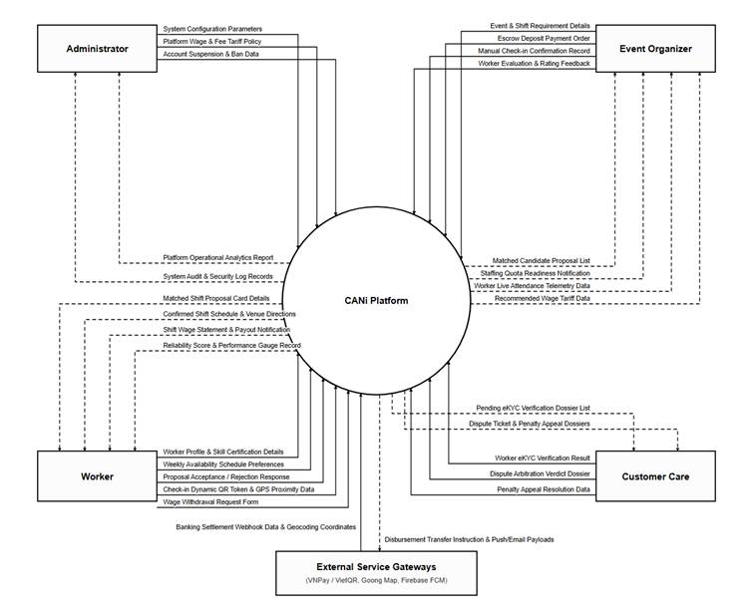
Figure 1.1: CANi Platform Context Diagram (DFD Level 0)
• External Entities & Primary Actors Specification:
1. Event Organizer (Client / Agency): Represents corporate event hosts, agencies, and event coordinators who declare labor demand. They submit Event and Shift definitions, staffing quotas, wage configurations, and attendance sign-offs. In return, the platform provides real-time applicant rosters, wage recommendations, event readiness indices, and timesheet reports.
2. Candidate Worker (Freelancer / Student): On-demand event personnel who maintain verified profiles (identity CCCD, skills, work history). They receive push shift offers, confirm contractual assignments, perform two-way QR check-in/out on-site, and access earnings statements.
3. Customer Care (Support Specialist): Operational personnel responsible for reviewing identity verification credentials (eKYC review, CCCD validation), investigating shift incident reports, mediating attendance and wage disputes between Organizers and Workers, and adjudicating penalty appeals. They access the support console on the Admin Web Portal under dedicated Customer Care permissions.
4. System Administrator (Admin): Platform governance and technical administrator responsible for maintaining system infrastructure, security audit logs, account role assignments (RBAC), and configuring core algorithmic guardrails (matching dispatch rules, geofence radius, fairness scores, and wage recommendations).
5. Payment & Banking Gateway (VietQR / PayOS): External financial infrastructure handling transaction lifecycle verification. The platform generates dynamic VietQR codes, integrates payment gateways (PayOS / VietQR) for Organizer escrow deposits, and initiates batch disbursement instructions to Worker bank accounts upon shift completion.
6. Mapping & Geolocation API (Goong Map / OpenStreetMap): Geospatial service providing forward geocoding, coordinates resolution, and road-distance matrix calculation used by the Dispatching Engine to rank candidates within configurable transit radiuses (< 5km, < 15km).
7. Push Notification Service (Firebase Cloud Messaging - FCM): Real-time mobile push gateway responsible for delivering urgent shift proposals, 15-minute response timeouts, check-in reminders, and emergency replacement dispatches directly to Worker mobile devices.
8. Email Dispatch Service (SendGrid / SMTP Gateway): Asynchronous transactional mailing provider transmitting account verification OTPs, contractual assignment confirmation summaries, and official dispute resolution notices.
9. AI Identity Verification Service (Google Gemini AI API): Automated document OCR verification service extracting citizen identity data from Worker CCCD photos to detect fraud and accelerate KYC clearance.
• Summary of Key Information Flows (DFD Level 0):
All data flows entering the CANi boundary represent structured transactions validated against business rules (e.g., wage floors, geofences, time overlaps), while all outgoing flows represent actionable status telemetry, push alerts, financial disbursements, or operational reports, guaranteeing strict data consistency across all integrated subsystems.

2. Main Business Flow

2.1 Event & Shift Management (BF-01)
Trigger:The Event Organizer creates a new event with one or more shift .
End condition: The shift is confirmed as completed, the payment status reaches COMPLETED, and both the Event Organizer and the Worker have submitted their ratings.
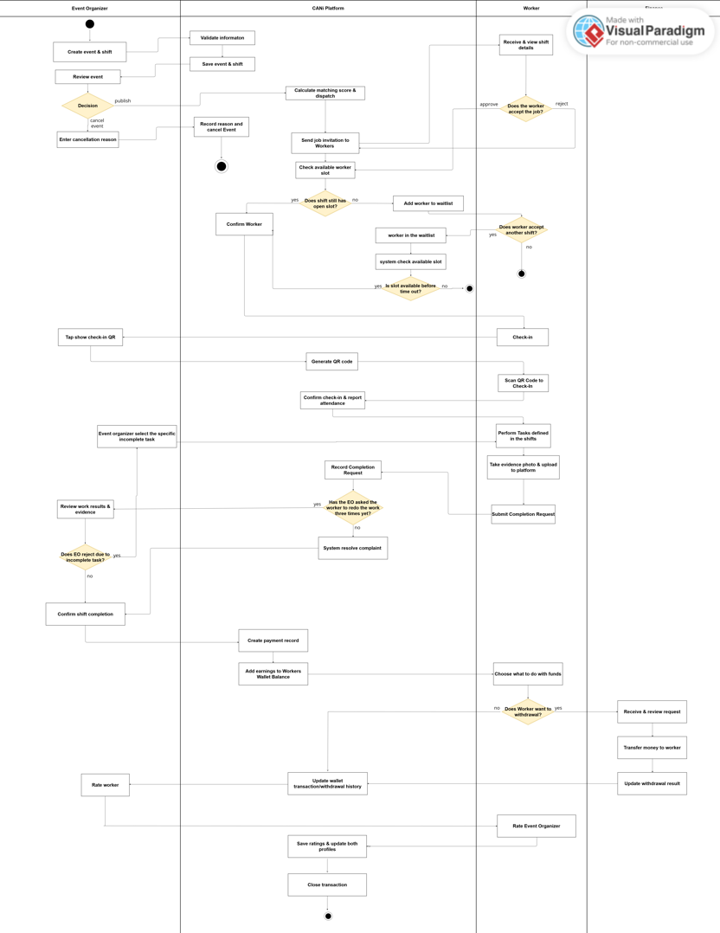

2.2 Dispute Resolution & Payment Settlement (BF-02)
Trigger:The process starts when the Worker submits a dispute with supporting evidence regarding a payment or event-related issue.
End condition: The process ends when Customer Care reviews the evidence and reaches a decision, the dispute status is updated to RESOLVED, and the payment is settled accordingly. If the Worker wins, the payment is released to the Worker; otherwise, the Event Organizer receives a refund
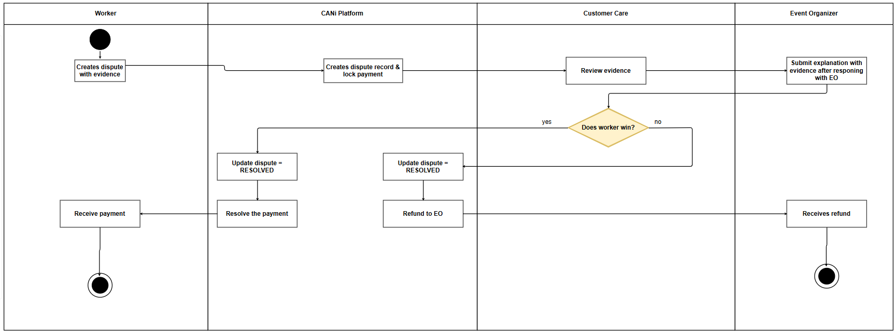

2.3 Worker Withdrawal & Payment Processing (BF-03)
Trigger:The process starts when the Worker opens the withdrawal page and submits a withdrawal request by entering the amount and bank account details.
End condition:The process ends when the withdrawal request is either rejected and the funds are returned to the Worker’s virtual wallet, or approved and the transfer is confirmed by Finance, the withdrawal status is updated to COMPLETED, and the Worker receives the money in their bank account. .
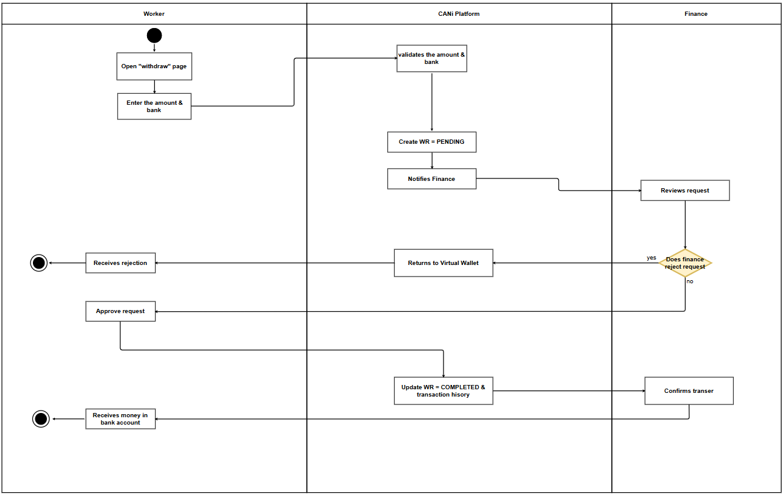

2.4 Event Invitation & Worker Assignment (BF-04)
Trigger:The process starts when the Event Organizer creates an event and selects the “Invite” mode to generate an invitation code or QR code for Workers .
End condition:The process ends when the Worker successfully joins the event and is assigned to the event, either through automatic assignment when no scheduling conflict exists or after resolving the conflict and proceeding with the invitation. Invalid or expired invitation codes, duplicate event participation, or unresolved scheduling conflicts are handled through notifications and appropriate actions before the process can be completed. .
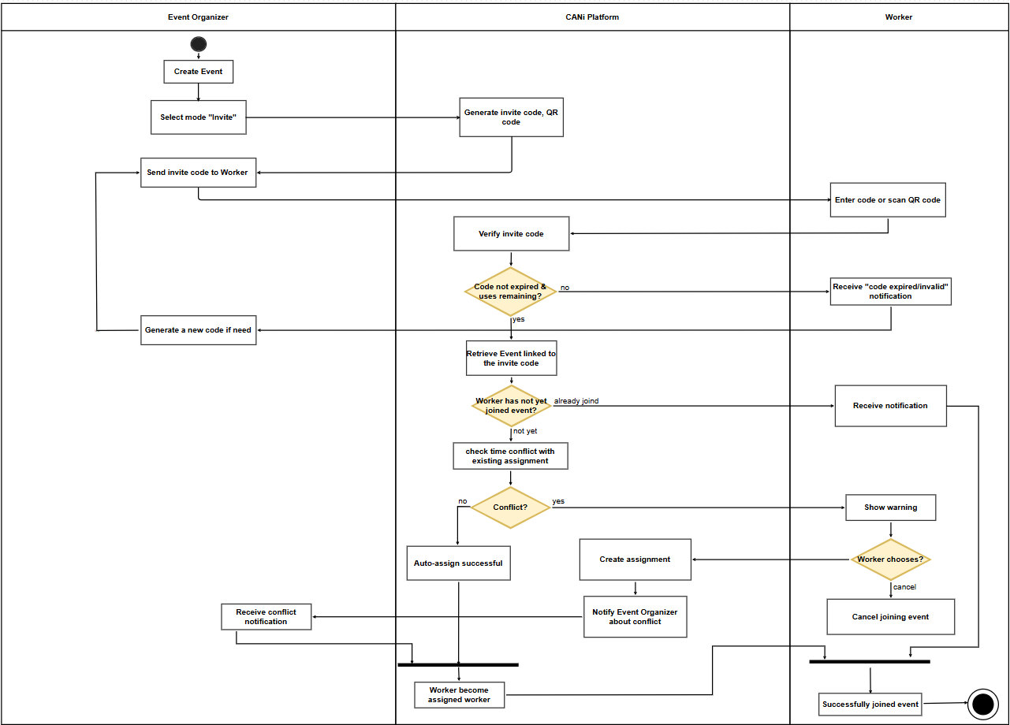

3. Conceptual Data Model

3.1 Entity Relationship Diagram
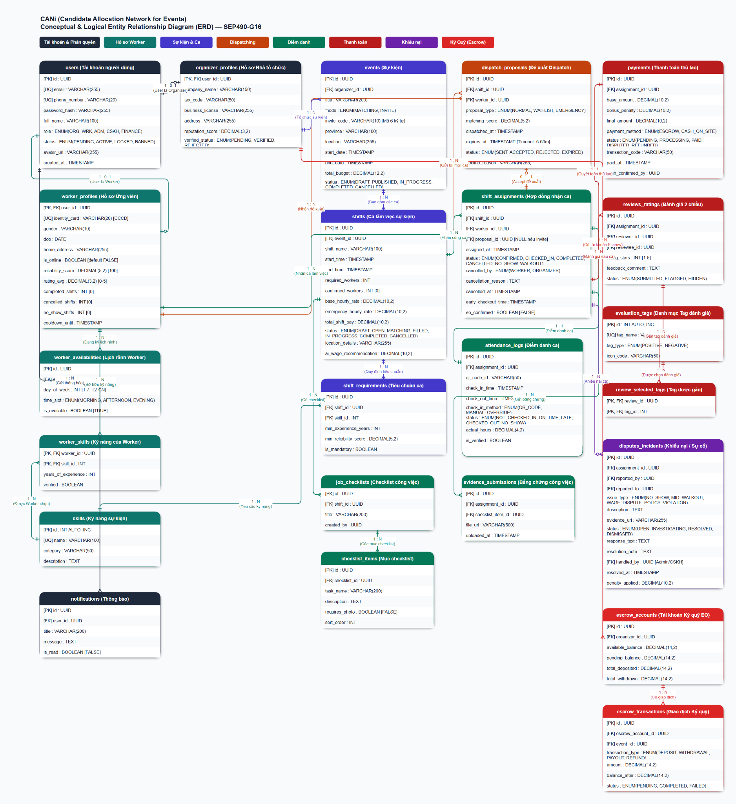
Figure 3.1: CANi Conceptual & Logical Entity Relationship Diagram (Crow's Foot Notation)

3.2 Entity Descriptions
[Provide one block per entity with descriptions and key business attributes only.]
Entity: User
Field | Value
Purpose | Represents all authenticated human accounts interacting with the CANi platform, establishing system identity, authentication credentials, and role-based permissions across Worker, Event Organizer, Administrator, Customer Care (Customer Care), and Finance Staff.
Key business attributes | id (UUID [PK]), email (VARCHAR(255) [UQ]), phone_number (VARCHAR(20) [UQ]), password_hash (VARCHAR(255)), full_name (VARCHAR(100)), role (ENUM(ORG, WRK, ADM, Customer Care, FINANCE)), status (ENUM(PENDING, ACTIVE, LOCKED, BANNED)), avatar_url (VARCHAR(255)), created_at (TIMESTAMP)
Business identity | Primary key id (UUID). Email address unique across the entire system. Mobile phone number unique across the entire system.
Status / lifecycle | PENDING (awaiting verification) · ACTIVE (normal operational state) · LOCKED (temporary security lockout) · BANNED (permanent disciplinary or fraud suspension)
Entity: Organizer Profile
Field | Value
Purpose | Stores legal corporate identity, enterprise tax registration, operating licenses, business address, and compliance verification status for event organizing entities on CANi.
Key business attributes | user_id (UUID [PK, FK]), company_name (VARCHAR(150)), tax_code (VARCHAR(50)), business_license (VARCHAR(255)), address (VARCHAR(255)), reputation_score (DECIMAL(3,2)), verified_status (ENUM(PENDING, VERIFIED, REJECTED))
Business identity | 1:1 relationship with User account (FK user_id). Corporate tax code and business license document identifier.
Status / lifecycle | PENDING (submitted KYC documentation) · VERIFIED (accredited by Admin/Customer Care) · REJECTED (failed validation audit)
Entity: Worker Profile
Field | Value
Purpose | Manages personal profile information, national citizen identity card (CCCD), real-time availability toggle, platform reliability score, rating track record, and disciplinary cooldown periods.
Key business attributes | user_id (UUID [PK, FK]), identity_card (VARCHAR(20) [UQ CCCD]), gender (VARCHAR(10)), dob (DATE), home_address (VARCHAR(255)), is_online (BOOLEAN [default FALSE]), reliability_score (DECIMAL(5,2) [default 100.00]), rating_avg (DECIMAL(3,2) [0-5]), completed_shifts (INT [0]), cancelled_shifts (INT [0]), no_show_shifts (INT [0]), cooldown_until (TIMESTAMP)
Business identity | 1:1 relationship with User account (FK user_id). National identity card (CCCD) unique system-wide.
Status / lifecycle | OFFLINE (is_online = FALSE) · ONLINE (is_online = TRUE, eligible for immediate dispatch) · IN_SHIFT (active shift in progress) · COOLDOWN (cooldown_until active due to late cancellation penalty)
Entity: Worker Availability
Field | Value
Purpose | Defines the recurring weekly schedule and time-slot availability preferences of a Worker, enabling the dispatch matching engine to filter and propose shifts matching candidate idle windows.
Key business attributes | id (UUID [PK]), worker_id (UUID [FK]), day_of_week (INT [1-7: Monday to Sunday]), time_slot (ENUM(MORNING, AFTERNOON, EVENING)), is_available (BOOLEAN [default TRUE])
Business identity | Primary key id (UUID). Composite logical key (worker_id, day_of_week, time_slot).
Status / lifecycle | Configured and dynamically maintained by Worker via mobile app schedule manager.
Entity: Worker Skill
Field | Value
Purpose | Associates practical event competencies and specialized capabilities with a Worker profile, tracking years of verified experience.
Key business attributes | worker_id (UUID [PK, FK]), skill_id (INT [PK, FK]), years_of_experience (INT), verified (BOOLEAN)
Business identity | Composite primary key (worker_id, skill_id).
Status / lifecycle | Unverified (self-declared by worker) · Verified (audited via certification upload or organizer rating endorsements)
Entity: Skill
Field | Value
Purpose | Centralized platform directory of standardized event labor competencies, specialized roles, and certification categories (e.g., PG/PB, Security, Audio/Visual, Logistics, Bartender, Registration).
Key business attributes | id (INT AUTO_INC [PK]), name (VARCHAR(100) [UQ]), category (VARCHAR(50)), description (TEXT)
Business identity | Primary key id. Standardized skill name unique system-wide.
Status / lifecycle | Catalog configured and governed directly by Platform Administrator.
Entity: Notification
Field | Value
Purpose | Delivers transactional, operational, and urgent event push/in-app notifications including dispatch proposals, shift reminders, QR check-in alerts, escrow balance changes, and dispute outcomes.
Key business attributes | id (UUID [PK]), user_id (UUID [FK]), title (VARCHAR(200)), message (TEXT), is_read (BOOLEAN [default FALSE]), created_at (TIMESTAMP)
Business identity | Primary key id (UUID).
Status / lifecycle | UNREAD (is_read = FALSE) · READ (is_read = TRUE, marked upon user view)
Entity: Event
Field | Value
Purpose | Represents a high-level event organized by an Event Organizer, encompassing venue location, geographic province, staffing mode (algorithmic matching vs private invite), budget, and schedule timeline.
Key business attributes | id (UUID [PK]), organizer_id (UUID [FK]), title (VARCHAR(200)), mode (ENUM(MATCHING, INVITE)), invite_code (VARCHAR(10) [6-char alphanumeric]), province (VARCHAR(100)), location (VARCHAR(255)), start_date (TIMESTAMP), end_date (TIMESTAMP), total_budget (DECIMAL(12,2)), status (ENUM(DRAFT, PUBLISHED, IN_PROGRESS, COMPLETED, CANCELLED))
Business identity | Primary key id (UUID). Unique invite_code when operating in INVITE mode.
Status / lifecycle | DRAFT (planning) · PUBLISHED (open for shift staffing) · IN_PROGRESS (event ongoing) · COMPLETED (all shifts finished & audited) · CANCELLED (aborted before execution)
Entity: Shift
Field | Value
Purpose | Specifies an operational work session within an event, defining exact working hours, target staffing headcount, base and emergency wage rates, gross shift payroll, and AI-recommended rates.
Key business attributes | id (UUID [PK]), event_id (UUID [FK]), shift_name (VARCHAR(100)), start_time (TIMESTAMP), end_time (TIMESTAMP), required_workers (INT), confirmed_workers (INT [default 0]), base_hourly_rate (DECIMAL(10,2)), emergency_hourly_rate (DECIMAL(10,2)), total_shift_pay (DECIMAL(10,2)), status (ENUM(DRAFT, OPEN, MATCHING, FILLED, IN_PROGRESS, COMPLETED, CANCELLED)), location_details (VARCHAR(255)), ai_wage_recommendation (DECIMAL(10,2))
Business identity | Primary key id (UUID) scoped under event_id.
Status / lifecycle | DRAFT · OPEN (ready for allocation) · MATCHING (dispatch engine running) · FILLED (100% headcount contracted) · IN_PROGRESS (check-in active) · COMPLETED · CANCELLED
Entity: Shift Requirement
Field | Value
Purpose | Establishes mandatory qualifications, minimum years of experience, and minimum reliability thresholds required for candidates applying or matched to a shift.
Key business attributes | id (UUID [PK]), shift_id (UUID [FK]), skill_id (INT [FK]), min_experience_years (INT), min_reliability_score (DECIMAL(5,2)), is_mandatory (BOOLEAN)
Business identity | Primary key id (UUID). Enforces criteria per (shift_id, skill_id).
Status / lifecycle | Defined during shift creation; acts as mandatory hard-filter in dispatching algorithm.
Entity: Job Checklist
Field | Value
Purpose | Groups operational work checklists, quality protocols, and SOP instructions assigned to shift personnel to ensure event execution standards.
Key business attributes | id (UUID [PK]), shift_id (UUID [FK]), title (VARCHAR(200)), created_by (UUID)
Business identity | Primary key id (UUID).
Status / lifecycle | Created by Event Organizer, assigned to shift assignments for operational tracking.
Entity: Checklist Item
Field | Value
Purpose | Individual actionable task within a job checklist, detailing instructions, execution order, and whether photographic proof submission is mandatory.
Key business attributes | id (UUID [PK]), checklist_id (UUID [FK]), task_name (VARCHAR(200)), description (TEXT), requires_photo (BOOLEAN [default FALSE]), sort_order (INT)
Business identity | Primary key id (UUID).
Status / lifecycle | Pending completion · Completed (verified via Evidence Submission)
Entity: Dispatch Proposal
Field | Value
Purpose | Tracks algorithmic shift invitations issued to candidate workers, capturing proposal urgency tier, calculated matching score, and response acceptance timeout.
Key business attributes | id (UUID [PK]), shift_id (UUID [FK]), worker_id (UUID [FK]), proposal_type (ENUM(NORMAL, WAITLIST, EMERGENCY)), matching_score (DECIMAL(5,2)), dispatched_at (TIMESTAMP), expires_at (TIMESTAMP [5-60m timeout]), status (ENUM(SENT, ACCEPTED, REJECTED, EXPIRED)), decline_reason (VARCHAR(255))
Business identity | Primary key id (UUID).
Status / lifecycle | SENT (dispatched to worker) · ACCEPTED (worker confirmed, creates Shift Assignment) · REJECTED (candidate declined) · EXPIRED (window elapsed without response)
Entity: Shift Assignment
Field | Value
Purpose | Represents the binding labor contract between Organizer and Worker for a specific shift, tracking attendance status, mutual confirmations, early checkouts, and cancellation reasons.
Key business attributes | id (UUID [PK]), shift_id (UUID [FK]), worker_id (UUID [FK]), proposal_id (UUID [FK, nullable if Invite]), assigned_at (TIMESTAMP), status (ENUM(CONFIRMED, CHECKED_IN, COMPLETED, CANCELLED, NO_SHOW, WALKOUT)), cancelled_by (ENUM(WORKER, ORGANIZER)), cancellation_reason (TEXT), cancelled_at (TIMESTAMP), early_checkout_time (TIMESTAMP), eo_confirmed (BOOLEAN [default FALSE])
Business identity | Primary key id (UUID). Composite unique constraint (shift_id, worker_id).
Status / lifecycle | CONFIRMED · CHECKED_IN · COMPLETED (worked and confirmed by EO) · CANCELLED · NO_SHOW (failed to arrive) · WALKOUT (abandoned post-check-in)
Entity: Attendance Log
Field | Value
Purpose | Audit log recording physical presence verification, dynamic QR check-in/out timestamps, check-in method, organizer override verification, and audited working hours.
Key business attributes | id (UUID [PK]), assignment_id (UUID [FK]), qr_code_id (VARCHAR(50)), check_in_time (TIMESTAMP), check_out_time (TIMESTAMP), check_in_method (ENUM(QR_CODE, MANUAL_OVERRIDE)), status (ENUM(NOT_CHECKED_IN, ON_TIME, LATE, CHECKED_OUT, NO_SHOW)), actual_hours (DECIMAL(4,2)), is_verified (BOOLEAN)
Business identity | 1:1 relationship with Shift Assignment (FK assignment_id).
Status / lifecycle | NOT_CHECKED_IN · ON_TIME · LATE · CHECKED_OUT · NO_SHOW
Entity: Evidence Submission
Field | Value
Purpose | Stores worker-submitted proof of task completion (photographs, task logs, media attachments) linked to specific checklist items during shift execution.
Key business attributes | id (UUID [PK]), assignment_id (UUID [FK]), checklist_item_id (UUID [FK]), file_url (VARCHAR(500)), uploaded_at (TIMESTAMP)
Business identity | Primary key id (UUID).
Status / lifecycle | Submitted by Worker · Approved by Organizer · Disputed in Incident
Entity: Payment
Field | Value
Purpose | Governs wage settlement and financial remuneration for completed shifts, computing base pay, bonus/penalties, final amount, payment method (escrow release vs cash-on-site), and disbursement status.
Key business attributes | id (UUID [PK]), assignment_id (UUID [FK]), base_amount (DECIMAL(10,2)), bonus_penalty (DECIMAL(10,2)), final_amount (DECIMAL(10,2)), payment_method (ENUM(ESCROW, CASH_ON_SITE)), status (ENUM(PENDING, PROCESSING, PAID, DISPUTED, REFUNDED)), transaction_code (VARCHAR(50)), paid_at (TIMESTAMP), cash_confirmed_by (UUID)
Business identity | 1:1 relationship with Shift Assignment (FK assignment_id). Primary key id (UUID).
Status / lifecycle | PENDING (awaiting post-shift audit) · PROCESSING (escrow disbursement in transit) · PAID (settled to worker wallet) · DISPUTED (funds frozen pending arbitration) · REFUNDED (returned to EO)
Entity: Review & Rating
Field | Value
Purpose | Captures mutual 2-way performance evaluations between Organizers and Workers upon shift completion, recording star ratings, qualitative feedback, and moderation status.
Key business attributes | id (UUID [PK]), assignment_id (UUID [FK]), reviewer_id (UUID [FK]), reviewee_id (UUID [FK]), rating_stars (INT [1-5]), feedback_comment (TEXT), status (ENUM(SUBMITTED, FLAGGED, HIDDEN))
Business identity | Primary key id (UUID). Composite unique constraint (assignment_id, reviewer_id).
Status / lifecycle | SUBMITTED · FLAGGED (reported for policy violation) · HIDDEN (moderated by Customer Care/Admin)
Entity: Evaluation Tag
Field | Value
Purpose | Standardized repository of professional behavioral tags (e.g., 'Punctual', 'Enthusiastic', 'Skillful', 'Late Arrival', 'Uncooperative') categorized by positive/negative valence.
Key business attributes | id (INT AUTO_INC [PK]), tag_name (VARCHAR(50) [UQ]), tag_type (ENUM(POSITIVE, NEGATIVE)), icon_code (VARCHAR(50))
Business identity | Primary key id. Standardized tag_name unique system-wide.
Status / lifecycle | Managed and curated by Platform Administrator.
Entity: Review Selected Tag
Field | Value
Purpose | Associative entity linking submitted evaluations with specific evaluation tags selected by the reviewer.
Key business attributes | review_id (UUID [PK, FK]), tag_id (INT [PK, FK])
Business identity | Composite primary key (review_id, tag_id).
Status / lifecycle | Persisted permanently alongside parent review record.
Entity: Dispute & Incident
Field | Value
Purpose | Manages formal breach-of-contract incidents (No-Show, mid-shift walkout, wage disputes, harassment), evidence files, investigation workflows, and administrative arbitration.
Key business attributes | id (UUID [PK]), assignment_id (UUID [FK]), reported_by (UUID [FK]), reported_to (UUID [FK]), issue_type (ENUM(NO_SHOW, MID_WALKOUT, WAGE_DISPUTE, POLICY_VIOLATION)), description (TEXT), evidence_url (VARCHAR(255)), status (ENUM(OPEN, INVESTIGATING, RESOLVED, DISMISSED)), response_text (TEXT), resolution_note (TEXT), handled_by (UUID [Admin/Customer Care]), resolved_at (TIMESTAMP), penalty_applied (DECIMAL(10,2))
Business identity | Primary key id (UUID).
Status / lifecycle | OPEN (filed) · INVESTIGATING (under review by Customer Care) · RESOLVED (arbitrated with penalty/refund) · DISMISSED (closed due to insufficient evidence)
Entity: Escrow Account
Field | Value
Purpose | Manages the dedicated financial escrow wallet of an Event Organizer on CANi, maintaining balances for shift wage reservations, platform service fees, and pending deposits.
Key business attributes | id (UUID [PK]), organizer_id (UUID [FK]), available_balance (DECIMAL(14,2)), pending_balance (DECIMAL(14,2)), total_deposited (DECIMAL(14,2)), total_withdrawn (DECIMAL(14,2))
Business identity | 1:1 relationship with Organizer (FK organizer_id). Primary key id (UUID).
Status / lifecycle | ACTIVE (operational wallet) · SUSPENDED (frozen due to negative balance or pending fraud arbitration)
Entity: Escrow Transaction
Field | Value
Purpose | Immutable financial audit ledger recording every balance modification in the escrow system, including deposits, wage reservations, completed payouts, and dispute refunds.
Key business attributes | id (UUID [PK]), escrow_account_id (UUID [FK]), event_id (UUID [FK, nullable]), transaction_type (ENUM(DEPOSIT, WITHDRAWAL, PAYOUT, REFUND)), amount (DECIMAL(14,2)), balance_after (DECIMAL(14,2)), status (ENUM(PENDING, COMPLETED, FAILED)), created_at (TIMESTAMP)
Business identity | Primary key id (UUID).
Status / lifecycle | PENDING (gateway transaction initiated) · COMPLETED (funds settled and balance updated) · FAILED (gateway timeout or rejection)

3.3 Data Business Rules
Rule | Description | Enforced On
DBR-01: Shift Staffing Integrity & Concurrency Control | At all times, shifts.confirmed_workers <= shifts.target_workers. Dynamic shift filling enforces database row-level locking (SELECT FOR UPDATE) and atomic compare-and-swap checks to strictly prevent race conditions and over-allocation. | Shift assignment creation & proposal acceptance
DBR-02: Proposal Soft-Hold & Expiration Protocol | When a dispatch proposal is generated, the candidate's availability slot is soft-reserved. If the worker does not respond within the configurable TTL window (15 minutes standard, 3-5 minutes emergency splice-dispatch), the proposal transitions to EXPIRED and the quota is immediately released. | Dispatching proposal lifecycle & scheduled expiration worker
DBR-03: Temporal Overlap Prevention (Zero Double-Booking) | A worker cannot hold overlapping active shift assignments. The matching algorithm and database trigger enforce: NOT EXISTS (assignment WHERE worker_id = X AND status IN ('CONFIRMED', 'CHECKED_IN') AND (new_start < exist_end AND new_end > exist_start)). | Proposal generation & assignment confirmation
DBR-04: Fair Opportunity & Anti-Discrimination Rule | Candidate selection strictly complies with egalitarian pooling without rigid caste or tier gating. First-time workers with unblemished baseline reliability (100.00) receive equal exposure in candidate pools, with dynamic calibration governed by administrative configuration parameters. | Candidate ranking & dispatch pool formulation
DBR-05: Social Proof Tag Allocation Constraints | During post-shift performance appraisal, an evaluator can select a minimum of 1 and a maximum of 5 qualitative badges from evaluation tags. Positive and negative tags are segregated to ensure objective peer feedback. | Review & rating submission (reviews ratings)
DBR-06: Two-Way Attendance Verification & Payout Trigger | Automatic disbursement of payments is gated by physical arrival and departure verification in attendance logs (is verified = TRUE), authenticated via dynamic rolling QR codes and GPS geofence proximity (radius <= 200m). | Check-in, check-out, and shift settlement
DBR-07: Prorated Settlement for Mid-Shift Abandonment (BF-06) | If a worker leaves a shift prematurely (WALKOUT), the attendance log records verified hours worked up to departure. Base compensation is prorated strictly to verified hours, while applicable penalty deductions are transferred to the incident escrow. | Early check-out & dispute resolution decree
DBR-08: Financial Ledger Immutability & Audit Trail | All financial records in payments operate on an append-only accounting ledger principle. Direct destructive modifications (UPDATE/DELETE) to completed transactions are strictly prohibited; retroactive adjustments require countervailing adjustment records. | Payment processing & financial reconciliation

4. User Requirements

4.1 Actors

# | Actor | Description
1 | Guest | Unauthenticated visitor. Can register an account (EO or Worker), verify email via OTP, reset password, and view Worker public profiles.
2 | Event Organizer (EO) | Creates events and shifts, recruits Workers through Matching Engine, manages My Team and Group invites, handles attendance, confirms completion, rates Workers, purchases subscription via VNPay.
3 | Worker | Builds profile, gets skills verified (3 tiers), receives shift proposals via Job Feed (online) or email (offline), accepts/rejects proposals, checks in/out via QR, completes checklist with evidence, confirms payment, rates EO, tracks Reliability Score.
4 | Admin | Full system access. Manages users, roles/permissions (RBAC), system parameters, reviews Level-3 verification, issues final dispute decisions, monitors System Dashboard and Audit Log.
5 | Customer Care (CC) | Reviews verification requests, handles Level-1 dispute resolution, manages support tickets and FAQ, reviews EO registrations, processes RS Penalty Appeals.

4.2 Use Cases (UC)
FE-01 Account & Subscription
ID | Use Case | Feature | Description
UC-01 | Register Account | FE-01 Account & Subscription | Guest registers as Event Organizer or Worker. Worker registers with email and password, receives OTP via email for verification, and account is automatically activated. Event Organizer registers with email, password, phone number, company name, and uploads CCCD images for manual approval by Admin before account activation.
UC-02 | Login | FE-01 Account & Subscription | Registered user logs into the platform using email and password. The system validates credentials, checks account status (Active, Suspended, Banned), and issues a session token upon success. Failed attempts are logged; repeated failures may trigger a temporary lockout per platform security policy.
UC-03 | Logout | FE-01 Account & Subscription | Authenticated user terminates the current session by logging out. The system invalidates the session token, clears local credentials, and redirects the user to the login screen. All unsaved data is discarded upon logout.
UC-04 | Reset Password | FE-01 Account & Subscription | User requests a password reset by providing a registered email address. The system sends a reset link valid for 15 minutes; the link expires after a single use. If the link expires before use, the user must request a new one. Account status must be Active for the reset to proceed.
UC-05 | Change Password | FE-01 Account & Subscription | Authenticated user changes their password by providing the current password and a new password meeting platform complexity requirements. The system validates the current password, updates credentials, and invalidates all active sessions except the current one to enforce re-authentication on other devices.
UC-06 | Verify Email | FE-01 Account & Subscription | After registration, the system sends an OTP or verification link to the user's registered email address. The user enters the OTP or clicks the link to confirm email ownership. Worker accounts are activated immediately upon verification; Event Organizer accounts remain pending Admin approval after email is verified.
UC-07 | View Own Profile | FE-01 Account & Subscription | Authenticated user views their own profile page, including personal information, contact details, account status, role, subscription history, and—for Workers—Skill Point summary, Reliability Score, and verification badges. Event Organizers see company information and active package details.
UC-08 | Edit Own Profile | FE-01 Account & Subscription | Authenticated user updates editable profile fields such as display name, phone number, avatar, and bio. Workers may also update job preferences and working area within this flow. Changes to sensitive fields such as email or legal identity require re-verification. Saved changes take effect immediately.
UC-09 | View Account Status | FE-01 Account & Subscription | Authenticated user views their current account status: Active, Pending Approval, Suspended, or Banned. Workers additionally see their Reliability Score tier (Good / Normal / Warning / Restricted / Locked) and any active restriction reason. Banned accounts display the ban reason and appeal channel.
UC-10 | View Package Plans | FE-01 Account & Subscription | Event Organizer views all available subscription packages including Invite Mode (50,000 VND/Event) and Matching + Invite Mode (80,000 VND/Event), with a breakdown of features, usage quotas, and pricing. The system displays remaining quota from the current active package and highlights recommended plans based on usage history.
UC-11 | Purchase Package via VNPay | FE-01 Account & Subscription | Event Organizer selects a service package and completes payment through VNPay integration. The system records the transaction, credits the purchased quota to the EO's account, and sends a payment confirmation notification. Failed or cancelled payments return the EO to the package selection screen without quota change.
UC-12 | View Subscription History | FE-01 Account & Subscription | Event Organizer views a chronological history of package purchases, including package type, purchase date, amount paid, transaction reference, and remaining quota. The system displays both active and expired subscriptions, allowing EO to track usage and plan future purchases accordingly.
UC-13 | Manage Notifications | FE-01 Account & Subscription | Authenticated user configures notification preferences, including which event types trigger alerts (Shift proposals, Assignment updates, Payment confirmations, Dispute notifications) and the delivery channel (in-app, email). Users can enable or disable individual notification categories while retaining mandatory system alerts.

FE-02 Event & Shift Management
ID | Use Case | Feature | Description
UC-14 | Search Events | FE-02 Event & Shift Management | Event Organizer searches and filters events by keyword, date range, status (Draft, Active, Completed, Archived), location, and staffing status such as Fully Staffed or Understaffed. Search results display event cards with key information and quick status indicators for rapid assessment.
UC-15 | Create Event | FE-02 Event & Shift Management | Event Organizer creates a new event by providing name, description, start and end date, venue location, and selecting a recruitment mode (Invite Mode or Matching + Invite Mode). The system validates package quota availability and deducts one usage credit upon confirmation before setting the event status to Draft.
UC-16 | View Event Details | FE-02 Event & Shift Management | Event Organizer views full details of an event including event metadata, list of Shifts with individual staffing progress, Assignment summary, and overall readiness status. The system also displays total confirmed Workers versus required headcount across all Shifts to support EO decision-making.
UC-17 | Edit Event | FE-02 Event & Shift Management | Event Organizer edits event metadata such as name, description, venue, or dates while the event is in Draft or Active status. Edits to Active events that affect already-confirmed Assignments trigger notifications to affected Workers. Changes are logged with a timestamp for audit purposes.
UC-18 | Cancel Event | FE-02 Event & Shift Management | Event Organizer cancels an Active or Draft event. The system updates all associated Shifts and Assignments to CANCELLED_BY_EO, notifies affected Workers, and releases their schedule. EO's cancellation history is updated for reputation tracking. Consumed package quota is not refunded upon cancellation.
UC-19 | Activate Event | FE-02 Event & Shift Management | Event Organizer transitions an event from Draft to Active status, making it eligible for Worker invitation or Matching. The system verifies that at least one Shift is configured and the required package quota has been consumed. Activated events appear in relevant Worker feeds based on recruitment mode.
UC-20 | Archive Event | FE-02 Event & Shift Management | Event Organizer archives a Completed or Cancelled event to move it out of the active event list. Archived events remain accessible for historical reference, reporting, and dispute resolution. Data including Assignments, Attendance, and Payment records is preserved in full after archiving.
UC-21 | View Event History | FE-02 Event & Shift Management | Event Organizer views a historical log of all past events including Completed, Cancelled, and Archived status. Each entry shows event name, date, total Shifts, Worker count, overall completion rate, and payment summary. The history supports filtering by date range and event status for reporting purposes.
UC-22 | Create Shift | FE-02 Event & Shift Management | Event Organizer creates a Shift within an event by specifying role, start and end time, venue location, required Worker headcount, mandatory skills and experience, and expected wage. The system automatically retrieves a Wage Matrix recommendation based on City, Job Type, Time Slot, and Lead Time dimensions.
UC-23 | Create Bulk Shifts | FE-02 Event & Shift Management | Event Organizer creates multiple Shifts simultaneously by providing a shared template (role, skills, wage) and specifying multiple time slots. The system validates each Shift entry individually and reports conflicts or validation errors per row, allowing partial batch creation when some entries are valid.
UC-24 | Edit Shift | FE-02 Event & Shift Management | Event Organizer edits Shift details such as headcount, timing, role requirements, or wage while the Shift has not yet reached Fully Staffed status. If confirmed Assignments exist, Workers are notified of material changes and given an option to accept or reject the revised terms before the update is finalized.
UC-25 | Cancel Shift | FE-02 Event & Shift Management | Event Organizer cancels a specific Shift, causing the system to update all linked Assignments to CANCELLED_BY_EO, notify affected Workers, and release their schedule availability. The cancellation event is recorded in the EO's reputation history and may affect EO reliability metrics used by Workers when evaluating future invitations.
UC-26 | View Staffing Progress | FE-02 Event & Shift Management | Event Organizer views the staffing dashboard for an event or individual Shift, showing Required Workers, Confirmed Workers, and Remaining Workers. Shifts that have reached Fully Staffed status are highlighted. The system aggregates headcount across all Shifts to provide an overall Event Readiness indicator.
UC-27 | Post Shift for Matching | FE-02 Event & Shift Management | Event Organizer activates the Matching & Dispatch process for a Shift in Matching + Invite Mode. The system validates eligibility, then runs the Matching Engine to produce a ranked candidate list. EO reviews the list and selects Workers to invite; the system does not automatically dispatch to the full candidate list.

FE-03 Wage Matrix Management
ID | Use Case | Feature | Description
UC-28 | View Wage Recommendation | FE-03 Wage Matrix Management | When creating or editing a Shift, Event Organizer views the recommended wage retrieved from the 4-dimensional Wage Matrix (City × Job Type × Time Slot × Lead Time). The system displays the recommended rate alongside the EO's entered wage, with a comparison indicator: below market, at market, or above market level.
UC-29 | Set Shift Wage | FE-03 Wage Matrix Management | Event Organizer sets the final wage for a Shift after reviewing the Wage Matrix recommendation. If the entered wage is significantly below the reference, the system displays a warning about potential low fill-rate risk. If significantly above, it notes the above-market premium. Final wage decision belongs to the EO.
UC-30 | View Wage Matrix | FE-03 Wage Matrix Management | Admin views the current Wage Matrix table organized by City, Job Type, Time Slot, and Lead Time dimensions, with a total of up to 405 combinations. The display includes the configured wage per hour for each row, last modified timestamp, and fallback-usage statistics to identify missing combinations.
UC-31 | Configure Wage Matrix | FE-03 Wage Matrix Management | Admin adds, edits, or deletes rows in the Wage Matrix using a CRUD interface, with Import/Export CSV support for bulk updates. The system provides a test lookup tool where Admin inputs Shift parameters to preview the returned recommendation and fallback level (0–3). Changes are versioned with a change log for audit purposes.

FE-04 Worker Profile & Preferences
ID | Use Case | Feature | Description
UC-32 | Manage Skills | FE-04 Worker Profile & Preferences | Worker adds, edits, or removes skills with proficiency levels: Beginner, Intermediate, Advanced, or Expert. Declared skills are tagged as Self-Declared until verified. Skills affect Eligibility Filtering and the Skill Match component of the Matching Score. Shifts requiring verified skills only accept Workers with the corresponding verification status.
UC-33 | Manage Experience | FE-04 Worker Profile & Preferences | Worker declares, edits, or removes relevant work experience by specifying role, job category, duration, and a brief description. Experience data contributes to the Relevant Experience component (15% weight) in the Matching Score. Self-declared experience is distinguished from Platform-Proven records automatically generated from completed Assignments.
UC-34 | Upload Portfolio | FE-04 Worker Profile & Preferences | Worker uploads portfolio items such as event photos, videos, or project samples to support skill verification. Uploaded files are associated with specific skill or role claims and are reviewed by Admin as part of the AI Document Verification process (Iter 3). Portfolio items are visible to Event Organizers on the Worker's public profile.
UC-35 | Declare Availability | FE-04 Worker Profile & Preferences | Worker declares recurring weekly availability by selecting available days and time slots, and can override specific dates for exceptions. The declared availability is used by the Matching Engine during Eligibility Filtering to identify schedule conflicts with candidate Shifts. Availability is editable at any time but does not retroactively affect confirmed Assignments.
UC-36 | Set Working Area | FE-04 Worker Profile & Preferences | Worker sets preferred working areas by selecting province/city and district(s). The system optionally uses the Worker's current GPS location as a suggestion but does not enforce GPS as a mandatory input. Working area contributes to the Location Match component (15% weight) of the Matching Score during candidate ranking.
UC-37 | Declare Job Preferences | FE-04 Worker Profile & Preferences | Worker declares preferred job roles (e.g., Guest Support, Waiter, MC, Security) and optionally sets a minimum expected wage. Declared preferences are used to personalize the Job Feed and improve Matching relevance. If the minimum wage is set as a hard filter, the system excludes Shifts below this threshold during Eligibility Filtering.
UC-38 | Block EO | FE-04 Worker Profile & Preferences | Worker adds a specific Event Organizer to their personal block list, preventing that EO from sending Shift proposals or invitations to the Worker. The block action is silent to the EO and does not affect existing confirmed Assignments. Blocked EOs are excluded from the Dispatch pipeline for all future Shifts posted by that EO.
UC-39 | Manage Blocked List | FE-04 Worker Profile & Preferences | Worker views, reviews, and manages their list of blocked Event Organizers. The list displays EO name, block date, and optional reason note. Workers can unblock an EO at any time, immediately restoring proposal eligibility. The blocked list is private and visible only to the Worker.
UC-40 | View Public Profile | FE-04 Worker Profile & Preferences | Event Organizer or Admin views a Worker's public profile, which includes display name, declared skills with verification badges, experience summary, Skill Point Tier (Starter to Master), Reliability Score, average Rating, completion statistics, and recent EO reviews. Sensitive personal data is hidden per platform privacy policy.

FE-05 Skill Point & Verification
ID | Use Case | Feature | Description
UC-41 | View Skill Point | FE-05 Skill Point & Verification | Worker views their accumulated Skill Points (SP) per role, broken down by source: SP_verify (from verified credentials), SP_experience (from completed Assignments), and SP_rating (from EO evaluations). The current Tier (Starter, Bronze, Silver, Gold, Platinum, Diamond, Master) and the SP threshold for the next Tier are clearly displayed.
UC-42 | Submit Self-Declared Verification | FE-05 Skill Point & Verification | Worker completes Tier 1 verification (Self-Declared) by selecting skills from the platform's standardized Skill Taxonomy during profile setup. No documents are required. This grants Starter-tier status with zero SP_verify and enables the Worker to pass Eligibility Filtering for standard Shifts that do not require verified credentials.
UC-43 | Submit AI Document Verification | FE-05 Skill Point & Verification | Worker uploads credential documents (CV, degree certificate, professional certificate, or portfolio image in PDF, DOCX, JPG, or PNG format) for Tier 2 AI-powered verification (Iter 3 — post-MVP). The system extracts skills, maps them to the Skill Taxonomy, and returns a confidence score. Auto-approved if confidence ≥ 0.85; routed to Admin review queue if 0.60–0.84; rejected if below 0.60.
UC-44 | Request Platform Verification | FE-05 Skill Point & Verification | Worker applies for Tier 3 (Platform-Proven) verification status for a specific role. The system automatically grants this status when the Worker has completed at least 3 Assignments for that role on CANi with an average Rating ≥ 4.5/5.0 and no active Disputes. No manual application is required; the system evaluates eligibility continuously.
UC-45 | View Verification Status | FE-05 Skill Point & Verification | Worker views the current verification status for each skill and role, showing Tier level (Self-Declared, AI-Verified, or Platform-Proven), verification date, and awarded SP_verify. For documents pending Admin review, the expected review window (4–12 business hours) is displayed. Rejection reasons are provided for resubmission guidance.
UC-46 | AI Verify Documents | FE-05 Skill Point & Verification | System (AI pipeline, Iter 3) processes uploaded Worker documents through a 5-step pipeline: file ingestion, multimodal extraction (text parser for PDFs, Vision LLM for images), Skill Taxonomy normalization, confidence-based approval routing, and Worker confirmation of recognized skills. Output includes Skill ID, evidence snippet, and confidence score per skill.
UC-47 | Admin Review Verification | FE-05 Skill Point & Verification | Admin reviews Worker credential documents queued for manual verification (confidence score 0.60–0.84 from AI pipeline). Admin compares AI-extracted skill claims against the uploaded evidence, approves or rejects each claim, and sets awarded SP_verify accordingly. Review decisions are logged and the Worker receives a notification with outcome and reason.
UC-48 | Calculate & Assign Tier | FE-05 Skill Point & Verification | System recalculates a Worker's total Skill Point per role after each SP-affecting event (completed Assignment, EO rating, or successful verification) and assigns the corresponding Tier: Starter (0–49), Bronze (50–149), Silver (150–299), Gold (300–599), Platinum (600–999), Diamond (1000–1499), or Master (1500+). Tier change triggers a notification to the Worker.

FE-06 Matching Engine
ID | Use Case | Feature | Description
UC-49 | View Shift Proposals | FE-06 Matching Engine | Worker views incoming Shift proposals from two sources depending on Online Status: in Job Feed (online mode — proposals appear in real-time when the app is open) or via email notification (offline mode — proposals are delivered by email when the Worker is not active on the platform). Each proposal card displays role, date, location, duration, and offered wage.
UC-50 | Filter Proposals | FE-06 Matching Engine | Worker applies filters to the Shift proposal list, including role type, date range, location/district, wage range, and event type. The system re-ranks the filtered results while preserving Matching Score order. Filters are session-based and do not permanently alter the Worker's declared preferences or Matching parameters.
UC-51 | View Proposal Details | FE-06 Matching Engine | Worker views the full details of a Shift proposal, including event name, role description, shift timing, venue address, required skills, checklist preview, offered wage compared to market reference, and Event Organizer's average rating. The Match Score Breakdown is optionally shown to explain why the proposal was generated.
UC-52 | Accept Shift | FE-06 Matching Engine | Worker accepts a Shift proposal within the response deadline. The system performs a real-time re-check of account status, schedule conflicts, and remaining slot availability before creating an Assignment. If any condition fails at acceptance time, the system declines the creation and notifies the Worker. Accepted Shift updates the staffing counter for that Shift.
UC-53 | Reject Shift | FE-06 Matching Engine | Worker declines a Shift proposal by selecting a rejection reason. The system updates the proposal status to REJECTED, removes it from the Worker's proposal list, and notifies the Event Organizer. The EO may then select additional Workers from the candidate list. Rejection does not affect the Worker's Reliability Score.
UC-54 | Toggle Online Status | FE-06 Matching Engine | Worker toggles their availability mode between Online and Offline. In Online mode, Shift proposals are delivered via Job Feed when the app is active. In Offline mode, proposals are routed via email instead of real-time in-app notifications. Real-time push notification dispatch is replaced by this dual-mode routing mechanism. The toggle is accessible from the app's main navigation bar.
UC-55 | Configure Matching Preferences | FE-06 Matching Engine | Worker configures Matching Engine input parameters including maximum travel distance, preferred job roles, minimum wage threshold, and days/times of availability. These preferences are used as weighted inputs in the Matching Score calculation and as filters during Eligibility Filtering. Changes take effect on the next Dispatch cycle.
UC-56 | View Match Score Breakdown | FE-06 Matching Engine | Worker or Event Organizer views a breakdown of the Matching Score for a specific Worker-Shift pairing, showing individual component scores and weights: Skill Match (40%), Relevant Experience (15%), Location Match (15%), Reliability (20%), and Rating (10%), plus any applied Fairness Boost adjustments (New Worker Boost or Idle Worker Boost).
UC-57 | Calculate Match Score | FE-06 Matching Engine | System calculates each eligible Worker's Matching Score using the Weighted Sum Model: 40% Skill Match (from Skill Point Tier), 15% Relevant Experience, 15% Location Match, 20% Reliability, and 10% Rating. Fairness Boost adds up to +15 points for new Workers (< 3 completed Assignments) or +20 points for idle Workers (no Assignments in 7 days). Result is used to rank the candidate list.
UC-58 | Monitor Readiness | FE-06 Matching Engine | Event Organizer monitors the real-time readiness status of all Shifts within an event, including Fully Staffed, Partially Staffed, and Understaffed indicators. The system highlights Shifts at risk of insufficient staffing before the event date, enabling proactive dispatch of additional invitations or use of Emergency Dispatch.
UC-59 | Trigger Emergency Dispatch | FE-06 Matching Engine | System automatically triggers Emergency Dispatch when a confirmed Assignment is cancelled or a No-show is recorded and the Shift falls below required headcount. The system re-runs Matching and extends invitations to next-ranked eligible Workers. Event Organizer is notified and can also manually trigger Emergency Dispatch for critical understaffed Shifts.
UC-60 | Apply Fairness Boost | FE-06 Matching Engine | System applies Fairness Boost adjustments to the Matching Score after the base score is calculated. New Worker Boost (+10 to +15 points) applies to accounts created within 14 days or with fewer than 3 completed Assignments. Idle Worker Boost (+20 points) applies to Workers with no Assignments in the past 7 days. Top-tier Workers are capped at 40% of dispatch slots per region per cycle.
UC-61 | Configure Fairness Rules | FE-06 Matching Engine | Admin configures the Fairness & Opportunity Guardrails parameters, including New Worker Boost range, Idle Worker Boost value, the inactivity threshold (default 7 days), Star Worker dispatch cap percentage (default 40%), and the Slot Reservation ratio for Starter/Bronze Workers in candidate lists (default 20–30%). Changes are logged and applied to the next Matching cycle.

FE-07 Assignment & My Team
ID | Use Case | Feature | Description
UC-62 | View Assignment List | FE-07 Assignment & My Team | Worker or Event Organizer views their list of Assignments filtered by status: Confirmed, Working, Completed, Cancelled, or No-show. Workers see their own upcoming and past Assignments; EOs see all Workers assigned to their Shifts. Each entry shows role, Shift timing, venue, and current Assignment and Attendance status.
UC-63 | View Assignment Details | FE-07 Assignment & My Team | Worker or Event Organizer views the full detail page of a specific Assignment, including role description, Shift schedule, venue address, EO/Worker contact summary, Checklist items, Attendance records (Check-in/Check-out timestamps), and Payment Status. Dispute and Appeal history related to this Assignment is also accessible from this view.
UC-64 | Filter Assignments | FE-07 Assignment & My Team | User applies filters to the Assignment list by date range, Shift role, Assignment status, Event name, or Payment Status. Event Organizers can additionally filter by Worker name or Reliability Score tier. The filtered view updates in real time, supporting operational oversight of multiple concurrent Assignments across events.
UC-65 | View My Team | FE-07 Assignment & My Team | Event Organizer views their My Team list, which contains Workers they have previously collaborated with. Each entry shows Worker name, Skill Point Tier, Reliability Score, last collaboration date, average Rating, internal note, and availability status. The list supports sorting by Reliability Score, Rating, or last active date.
UC-66 | Add to My Team | FE-07 Assignment & My Team | Event Organizer adds a Worker to My Team either via a post-Assignment prompt (system suggests 'Add to My Team?' after first collaboration) or by manually searching for a Worker by name or phone number and sending an invitation. Workers must accept the team invitation before being added. Team size has no platform-enforced limit.
UC-67 | Remove from My Team | FE-07 Assignment & My Team | Event Organizer removes a Worker from My Team. The removal is silent to the Worker and does not affect any existing confirmed Assignments. The Worker remains accessible in the platform's general Matching pool and can be re-added to My Team at any time. Removal reason can be noted internally for EO reference.
UC-68 | Invite My Team Member | FE-07 Assignment & My Team | Event Organizer invites one or more My Team members to a specific Shift by selecting them from the team list and confirming the invitation. The system validates schedule availability and sends a Shift proposal to each selected Worker. EO can track acceptance status per member from the staffing dashboard without waiting for the full Matching cycle.
UC-69 | Send Bulk Invite | FE-07 Assignment & My Team | Event Organizer sends Shift invitations to multiple Workers simultaneously by selecting a group from My Team or a filtered platform candidate list. The system validates each candidate individually before dispatching and reports per-Worker validation results. Workers receive individual proposals and respond independently within the specified response deadline.
UC-70 | Create Worker Group | FE-07 Assignment & My Team | Worker (Group Leader) creates a named Worker Group with defined roles and group size (typically 5–20 members). The group is associated with the Worker (Group Leader) 's account and can be offered collectively to Event Organizers. Group metadata includes a description, primary skill focus, and availability calendar shared across the group.
UC-71 | Manage Worker Group | FE-07 Assignment & My Team | Worker (Group Leader) adds, removes, or updates members within a Worker Group, assigns roles per member, and updates group metadata. The Worker (Group Leader) is responsible for group quality and represents the group when responding to EO inquiries. Group rating and reliability metrics are aggregated from individual member records and displayed on the group profile.

FE-08 Group Recruitment
ID | Use Case | Feature | Description
UC-72 | Generate & Share Invite Link | FE-08 Group Recruitment | Worker (Group Leader) or Event Organizer generates a unique invite link or QR code for a specific Shift or Worker Group. The link encodes Shift ID and group parameters, and can be shared via messaging apps or email. Links have a configurable expiry period and track the number of uses. The system validates link authenticity on access.
UC-73 | Join via Invite Code or QR | FE-08 Group Recruitment | Worker joins a Shift or Worker Group by entering an invite code or scanning a QR code. The system validates the code's validity and expiry, checks the Worker's eligibility against Shift requirements (status, schedule, skills), and creates a provisional Assignment or group membership pending confirmation. Ineligible Workers receive a clear rejection reason.
UC-74 | Confirm Group Assignment | FE-08 Group Recruitment | Worker (Group Leader) or Event Organizer confirms the Assignment of a Worker Group to a Shift after reviewing group member profiles and availability. Individual Assignments are created for each confirmed group member. If any member fails the re-validation check at confirmation time, their Assignment is skipped and EO is notified to select a replacement.
UC-75 | View Group Shifts | FE-08 Group Recruitment | Worker (Group Leader) views all Shifts that their Worker Group has been assigned to or invited for, with aggregated staffing status per Shift showing how many group members are confirmed, pending, or declined. Individual member status is accessible via drill-down. EO contact details and Shift requirements are visible to the Worker (Group Leader) for coordination.

FE-09 Attendance & Payment
ID | Use Case | Feature | Description
UC-76 | Generate Attendance QR | FE-09 Attendance & Payment | Event Organizer or Supervisor generates a unique QR code for a specific Shift's Check-in and/or Check-out process. The QR code encodes the Shift ID and a time-bound token to prevent reuse after the valid window. EO can display the QR at the venue or share it with on-site supervisors who manage the attendance process.
UC-77 | Check-in/out at Shift | FE-09 Attendance & Payment | Worker scans the Shift QR code using the CANi Partner App to record Check-in at shift start and Check-out at shift end. The system logs the exact timestamp and device identifier for each scan. Attendance status is updated to ON_TIME, LATE, or NO_SHOW based on the Check-in time relative to the scheduled start. Check-out timestamp is used for actual hours calculation.
UC-78 | Create Job Checklist | FE-09 Attendance & Payment | Event Organizer creates a task Checklist for a Shift by defining a list of named items that Workers must complete during the assignment. Each checklist item can have a description and an optional completion evidence type (checkbox, photo upload, or text note). The Checklist is attached to the Shift and visible to all assigned Workers upon Assignment creation.
UC-79 | Update Checklist | FE-09 Attendance & Payment | Worker marks Checklist items as completed during the Shift, optionally attaching required evidence (photo or note). Event Organizer or Supervisor can also update item status and leave review notes. Checklist completion data is preserved independently of Assignment Status and used during the work completion confirmation and Dispute resolution processes.
UC-80 | View Checklist | FE-09 Attendance & Payment | Worker or Event Organizer views the Checklist for a specific Assignment, including item names, completion status, evidence attachments, and last-updated timestamps. EO uses the Checklist view to assess Worker performance during or after the Shift. Incomplete checklist items are highlighted for easy identification during the completion confirmation step.
UC-81 | Submit Work Evidence | FE-09 Attendance & Payment | Worker submits photographic or documentary evidence of work completed during a Shift, linked to specific Checklist items or as general work proof. Submitted evidence is timestamped and stored with the Assignment record. Evidence is used by the Event Organizer during completion review and is available to Customer Care in the event of a Dispute.
UC-82 | EO Confirms Completion | FE-09 Attendance & Payment | Event Organizer reviews Worker Attendance records and Checklist completion, then confirms or disputes completion for each Assignment. Confirmation changes Assignment Status to COMPLETED and triggers the payment recording flow. If the EO does not respond within 72 hours, the system automatically sets status to COMPLETED_PENDING_CONFIRMATION but does not auto-confirm payment.
UC-83 | Report Incomplete Work | FE-09 Attendance & Payment | Event Organizer reports that a Worker's Assignment was not completed as required by submitting a report with specific reasons, evidence (photos, video, incomplete Checklist items), and the claimed deficiency. The system transitions the Assignment to DISPUTED status and opens a Dispute case for Customer Care review without automatically penalizing the Worker.
UC-84 | Request Early Checkout | FE-09 Attendance & Payment | Worker requests permission to check out before the scheduled end time due to justified reasons (e.g., shift completed early, EO approval). The Event Organizer receives an in-app notification to approve or deny the request. Approved early checkouts are recorded with the actual checkout timestamp; denied requests require the Worker to complete the full shift duration.
UC-85 | Calculate Actual Hours & Payment | FE-09 Attendance & Payment | System calculates the actual hours worked by a Worker based on QR Check-in and Check-out timestamps, compared against the scheduled Shift duration. Overtime beyond the scheduled end time is flagged for EO awareness. The calculated hours multiplied by the agreed wage rate produces the reference payment amount displayed to both parties for reconciliation purposes.
UC-86 | Confirm Payment Sent/Received | FE-09 Attendance & Payment | Event Organizer declares payment by entering the amount paid, payment method, transaction reference, and uploading evidence (bank transfer receipt or cash receipt). The system changes Payment Status to DECLARED_PENDING_WORKER and notifies the Worker. Worker confirms receipt (CONFIRMED_FULL, CONFIRMED_PARTIAL) or raises a dispute. System never auto-confirms payment on timeout.
UC-87 | View Payment History | FE-09 Attendance & Payment | Worker or Event Organizer views the payment history for all Assignments, showing per-Assignment payment status: NOT_DECLARED, DECLARED_PENDING_WORKER, CONFIRMED_FULL, CONFIRMED_PARTIAL, DISPUTED, or UNVERIFIED. EOs see total payroll per event; Workers see per-shift earnings. Payment records are preserved for at least the platform's data retention period.
UC-88 | Handle No-show | FE-09 Attendance & Payment | System marks a Worker as NO_SHOW if no QR Check-in is recorded 30 minutes after the scheduled Shift start. The Worker's Reliability Score is immediately reduced by 25 points, account usage may be restricted for 3–7 days depending on recurrence, and Emergency Dispatch is automatically triggered to find a replacement for the affected Shift.
UC-89 | Cancel Assignment | FE-09 Attendance & Payment | Worker cancels a confirmed Assignment with a stated reason. The penalty applied depends on cancellation timing: before T-24h (no RS penalty, recorded in Cancellation Rate), T-24h to T-2h (−10 RS points), or after T-2h (−20 RS points). Workers with valid force-majeure documentation may submit an Appeal to have RS points restored after Admin review.

FE-10 Rating & Reputation
ID | Use Case | Feature | Description
UC-90 | Rate Worker | FE-10 Rating & Reputation | Event Organizer rates a Worker within 7 days of Shift completion across five weighted criteria: task completion (30%), punctuality (25%), professional attitude (20%), venue compliance (15%), and teamwork (10%). The weighted average determines the star rating (1–5). Ratings contribute to the Worker's SP_rating and Reliability Score. The window closes automatically after 7 days, defaulting to 5 stars.
UC-91 | Rate EO | FE-10 Rating & Reputation | Worker rates an Event Organizer within 7 days of Shift completion across five weighted criteria: Shift description clarity (30%), schedule accuracy (20%), working environment quality (20%), on-site support (15%), and payment timeliness (15%). EO ratings form part of the EO reputation profile visible to Workers when evaluating future proposals.
UC-92 | View Ratings | FE-10 Rating & Reputation | User views the rating history for a Worker or Event Organizer, including individual star scores, per-criterion breakdowns, reviewer display name, Shift date, and review text. Workers view ratings on their profile; EOs view Worker ratings when considering candidates. Admin can view all ratings for moderation and anti-abuse enforcement purposes.
UC-93 | View Reliability Score | FE-10 Rating & Reputation | Worker views their current Reliability Score (RS, scale 0–100), including the tier classification: Good (80–100), Normal (60–79), Warning (40–59), Restricted (20–39), or Locked (< 20). The view displays the score breakdown by contribution type: completed shifts, cancellations, no-shows, and EO ratings, along with any active restrictions on account features.
UC-94 | RS Penalty & Appeal | FE-10 Rating & Reputation | When an RS penalty is applied (e.g., −25 for no-show, −20 for late cancel, −10 for T-24h cancel), the Worker is notified with the reason and updated score. Worker may submit an Appeal within 7 days by providing supporting evidence for force-majeure cases. Admin reviews the appeal and may restore RS points; the decision is final and logged for audit.
UC-95 | Lock/Unlock Account | FE-10 Rating & Reputation | System automatically locks a Worker account when the Reliability Score drops below 20. A locked account cannot receive new Shift proposals or check in to active Assignments. Admin may manually unlock the account after reviewing the Worker's history and appeal submission. Locked status and unlock reasons are recorded in the account audit log.

FE-11 Dispute & Resolution
ID | Use Case | Feature | Description
UC-96 | Submit Dispute | FE-11 Dispute & Resolution | Worker or Event Organizer submits a Dispute against the other party regarding work completion quality, payment discrepancy, No-show, or conduct violation. The submitting party provides a dispute category, description, and initial evidence. The Assignment is set to DISPUTED status, pausing any pending payment confirmation, and the case enters the Customer Care queue.
UC-97 | View Dispute Details | FE-11 Dispute & Resolution | Involved parties (Worker, EO, Customer Care, Admin) view the full Dispute record, including the original complaint, submitted evidence from both sides, QR Attendance logs, Checklist completion records, and any communications logged on the platform. The current resolution status and assigned CC agent are also displayed.
UC-98 | Upload Evidence | FE-11 Dispute & Resolution | Worker or Event Organizer uploads supporting evidence for an active Dispute, including images, videos, document scans, or transaction records. Uploaded evidence is timestamped and linked to the specific Dispute case. Both parties may upload evidence within the defined submission window. Evidence labels distinguish party-submitted documents from system-generated logs.
UC-99 | CC Receives & Investigates | FE-11 Dispute & Resolution | Customer Care agent accepts a Dispute from the queue and begins investigation by reviewing QR Attendance timestamps, system logs, Checklist data, and evidence submitted by both parties. CC may request additional information from either party within a defined response window. Investigation findings are recorded in the Dispute record before a decision is issued.
UC-100 | CC Issues Decision | FE-11 Dispute & Resolution | Customer Care agent issues a resolution decision based on collected evidence, selecting an outcome: resolved in favor of EO, resolved in favor of Worker, partial resolution, or marked as Unverified due to insufficient evidence. The decision is communicated to both parties with reasoning. Either party may escalate to Admin within 7 days if they disagree with the outcome.
UC-101 | Escalate to Admin | FE-11 Dispute & Resolution | Worker or Event Organizer escalates a CC-issued Dispute decision to Admin level within 7 days of receiving the outcome. The escalation request must include the reason for disagreement and any new evidence not previously submitted. Admin is notified of the escalation and the case is transferred to the Admin review queue with full Dispute history.
UC-102 | Admin Reviews & Decision | FE-11 Dispute & Resolution | Admin reviews an escalated Dispute, examining all evidence, CC investigation notes, and new information provided during escalation. Admin issues a final binding decision that overrides the CC ruling, selecting from: uphold CC decision, reverse in favor of either party, or maintain UNVERIFIED status. The final decision is logged and communicated to all parties.
UC-103 | Apply RS Penalty | FE-11 Dispute & Resolution | System or Admin applies Reliability Score penalties to the party found at fault in a resolved Dispute, according to the platform's published penalty schedule. Penalties may include RS point deductions, temporary feature restrictions, or account suspension depending on severity and recurrence. The penalty is logged in the account's audit history.
UC-104 | View Dispute History | FE-11 Dispute & Resolution | Worker, Event Organizer, or Admin views the historical log of all Disputes involving their account, including Dispute category, submitted date, resolution status, outcome, and any applied penalties. Admin can search and filter all platform Disputes by actor, date range, category, and resolution outcome for reporting and quality monitoring.

FE-12 Customer Care
ID | Use Case | Feature | Description
UC-105 | Submit Support Ticket | FE-12 Customer Care | Worker or Event Organizer submits a support request for issues not covered by the Dispute process, such as account access problems, billing queries, or platform usage questions. The submitter selects a category, provides a description, and optionally attaches screenshots. The system auto-assigns the ticket to a CC agent based on category and generates a tracking reference number.
UC-106 | Track Support Ticket | FE-12 Customer Care | User views the status and communication thread of a submitted support ticket, including current status (Open, In Progress, Resolved, Closed), assigned CC agent name, latest response, and expected resolution time. Users can add follow-up replies or attach additional information to an open ticket directly from the tracking view.
UC-107 | Manage Member Accounts | FE-12 Customer Care | Customer Care agent reviews, approves, or rejects Event Organizer account registration applications by verifying submitted CCCD documents and company information. CC can flag accounts for additional review, request resubmission of documents, or escalate to Admin for borderline cases. All actions are recorded with timestamps and agent identifier.
UC-108 | View Revenue Dashboard | FE-12 Customer Care | Admin or Finance role views the platform revenue dashboard showing total package sales, revenue by package type (Invite Mode vs. Matching + Invite Mode), transaction count, and period-over-period comparison. The dashboard includes VNPay transaction status summary and flags any failed or refunded transactions for follow-up.
UC-109 | Manage Dispute Queue | FE-12 Customer Care | Customer Care agent views and manages the queue of open Disputes, filtering by category (payment, work quality, conduct), priority, age, and assigned agent. CC can self-assign cases, transfer cases to colleagues, set response deadlines, and escalate overdue cases. Queue metrics including average resolution time are displayed for performance monitoring.
UC-110 | Manage FAQ | FE-12 Customer Care | Admin or Customer Care agent creates, edits, archives, or publishes FAQ articles organized by category (Account, Shift, Payment, Dispute). Published FAQs are surfaced in the platform's help center accessible to all users. Analytics on FAQ view counts and ticket deflection rates are available to identify gaps in self-service content.

FE-13 System Administration
ID | Use Case | Feature | Description
UC-111 | View System Dashboard | FE-13 System Administration | Admin views the operational system dashboard displaying key platform metrics: active Events, total Assignments by status, Dispute queue size, Reliability Score distribution across Workers, Matching Engine performance indicators, and platform revenue summary. Real-time alerts for anomalies such as high no-show rates or RS threshold breaches are displayed prominently.
UC-112 | Manage Users (CRUD) | FE-13 System Administration | Admin creates, reads, updates, or deactivates user accounts for all roles (Worker, Event Organizer, Customer Care, Admin). Admin can force-reset passwords, change account status, update role assignments, and view full account history including login events, Dispute records, and RS history. All modifications are logged in the system audit trail.
UC-113 | Manage Roles (RBAC) | FE-13 System Administration | Admin configures Role-Based Access Control by defining permissions for each system role (Worker, Event Organizer, Customer Care, Admin, Finance). Admin can create custom roles, assign feature-level permissions, and review the access matrix. Changes to roles immediately apply to all accounts holding that role. RBAC changes are logged and auditable.
UC-115 | Configure Skill Point Rules | FE-13 System Administration | Admin configures Skill Point accrual rules including SP awarded per Assignment type (short shift +5, standard +10, long shift +15), SP from EO rating (5-star +5, 4-star +3, below 3.5 −3), SP from late cancel (−8) and no-show (−15), and Role Alignment Factor multipliers for related and unrelated skill matches (100%, 50%, 20%).
UC-116 | System Maintenance & Configuration | FE-13 System Administration | Admin manages system-level maintenance tasks including database backup scheduling, cache invalidation, feature flag toggling for staged rollouts, and service health monitoring. Admin can enable or disable specific platform features (e.g., AI Verification, Matching Engine) without a code deployment, using the platform's configuration management interface.
UC-114 | Configure System Parameters | FE-13 System Administration | Admin configures global platform parameters including Invite Mode pricing (default 50,000 VND/Event), Matching + Invite Mode pricing (default 80,000 VND/Event), No-show detection threshold (default 30 minutes), rating window duration (default 7 days), and RS thresholds for each tier. Parameter changes are versioned and do not affect active transactions.

SUP Common Services
ID | Use Case | Feature | Description
UC-117 | Send Notifications | SUP Common Services | System sends platform notifications to users via configured delivery channels (in-app and email) based on trigger events such as Shift proposal received, Assignment status change, Payment declaration, Dispute update, and RS change. Notification content is templated per event type and respects each user's notification preference settings configured in UC-13.
UC-118 | Dispatch Proposals (Online/Offline) | SUP Common Services | System dispatches Shift proposals to eligible Workers using a dual-mode routing mechanism: in Online mode, proposals are delivered via Job Feed when the Worker's app is active; in Offline mode, proposals are sent via email. The dispatch route is determined by each Worker's current Online Status toggle (UC-54). Real-time push notifications are not used; routing is mode-based per Worker preference.
UC-119 | Upload & Validate Files | SUP Common Services | System provides a shared file upload service used across platform features (profile photo, portfolio, verification documents, payment evidence, Dispute attachments). The service validates file type (PDF, DOCX, JPG, PNG), file size limits, and virus scan before storing. Failed validations return descriptive error messages to the uploading user with guidance for resubmission.
UC-120 | Search | SUP Common Services | Platform provides a unified search service enabling keyword-based and filter-based lookup across entities: Events (by name, date, status), Workers (by name, skill, Tier), Disputes (by ID, actor, status), and Support Tickets (by reference, category). Search results are role-scoped so users only see records they are permitted to access per RBAC configuration.
UC-121 | Audit Log | SUP Common Services | System records an immutable audit log entry for every significant action on the platform, capturing actor identity, action type, affected entity, timestamp, IP address, and before/after state for data changes. Admin can query the audit log by actor, entity, date range, and action type. Audit records are retained per the platform's data governance policy and support compliance reporting.

4.3 Use Case Diagrams

4.3.1 UCs for Worker
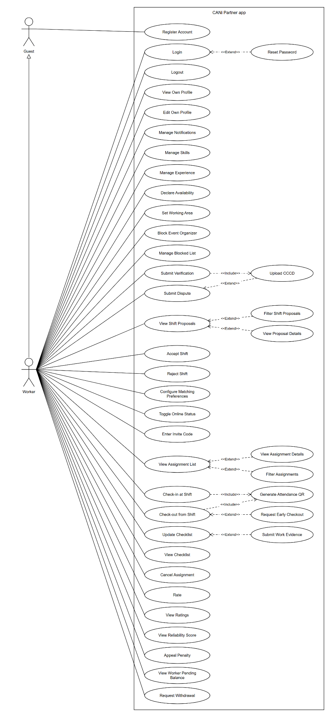

4.3.2 UCs for Event Organizer
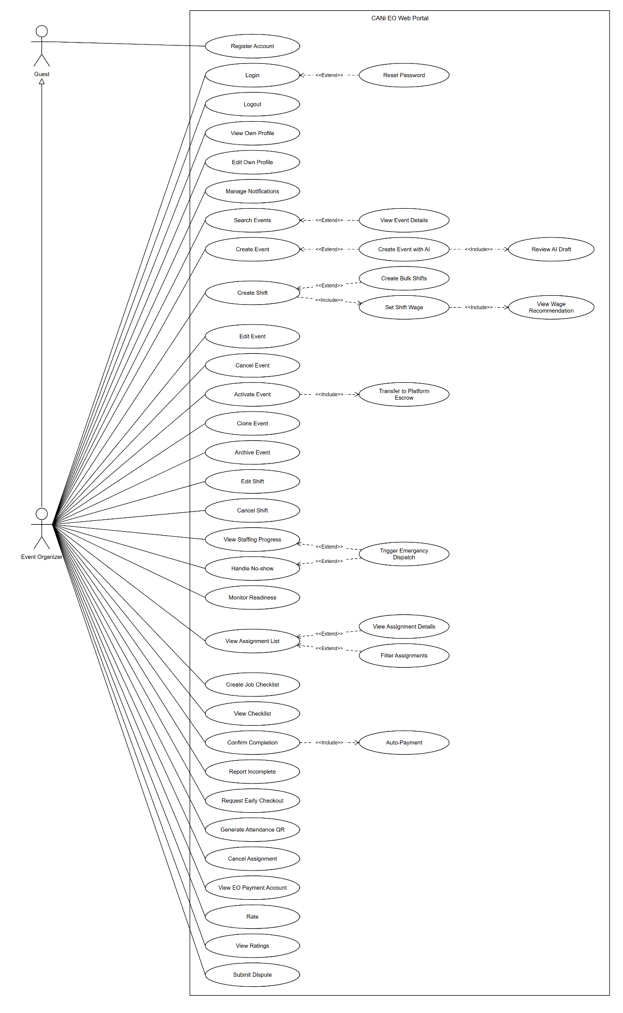

4.3.3 UCs for Admin
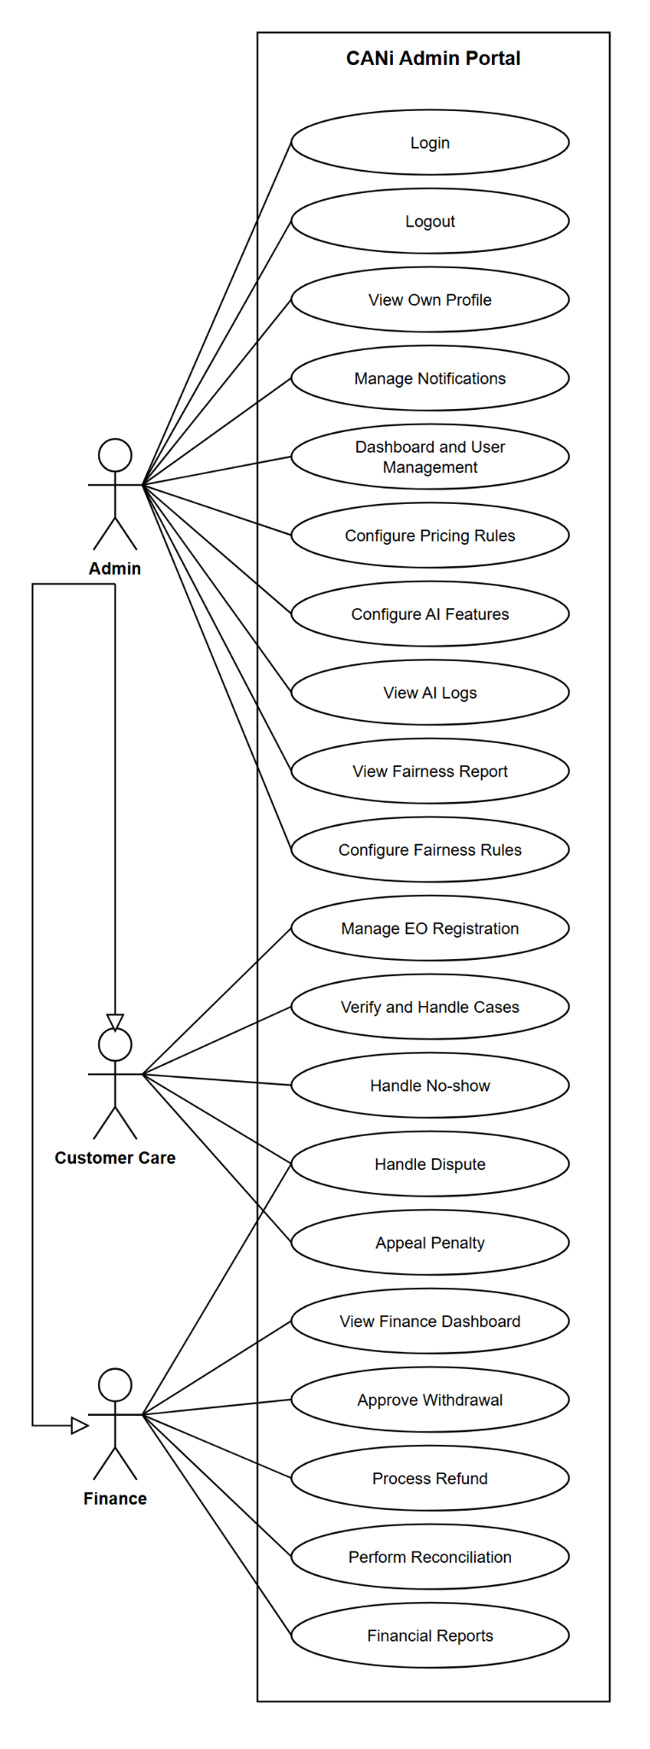

4.3.4 UCs for Customer care
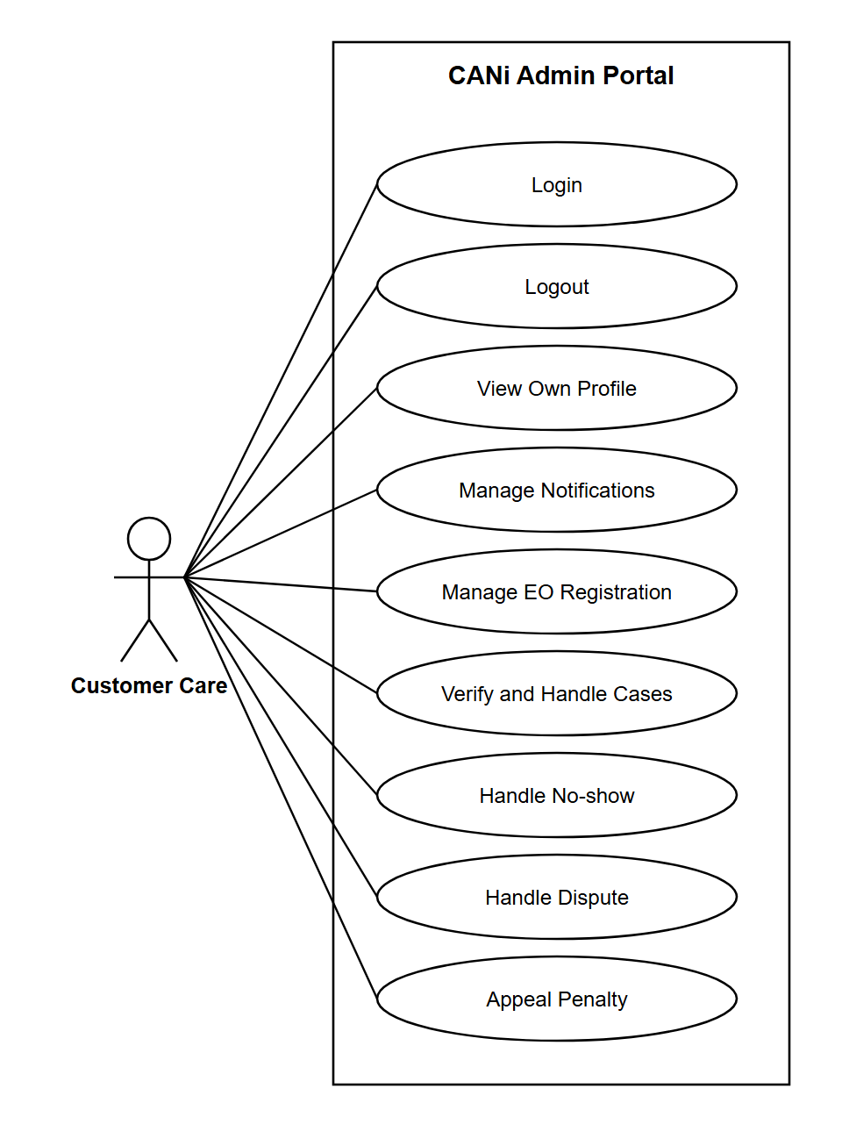
4.3.5 UCs for Finance
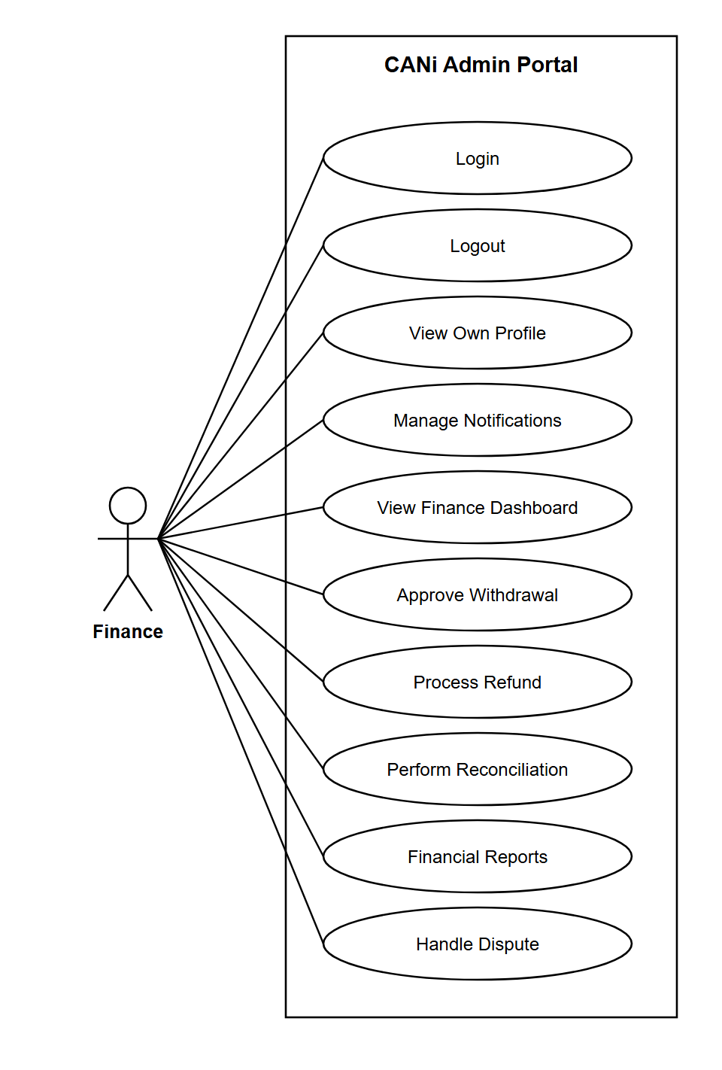

4.4 Permission Matrix
Full = unrestricted · Restricted = conditions apply (see footnotes) · No = denied
Entity | Action | Guest | Event  Organizer | Worker | Customer  Care | Admin
Account &  Subscription | Register Account | Yes | Yes | Yes | No | Full
Account &  Subscription | Login | No | Full | Full | Full | Full
Account &  Subscription | Logout | No | Full | Full | Full | Full
Account &  Subscription | Reset Password | Yes | Full | Full | Full | Full
Account &  Subscription | Change Password | No | Full | Full | Full | Full
Account &  Subscription | Verify Email | Yes | Full | Full | No | No
Account &  Subscription | View Own Profile | No | Full | Full | No | Full
Account &  Subscription | Edit Own Profile | No | Full | Full | No | No
Account &  Subscription | View Account Status | No | Full | Full | Full | Full
Account &  Subscription | View Package Plans | Yes | Full | No | No | Full
Account &  Subscription | Purchase Package (VNPay) | No | Full | No | No | No
Account &  Subscription | View Subscription History | No | Full | No | Full | Full
Account &  Subscription | Manage Notifications | No | Full | Full | Full | Full
Event & Shift  Management | Search / View Events | No | Full | Restricted² | No | Full
Event & Shift  Management | Create Event | No | Full | No | No | No
Event & Shift  Management | Edit Event | No | Full | No | No | Full
Event & Shift  Management | Activate Event | No | Full | No | No | Full
Event & Shift  Management | Cancel Event | No | Restricted¹ | No | No | Full
Event & Shift  Management | Archive Event | No | Full | No | No | Full
Event & Shift  Management | View Event History | No | Full | No | Full | Full
Event & Shift  Management | Create Shift | No | Full | No | No | No
Event & Shift  Management | Create Bulk Shifts | No | Full | No | No | No
Event & Shift  Management | Edit Shift | No | Full | No | No | Full
Event & Shift  Management | Cancel Shift | No | Restricted¹ | No | No | Full
Event & Shift  Management | View Staffing Progress | No | Full | No | Full | Full
Event & Shift  Management | Post Shift for Matching | No | Full | No | No | No
Wage Matrix  Management | View Wage Recommendation | No | Full | No | No | Full
Wage Matrix  Management | Set Shift Wage | No | Full | No | No | No
Wage Matrix  Management | View Wage Matrix | No | No | No | No | Full
Wage Matrix  Management | Configure Wage Matrix | No | No | No | No | Full
Worker Profile  & Preferences | Manage Skills | No | No | Full | No | No
Worker Profile  & Preferences | Manage Experience | No | No | Full | No | No
Worker Profile  & Preferences | Upload Portfolio | No | No | Full | No | No
Worker Profile  & Preferences | Declare Availability | No | No | Full | No | No
Worker Profile  & Preferences | Set Working Area | No | No | Full | No | No
Worker Profile  & Preferences | Declare Job Preferences | No | No | Full | No | No
Worker Profile  & Preferences | Block Event Organizer | No | No | Full | No | No
Worker Profile  & Preferences | Manage Blocked List | No | No | Full | No | No
Worker Profile  & Preferences | View Public Profile | Yes | Restricted³ | Full | Full | Full
Skill Point &  Verification | View Skill Point | No | No | Full | Full | Full
Skill Point &  Verification | Submit Self-Declared Verification | No | No | Full | No | No
Skill Point &  Verification | Submit AI Document Verification | No | No | Full | No | No
Skill Point &  Verification | Request Platform Verification | No | No | Restricted⁴ | No | No
Skill Point &  Verification | View Verification Status | No | No | Restricted⁴ | Restricted⁵ | Full
Skill Point &  Verification | AI Verify Documents (System) | No | No | No | No | Full
Skill Point &  Verification | Admin Review Verification | No | No | No | Restricted⁵ | Full
Skill Point &  Verification | Calculate & Assign Tier (System) | No | No | No | No | Full
Matching  Engine | View Shift Proposals | No | No | Full | No | No
Matching  Engine | Filter Proposals | No | No | Full | No | No
Matching  Engine | View Proposal Details | No | No | Full | No | No
Matching  Engine | Accept Shift | No | No | Full | No | No
Matching  Engine | Reject Shift | No | No | Full | No | No
Matching  Engine | Toggle Online Status | No | No | Restricted⁶ | No | No
Matching  Engine | Configure Matching Preferences | No | No | Full | No | No
Matching  Engine | View Match Score Breakdown | No | Full | Full | No | Full
Matching  Engine | Calculate Match Score (System) | No | No | No | No | Full
Matching  Engine | Monitor Readiness | No | Full | No | Full | Full
Matching  Engine | Trigger Emergency Dispatch | No | Restricted¹² | No | No | Full
Matching  Engine | Configure Fairness Rules | No | No | No | No | Full
Assignment &  My Team | View Assignment List | No | Full | Full | Full | Full
Assignment &  My Team | View Assignment Details | No | Full | Full | Full | Full
Assignment &  My Team | Filter Assignments | No | Full | Full | Full | Full
Assignment &  My Team | View My Team | No | Full | No | No | Full
Assignment &  My Team | Add to My Team | No | Full | No | No | No
Assignment &  My Team | Remove from My Team | No | Full | No | No | No
Assignment &  My Team | Invite My Team Member | No | Full | No | No | No
Assignment &  My Team | Send Bulk Invite | No | Full | No | No | No
Assignment &  My Team | Create Worker Group | No | Full | No | No | No
Assignment &  My Team | Manage Worker Group | No | Full | No | No | Full
Group  Recruitment | Generate & Share Invite Link | No | Full | No | No | No
Group  Recruitment | Join via Invite Code / QR | No | No | Full | No | No
Group  Recruitment | Confirm Group Assignment | No | Full | No | No | No
Group  Recruitment | View Group Shifts | No | Full | Full | No | Full
Attendance &  Payment Status | Generate Attendance QR | No | Full | No | No | No
Attendance &  Payment Status | Check-in / Check-out (QR Scan) | No | No | Full | No | No
Attendance &  Payment Status | Create Job Checklist | No | Full | No | No | No
Attendance &  Payment Status | Update Checklist | No | Full | Full | No | No
Attendance &  Payment Status | View Checklist | No | Full | Full | Full | Full
Attendance &  Payment Status | Submit Work Evidence | No | No | Full | No | No
Attendance &  Payment Status | Confirm Shift Completion (EO) | No | Full | No | No | Full
Attendance &  Payment Status | Report Incomplete Work | No | Full | No | No | No
Attendance &  Payment Status | Request Early Checkout | No | No | Full | No | No
Attendance &  Payment Status | Calculate Actual Hours (System) | No | No | No | No | Full
Attendance &  Payment Status | Declare Payment Status (EO) | No | Full | No | Full | Full
Attendance &  Payment Status | Confirm Payment Receipt (Worker) | No | No | Restricted⁷ | No | Full
Attendance &  Payment Status | View Payment History | No | Full | Full | Full | Full
Attendance &  Payment Status | Handle No-show (System / Customer Care) | No | No | No | Restricted⁸ | Full
Attendance &  Payment Status | Cancel Assignment | No | Full | Full | No | Full
Rating &  Reputation | Rate Worker | No | Full | No | No | No
Rating &  Reputation | Rate Event Organizer | No | No | Full | No | No
Rating &  Reputation | View Ratings | Yes | Full | Full | Full | Full
Rating &  Reputation | View Reliability Score | No | No | Full | Full | Full
Rating &  Reputation | RS Penalty Appeal | No | No | Full | Full | Full
Rating &  Reputation | Lock / Unlock Account | No | No | No | No | Full
Dispute &  Resolution | Submit Dispute | No | Full | Full | No | No
Dispute &  Resolution | View Dispute Details | No | Full | Full | Full | Full
Dispute &  Resolution | Upload Evidence | No | Full | Full | Full | Full
Dispute &  Resolution | Investigate Dispute (CC) | No | No | No | Full | Full
Dispute &  Resolution | Issue Dispute Decision (CC) | No | No | No | Full | No
Dispute &  Resolution | Escalate to Admin | No | Restricted⁹ | Restricted⁹ | No | No
Dispute &  Resolution | Admin Final Decision | No | No | No | No | Full
Dispute &  Resolution | Apply RS Penalty | No | No | No | Full | Full
Dispute &  Resolution | View Dispute History | No | Full | Full | Full | Full
Customer  Care | Submit Support Ticket | No | Full | Full | No | No
Customer  Care | Track Support Ticket | No | Full | Full | Full | Full
Customer  Care | Manage Member Accounts | No | No | No | Full | Full
Customer  Care | View Revenue Dashboard | No | No | No | Full | Full
Customer  Care | Manage Dispute Queue | No | No | No | Full | Full
Customer  Care | Manage FAQ | No | No | No | Full | Full
System  Administration | View System Dashboard | No | No | No | No | Full
System  Administration | Manage Users (CRUD) | No | No | No | No | Full
System  Administration | Manage Roles (RBAC) | No | No | No | No | Restricted¹¹
System  Administration | Configure System Parameters | No | No | No | No | Full
System  Administration | Configure Skill Point Rules | No | No | No | No | Full
System  Administration | System Maintenance & Feature Flags | No | No | No | No | Full
Common  Services | Send Notifications (System) | No | No | No | No | Full
Common  Services | Dispatch Proposals Online/Offline | No | No | No | No | Restricted¹³
Common  Services | Upload & Validate Files | No | Full | Full | Full | Full
Common  Services | Search | Yes | Full | Full | Full | Full
Common  Services | Audit Log | No | No | No | No | Restricted¹⁰

Footnotes
¹ Cancellation/deletion only permitted when Event/Shift status is DRAFT and has no confirmed Assignments.
² Workers may only view Events/Shifts for which they have a confirmed Assignment or a pending Proposal.
³ Event Organizers may view a limited set of Worker profile fields only for Workers already assigned to their Events.
⁴ Workers can view their own verification status only; they cannot self-approve any verification tier.
⁵ Customer Care handles verification requests at Level 1 (approve / reject / request resubmission); complex cases are escalated to Admin.
⁶ Toggle Online Status — ON: Worker receives proposals via Job Feed (pull model when app is open). OFF: proposals delivered by email with a deep link. Real-time push notifications are NOT used.
⁷ Payment Status tracking only — CANi records declaration/confirmation state between EO and Worker. CANi does NOT hold funds or act as payment intermediary. The EO pays the Worker directly outside the app.
⁸ No-show handling: System auto-flags 30 minutes after scheduled start. Customer Care / Admin may override manually. Penalty: −25 RS points + access restriction for 3–7 days depending on recurrence.
⁹ Dispute escalation: Level 1 = Customer Care investigates and issues decision. Within 7 days of that decision, either party (EO or Worker) may escalate to Admin (Level 2). Admin decision is final and cannot be further appealed.
¹⁰ Audit Log: all significant state changes are logged automatically by the System. Only Admin may query the log. Log entries are immutable — no user, including Admin, may edit or delete them.
¹¹ Manage Roles (RBAC): only Super Admin may assign or revoke the Customer Care, Admin, and IT roles to prevent privilege escalation.
¹² Emergency Dispatch: System auto-triggers when a Shift has unfilled slots due to No-show or cancellation. Event Organizers may also trigger it manually from the Readiness Dashboard.
¹³ Dispatch Proposals (Online/Offline): System routes each proposal based on Worker.online_mode at dispatch time. ONLINE → pushed to Job Feed (Worker pulls when opening the app). OFFLINE → sent via email with a deep link.

5. System Functionalities

5.1 Screen Inventory

a. Screen Flow
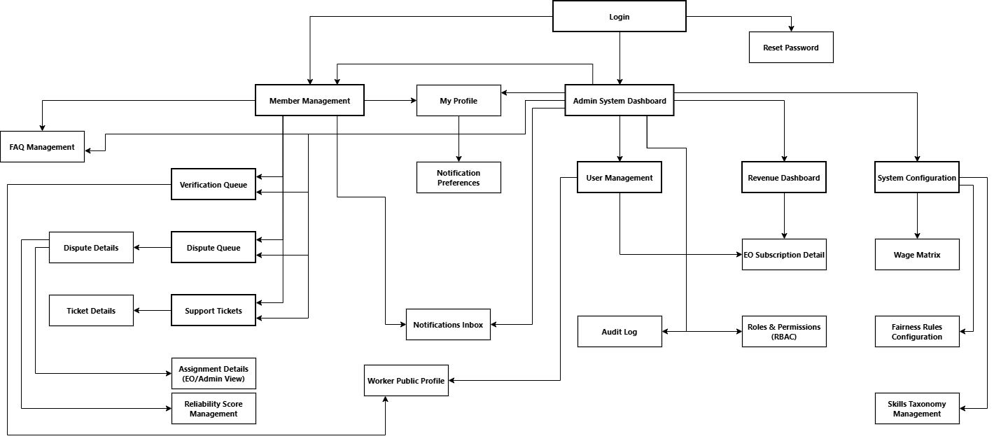
Admin/Customer Care Web App

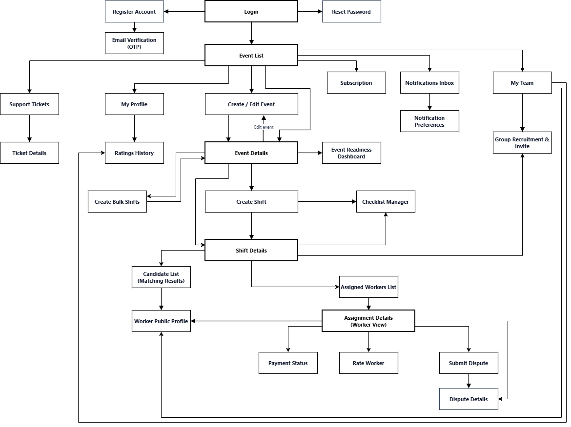
Event Organizer Web App

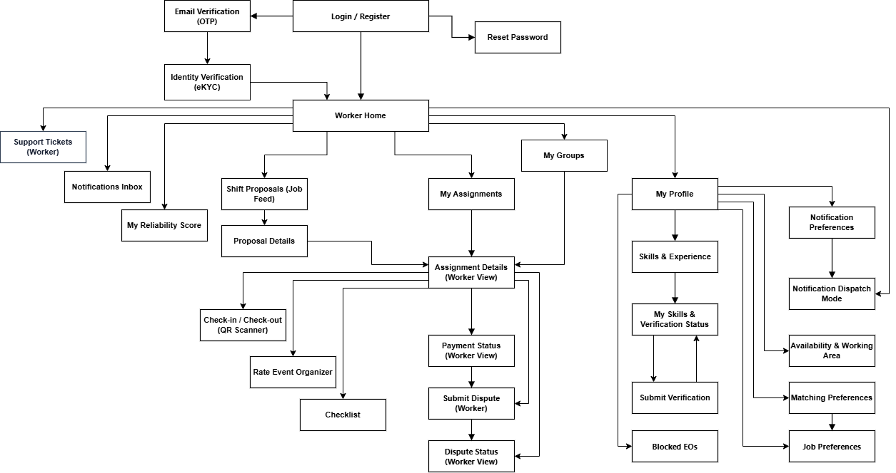
CANi Partner App

b. Screen List
- CANi Web App ( Admin , Customer care, Event Organizer)
# | Screen Name | Feature | Description
W-01 | Login | Auth | Shared login page for EO, Customer Care, and Admin. Email + password fields, 'Forgot Password' link, role indicator. Logout action available via top-right menu on all authenticated pages. (covers UC-02, UC-03)
W-02 | Register Account | Auth | Multi-step registration form. Step 1: select role (EO or Worker via web). Step 2: fill personal / company details. Step 3: submit & await OTP. (covers UC-01)
W-03 | Email Verification (OTP) | Auth | 6-digit OTP entry screen. Resend OTP link with cooldown. On success: redirect to role dashboard. (covers UC-06)
W-04 | Reset Password | Auth | Two-step: Step 1 – enter registered email; Step 2 – enter new password via link received by email. (covers UC-04)
W-05 | My Profile | FE-01 | Tabbed profile page. Tabs: Overview (avatar, name, role, status), Edit Details (UC-08), Security (Change Password UC-05), Account Status (UC-09). (covers UC-07, UC-08, UC-09, UC-05)
W-06 | Subscription | FE-01 | Tabbed page. Tabs: View Plans (pricing cards UC-10), Purchase (VNPay flow UC-11), History (transaction log UC-12). Payment processed via VNPay sandbox gateway — no card details stored in app. Reaches external VNPay checkout; on success, IPN callback activates package. (no card/account management screen required). (covers UC-10, UC-11, UC-12)
W-07 | Notification Preferences | FE-01 | Toggle list of notification types (In-App / Email per event type). Mandatory notifications locked. (covers UC-13)
W-08 | Notifications Inbox | SUP | Bell-icon panel / dedicated page listing all received notifications with read/unread status and deep links. (covers UC-117 — received side)
W-09 | Event List | FE-02 | Searchable, filterable list of EO's events (keyword, date, status). Cards show: name, dates, venue, staffing badge. Link to Event History tab for completed/archived. (covers UC-14, UC-21)
W-10 | Create / Edit Event | FE-02 | Form to create a new event (name, dates, venue, recruitment mode). Reused for editing metadata. Quota check displayed. (covers UC-15, UC-17)
W-11 | Event Details | FE-02 | Full event page with tabs: Overview, Shifts list, Staffing Progress, Actions (Activate UC-19, Cancel UC-18, Archive UC-20). Readiness indicator bar. (covers UC-16, UC-18, UC-19, UC-20, UC-26)
W-12 | Create Shift | FE-02 | Shift creation form inside an Event. Auto-resolves Wage Matrix 4D dimensions and shows wage recommendation inline (UC-28). EO sets final wage (UC-29). Checklist builder embedded (UC-78). (covers UC-22, UC-28, UC-29, UC-78)
W-13 | Create Bulk Shifts | FE-02 | Template form + time-slot table for mass shift creation. Preview with per-row validation before confirming. (covers UC-23)
W-14 | Shift Details | FE-02 | Shift page: details, assigned workers list, QR generator (UC-76), Edit (UC-24), Cancel (UC-25), Post for Matching button (UC-27). (covers UC-24, UC-25, UC-27, UC-76)
W-15 | Wage Matrix | FE-03 | Admin-only page: filterable 4D matrix table (City × Job Type × Time Slot × Lead Time). Actions: Add row, Edit row, Delete row, Import CSV, Export CSV, Test Lookup. Fallback stats shown. (covers UC-30, UC-31)
W-16 | Worker Public Profile | FE-04 | Read-only public profile card: avatar, Tier badges, RS band, skills, verifications, portfolio, rating summary, recent reviews. EO actions: Add to My Team, Invite to Shift. (covers UC-40)
W-17 | Verification Queue | FE-05 | Admin/Customer Care queue of pending verification requests (medium-confidence AI docs). Shows AI-extracted skills, confidence scores, uploaded docs. Actions: Approve / Reject / Request Resubmission per skill claim. Tier recalculation on approve. (covers UC-46, UC-47, UC-48)
W-45 | Skills Taxonomy Management | FE-05 | Admin-only page to manage the canonical Skills Taxonomy. CRUD operations: add new skill (name, category, default proficiency levels), edit, archive (soft delete), reorder. Changes propagate immediately to Worker skill picker (A-06) and Matching filters. Bulk import via CSV. Audit-logged. (covers UC-32 taxonomy side, UC-115)
W-18 | Candidate List (Matching Results) | FE-06 | Ranked list of eligible Workers for a Shift. Cards: name, Tier, RS, Match Score bar. Expandable row shows Match Score Breakdown (UC-56). EO selects candidates and clicks Send Invitations. (covers UC-56, UC-57, UC-60)
W-19 | Fairness Rules Configuration | FE-06 | Admin form to configure Fairness Guardrail parameters: New Worker Boost, Idle Boost, Inactivity threshold, Star Worker Cap %, Slot Reservation %. (covers UC-61)
W-20 | Event Readiness Dashboard | FE-06 | Real-time gauge + per-Shift status indicators (Green=Full, Yellow>50%, Red≤50%). Emergency Dispatch button. (covers UC-58, UC-59)
W-21 | Assigned Workers List | FE-07 | EO view of all Assignments across events. Filterable by status, date, event, Worker name. Rows link to Assignment Details. (covers UC-62, UC-64)
W-22 | Assignment Details (EO/Admin View) | FE-07 | Full Assignment page: Attendance records, Checklist status, Evidence gallery, Payment Status summary. Actions: Confirm Completion (UC-82), Report Incomplete (UC-83), approve Early Checkout (UC-84), Cancel Assignment (UC-89). Dispute link. (covers UC-63, UC-82, UC-83, UC-84, UC-85, UC-88, UC-89)
W-23 | Checklist Manager | FE-09 | Checklist create/edit interface for EO. Items: name, type (Checkbox / Photo / Note), mandatory flag. View mode shows completion status per Worker. (covers UC-78, UC-79, UC-80, UC-81)
W-24 | My Team | FE-07 | Tabbed page. Tabs: Members (list, add UC-66, remove UC-67, invite UC-68, bulk invite UC-69), Groups (create UC-70, manage UC-71), Pending Invites. Member cards link to Worker Public Profile. (covers UC-65, UC-66, UC-67, UC-68, UC-69, UC-70, UC-71)
W-25 | Group Recruitment & Invite | FE-08 | Generate invite link / QR code for a Shift or Group. Set expiry & max uses. View pending group join requests and confirm/reject each. View Group Shifts with per-member status. (covers UC-72, UC-73, UC-74, UC-75)
W-26 | Payment Status — EO View | FE-09 | EO declares payment (amount, method, reference, receipt upload). Displays Reference Payment calculated from actual hours. View declaration/confirmation state per Assignment. No escrow or fund transfer involved. (covers UC-85, UC-86, UC-87)
W-27 | Rate Worker | FE-10 | Rating dialog (modal or page) triggered after EO confirms completion. 5-criteria star input. Optional text review. Rating history view tab. (covers UC-90, UC-92)
W-28 | Ratings History | FE-10 | Filterable list of all EO-submitted ratings with criteria breakdown. Admin view includes all platform ratings. (covers UC-92)
W-29 | Reliability Score Management | FE-10 | View Worker RS value, Tier, component breakdown, penalty history. Review RS penalty appeals (UC-94). Lock / Unlock account actions (UC-95). (covers UC-93, UC-94, UC-95)
W-30 | Submit Dispute | FE-11 | Dispute submission form: category, description (min 50 chars), evidence upload (multi-file). Submittable by EO. (covers UC-96, UC-98)
W-31 | Dispute Details | FE-11 | Single dispute page with role-adaptive UI. EO/Worker: view status, evidence, timeline. Customer Care: investigation notes, Add Decision, Request Info buttons (UC-99, UC-100). EO/Worker: Escalate to Admin button (UC-101). Admin: Final Decision panel (UC-102). RS Penalty applied automatically on decision (UC-103). (covers UC-97, UC-99, UC-100, UC-101, UC-102, UC-103, UC-104)
W-32 | Dispute Queue | FE-12 | Customer Care queue of open/investigating disputes, sorted by priority & age. Self-assign, transfer, set deadline. Queue metrics sidebar. (covers UC-109)
W-33 | Member Management | FE-12 | List of pending EO account approvals + all accounts. Actions: Approve, Reject (with reason), Request Resubmission. View RS-locked Workers. (covers UC-107)
W-34 | Revenue Dashboard | FE-12 | Subscription revenue analytics: total revenue, breakdown by package, transaction count, period-over-period chart, VNPay transaction health. No escrow/wallet data. (covers UC-108)
W-46 | EO Subscription Detail | FE-13 | Admin drill-down view of a specific EO's subscription: current package, start/expiry dates, payment history via VNPay (transaction refs, amount, status, receipt link), remaining credits, auto-renew status. Actions: manual extend, change package, refund intent (records intent only — no wallet). Reached from W-34 Revenue Dashboard or W-39 User Management. (covers UC-12, UC-114, UC-115)
W-35 | Support Tickets | FE-12 | User view: list of own tickets (status, date) + 'New Ticket' button. Customer Care view: incoming ticket queue with SLA indicators. (covers UC-105, UC-106)
W-36 | Ticket Details | FE-12 | Full conversation thread for a support ticket. Add reply, change status (Open / In Progress / Closed), internal notes for Customer Care. (covers UC-106)
W-37 | FAQ Management | FE-12 | Customer Care/Admin create, edit, publish, archive FAQ articles by category. View analytics: view count, ticket deflection rate. (covers UC-110)
W-38 | Admin System Dashboard | FE-13 | Real-time KPI dashboard: active events, assignments by status, open disputes, RS distribution, DAU, Matching Engine throughput. Alerts banner for anomalies. (covers UC-111)
W-39 | User Management | FE-13 | Search users by email/role/status. View profile, edit role, force reset password, suspend, ban, deactivate. Cannot delete records (deactivate only). (covers UC-112)
W-40 | Roles & Permissions (RBAC) | FE-13 | Permission matrix editor: per-role feature access toggles. Create custom roles. Changes take effect immediately. (covers UC-113)
W-41 | System Configuration | FE-13 | Tabbed config page. Tabs: Pricing (package prices UC-114), Matching (thresholds), Attendance (no-show timer), Rating (window), RS Thresholds, Skill Point Rules (UC-115), Feature Flags & Maintenance (UC-116). (covers UC-114, UC-115, UC-116)
W-42 | Audit Log | SUP | Searchable, filterable immutable log of all system state changes. Filters: actor, action type, entity, date range, IP. Export to CSV. Read-only. (covers UC-121)

- CANi Partner App (Worker)
# | Screen Name | Feature | Description
A-01 | Login / Register | Auth | Combined entry screen: Login tab and Register tab. Register: select Worker role, enter name/email/password. Social SSO option. (covers UC-01, UC-02)
A-02 | Email Verification (OTP) | Auth | OTP entry with resend & countdown. On success: redirect to Home. (covers UC-06)
A-03 | Identity Verification ( eKYC) | Auth | Allows Workers to submit identity documents for eKYC after email verification. Displays verification status and supports resubmission if verification fails. The account is activated upon successful verification. (covers UC-01; BR-14)
A-04 | Reset Password | Auth | Enter email → receive link → set new password. (covers UC-04)
A-05 | Worker Home | FE-06 | Main dashboard. Prominent Online/Offline toggle in header (UC-54) with channel badge (Job Feed or Email). Summary cards: pending proposals count, upcoming shifts, RS band. Notification bell. Quick-nav to Proposals, Assignments, Profile. (covers UC-54)
A-06 | My Profile | FE-01 | Personal info view/edit: avatar, name, phone, bio (UC-08). Account status, Change Password (UC-05). (covers UC-07, UC-08, UC-09, UC-05)
A-07 | Subscription (Worker View) | FE-01 | Read-only subscription view for Workers: current plan tier (Free/Basic/Pro), features included, expiry and renewal dates. Purchase button deep-links to web W-06 if upgrade needed (mobile web fallback). Admin view: full purchase history per Worker, manual extend/upgrade. (covers UC-10, UC-12 — Worker side; complements UC-114)
A-08 | Skills & Experience | FE-04 | Tabs: Skills (add/edit/remove from taxonomy UC-32), Experience (self-declared + platform records UC-33), Portfolio (upload items UC-34). (covers UC-32, UC-33, UC-34)
A-09 | Availability & Working Area | FE-04 | Weekly grid availability picker (UC-35). District/city selector for working area with GPS suggestion (UC-36). (covers UC-35, UC-36)
A-10 | Job Preferences | FE-04 | Preferred job roles (multi-select from taxonomy). Minimum wage input (hard filter or soft preference toggle). (covers UC-37)
A-11 | Blocked EOs | FE-04 | List of blocked Event Organizers. Block action (UC-38) accessible from EO profile or proposal. Unblock action in this list. (covers UC-38, UC-39)
A-12 | Notification Preferences | FE-01 | Toggle notification types (In-App / Email per event category). Mandatory types locked. (covers UC-13 — Worker side)
A-13 | Notification Dispatch Mode | SUP | Settings screen for offline proposal delivery. Worker configures: (1) verified email address, (2) email digest frequency (Immediate / Hourly / Daily) when Offline, (3) quiet hours. Pairs with A-10 channel toggles and A-04 Online/Offline toggle. System prompts to configure on first Offline toggle if not yet set. (covers UC-118 — email delivery side)
A-14 | My Skills & Verification Status | FE-05 | Per-role Skill Point breakdown: SP_verify, SP_experience, SP_rating, Total SP, Tier badge, progress to next Tier. Verification status per skill (Self-Declared / AI-Verified / Platform-Proven). Pending review items shown with timeline. (covers UC-41, UC-45, UC-48)
A-15 | Submit Verification | FE-05 | Step wizard. Step 1: select verification type (Self-Declare UC-42 / AI Document UC-43 / Platform-Proven info UC-44). Step 2: fill form / upload credential. Step 3: review & submit. Platform-Proven shows criteria status (auto-granted). (covers UC-42, UC-43, UC-44)
A-16 | Shift Proposals (Job Feed) | FE-06 | Scrollable proposal feed (Online mode) or list from email links (Offline mode). Channel badge per proposal: 'Job Feed' or 'From Email'. Filter bar: role, date, district, wage (UC-50). Each card: role, event, date, venue, wage, expiry countdown. (covers UC-49, UC-50)
A-17 | Proposal Details | FE-06 | Full proposal card: Shift details, EO rating summary, wage vs reference, expiry timer. Expandable Match Score Breakdown section (UC-56). Accept (UC-52) / Reject (UC-53) buttons. (covers UC-51, UC-52, UC-53, UC-56)
A-18 | Matching Preferences | FE-06 | Settings screen: max travel distance, minimum wage (hard/soft), preferred roles link to A-08. (covers UC-55)
A-19 | My Assignments | FE-07 | List of Worker's Assignments sorted by Shift date. Status filter chips: Upcoming, Completed, Cancelled, Disputed. (covers UC-62, UC-64)
A-20 | Assignment Details (Worker View) | FE-07 | Full Assignment page: Shift info, EO contact, Attendance record, Checklist progress (tap to open UC-79), Payment Status section, Evidence upload (UC-81), Cancel Assignment button (UC-89), Dispute link. (covers UC-63, UC-81, UC-89)
A-21 | Checklist | FE-09 | Worker view of Shift checklist items. Tap item to mark complete: Checkbox, Photo capture, Text note. Evidence thumbnails shown. (covers UC-79, UC-80, UC-81)
A-22 | Check-in / Check-out (QR Scanner) | FE-09 | Camera QR scanner. Validates token in real-time. Records Check-in with ON_TIME / LATE status. Second scan records Check-out and displays actual hours. Request Early Checkout flow embedded. (covers UC-77, UC-84)
A-23 | Payment Status (Worker View) | FE-09 | Shows EO's declared payment (amount, method, reference, receipt image). Worker actions: Confirm Full Receipt, Confirm Partial, or Dispute. Payment history list below. Note: no wallet, no transfer via app. (covers UC-86, UC-87)
A-24 | Rate Event Organizer | FE-10 | Post-Shift rating dialog. 5-criteria star input for EO. Optional text review. Prompted 7-day window. (covers UC-91, UC-92)
A-25 | My Reliability Score | FE-10 | RS gauge (0-100), Tier badge, component breakdown, penalty/event history. RS Penalty Appeal form inline (UC-94). Active restrictions displayed if RS < 40. (covers UC-93, UC-94)
A-26 | Submit Dispute (Worker) | FE-11 | Dispute form: category, description, evidence upload. Submittable by Worker from Assignment Details or Payment Status. (covers UC-96, UC-98)
A-27 | Dispute Status (Worker View) | FE-11 | Read-only dispute timeline with CC decision, RS impact, Escalate to Admin button (within 7-day window). Dispute history list. (covers UC-97, UC-101, UC-104)
A-28 | Support Tickets (Worker) | FE-12 | List of submitted tickets with status. New Ticket button. Tap ticket for conversation thread, add reply. (covers UC-105, UC-106)
A-29 | Notifications Inbox | SUP | In-app notification list: unread/read, type icon, deep link. Notification arrives when app opens (pull model — no real-time push). (covers UC-117 — received side, UC-118 job feed portion)
A-30 | My Groups | FE-08 | Displays groups, group Shifts, and member statuses. Workers can join via invite code/QR. Group Leaders can share invitations and confirm or reject pending Assignments. (covers UC-72–UC-75)

5.2 External API Inventory
[Fill details of each external API into the table with the columns and sample data as below]
# | API Name | Calling Path | Description
1 | AI Embedding API | POST /api/ai/embedding | Calculate semanticFitScore (0-100) for Worker-Shift matching based on embedding vectors
2 | AI LLM API | POST /api/ai/extract | FE-13: Extract Shift information from natural language request to generate structured Shift draft
3 | Firebase Cloud Messaging | POST /api/notifications/push | Send push notification to Partner App for Worker
4 | Email SMTP | SMTP | Send email notification to Customer (event reminders, staffing alerts) and Admin (system alerts)

5.3 Background Job Inventory
[Fill details of each background job into the table with the columns and sample data as below]
# | Job Name | Group | Description
1 | Proposal Expiry | Scheduled | Review expired proposals and update status to EXPIRED
2 | Soft-Hold Release | Scheduled | Release soft-hold on Workers whose hold period has expired
3 | Event Readiness Check | Scheduled | Calculate Event Readiness Score and send alerts when staffing is low
4 | Notification Cleanup | Scheduled | Delete old notifications older than 90 days
5 | Reliability Score Update | Event-driven | Update Worker's Reliability score based on work history

II. Use Case Specifications

1. FE-01 Account & Subscription

1.1 UC-01: Register Account
UC ID | UC-01 | UC Name | Register Account
Feature | FE-01 Account & Subscription
Primary Actors | Guest | Secondary Actors | System, eKYC Provider, Admin (for EO approval flow)
Description | As a Guest, I want to register an account as a Worker or Event Organizer so that I can access the CANi platform features relevant to my role.
Preconditions | User is not authenticated.  User has a valid, unused email address.
Normal Flow | 1. Guest navigates to the Registration page.  2. Guest selects account type: Worker or Event Organizer.  3. Guest enters required fields: email, password, and role-specific information (Worker: full name; EO: full name, company name, phone number).  4. System validates input format and checks email uniqueness (BR-01).  5. System creates account in Pending Email Verification status and sends OTP to the provided email (BR-02).  6. Guest enters OTP on the verification screen.  7. System validates OTP (BR-02).  8. For Worker: System sets account to Pending eKYC Verification and initiates the eKYC flow (UC-17-eKYC). System activates account upon successful eKYC result from provider (BR-14).  9. For EO: System sets account to Pending Approval and submits EO documents to eKYC provider for pre-screening; CC reviews eKYC result and approves/rejects (UC-107).
Alternative Flows | AF-01 (Resend OTP): At Step 6, Guest requests OTP resend. System invalidates previous OTP, sends a new one, and resets expiry timer. Rejoins Normal Flow at Step 6.
Exception Flows | Step 4a: Email already registered -> System displays MSG01 'This email is already associated with an account.'  Step 4b: Password fails complexity check -> System displays MSG02 and highlights the password field.  Step 7a: OTP expired or invalid -> System displays MSG03. Rejoins Step 5.  Step 4c: Required field missing -> System highlights missing field and displays MSG04.  Step 8a: eKYC verification fails (document unreadable or identity mismatch) -> System notifies user with MSG05-eKYC and prompts re-upload.
Business Rules | BR-01: account identity uniqueness  BR-02: password security standards  BR-03: eo account approval  BR-04: otp security  BR-14: cccd/ekyc requirement for account activation  BR-82: identity verification sla
Postconditions | Worker: eKYC initiated; account moves to Active upon eKYC success.  EO: Account is Pending Approval; eKYC result available to CC for review.

1.2 UC-02: Login
UC ID | UC-02 | UC Name | Login
Feature | FE-01 Account & Subscription
Primary Actors | Worker, Event Organizer, Admin, Customer Care | Secondary Actors | System
Description | As a registered user, I want to log in with my email and password so that I can access my account and platform features.
Preconditions | User has a registered account.  Account is in Active status.
Normal Flow | 1. User navigates to the Login page.  2. User enters email and password.  3. System validates credentials against stored records.  4. System checks account status (BR-04).  5. System generates a session token and stores it securely.  6. System redirects user to their role-specific home dashboard.
Alternative Flows | AF-01 (Remember Me): At Step 2, User checks 'Remember Me'. System extends session token validity to 30 days. Rejoins Normal Flow at Step 3.
Exception Flows | Step 3a: Credentials do not match -> System increments failed attempt counter and displays MSG05.  Step 3b: Failed attempts >= 5 within 15 minutes -> System temporarily locks login and displays MSG06.  Step 4a: Account is Suspended -> System displays MSG07.  Step 4b: Account is Banned -> System displays MSG08.  Step 4c: Account is Pending Approval (EO) -> System displays MSG09.
Business Rules | BR-02: password security standards  BR-06: session limits
Postconditions | User is authenticated with an active session token.  User is on their role-specific dashboard.

1.3 UC-03: Logout
UC ID | UC-03 | UC Name | Logout
Feature | FE-01 Account & Subscription
Primary Actors | Worker, Event Organizer, Admin, Customer Care | Secondary Actors | System
Description | As an authenticated user, I want to log out of my session so that my account is secured when I finish using the platform.
Preconditions | User is authenticated with an active session.
Normal Flow | 1. User clicks the Logout button from any page.  2. System displays confirmation prompt.  3. User confirms logout.  4. System invalidates the current session token.  5. System clears local session data.  6. System redirects user to the Login page.
Alternative Flows | AF-01 (Cancel): At Step 3, User selects Cancel. System dismisses prompt and returns to current page.
Exception Flows | Step 4a: Session token already expired -> System proceeds with local cleanup and redirects to Login (MSG10).
Business Rules | BR-06: session limits
Postconditions | User session is terminated.  User is redirected to the Login page.

1.4 UC-04: Reset Password
UC ID | UC-04 | UC Name | Reset Password
Feature | FE-01 Account & Subscription
Primary Actors | Guest (unauthenticated user) | Secondary Actors | System
Description | As a user who has forgotten my password, I want to reset it via a link sent to my registered email so that I can regain access to my account.
Preconditions | User is not authenticated.  User has an Active account with a registered email.
Normal Flow | 1. User navigates to 'Forgot Password' page.  2. User enters their registered email address.  3. System validates that the email exists and the account is Active.  4. System generates a one-time reset token and sends a reset link to the email (BR-07).  5. User clicks the reset link in the email.  6. System validates the reset token (not expired, not used).  7. System presents the new password form.  8. User enters and confirms a new password meeting complexity requirements.  9. System hashes and updates the password, invalidates the reset token.  10. System invalidates all existing active sessions for the account.  11. System displays MSG11 and redirects to Login.
Alternative Flows | AF-01 (Resend Link): At Step 4, if User did not receive email, User requests resend. System invalidates previous token and issues new one.
Exception Flows | Step 3a: Email not found or not Active -> System displays MSG12 (no account existence disclosure).  Step 6a: Reset token expired -> System displays MSG13. Redirects to Step 1.  Step 8a: New password fails complexity -> System displays MSG02.
Business Rules | BR-02: password security standards  BR-06: session limits
Postconditions | Password updated.  All previous sessions invalidated.  User redirected to Login.

1.5 UC-05: Change Password
UC ID | UC-05 | UC Name | Change Password
Feature | FE-01 Account & Subscription
Primary Actors | Worker, Event Organizer, Admin, Customer Care | Secondary Actors | System
Description | As an authenticated user, I want to change my password by providing my current and new password so that I can maintain account security.
Preconditions | User is authenticated.  Account is Active.
Normal Flow | 1. User navigates to Account Settings > Security > Change Password.  2. User enters their current password.  3. System validates the current password.  4. User enters the new password and confirmation field.  5. System validates new password complexity (BR-09) and that it differs from current.  6. System hashes and saves the new password.  7. System invalidates all other active sessions.  8. System displays MSG14 'Password changed successfully.'
Alternative Flows | None
Exception Flows | Step 3a: Current password incorrect -> System displays MSG15.  Step 5a: New password fails complexity -> System displays MSG02.  Step 5b: New matches current -> System displays MSG16.  Step 5c: Confirmation mismatch -> System displays MSG17.
Business Rules | BR-02: password security standards  BR-06: session limits
Postconditions | Password updated.  All other sessions invalidated.  User remains logged in on current device.

1.6 UC-06: Verify Email
UC ID | UC-06 | UC Name | Verify Email
Feature | FE-01 Account & Subscription
Primary Actors | Guest (newly registered user) | Secondary Actors | System, eKYC Provider
Description | As a newly registered user, I want to verify my email address via OTP so that my account can proceed to identity verification and activation.
Preconditions | User has completed the registration form (UC-01).  Account is in Pending Email Verification status.
Normal Flow | 1. System sends OTP to registered email immediately after registration.  2. User opens the verification screen.  3. User enters the 6-digit OTP.  4. System validates OTP: checks match, expiry, and single-use status (BR-02).  5. For Worker: System sets account to Pending eKYC Verification and redirects to eKYC onboarding screen. Worker uploads identity document; system submits to eKYC provider. Upon successful callback, System sets account to Active and redirects to profile setup (BR-14).  6. For EO: System sets account to Pending Approval; eKYC pre-screening initiated automatically. CC receives notification with eKYC result attached (UC-107).
Alternative Flows | AF-01 (Resend OTP): At Step 3, User requests resend. System invalidates previous OTP and sends new one. Rejoins Step 3.  AF-02 (eKYC Re-upload): If eKYC document rejected by provider, User is prompted to re-upload document. System resubmits to provider.
Exception Flows | Step 4a: OTP incorrect -> System displays MSG03 (up to 5 attempts).  Step 4b: OTP expired -> System displays MSG18. Rejoins Step 1.  Step 4c: 5 failed attempts -> System locks verification for 30 minutes and displays MSG19.  Step 5a (Worker): eKYC provider returns failure (document unreadable, mismatch) -> System displays MSG-eKYC01 and prompts re-upload. Three consecutive failures trigger CC manual review.  Step 5b (Worker): eKYC callback not received within SLA window -> System flags account for CC follow-up and notifies user (BR-82).
Business Rules | BR-04: otp security  BR-14: cccd/ekyc requirement for account activation  BR-82: identity verification sla
Postconditions | Worker: eKYC initiated; account Active upon successful eKYC callback.  EO: Status=Pending Approval; CC has eKYC result for review.  Email is marked verified.

1.7 UC-07: View Own Profile
UC ID | UC-07 | UC Name | View Own Profile
Feature | FE-01 Account & Subscription
Primary Actors | Worker, Event Organizer, Admin, Customer Care | Secondary Actors | System
Description | As an authenticated user, I want to view my own profile so that I can review my personal information, account status, and platform statistics.
Preconditions | User is authenticated.  Account is Active.
Normal Flow | 1. User navigates to My Profile from the navigation menu.  2. System retrieves and displays personal information: name, email, phone, avatar, account type, and status.  3. For Worker: System additionally displays Skill Point summary, Tier badges, Reliability Score, average Rating, and verification badges.  4. For EO: System displays company info, active subscription package, quota usage, and average EO Rating.  5. User reviews the displayed information.
Alternative Flows | AF-01 (Navigate to Edit): At Step 5, User clicks 'Edit Profile'. System redirects to UC-08.
Exception Flows | Step 2a: Profile data load fails -> System displays MSG20 with Retry button.
Business Rules | BR-73: personal data access restriction  BR-05: soft delete policy
Postconditions | Profile information displayed to user.  No data changes occur.

1.8 UC-08: Edit Own Profile
UC ID | UC-08 | UC Name | Edit Own Profile
Feature | FE-01 Account & Subscription
Primary Actors | Worker, Event Organizer | Secondary Actors | System
Description | As an authenticated user, I want to edit my profile information so that my personal details remain accurate and up to date.
Preconditions | User is authenticated.  Account is Active.
Normal Flow | 1. User navigates to My Profile and clicks 'Edit Profile'.  2. System displays the editable profile form pre-filled with current values.  3. User modifies desired fields: display name, phone, avatar, bio.  4. Worker may also update preferred job roles and working area.  5. User clicks 'Save Changes'.  6. System validates all field formats and constraints.  7. System saves the updated profile and returns to profile view.  8. System displays MSG21 'Profile updated successfully.'
Alternative Flows | AF-01 (Avatar Upload): At Step 3, User uploads a new avatar. System validates file (UC-119), stores image, and updates avatar URL. Rejoins Step 5.
Exception Flows | Step 6a: Phone number format invalid -> System displays MSG22.  Step 6b: Display name < 2 characters -> System displays MSG23.  Step 5a: User clicks Cancel -> System discards changes. Use case ends.
Business Rules | BR-76: file upload validation  BR-73: personal data access restriction
Postconditions | Profile updated with new values.  Updated information immediately visible on profile view.

1.9 UC-09: View Account Status
UC ID | UC-09 | UC Name | View Account Status
Feature | FE-01 Account & Subscription
Primary Actors | Worker, Event Organizer | Secondary Actors | System
Description | As an authenticated user, I want to view my current account status and restrictions so that I understand what platform features I can access.
Preconditions | User is authenticated.
Normal Flow | 1. User navigates to Account Settings > Account Status.  2. System retrieves and displays: Account Status, creation date, last login date.  3. For Worker: System displays Reliability Score tier, RS value, and any active feature restrictions.  4. For EO: System displays verification status and subscription quota summary.  5. If restrictions active, System displays an appeal or contact link.
Alternative Flows | None
Exception Flows | Step 2a: Status data unavailable -> System displays MSG20 with Retry button.
Business Rules | BR-60: reliability score scale & bands  BR-64: skill point system & tier thresholds  BR-05: soft delete policy
Postconditions | User has viewed current account status and restrictions.  No data modified.

1.10 UC-10: View Package Plans
UC ID | UC-10 | UC Name | View Package Plans
Feature | FE-01 Account & Subscription
Primary Actors | Event Organizer | Secondary Actors | System
Description | As an Event Organizer, I want to view available subscription packages so that I can choose the plan that fits my event staffing needs.
Preconditions | User is authenticated as Event Organizer.  Account is Active.
Normal Flow | 1. EO navigates to Subscription > View Plans.  2. System retrieves and displays all active package plans.  3. System displays for each plan: name, mode, price per event, feature list, and quota.  4. System highlights the currently active package and remaining quota.  5. System displays a 'Purchase' button for each plan.  6. EO reviews plans and optionally clicks 'Purchase' to proceed to UC-11.
Alternative Flows | None
Exception Flows | Step 2a: No active plans -> System displays MSG24.
Business Rules | BR-08: subscription quota enforcement
Postconditions | EO has reviewed available packages.  No purchase or data change occurs.

1.11 UC-11: Purchase Package via VNPay
UC ID | UC-11 | UC Name | Purchase Package via VNPay
Feature | FE-01 Account & Subscription
Primary Actors | Event Organizer | Secondary Actors | System, VNPay Payment Gateway
Description | As an Event Organizer, I want to purchase a service package via VNPay so that I receive quota credits to create and activate Events on CANi.
Preconditions | EO is authenticated and Active.  At least one package plan is available (UC-10).
Normal Flow | 1. EO selects a package plan and clicks 'Purchase'.  2. System displays order summary: plan name, price, and applicable terms.  3. EO confirms the order.  4. System creates a pending transaction record and generates a VNPay payment session.  5. System redirects EO to the VNPay payment page.  6. EO completes payment via VNPay.  7. VNPay sends a payment result callback to System.  8. System verifies callback authenticity and payment status.  9. System marks transaction COMPLETED, credits quota to EO's account, and sends confirmation (UC-117).  10. System redirects EO to Subscription History (UC-12) with success message MSG25.
Alternative Flows | None
Exception Flows | Step 6a: EO cancels on VNPay -> System marks CANCELLED, displays MSG26.  Step 8a: Payment FAILED -> System marks FAILED, displays MSG27.  Step 8b: Callback timeout -> System marks PENDING_VERIFICATION for manual reconciliation.
Business Rules | BR-08: subscription quota enforcement  BR-09: data ownership
Postconditions | Success: Transaction COMPLETED; EO quota increased.  Failed/Cancelled: Transaction FAILED/CANCELLED; EO quota unchanged.

1.12 UC-12: View Subscription History
UC ID | UC-12 | UC Name | View Subscription History
Feature | FE-01 Account & Subscription
Primary Actors | Event Organizer | Secondary Actors | System
Description | As an Event Organizer, I want to view my subscription purchase history so that I can track spending and monitor remaining quota.
Preconditions | EO is authenticated and Active.
Normal Flow | 1. EO navigates to Subscription > History.  2. System retrieves all subscription transactions for this EO account.  3. System displays each transaction: date, package, amount, method, reference, status, and quota credited.  4. System displays summary: total purchased, total used, remaining quota.  5. EO may click a transaction to view full details.
Alternative Flows | AF-01 (Filter by Date): EO applies date range filter. System refreshes the list.
Exception Flows | Step 2a: No transaction history -> System displays MSG28.
Business Rules | BR-08: subscription quota enforcement  BR-05: soft delete policy
Postconditions | EO has viewed subscription history.  No data modified.

1.13 UC-13: Manage Notifications
UC ID | UC-13 | UC Name | Manage Notifications
Feature | FE-01 Account & Subscription
Primary Actors | Worker, Event Organizer | Secondary Actors | System
Description | As an authenticated user, I want to configure which notifications I receive and via which channels so that I stay informed without being overwhelmed.
Preconditions | User is authenticated and Active.
Normal Flow | 1. User navigates to Account Settings > Notifications.  2. System displays notification preference settings with toggles per event type.  3. System displays channel options: In-App and Email for each type.  4. User enables or disables types and selects preferred channels.  5. User clicks 'Save Preferences'.  6. System saves preferences and applies to future notification dispatch.  7. System displays MSG29 'Notification preferences saved.'
Alternative Flows | None
Exception Flows | Step 5a: User disables mandatory notification -> System displays MSG30 and keeps mandatory types enabled.
Business Rules | BR-75: notification retention
Postconditions | User notification preferences saved and applied to all future notifications (UC-117).

2. FE-02 Event & Shift Management

2.1 UC-14: Search Events
UC ID | UC-14 | UC Name | Search Events
Feature | FE-02 Event & Shift Management
Primary Actors | Event Organizer | Secondary Actors | System
Description | As an Event Organizer, I want to search and filter my events by keyword, date, and status so that I can quickly locate specific events to manage.
Preconditions | EO is authenticated and Active.  EO has at least one Event record.
Normal Flow | 1. EO navigates to the Events section.  2. System displays the event list with default filter: all events sorted by creation date descending.  3. EO enters a search keyword and/or applies filters: date range, status, location, staffing status.  4. System queries events matching the EO's account and applied filters.  5. System displays matching event cards with: name, date, venue, total Shifts, confirmed vs. required headcount, and status badge.  6. EO clicks an event card to view details (UC-16).
Alternative Flows | AF-01 (Clear Filters): EO clicks 'Clear All Filters'. System resets to default view.
Exception Flows | Step 5a: No events match -> System displays MSG31.
Business Rules | BR-07: event scheduling horizon  BR-08: subscription quota enforcement  BR-05: soft delete policy
Postconditions | EO views filtered list.  No data modified.

2.2 UC-15: Create Event
UC ID | UC-15 | UC Name | Create Event
Feature | FE-02 Event & Shift Management
Primary Actors | Event Organizer | Secondary Actors | System
Description | As an Event Organizer, I want to create a new event by providing event details and selecting a recruitment mode so that I can begin staffing it with Workers.
Preconditions | EO is authenticated and Active.  EO has remaining event quota (at least 1 unused credit from UC-11).
Normal Flow | 1. EO navigates to Events > Create New Event.  2. EO enters event details: name, description, start date, end date, and venue location.  3. EO selects recruitment mode: Invite Mode or Matching+Invite Mode (BR-24).  4. System displays the service fee for the selected mode.  5. EO clicks 'Create Event'.  6. System validates all required fields and quota availability.  7. System creates the Event record with status=Draft, records selected mode and price.  8. System deducts one quota credit from EO's subscription balance.  9. System redirects EO to Event Detail page (UC-16) to add Shifts.
Alternative Flows | None
Exception Flows | Step 6a: Required field missing -> System highlights and displays MSG04.  Step 6b: EO has no remaining quota -> System displays MSG32.  Step 6c: End date before start date -> System displays MSG33.
Business Rules | BR-07: event scheduling horizon  BR-08: subscription quota enforcement
Postconditions | Event record created with status=Draft.  EO quota decremented by 1.  EO redirected to Event Detail to add Shifts.

2.3 UC-16: View Event Details
UC ID | UC-16 | UC Name | View Event Details
Feature | FE-02 Event & Shift Management
Primary Actors | Event Organizer | Secondary Actors | System
Description | As an Event Organizer, I want to view full details of an event including all Shifts and staffing progress so that I can monitor and manage the event effectively.
Preconditions | EO is authenticated.  Event record exists and belongs to EO.
Normal Flow | 1. EO selects an event from the event list (UC-14) or navigates directly.  2. System retrieves and displays event header: name, description, dates, venue, status, recruitment mode, and price paid.  3. System displays staffing summary: total required Workers across all Shifts vs. total confirmed Workers.  4. System displays list of Shifts with per-Shift data: role, time, required count, confirmed count, and staffing status indicator.  5. System displays quick action buttons based on current event status: Edit, Activate, Cancel, Archive.  6. EO may click a Shift row to view Shift details or take actions.
Alternative Flows | None
Exception Flows | Step 2a: Event not found or access denied -> System displays MSG34.
Business Rules | BR-07: event scheduling horizon  BR-05: soft delete policy
Postconditions | EO has viewed event details.  No data modified.

2.4 UC-17: Edit Event
UC ID | UC-17 | UC Name | Edit Event
Feature | FE-02 Event & Shift Management
Primary Actors | Event Organizer | Secondary Actors | System
Description | As an Event Organizer, I want to edit event metadata so that I can correct or update event information before or during staffing.
Preconditions | EO is authenticated.  Event is in Draft or Active status.
Normal Flow | 1. EO navigates to Event Detail (UC-16) and clicks 'Edit Event'.  2. System displays the event edit form pre-filled with current values.  3. EO modifies editable fields: name, description, venue, start/end date.  4. EO clicks 'Save Changes'.  5. System validates all fields.  6. System saves the updated event metadata.  7. If event is Active and venue or date changed: System sends notifications to affected Workers (UC-117).  8. System displays MSG35 and returns to Event Detail view.
Alternative Flows | None
Exception Flows | Step 5a: End date before start date -> System displays MSG33.  Step 4a: User clicks Cancel -> System discards changes.  Step 3a: Attempt to change recruitment mode -> System displays MSG36.
Business Rules | BR-07: event scheduling horizon  BR-08: subscription quota enforcement
Postconditions | Event metadata updated.  Affected Workers notified if Active event with impacted Assignments.

2.5 UC-18: Cancel Event
UC ID | UC-18 | UC Name | Cancel Event
Feature | FE-02 Event & Shift Management
Primary Actors | Event Organizer | Secondary Actors | System
Description | As an Event Organizer, I want to cancel an event so that all associated Workers are notified and released from their Assignments.
Preconditions | EO is authenticated.  Event is in Draft or Active status.
Normal Flow | 1. EO navigates to Event Detail (UC-16) and clicks 'Cancel Event'.  2. System displays confirmation dialog listing the number of affected Workers.  3. EO enters a cancellation reason and confirms.  4. System performs atomic cancellation: a. Updates Event status to CANCELLED. b. Updates all Shift statuses to CANCELLED. c. Updates all Assignments to CANCELLED_BY_EO. d. Releases Workers' schedule availability.  5. System sends cancellation notifications to all affected Workers (UC-117).  6. System records EO cancellation in EO's reputation history.  7. System redirects EO to the Events list.
Alternative Flows | None
Exception Flows | Step 3a: EO clicks Cancel on confirmation -> System dismisses dialog.  Step 4a: Atomic cancellation fails -> System rolls back and displays MSG37.
Business Rules | BR-05: soft delete policy  BR-45: eo shift cancellation
Postconditions | Event status=CANCELLED.  All Shifts and Assignments=CANCELLED_BY_EO.  Workers notified and schedules freed.

2.6 UC-19: Activate Event
UC ID | UC-19 | UC Name | Activate Event
Feature | FE-02 Event & Shift Management
Primary Actors | Event Organizer | Secondary Actors | System
Description | As an Event Organizer, I want to activate a Draft event so that Workers can be invited or matched to its Shifts.
Preconditions | EO is authenticated.  Event is in Draft status.  Event has at least one Shift configured (BR-25).
Normal Flow | 1. EO navigates to Event Detail (UC-16) and clicks 'Activate Event'.  2. System validates: event has at least one Shift, all required Shift fields are complete, quota has been consumed.  3. System updates Event status to Active.  4. For Invite Mode: System enables the invite Worker workflow.  5. For Matching+Invite Mode: System additionally enables the Matching & Dispatch workflow (UC-27).  6. System displays MSG38 'Event activated.'
Alternative Flows | None
Exception Flows | Step 2a: No Shifts configured -> System displays MSG39.  Step 2b: Shift missing required fields -> System displays MSG40 listing incomplete Shifts.
Business Rules | BR-07: event scheduling horizon  BR-08: subscription quota enforcement
Postconditions | Event status is Active.  Workers can receive invitations or be matched to the event's Shifts.

2.7 UC-20: Archive Event
UC ID | UC-20 | UC Name | Archive Event
Feature | FE-02 Event & Shift Management
Primary Actors | Event Organizer | Secondary Actors | System
Description | As an Event Organizer, I want to archive a completed or cancelled event so that it is removed from my active view while data is preserved.
Preconditions | EO is authenticated.  Event is in Completed or Cancelled status.
Normal Flow | 1. EO navigates to Event Detail (UC-16) and clicks 'Archive Event'.  2. System displays confirmation.  3. EO confirms archiving.  4. System updates Event status to Archived.  5. System moves event out of the default active events list.  6. System displays MSG41.
Alternative Flows | None
Exception Flows | Step 3a: EO cancels confirmation -> System dismisses. Use case ends.  Step 2a: Event is still Active -> System displays MSG42.
Business Rules | BR-05: soft delete policy
Postconditions | Event status=Archived.  Event hidden from default active event lists.  All associated data preserved.

2.8 UC-21: View Event History
UC ID | UC-21 | UC Name | View Event History
Feature | FE-02 Event & Shift Management
Primary Actors | Event Organizer | Secondary Actors | System
Description | As an Event Organizer, I want to view a history of all my past events so that I can track performance and plan future events.
Preconditions | EO is authenticated and Active.
Normal Flow | 1. EO navigates to Events > History.  2. System retrieves all events for this EO with status: Completed, Cancelled, or Archived.  3. System displays each event with: name, dates, venue, total Shifts, confirmed headcount, completion rate, and payment summary.  4. EO applies optional filters: date range, status.  5. EO clicks on an event to view Event Detail (UC-16) in read-only mode.
Alternative Flows | None
Exception Flows | Step 2a: No historical events -> System displays MSG43.
Business Rules | BR-05: soft delete policy  BR-07: event scheduling horizon
Postconditions | EO views event history.  No data modified.

2.9 UC-22: Create Shift
UC ID | UC-22 | UC Name | Create Shift
Feature | FE-02 Event & Shift Management
Primary Actors | Event Organizer | Secondary Actors | System
Description | As an Event Organizer, I want to create a Shift within an event by specifying role, timing, headcount, and wage so that I can define a specific staffing need.
Preconditions | EO is authenticated.  Parent Event exists (status: Draft or Active).
Normal Flow | 1. EO navigates to Event Detail and clicks 'Add Shift'.  2. EO enters Shift details: role/job type, start datetime, end datetime, venue, and required Worker headcount.  3. EO specifies required skills, experience level, and any mandatory conditions.  4. System automatically resolves the 4 Wage Matrix dimensions: City, Job Type, Time Slot, Lead Time.  5. System queries Wage Matrix and displays recommended wage per hour (UC-28).  6. EO reviews wage recommendation and sets the final wage (UC-29).  7. EO optionally creates a Job Checklist (UC-78).  8. EO clicks 'Save Shift'.  9. System validates all required fields.  10. System creates Shift record with status=Draft and staffing counters initialized to 0.
Alternative Flows | None
Exception Flows | Step 9a: Required fields missing -> System displays MSG04.  Step 9b: Shift end time before start time -> System displays MSG44.  Step 9c: Headcount is 0 or negative -> System displays MSG45.  Step 4a: Wage Matrix fallback used -> System displays MSG46.
Business Rules | BR-10: wage floor  BR-11: wage matrix lookup  BR-12: eo wage authority  BR-74: shift template reuse
Postconditions | Shift record created with status=Draft.  Staffing counters initialized.  Shift appears in Event Detail's Shift list.

2.10 UC-23: Create Bulk Shifts
UC ID | UC-23 | UC Name | Create Bulk Shifts
Feature | FE-02 Event & Shift Management
Primary Actors | Event Organizer | Secondary Actors | System
Description | As an Event Organizer, I want to create multiple Shifts simultaneously using a template and a list of time slots so that I can quickly configure a multi-session event.
Preconditions | EO is authenticated.  Parent Event exists in Draft or Active status.
Normal Flow | 1. EO navigates to Event Detail and clicks 'Bulk Add Shifts'.  2. EO defines a Shift template: role, venue, headcount, required skills, and wage.  3. EO specifies multiple time slots with start and end datetimes.  4. EO clicks 'Preview Bulk Creation'.  5. System validates each time slot individually.  6. System displays a preview table flagging validation errors per row.  7. EO reviews and confirms the bulk creation.  8. System creates all valid Shift records; invalid rows are skipped.  9. System displays MSG47 'X Shifts created successfully. Y rows had errors.'
Alternative Flows | AF-01 (Fix Errors): At Step 7, EO edits invalid rows in preview. System re-validates. Rejoins Step 6.
Exception Flows | Step 5a: All time slots fail validation -> System displays MSG48.
Business Rules | BR-10: wage floor  BR-11: wage matrix lookup  BR-12: eo wage authority
Postconditions | Valid Shifts created under the parent Event.  EO receives error summary for skipped rows.

2.11 UC-24: Edit Shift
UC ID | UC-24 | UC Name | Edit Shift
Feature | FE-02 Event & Shift Management
Primary Actors | Event Organizer | Secondary Actors | System
Description | As an Event Organizer, I want to edit a Shift's details so that I can correct errors or update requirements before the Shift begins.
Preconditions | EO is authenticated.  Shift is not yet in Working or Completed status.  Shift belongs to EO's event.
Normal Flow | 1. EO navigates to Event Detail, selects a Shift, and clicks 'Edit Shift'.  2. System displays the Shift edit form pre-filled with current values.  3. EO modifies allowed fields: headcount, role description, required skills, checklist, wage.  4. EO clicks 'Save Changes'.  5. System validates all fields.  6. If confirmed Assignments exist and material fields changed: System identifies affected Workers.  7. System saves the updated Shift.  8. System sends change notifications to affected Workers (UC-117).  9. System displays MSG35.
Alternative Flows | None
Exception Flows | Step 5a: Headcount reduced below current confirmed count -> System displays MSG49.  Step 4a: User clicks Cancel -> System discards changes.
Business Rules | BR-10: wage floor  BR-12: eo wage authority  BR-22: shift slot capacity
Postconditions | Shift details updated.  Affected Workers (if any) notified of changes.

2.12 UC-25: Cancel Shift
UC ID | UC-25 | UC Name | Cancel Shift
Feature | FE-02 Event & Shift Management
Primary Actors | Event Organizer | Secondary Actors | System
Description | As an Event Organizer, I want to cancel a specific Shift so that affected Workers are notified and released from their commitments.
Preconditions | EO is authenticated.  Shift is in Draft or Active status (not Completed).
Normal Flow | 1. EO navigates to Event Detail, selects a Shift, and clicks 'Cancel Shift'.  2. System displays confirmation with the number of Workers currently assigned.  3. EO enters a cancellation reason and confirms.  4. System updates Shift status to CANCELLED.  5. System updates all associated Assignments to CANCELLED_BY_EO.  6. System releases Workers' schedule availability.  7. System sends cancellation notifications to all affected Workers (UC-117).  8. System records the cancellation in EO's reputation history.
Alternative Flows | None
Exception Flows | Step 3a: EO cancels confirmation -> System dismisses dialog.
Business Rules | BR-45: eo shift cancellation  BR-05: soft delete policy
Postconditions | Shift status=CANCELLED.  All Assignments for this Shift=CANCELLED_BY_EO.  Workers notified and schedules freed.

2.13 UC-26: View Staffing Progress
UC ID | UC-26 | UC Name | View Staffing Progress
Feature | FE-02 Event & Shift Management
Primary Actors | Event Organizer | Secondary Actors | System
Description | As an Event Organizer, I want to view the staffing progress dashboard for my event so that I can monitor headcount and identify understaffed Shifts.
Preconditions | EO is authenticated.  Event is Active.
Normal Flow | 1. EO navigates to Event Detail > Staffing Dashboard.  2. System displays overall event staffing: total required, total confirmed, and remaining slots.  3. System displays per-Shift staffing status: Fully Staffed, Partially Staffed, or Understaffed.  4. System highlights Shifts that are Understaffed and approaching the event date.  5. EO can click an understaffed Shift to trigger dispatch or invite actions.
Alternative Flows | None
Exception Flows | Step 2a: No Shifts configured -> System displays MSG39.
Business Rules | BR-22: shift slot capacity  BR-07: event scheduling horizon
Postconditions | EO reviewed staffing progress.  No data modified.

2.14 UC-27: Post Shift for Matching
UC ID | UC-27 | UC Name | Post Shift for Matching
Feature | FE-02 Event & Shift Management
Primary Actors | Event Organizer | Secondary Actors | System (Matching Engine)
Description | As an Event Organizer using Matching+Invite Mode, I want to trigger the Matching Engine for a Shift so that I receive a ranked list of eligible Workers to invite.
Preconditions | EO is authenticated.  Event is in Matching+Invite Mode.  Shift is Active and has remaining open slots.
Normal Flow | 1. EO navigates to Shift Detail and clicks 'Find Matching Workers'.  2. System validates that the Shift has remaining open headcount.  3. System triggers the Matching Engine (UC-57): Eligibility Filtering then Ranking.  4. System displays a ranked candidate list with Worker cards: name, Tier badge, Reliability Score, Match Score, and skill highlights.  5. EO reviews candidate profiles (via UC-40) and selects Workers to invite.  6. EO clicks 'Send Invitations' for selected Workers.  7. System dispatches proposals to each selected Worker (UC-118).  8. System displays MSG50 'Invitations sent to X Workers.'
Alternative Flows | AF-01 (Refresh Candidates): EO requests fresh Matching run. System re-executes. Rejoins Step 4.
Exception Flows | Step 3a: No eligible Workers found -> System displays MSG51.  Step 2a: Shift is fully staffed -> System displays MSG52.
Business Rules | BR-18: online/offline dispatch mode  BR-19: match score formula  BR-22: shift slot capacity
Postconditions | Proposals sent to selected Workers.  Staffing progress updates as Workers respond.

3. FE-03 Wage Matrix Management

3.1 UC-28: View Wage Recommendation
UC ID | UC-28 | UC Name | View Wage Recommendation
Feature | FE-03 Wage Matrix Management
Primary Actors | Event Organizer | Secondary Actors | System (Wage Matrix Engine)
Description | As an Event Organizer creating a Shift, I want to see the system-recommended wage based on market reference data so that I can set a competitive and realistic wage.
Preconditions | EO is in the Shift creation or editing flow (UC-22).  Wage Matrix has at least one configured row.
Normal Flow | 1. System automatically resolves Shift dimensions: City (from venue), Job Type (from role), Time Slot (from start time/day), Lead Time (from now to shift start).  2. System queries the Wage Matrix for an exact match on all 4 dimensions.  3. If exact match found: System displays recommended wage per hour from the matching row.  4. System displays comparison indicators: market median for this combination over the past 30 days if available.  5. EO reviews the recommendation before entering the final wage (UC-29).
Alternative Flows | AF-01 (Fallback): No exact match found. System executes fallback chain: drop Time Slot -> drop Lead Time -> drop Job Type -> use Admin-configured default. System displays MSG46. Rejoins Step 3.
Exception Flows | Step 2a: Wage Matrix is completely empty -> System displays MSG53 and skips recommendation display.
Business Rules | BR-11: wage matrix lookup
Postconditions | Wage recommendation displayed with applicable reference or fallback level.  Lookup logged in wage_recommendations table.

3.2 UC-29: Set Shift Wage
UC ID | UC-29 | UC Name | Set Shift Wage
Feature | FE-03 Wage Matrix Management
Primary Actors | Event Organizer | Secondary Actors | System
Description | As an Event Organizer, I want to set the final wage for a Shift after reviewing the recommendation so that Workers are offered a clear and agreed-upon pay rate.
Preconditions | EO is in the Shift creation or editing flow.  Wage recommendation has been displayed (UC-28).
Normal Flow | 1. System displays the wage recommendation from Wage Matrix (UC-28).  2. EO enters the final wage per hour in the wage field.  3. System compares EO's wage to the Wage Matrix reference.  4. If EO wage >= reference: System shows MSG54 'Wage is at or above market reference.'  5. If EO wage < 80% of reference: System shows MSG55 'Warning: wage significantly below market.'  6. If EO wage > 150% of reference: System shows MSG56 'Note: wage is above market rate.'  7. EO confirms the wage and proceeds to save the Shift.
Alternative Flows | AF-01 (Accept Recommendation): EO clicks 'Use Recommended Wage'. System auto-fills the wage field. Rejoins Step 3.
Exception Flows | Step 2a: EO enters 0 or negative wage -> System displays MSG57.  Step 2b: Non-numeric value -> System displays MSG58.
Business Rules | BR-10: wage floor  BR-12: eo wage authority
Postconditions | Shift wage set to EO's confirmed value.  Wage comparison result logged.

3.3 UC-30: View Wage Matrix
UC ID | UC-30 | UC Name | View Wage Matrix
Feature | FE-03 Wage Matrix Management
Primary Actors | Admin | Secondary Actors | System
Description | As an Admin, I want to view the full Wage Matrix table so that I can review current wage configurations and identify gaps or missing combinations.
Preconditions | Admin is authenticated and Active.
Normal Flow | 1. Admin navigates to Admin Console > Wage Matrix.  2. System displays the matrix as a sortable, filterable table: City, Job Type, Time Slot, Lead Time, Wage/Hour, Last Modified.  3. Admin applies filters by City or Job Type to narrow the view.  4. System displays fallback statistics: % of Shifts using each fallback level, and top missing combinations.  5. Admin reviews the matrix and identifies rows to add, edit, or remove.
Alternative Flows | None
Exception Flows | Step 2a: Wage Matrix is empty -> System displays MSG59.
Business Rules | BR-11: wage matrix lookup  BR-71: system configuration access control
Postconditions | Admin viewed current Wage Matrix and fallback statistics.  No data modified.

3.4 UC-31: Configure Wage Matrix
UC ID | UC-31 | UC Name | Configure Wage Matrix
Feature | FE-03 Wage Matrix Management
Primary Actors | Admin | Secondary Actors | System
Description | As an Admin, I want to add, edit, delete, import, and export Wage Matrix rows so that I can keep wage recommendations accurate and up to date.
Preconditions | Admin is authenticated.  Admin navigated to Wage Matrix management (UC-30).
Normal Flow | 1. Admin selects an action: Add Row, Edit Row, Delete Row, Import CSV, Export CSV, or Test Lookup.  2. For Add/Edit Row: Admin fills in City, Job Type, Time Slot, Lead Time, and Wage/Hour. System validates uniqueness.  3. For Delete Row: Admin selects a row and confirms deletion.  4. For Import CSV: Admin uploads a CSV file. System validates format, checks for duplicates, and imports valid rows.  5. For Export CSV: System generates and downloads the current Matrix as CSV.  6. For Test Lookup: Admin inputs Shift parameters. System returns matched wage and fallback level.  7. System saves changes and logs them with Admin ID, timestamp, and before/after values.  8. System displays MSG60.
Alternative Flows | AF-01 (Import Partial Success): Some CSV rows fail validation. System imports valid rows and displays error report.
Exception Flows | Step 2a: Duplicate 4-dimension combination -> System displays MSG61.  Step 4a: CSV format invalid -> System displays MSG62.
Business Rules | BR-11: wage matrix lookup  BR-71: system configuration access control  BR-70: audit log integrity
Postconditions | Wage Matrix updated with Admin's changes.  Change log entry created.  Future Shift wage recommendations reflect the updated Matrix.

4. FE-04 Worker Profile & Preferences

4.1 UC-32: Manage Skills
UC ID | UC-32 | UC Name | Manage Skills
Feature | FE-04 Worker Profile & Preferences
Primary Actors | Worker | Secondary Actors | System
Description | As a Worker, I want to add, edit, and remove skills with proficiency levels so that the Matching Engine can accurately assess my suitability for Shifts.
Preconditions | Worker is authenticated and Active.
Normal Flow | 1. Worker navigates to Profile > Skills.  2. System displays current skills list with proficiency levels and verification status.  3. Worker clicks 'Add Skill'.  4. Worker selects a skill from the standardized Skill Taxonomy and sets proficiency: Beginner, Intermediate, Advanced, or Expert.  5. Worker clicks 'Save'.  6. System adds the skill with status=Self-Declared.  7. System recalculates Skill Match eligibility for future Matching runs.
Alternative Flows | AF-01 (Edit Skill): Worker selects existing skill and edits proficiency. System updates record.  AF-02 (Remove Skill): Worker selects skill and clicks 'Remove'. System confirms and deletes.
Exception Flows | Step 4a: Skill already in profile -> System displays MSG63.
Business Rules | BR-16: skill taxonomy & verification tiers  BR-13: verification requirement for dispatch
Postconditions | Worker's skills profile updated.  Matching Engine uses updated skills in subsequent runs.

4.2 UC-33: Manage Experience
UC ID | UC-33 | UC Name | Manage Experience
Feature | FE-04 Worker Profile & Preferences
Primary Actors | Worker | Secondary Actors | System
Description | As a Worker, I want to declare, edit, or remove relevant work experience so that Event Organizers can evaluate my background and the Matching Engine scores appropriately.
Preconditions | Worker is authenticated and Active.
Normal Flow | 1. Worker navigates to Profile > Experience.  2. System displays declared experience entries and platform-generated records from completed Assignments.  3. Worker clicks 'Add Experience'.  4. Worker selects related Job Category, enters role title, employer/event name, and duration.  5. Worker adds a brief description (optional, max 300 characters).  6. Worker clicks 'Save'.  7. System saves the experience entry as Self-Declared.  8. System notes the new experience in the Relevant Experience scoring pool for future Matching.
Alternative Flows | AF-01 (Edit Experience): Worker selects existing entry and edits fields.  AF-02 (Remove Experience): Worker removes a self-declared entry. Platform-generated records cannot be removed.
Exception Flows | Step 6a: Description exceeds 300 characters -> System displays MSG64.
Business Rules | BR-15: profile completeness  BR-66: sp_experience accrual
Postconditions | Experience profile updated.  Relevant Experience component recalculated on next Matching run.

4.3 UC-34: Upload Portfolio
UC ID | UC-34 | UC Name | Upload Portfolio
Feature | FE-04 Worker Profile & Preferences
Primary Actors | Worker | Secondary Actors | System, Admin
Description | As a Worker, I want to upload portfolio items linked to my skills so that Event Organizers can assess the quality of my work and support skill verification.
Preconditions | Worker is authenticated and Active.
Normal Flow | 1. Worker navigates to Profile > Portfolio.  2. Worker clicks 'Add Portfolio Item'.  3. Worker selects the related skill or role.  4. Worker uploads a file (image, video thumbnail, or PDF) via UC-119.  5. Worker adds a title and optional description.  6. Worker clicks 'Save'.  7. System stores the portfolio item linked to the selected skill.  8. System displays the item on the Worker's public profile (UC-40).
Alternative Flows | AF-01 (Remove Item): Worker selects existing item and clicks 'Remove'. System confirms and deletes.
Exception Flows | Step 4a: File validation fails -> System displays MSG65 from UC-119.  Step 4b: Upload fails due to network error -> System displays MSG66.
Business Rules | BR-76: file upload validation  BR-15: profile completeness
Postconditions | Portfolio item saved and linked to specified skill.  Item visible on Worker's public profile.

4.4 UC-35: Declare Availability
UC ID | UC-35 | UC Name | Declare Availability
Feature | FE-04 Worker Profile & Preferences
Primary Actors | Worker | Secondary Actors | System
Description | As a Worker, I want to declare my weekly availability schedule so that the Matching Engine can find Shifts that fit my free time.
Preconditions | Worker is authenticated and Active.
Normal Flow | 1. Worker navigates to Profile > Availability.  2. System displays a weekly availability grid (days x time blocks).  3. Worker selects available time blocks by clicking or dragging on the grid.  4. Worker optionally marks specific dates as unavailable (exception overrides).  5. Worker clicks 'Save Availability'.  6. System saves the availability schedule.  7. System immediately applies updated availability to future Matching Eligibility Filtering.
Alternative Flows | AF-01 (Clear All): Worker clicks 'Clear All'. System resets all blocks to unavailable.  AF-02 (Set All Available): Worker clicks 'Mark All Available'. System marks all blocks available.
Exception Flows | Step 6a: Save fails -> System displays MSG20 and retains in-progress edits.
Business Rules | BR-18: online/offline dispatch mode
Postconditions | Worker's availability schedule saved.  Matching Engine uses updated availability on next run.

4.5 UC-36: Set Working Area
UC ID | UC-36 | UC Name | Set Working Area
Feature | FE-04 Worker Profile & Preferences
Primary Actors | Worker | Secondary Actors | System
Description | As a Worker, I want to set my preferred working areas by district and city so that the Matching Engine prioritizes Shifts near my location.
Preconditions | Worker is authenticated and Active.
Normal Flow | 1. Worker navigates to Profile > Working Area.  2. System displays a location selector with province/city and district options.  3. Worker selects one or more districts across supported cities.  4. System optionally offers GPS-based suggestion (with Worker permission).  5. Worker clicks 'Save Working Area'.  6. System saves the selected working area.  7. System updates Location Match scoring in future Matching runs.
Alternative Flows | AF-01 (GPS Suggestion): Worker grants GPS permission. System suggests nearest district. Worker may accept or adjust.
Exception Flows | Step 3a: Worker selects no area and clicks Save -> System displays MSG68.
Business Rules | BR-18: online/offline dispatch mode
Postconditions | Worker's preferred working areas saved.  Location Match component updated in next Matching run.

4.6 UC-37: Declare Job Preferences
UC ID | UC-37 | UC Name | Declare Job Preferences
Feature | FE-04 Worker Profile & Preferences
Primary Actors | Worker | Secondary Actors | System
Description | As a Worker, I want to declare preferred job roles and minimum expected wage so that the platform sends me relevant Shift proposals.
Preconditions | Worker is authenticated and Active.
Normal Flow | 1. Worker navigates to Profile > Job Preferences.  2. Worker selects preferred job roles from Skill Taxonomy.  3. Worker optionally sets a minimum expected wage per hour.  4. Worker indicates whether minimum wage is a hard filter or soft preference.  5. Worker clicks 'Save Preferences'.  6. System saves job preferences and applies to Job Feed filtering and Dispatch routing.
Alternative Flows | None
Exception Flows | Step 3a: Wage value is non-numeric or negative -> System displays MSG57.  Step 2a: No preferred roles selected -> System displays MSG69.
Business Rules | BR-18: online/offline dispatch mode  BR-19: match score formula
Postconditions | Job preferences saved.  Dispatch and Job Feed filtering updated for this Worker.

4.7 UC-38: Block EO
UC ID | UC-38 | UC Name | Block EO
Feature | FE-04 Worker Profile & Preferences
Primary Actors | Worker | Secondary Actors | System
Description | As a Worker, I want to block a specific Event Organizer so that I no longer receive Shift proposals from them.
Preconditions | Worker is authenticated and Active.  Worker has interacted with or been proposed to by the EO.
Normal Flow | 1. Worker navigates to an EO's profile or a Shift proposal from that EO.  2. Worker selects 'Block this EO' from the options menu.  3. System displays confirmation: 'This action is private and will not be disclosed to the EO.'  4. Worker confirms the block.  5. System adds the EO to the Worker's block list.  6. System immediately removes the blocked EO from all future Dispatch pipelines for this Worker.  7. System displays MSG70.
Alternative Flows | None
Exception Flows | Step 4a: EO already in block list -> System displays MSG71.
Business Rules | BR-25: worker block list  BR-83: mutual block isolation
Postconditions | EO added to Worker's block list.  Future proposals from EO excluded for this Worker.  Existing Assignments unaffected.

4.8 UC-39: Manage Blocked List
UC ID | UC-39 | UC Name | Manage Blocked List
Feature | FE-04 Worker Profile & Preferences
Primary Actors | Worker | Secondary Actors | System
Description | As a Worker, I want to view and manage my list of blocked Event Organizers so that I can unblock EOs if I change my mind.
Preconditions | Worker is authenticated and Active.
Normal Flow | 1. Worker navigates to Profile > Blocked EOs.  2. System displays the blocked EO list with: EO name, date blocked, and optional note.  3. Worker selects an EO entry and clicks 'Unblock'.  4. System displays confirmation: 'Unblocking will allow them to send proposals again.'  5. Worker confirms.  6. System removes the EO from the block list.  7. System restores Dispatch eligibility for this EO-Worker pair.  8. System displays MSG72.
Alternative Flows | None
Exception Flows | Step 2a: Block list is empty -> System displays MSG73.
Business Rules | BR-25: worker block list  BR-83: mutual block isolation
Postconditions | Selected EO removed from Worker's block list.  Dispatch pipeline restored.

4.9 UC-40: View Public Profile
UC ID | UC-40 | UC Name | View Public Profile
Feature | FE-04 Worker Profile & Preferences
Primary Actors | Event Organizer, Admin | Secondary Actors | System
Description | As an Event Organizer or Admin, I want to view a Worker's public profile so that I can assess their skills, experience, and reliability before inviting them to a Shift.
Preconditions | Actor is authenticated.  Worker account exists and is not Banned.
Normal Flow | 1. Actor navigates to a Worker's public profile via candidate list, My Team, or search.  2. System retrieves and displays: display name, avatar, Skill Point Tiers per role, verification badges, portfolio items, average Rating, Reliability Score band, and completed Shift count.  3. System displays recent EO reviews.  4. System displays skills with verification status (Self-Declared / AI-Verified / Platform-Proven).  5. Actor may take actions: Add to My Team (UC-66), Invite to Shift (UC-68).
Alternative Flows | None
Exception Flows | Step 2a: Worker account not found or Banned -> System displays MSG74.
Business Rules | BR-73: personal data access restriction  BR-63: rs penalty transparency  BR-15: profile completeness
Postconditions | Actor reviewed Worker's public profile.  No Worker data modified.

5. FE-05 Skill Point & Verification

5.1 UC-41: View Skill Point
UC ID | UC-41 | UC Name | View Skill Point
Feature | FE-05 Skill Point & Verification
Primary Actors | Worker | Secondary Actors | System
Description | As a Worker, I want to view my accumulated Skill Points per role and current Tier so that I understand my standing and progression path.
Preconditions | Worker is authenticated and Active.
Normal Flow | 1. Worker navigates to Profile > Skill Points.  2. System displays per-role SP breakdown: SP_verify, SP_experience, SP_rating, and Total SP.  3. System displays current Tier badge per role: Starter, Bronze, Silver, Gold, Platinum, Diamond, or Master.  4. System displays SP threshold for the next Tier and the gap remaining.  5. System displays SP history: recent events that changed SP with timestamps.
Alternative Flows | None
Exception Flows | Step 2a: No SP data -> System displays MSG75.
Business Rules | BR-64: skill point system & tier thresholds  BR-65: sp_verify accrual  BR-66: sp_experience accrual  BR-67: sp_rating computation
Postconditions | Worker reviewed SP breakdown and Tier status.  No data modified.

5.2 UC-42: Submit Self-Declared Verification
UC ID | UC-42 | UC Name | Submit Self-Declared Verification
Feature | FE-05 Skill Point & Verification
Primary Actors | Worker | Secondary Actors | System
Description | As a Worker, I want to complete Tier 1 self-declared verification by selecting skills from the Skill Taxonomy so that I can pass Eligibility Filtering for standard Shifts.
Preconditions | Worker is authenticated and Active.  Worker has not yet declared skills for a given role.
Normal Flow | 1. Worker navigates to Profile > Skills or Verification > Self-Declare.  2. System displays Skill Taxonomy organized by category.  3. Worker selects applicable skills and assigns proficiency levels.  4. Worker clicks 'Confirm Self-Declaration'.  5. System saves selected skills as Self-Declared (Tier 1) with SP_verify=0.  6. System assigns Worker a Starter Tier for the declared role.  7. System displays MSG76.
Alternative Flows | None
Exception Flows | Step 3a: No skills selected -> System displays MSG69.
Business Rules | BR-16: skill taxonomy & verification tiers  BR-65: sp_verify accrual
Postconditions | Skills saved as Self-Declared (Tier 1).  Worker eligible for standard Shifts.

5.3 UC-43: Submit AI Document Verification
UC ID | UC-43 | UC Name | Submit AI Document Verification
Feature | FE-05 Skill Point & Verification
Primary Actors | Worker | Secondary Actors | System (AI Pipeline — Iter 3)
Description | As a Worker, I want to upload credential documents for AI-powered Tier 2 verification so that my skills are recognized as AI-Verified, earning SP_verify. (Iter 3 — post-MVP)
Preconditions | Worker is authenticated and Active.  AI Document Verification feature is enabled (Iter 3).
Normal Flow | 1. Worker navigates to Profile > Verification > Submit AI Verification.  2. Worker selects the skill/role to verify.  3. Worker uploads credential document (CV, degree, or certificate) via UC-119.  4. System triggers AI pipeline (UC-46): Multimodal Extraction -> Taxonomy Normalization -> Confidence Scoring.  5. Confidence >= 0.85: System auto-approves, grants AI-Verified badge, awards SP_verify, and notifies Worker (MSG77).  6. Confidence 0.60-0.84: System queues for Admin review (UC-47) and displays MSG78.  7. Confidence < 0.60: System rejects with MSG79 and improvement guidance.
Alternative Flows | None
Exception Flows | Step 3a: File validation fails (UC-119) -> System displays MSG65.  Step 4a: AI pipeline unavailable -> System queues for Admin manual review.
Business Rules | BR-16: skill taxonomy & verification tiers  BR-65: sp_verify accrual  BR-76: file upload validation
Postconditions | High confidence: Skill upgraded to AI-Verified; SP_verify credited.  Medium confidence: Document queued for Admin review.  Low confidence: Submission rejected; Worker may resubmit.

5.4 UC-44: Request Platform Verification
UC ID | UC-44 | UC Name | Request Platform Verification
Feature | FE-05 Skill Point & Verification
Primary Actors | Worker | Secondary Actors | System
Description | As a Worker, I want to be automatically recognized as Platform-Proven (Tier 3) when I meet the criteria so that my profile gains the highest trust level on the platform.
Preconditions | Worker has completed >= 3 Assignments for a specific role.  Average Rating for that role >= 4.5/5.0.  No active Disputes linked to those Assignments.
Normal Flow | 1. System continuously evaluates all Workers' Assignment history per role.  2. System checks: completed Assignments >= 3 AND avg Rating >= 4.5 AND no active Disputes.  3. When criteria met: System automatically grants Platform-Proven (Tier 3) for that role.  4. System awards badge on Worker's public profile.  5. System updates Skill Match scoring to maximum Tier score for this role.  6. System sends notification to Worker (UC-117) MSG80.
Alternative Flows | None
Exception Flows | Step 3a: Worker's avg Rating drops below 4.5 after Tier 3 granted -> System monitors degradation. If 3 consecutive ratings < 3.5, Tier 3 is revoked (BR-67).
Business Rules | BR-16: skill taxonomy & verification tiers  BR-65: sp_verify accrual
Postconditions | Worker has Platform-Proven status for specified role.  Worker receives top Matching priority for that role.

5.5 UC-45: View Verification Status
UC ID | UC-45 | UC Name | View Verification Status
Feature | FE-05 Skill Point & Verification
Primary Actors | Worker | Secondary Actors | System
Description | As a Worker, I want to view the verification status of each skill so that I know which credentials have been verified and what actions to take.
Preconditions | Worker is authenticated and Active.
Normal Flow | 1. Worker navigates to Profile > Verification Status.  2. System displays list of Worker's skills with verification tier: Self-Declared, AI-Verified, or Platform-Proven.  3. For skills pending Admin review: System displays expected review window and submission date.  4. For skills with rejected verification: System displays rejection reason and resubmission guidance.  5. Worker may click 'Upgrade Verification' to submit additional documents (UC-43).
Alternative Flows | None
Exception Flows | Step 2a: No skills on profile -> System displays MSG75.
Business Rules | BR-16: skill taxonomy & verification tiers  BR-17: verification expiry  BR-65: sp_verify accrual
Postconditions | Worker viewed verification status for all skills.  No data modified.

5.6 UC-46: AI Verify Documents
UC ID | UC-46 | UC Name | AI Verify Documents
Feature | FE-05 Skill Point & Verification
Primary Actors | System (AI Pipeline) | Secondary Actors | Admin (if routed to review queue)
Description | As a System service (Iter 3), I process uploaded Worker documents through a multi-step AI pipeline to extract skills, normalize them to the Skill Taxonomy, and route approval based on confidence score.
Preconditions | Worker has submitted a document for Tier 2 verification (UC-43).  AI verification feature is active (Iter 3).
Normal Flow | 1. System receives uploaded document (PDF, DOCX, JPG, or PNG).  2. System performs file ingestion and format detection.  3. For text documents: System applies Text Parser to extract structured content.  4. For image files: System applies Vision LLM to identify institution, seal, recipient name, and skill content.  5. System normalizes extracted skills to Skill Taxonomy (outputs Skill ID + Evidence Snippet + Confidence Score per skill).  6. System routes by confidence: >=0.85 auto-approve; 0.60-0.84 queue for Admin review (UC-47); <0.60 auto-reject.  7. System records pipeline result in verification_log with: file hash, extracted skills, confidence scores, routing decision, and timestamp.  8. System presents recognized skills to Worker for confirmation before committing SP_verify.
Alternative Flows | None
Exception Flows | Step 3a: Document corrupted or unreadable -> System logs failure and auto-rejects with MSG79.  Step 5a: No recognizable skills found -> System auto-rejects with MSG79 and guidance.
Business Rules | BR-16: skill taxonomy & verification tiers  BR-65: sp_verify accrual  BR-76: file upload validation
Postconditions | High confidence: Skills queued for Worker confirmation, then SP_verify credited.  Medium confidence: Queued in Admin review queue.  Low confidence: Rejected; Worker notified with reason.

5.7 UC-47: Admin Review Verification
UC ID | UC-47 | UC Name | Admin Review Verification
Feature | FE-05 Skill Point & Verification
Primary Actors | Admin | Secondary Actors | System, Worker
Description | As an Admin, I want to review Worker credential documents flagged for manual review so that I can approve or reject skill verification requests accurately.
Preconditions | Admin is authenticated.  At least one verification request in Admin review queue (confidence 0.60-0.84).
Normal Flow | 1. Admin navigates to Admin Console > Verification Queue.  2. System displays pending requests sorted by submission date with AI-extracted skills and confidence scores.  3. Admin selects a request and reviews: uploaded document, AI-identified skills, evidence snippets, and confidence scores.  4. Admin approves or rejects each extracted skill claim individually.  5. For approved skills: Admin sets the SP_verify amount (within guidelines BR-66).  6. Admin submits the review decision.  7. System updates Worker's verification status to AI-Verified, awards SP_verify, and recalculates Tier.  8. System notifies Worker of the outcome (UC-117).  9. System logs Admin decision with identifier, timestamp, and rationale.
Alternative Flows | AF-01 (Request Resubmission): Admin identifies insufficient evidence. Admin selects 'Request Resubmission'. System notifies Worker with guidance.
Exception Flows | Step 6a: Admin rejects all skill claims -> System sets status to Rejected, notifies Worker with Admin's reasoning.
Business Rules | BR-16: skill taxonomy & verification tiers  BR-65: sp_verify accrual  BR-82: identity verification sla  BR-59: cc jurisdiction & escalation path
Postconditions | Approved: Skills updated to AI-Verified; SP_verify credited.  Rejected: Worker notified with reason and guidance.

5.8 UC-48: Calculate & Assign Tier
UC ID | UC-48 | UC Name | Calculate & Assign Tier
Feature | FE-05 Skill Point & Verification
Primary Actors | System | Secondary Actors | Worker (notified)
Description | As a System service, I recalculate a Worker's total Skill Points per role after each SP-affecting event and update the Tier assignment accordingly.
Preconditions | An SP-affecting event has occurred: Assignment completed, EO rating submitted, or verification approved.
Normal Flow | 1. System receives an SP update trigger.  2. System fetches the Worker's current total SP for the affected role.  3. System calculates new total SP = SP_verify + SP_experience + SP_rating.  4. System maps total SP to Tier: Starter (0-49), Bronze (50-149), Silver (150-299), Gold (300-599), Platinum (600-999), Diamond (1000-1499), Master (1500+).  5. If Tier has changed: System updates Worker's Tier record for the role.  6. If Tier increased: System sends promotion notification MSG81.  7. If Tier decreased: System sends MSG82.
Alternative Flows | None
Exception Flows | Step 3a: SP calculation results in negative -> System clamps to 0.
Business Rules | BR-64: skill point system & tier thresholds  BR-65: sp_verify accrual  BR-66: sp_experience accrual  BR-67: sp_rating computation
Postconditions | Worker's SP total and Tier updated for affected role.  If Tier changed, Worker notified and Matching Engine uses new Tier on next run.

6. FE-06 Matching Engine

6.1 UC-49: View Shift Proposals
UC ID | UC-49 | UC Name | View Shift Proposals
Feature | FE-06 Matching Engine
Primary Actors | Worker | Secondary Actors | System
Description | As a Worker, I want to view incoming Shift proposals so that I can review and respond to opportunities. Proposals arrive via Job Feed (online mode) or email (offline mode).
Preconditions | Worker is authenticated.  Worker has at least one pending proposal.
Normal Flow | 1. Worker opens the CANi Partner App.  2. System reads Worker's current Online Status (UC-54).  3. If Online mode (Toggle=ON): System displays the Job Feed with all pending proposals sorted by relevance. Proposals are available in real-time when app is open.  4. If Offline mode (Toggle=OFF): System displays proposals received via email. Worker taps the deep link in the email to open the proposal detail within the app.  5. System displays each proposal card: role, event name, Shift date/time, venue, offered wage vs. market reference, and expiry countdown.  6. Worker taps a proposal card to view Proposal Details (UC-51).
Alternative Flows | AF-01 (Online-to-Offline mid-session): Worker toggles to Offline (UC-54) while viewing Job Feed. System stops pushing new proposals to feed; new proposals route to email.
Exception Flows | Step 3a: No pending proposals in Job Feed -> System displays MSG83.  Step 4a: Email deep link expired -> System displays MSG84.
Business Rules | BR-18: online/offline dispatch mode  BR-19: match score formula  BR-20: proposal expiry  BR-26: proposal source transparency
Postconditions | Worker has viewed pending proposals.  No data modified by viewing.

6.2 UC-50: Filter Proposals
UC ID | UC-50 | UC Name | Filter Proposals
Feature | FE-06 Matching Engine
Primary Actors | Worker | Secondary Actors | System
Description | As a Worker, I want to filter my Shift proposal list by role, date, location, and wage so that I can quickly find the most relevant opportunities.
Preconditions | Worker is viewing the proposal list (UC-49).
Normal Flow | 1. Worker taps the Filter icon on the proposal list screen.  2. System displays filter options: Role Type, Date Range, District/City, Wage Range.  3. Worker selects filter values and taps 'Apply Filters'.  4. System filters the proposal list based on selected criteria.  5. System displays the filtered results with count: 'Showing X of Y proposals.'  6. Worker reviews filtered results.
Alternative Flows | AF-01 (Clear Filters): Worker taps 'Clear Filters'. System resets to unfiltered list.
Exception Flows | Step 4a: No proposals match filters -> System displays MSG85.
Business Rules | BR-19: match score formula  BR-18: online/offline dispatch mode
Postconditions | Proposal list filtered as specified.  No data modified.

6.3 UC-51: View Proposal Details
UC ID | UC-51 | UC Name | View Proposal Details
Feature | FE-06 Matching Engine
Primary Actors | Worker | Secondary Actors | System
Description | As a Worker, I want to view the full details of a Shift proposal so that I can make an informed decision to accept or reject it.
Preconditions | Worker has tapped a proposal card (from UC-49 or email link).
Normal Flow | 1. Worker taps a proposal card.  2. System retrieves and displays: Event name and description, role, Shift date/time, venue address, required skills, Checklist preview, offered wage vs. market reference.  3. System displays EO's average rating and recent reviews.  4. System displays proposal expiry deadline and countdown.  5. Worker may tap 'View Match Score' to see Match Score Breakdown (UC-56).  6. Worker chooses to Accept (UC-52) or Reject (UC-53).
Alternative Flows | None
Exception Flows | Step 2a: Proposal expired -> System displays MSG86.  Step 2b: Worker already responded from another device -> System displays MSG87.
Business Rules | BR-18: online/offline dispatch mode  BR-26: proposal source transparency  BR-19: match score formula
Postconditions | Worker viewed proposal details.  No data modified.

6.4 UC-52: Accept Shift
UC ID | UC-52 | UC Name | Accept Shift
Feature | FE-06 Matching Engine
Primary Actors | Worker | Secondary Actors | System
Description | As a Worker, I want to accept a Shift proposal so that an Assignment is created and I am confirmed to work the Shift.
Preconditions | Worker is viewing a pending proposal (UC-51).  Proposal has not expired.
Normal Flow | 1. Worker taps 'Accept Shift' on the proposal detail screen.  2. System performs real-time pre-acceptance checks: a. Account status is Active. b. No confirmed Assignments conflict with this Shift's time slot. c. Remaining open slots > 0.  3. All checks pass: System creates Assignment record with status=CONFIRMED.  4. System updates Shift staffing counters: Confirmed Workers +1, Remaining Workers -1.  5. System sends confirmation notification to Worker (UC-117) MSG88.  6. System notifies EO of the new confirmation (UC-117).  7. System updates Shift status to Fully Staffed if remaining=0.
Alternative Flows | None
Exception Flows | Step 2a: Schedule conflict -> System displays MSG89.  Step 2b: Shift just filled -> System displays MSG90.  Step 2c: Account restricted or locked -> System displays MSG07.
Business Rules | BR-20: proposal expiry  BR-22: shift slot capacity  BR-27: schedule overlap prevention
Postconditions | Assignment record created with status=CONFIRMED.  Shift's confirmed headcount incremented.  Worker's schedule blocked for Shift time slot.

6.5 UC-53: Reject Shift
UC ID | UC-53 | UC Name | Reject Shift
Feature | FE-06 Matching Engine
Primary Actors | Worker | Secondary Actors | System
Description | As a Worker, I want to reject a Shift proposal with a reason so that the Event Organizer can seek other candidates.
Preconditions | Worker is viewing a pending proposal (UC-51).
Normal Flow | 1. Worker taps 'Reject Shift' on the proposal detail screen.  2. System presents optional reason selection: Schedule conflict, Wage too low, Location too far, Role not suitable, Other.  3. Worker selects a reason and taps 'Confirm Rejection'.  4. System updates proposal status to REJECTED.  5. System removes the proposal from Worker's pending list.  6. System notifies EO that the Worker declined (UC-117) without disclosing the specific reason.
Alternative Flows | None
Exception Flows | Step 3a: Proposal already expired -> System displays MSG86 and closes proposal view.
Business Rules | BR-20: proposal expiry
Postconditions | Proposal status=REJECTED.  EO notified.  Worker's RS and SP unaffected.

6.6 UC-54: Toggle Online Status
UC ID | UC-54 | UC Name | Toggle Online Status
Feature | FE-06 Matching Engine
Primary Actors | Worker | Secondary Actors | System
Description | As a Worker, I want to toggle my Online Status between Online and Offline so that I control how I receive Shift proposals: via Job Feed or email.
Preconditions | Worker is authenticated.
Normal Flow | 1. Worker taps the Online/Offline toggle in the app's navigation bar or Profile settings.  2. System reads the current Online Status value.  3. If currently Online: System switches to Offline. Stores Worker.online_mode='OFFLINE' in DB.  4. If currently Offline: System switches to Online. Stores Worker.online_mode='ONLINE' in DB.  5. System updates Dispatch routing configuration for this Worker immediately (UC-118).  6. System displays current mode indicator: green dot (Online) or grey envelope icon (Offline).  7. New proposals dispatched after this toggle follow the new routing mode.
Alternative Flows | None
Exception Flows | Step 5a: DB write fails -> System reverts the toggle display and shows MSG91.
Business Rules | BR-18: online/offline dispatch mode
Postconditions | Worker.online_mode updated in DB.  Future proposals dispatched via the new channel.

6.7 UC-55: Configure Matching Preferences
UC ID | UC-55 | UC Name | Configure Matching Preferences
Feature | FE-06 Matching Engine
Primary Actors | Worker | Secondary Actors | System
Description | As a Worker, I want to configure my Matching preferences including distance tolerance and minimum wage so that the Matching Engine uses my constraints when ranking candidates.
Preconditions | Worker is authenticated and Active.
Normal Flow | 1. Worker navigates to Settings > Matching Preferences.  2. System displays current matching preferences.  3. Worker sets: maximum travel distance (km), preferred job roles (UC-37), minimum wage per hour (UC-37), and availability window (UC-35).  4. Worker clicks 'Save Preferences'.  5. System validates inputs.  6. System saves preferences and marks them as inputs for Matching Engine (UC-57).  7. System displays MSG92.
Alternative Flows | None
Exception Flows | Step 5a: Distance value invalid -> System displays MSG93.
Business Rules | BR-18: online/offline dispatch mode  BR-19: match score formula
Postconditions | Matching preferences saved.  Next Matching run uses updated preferences.

6.8 UC-56: View Match Score Breakdown
UC ID | UC-56 | UC Name | View Match Score Breakdown
Feature | FE-06 Matching Engine
Primary Actors | Worker, Event Organizer | Secondary Actors | System
Description | As a Worker or Event Organizer, I want to view the Match Score breakdown for a Worker-Shift pairing so that I understand why a candidate was ranked at a particular position.
Preconditions | Actor is viewing a proposal detail (Worker) or candidate list (EO).  Match Score has been calculated.
Normal Flow | 1. Actor taps 'View Match Score' on a proposal or candidate entry.  2. System retrieves the stored Match Score breakdown for the Worker-Shift pairing.  3. System displays: Total Match Score (0-100), component scores and weights: Skill Match 40%, Relevant Experience 15%, Location Match 15%, Reliability 20%, Rating 10%.  4. System displays any applied Fairness Boost adjustments: New Worker Boost or Idle Worker Boost.  5. System displays the Worker's Tier badge contributing to Skill Match score.
Alternative Flows | None
Exception Flows | Step 2a: Score breakdown not available -> System displays MSG94.
Business Rules | BR-19: match score formula  BR-63: rs penalty transparency
Postconditions | Actor reviewed Match Score breakdown.  No data modified.

6.9 UC-57: Calculate Match Score
UC ID | UC-57 | UC Name | Calculate Match Score
Feature | FE-06 Matching Engine
Primary Actors | System (Matching Engine) | Secondary Actors | None
Description | As a System service, I calculate a Matching Score for each eligible Worker-Shift pairing using the Weighted Sum Model so that Event Organizers receive a ranked candidate list.
Preconditions | Shift is posted for Matching (UC-27).  Eligibility Filtering has been applied.
Normal Flow | 1. System receives the list of Workers who passed Eligibility Filtering for the target Shift.  2. For each eligible Worker, System calculates component scores: a. Skill Match (40%): maps Worker's SP Tier to normalized score. b. Relevant Experience (15%): based on completed Assignments for role/category. c. Location Match (15%): distance/district match between Worker area and Shift venue. d. Reliability (20%): from Completion Rate, Cancellation Rate, No-show Rate. e. Rating (10%): (avg_rating / 5.0) x 100.  3. System calculates base score: sum of (component score x weight).  4. System applies Fairness Boost adjustments (UC-60).  5. System stores final Match Score per Worker-Shift pair.  6. System returns Workers ranked by final Match Score (descending) for EO review.
Alternative Flows | None
Exception Flows | Step 3a: Worker has no Rating history -> System uses neutral score (50 pts) for Rating component.
Business Rules | BR-19: match score formula  BR-24: fairness guardrails
Postconditions | Match Scores stored for all eligible Workers.  Ranked candidate list available for EO review.

6.10 UC-58: Monitor Readiness
UC ID | UC-58 | UC Name | Monitor Readiness
Feature | FE-06 Matching Engine
Primary Actors | Event Organizer | Secondary Actors | System
Description | As an Event Organizer, I want to monitor overall event readiness in real time so that I can take action if any Shifts are at risk of being understaffed.
Preconditions | EO is authenticated.  Event is Active with at least one Shift.
Normal Flow | 1. EO navigates to Event Detail > Readiness Dashboard.  2. System computes and displays overall readiness %: (total confirmed / total required) x 100%.  3. System displays per-Shift indicators: Green (Fully Staffed), Yellow (>50% staffed), Red (<=50% or within 24h and not fully staffed).  4. System highlights Shifts with Emergency risk.  5. EO can click a Red or Yellow Shift to trigger Matching (UC-27) or Emergency Dispatch (UC-59).
Alternative Flows | None
Exception Flows | None
Business Rules | BR-23: emergency dispatch  BR-22: shift slot capacity
Postconditions | EO reviewed overall event readiness.  No data modified.

6.11 UC-59: Trigger Emergency Dispatch
UC ID | UC-59 | UC Name | Trigger Emergency Dispatch
Feature | FE-06 Matching Engine
Primary Actors | System (automatic) or Event Organizer (manual) | Secondary Actors | System, Workers
Description | As a System or Event Organizer, I want to trigger Emergency Dispatch when a Shift is understaffed due to cancellation or No-show so that replacement Workers can be found quickly.
Preconditions | A Shift has remaining open slots due to cancellation or No-show.  Event is Active.
Normal Flow | 1. Trigger: System auto-triggers when CONFIRMED Assignment is CANCELLED or NO_SHOW recorded. Or EO manually clicks 'Emergency Dispatch'.  2. System re-runs Matching Engine (UC-57) with Emergency priority flag.  3. System generates fresh candidate list of eligible Workers not already dispatched for this Shift.  4. System sends proposals to next N ranked candidates (N = remaining open slots + buffer).  5. System dispatches via appropriate channel based on each Worker's Online Status (UC-118).  6. System notifies EO that Emergency Dispatch has been triggered MSG95.  7. EO monitors acceptance in real time via staffing dashboard (UC-26).
Alternative Flows | None
Exception Flows | Step 3a: No additional eligible Workers found -> System notifies EO MSG96.
Business Rules | BR-23: emergency dispatch
Postconditions | Emergency proposals sent to eligible Workers.  EO notified and monitoring staffing recovery.

6.12 UC-60: Apply Fairness Boost
UC ID | UC-60 | UC Name | Apply Fairness Boost
Feature | FE-06 Matching Engine
Primary Actors | System (Matching Engine) | Secondary Actors | None
Description | As a System service, I apply Fairness Boost adjustments after the base Match Score is calculated so that new and inactive Workers have a competitive chance.
Preconditions | Base Match Scores calculated for all eligible Workers (UC-57).
Normal Flow | 1. System evaluates each eligible Worker against criteria: a. New Worker Boost: account created within 14 days OR completed Assignments < 3. Boost = +10 to +15 points. b. Idle Worker Boost: no Assignments accepted in past 7 days. Boost = +20 points.  2. System adds applicable boost to Worker's base Match Score.  3. System checks Star Worker Dispatch Cap: Top 10% Workers limited to 40% of total dispatch slots per region per cycle.  4. System checks Slot Reservation: at least 20-30% of top candidates must be Starter or Bronze tier Workers.  5. System stores boosted final score and returns adjusted ranked list.
Alternative Flows | None
Exception Flows | Step 3a: Boosted score exceeds 100 -> System caps at 100.
Business Rules | BR-24: fairness guardrails
Postconditions | Fairness-adjusted Match Scores stored.  Ranked list includes Fairness Boost adjustments and Slot Reservation.

6.13 UC-61: Configure Fairness Rules
UC ID | UC-61 | UC Name | Configure Fairness Rules
Feature | FE-06 Matching Engine
Primary Actors | Admin | Secondary Actors | System
Description | As an Admin, I want to configure Fairness & Opportunity Guardrail parameters so that the Matching Engine applies appropriate boost and cap rules aligned with platform policy.
Preconditions | Admin is authenticated.
Normal Flow | 1. Admin navigates to Admin Console > Matching > Fairness Rules.  2. System displays current parameter values: New Worker Boost range, Idle Worker Boost value, Inactivity threshold, Star Worker Cap %, Slot Reservation %.  3. Admin modifies desired parameters.  4. Admin clicks 'Save Configuration'.  5. System validates parameter values.  6. System saves the new configuration.  7. System logs the change with Admin ID, timestamp, and old vs. new values.  8. System displays MSG97.
Alternative Flows | None
Exception Flows | Step 5a: Invalid parameter value -> System displays MSG98.
Business Rules | BR-24: fairness guardrails  BR-71: system configuration access control
Postconditions | Fairness Rule parameters updated.  Next Matching cycle applies new configuration.

7. FE-07 Assignment & My Team

7.1 UC-62: View Assignment List
UC ID | UC-62 | UC Name | View Assignment List
Feature | FE-07 Assignment & My Team
Primary Actors | Worker, Event Organizer | Secondary Actors | System
Description | As a Worker or Event Organizer, I want to view my list of Assignments filtered by status so that I can monitor upcoming and past work engagements.
Preconditions | User is authenticated and Active.
Normal Flow | 1. User navigates to Assignments section.  2. System retrieves Assignments scoped to the user.  3. System displays list sorted by Shift date (upcoming first): role, event name, date/time, venue, Assignment Status, Attendance Status.  4. User applies optional filters: status, date range, event name.  5. User taps an Assignment entry to view Assignment Details (UC-63).
Alternative Flows | None
Exception Flows | Step 2a: No Assignments found -> System displays MSG99.
Business Rules | BR-27: schedule overlap prevention  BR-05: soft delete policy
Postconditions | User views their Assignment list.  No data modified.

7.2 UC-63: View Assignment Details
UC ID | UC-63 | UC Name | View Assignment Details
Feature | FE-07 Assignment & My Team
Primary Actors | Worker, Event Organizer | Secondary Actors | System
Description | As a Worker or Event Organizer, I want to view the full details of an Assignment including attendance, checklist, and payment status.
Preconditions | User is authenticated.  Assignment record exists and belongs to user's scope.
Normal Flow | 1. User taps an Assignment entry from the list (UC-62).  2. System retrieves and displays Assignment header: role, event name, EO/Worker contact, Shift date/time, venue.  3. System displays Attendance records: Check-in/Check-out timestamps and Attendance Status.  4. System displays Checklist completion: items, status, and evidence attachments.  5. System displays Assignment Status and Payment Status.  6. System displays any linked Dispute case (read-only link).  7. User may initiate actions: Check-in/out (UC-77), Submit Evidence (UC-81), Confirm Payment (UC-86), or Submit Dispute (UC-96).
Alternative Flows | None
Exception Flows | Step 2a: Assignment not found -> System displays MSG34.
Business Rules | BR-27: schedule overlap prevention  BR-38: work evidence submission
Postconditions | User viewed full Assignment detail.  No data modified.

7.3 UC-64: Filter Assignments
UC ID | UC-64 | UC Name | Filter Assignments
Feature | FE-07 Assignment & My Team
Primary Actors | Worker, Event Organizer | Secondary Actors | System
Description | As a Worker or Event Organizer, I want to filter my Assignment list by date, status, and role so that I can quickly locate specific Assignments.
Preconditions | User is on the Assignment list screen (UC-62).
Normal Flow | 1. User taps the Filter icon.  2. System displays filter options: Date Range, Assignment Status, Role, Event Name.  3. EO additionally sees filter by Worker Name and Reliability Score Tier.  4. User selects filter values and taps 'Apply'.  5. System re-queries and displays the filtered list with count indicator.
Alternative Flows | AF-01 (Clear Filters): User taps 'Clear Filters'. System resets to unfiltered list.
Exception Flows | Step 4a: No Assignments match -> System displays MSG100.
Business Rules | BR-27: schedule overlap prevention  BR-05: soft delete policy
Postconditions | Assignment list filtered as specified.  No data modified.

7.4 UC-65: View My Team
UC ID | UC-65 | UC Name | View My Team
Feature | FE-07 Assignment & My Team
Primary Actors | Event Organizer | Secondary Actors | System
Description | As an Event Organizer, I want to view my My Team list so that I can see trusted Workers and quickly invite them to Shifts.
Preconditions | EO is authenticated and Active.
Normal Flow | 1. EO navigates to My Team.  2. System retrieves and displays the EO's team members.  3. For each member: name, Skill Point Tier badges, Reliability Score, average Rating, last collaboration date, availability status, and internal note.  4. EO may sort by Reliability Score, Rating, or last active date.  5. EO may click a member's name to view public profile (UC-40).  6. EO may select members to invite (UC-68) or remove (UC-67).
Alternative Flows | None
Exception Flows | Step 2a: Team is empty -> System displays MSG101.
Business Rules | BR-28: my team priority
Postconditions | EO viewed My Team.  No data modified.

7.5 UC-66: Add to My Team
UC ID | UC-66 | UC Name | Add to My Team
Feature | FE-07 Assignment & My Team
Primary Actors | Event Organizer | Secondary Actors | System, Worker
Description | As an Event Organizer, I want to add a Worker to My Team so that I can quickly invite them to future Shifts without going through the full Matching process.
Preconditions | EO is authenticated.  Worker has worked with the EO or EO finds Worker via search.
Normal Flow | 1. After a Worker's first completed Assignment: System prompts EO with MSG102 to add the Worker.  2. EO confirms the prompt or navigates to Worker's profile (UC-40) and clicks 'Add to My Team'.  3. System sends a team invitation to the Worker.  4. System notifies Worker MSG103 'EO has invited you to their team.'  5. Worker accepts or declines the invitation.  6. If Worker accepts: System adds Worker to EO's My Team list.  7. System notifies EO MSG104.
Alternative Flows | AF-01 (Worker Declines): Worker declines. System notifies EO MSG105.
Exception Flows | Step 3a: Worker already in My Team -> System displays MSG106.
Business Rules | BR-28: my team priority
Postconditions | Worker is in EO's My Team list.  EO can directly invite this Worker to Shifts (UC-68).

7.6 UC-67: Remove from My Team
UC ID | UC-67 | UC Name | Remove from My Team
Feature | FE-07 Assignment & My Team
Primary Actors | Event Organizer | Secondary Actors | System
Description | As an Event Organizer, I want to remove a Worker from My Team so that my team list stays relevant and manageable.
Preconditions | EO is authenticated.  Worker is in EO's My Team.
Normal Flow | 1. EO navigates to My Team (UC-65) and selects a Worker entry.  2. EO clicks 'Remove from Team'.  3. System displays confirmation: 'Removing will not affect existing Assignments.'  4. EO confirms.  5. System removes the Worker from EO's My Team list.  6. System displays MSG107.
Alternative Flows | None
Exception Flows | Step 4a: EO clicks Cancel -> System dismisses.
Business Rules | BR-28: my team priority
Postconditions | Worker removed from EO's My Team list.  Existing Assignments unaffected.

7.7 UC-68: Invite My Team Member
UC ID | UC-68 | UC Name | Invite My Team Member
Feature | FE-07 Assignment & My Team
Primary Actors | Event Organizer | Secondary Actors | System, Worker
Description | As an Event Organizer, I want to invite one or more My Team members to a specific Shift so that I can quickly fill positions with trusted Workers.
Preconditions | EO is authenticated.  Event is Active.  Target Shift has remaining open slots.  Workers are in EO's My Team.
Normal Flow | 1. EO navigates to Shift detail and selects 'Invite Team Members'.  2. System displays My Team members with availability indicators for the Shift's time slot.  3. EO selects one or more available team members.  4. EO clicks 'Send Invitations'.  5. System validates each selected Worker: Active account, no schedule conflict, not already invited.  6. System creates a Proposal record for each valid Worker.  7. System dispatches proposals via each Worker's preferred channel (UC-118).  8. System displays MSG50 'Invitations sent to X Workers.'
Alternative Flows | None
Exception Flows | Step 5a: Selected Worker has a schedule conflict -> System skips and includes in error list.  Step 5b: Worker no longer Active -> System skips and includes in error summary.
Business Rules | BR-20: proposal expiry  BR-22: shift slot capacity  BR-28: my team priority
Postconditions | Proposals sent to selected valid team members.  Staffing progress updates as Workers accept.

7.8 UC-69: Send Bulk Invite
UC ID | UC-69 | UC Name | Send Bulk Invite
Feature | FE-07 Assignment & My Team
Primary Actors | Event Organizer | Secondary Actors | System, Workers
Description | As an Event Organizer, I want to send Shift invitations to multiple Workers at once so that I can efficiently staff a Shift simultaneously.
Preconditions | EO is authenticated.  Event is Active.  Shift has remaining open slots.
Normal Flow | 1. EO navigates to Shift Detail and selects 'Bulk Invite Workers'.  2. System displays selection interface: My Team members and/or platform candidate list.  3. EO selects multiple Workers (can filter by role, availability, Tier).  4. EO clicks 'Send All Invitations'.  5. System validates each selected Worker individually.  6. System creates Proposal records for all valid Workers and dispatches via UC-118.  7. System reports: 'Invitations sent to X Workers. Y skipped (see details).'
Alternative Flows | None
Exception Flows | Step 5a: All selected Workers fail validation -> System displays MSG109.
Business Rules | BR-31: bulk invite limits  BR-28: my team priority
Postconditions | Proposals dispatched to all valid selected Workers.  Error report available for skipped Workers.

7.9 UC-70: Create Worker Group
UC ID | UC-70 | UC Name | Create Worker Group
Feature | FE-07 Assignment & My Team
Primary Actors | Worker | Secondary Actors | System
Description | As a Worker (Group Leader), I create a Worker Group and become it’s Group Leader so that I can offer the group collectively to Event Organizers.
Preconditions | Worker (Group Leader) is authenticated and Active.  Worker (Group Leader) role is assigned.
Normal Flow | 1. Worker (Group Leader) navigates to My Groups > Create New Group.  2. Worker (Group Leader) enters: group name, description, primary skill focus, and target group size (5-20 members).  3. Worker (Group Leader) adds initial members by searching for Workers and sending join invitations.  4. Workers accept or decline join invitations.  5. System creates the Worker Group record with Worker (Group Leader) as leader.  6. System displays MSG110 'Group created. Invite members to join.'
Alternative Flows | None
Exception Flows | Step 2a: Group name already used -> System displays MSG111.
Business Rules | BR-28: my team priority
Postconditions | Worker Group created under Worker (Group Leader)'s account.  Members who accepted are listed as group members.

7.10 UC-71: Manage Worker Group
UC ID | UC-71 | UC Name | Manage Worker Group
Feature | FE-07 Assignment & My Team
Primary Actors | Worker (Group Leader) | Secondary Actors | System, Workers
Description | As a Worker (Group Leader), I want to add, remove, and update members within my Worker Group so that I maintain a quality and current team roster.
Preconditions | Worker (Group Leader) is authenticated.  At least one Worker Group exists.
Normal Flow | 1. Worker (Group Leader) navigates to My Groups and selects a group.  2. System displays group profile: name, description, member list with roles and status.  3. Worker (Group Leader) selects an action: Add Member, Remove Member, Update Role, or Edit Group Profile.  4. For Add Member: Worker (Group Leader) searches for Worker and sends join invitation. Worker accepts or declines.  5. For Remove Member: Worker (Group Leader) selects member and confirms removal.  6. For Update Role: Worker (Group Leader) edits member's assigned role within the group.  7. For Edit Group Profile: Worker (Group Leader) updates name, description, or skill focus.  8. System saves changes and updates the group's public profile.
Alternative Flows | None
Exception Flows | Step 4a: Target Worker already in group -> System displays MSG112.  Step 5a: Cannot remove Worker (Group Leader) -> System displays MSG113.
Business Rules | BR-28: my team priority
Postconditions | Group membership and profile reflect applied changes.  Group analytics recalculated.

8. FE-08 Group Recruitment

8.1 UC-72: Generate & Share Invite Link
UC ID | UC-72 | UC Name | Generate & Share Invite Link
Feature | FE-08 Group Recruitment
Primary Actors | Worker (Group Leader), Event Organizer | Secondary Actors | System
Description | As a Worker (Group Leader) or Event Organizer, I want to generate a unique invite link or QR code for a Shift or Worker Group so that Workers can join directly.
Preconditions | Actor is authenticated.  Target Shift or Group exists.
Normal Flow | 1. Actor navigates to Shift Detail or Group Profile and selects 'Generate Invite Link'.  2. Actor sets link parameters: expiry duration and maximum uses.  3. System generates a unique invite code/token and constructs an invite URL and QR code.  4. System displays the invite link and QR code with copy and share options.  5. Actor shares the link/QR via messaging apps, email, or on-site display.  6. System stores the link record: code, expiry, target, and usage count.
Alternative Flows | AF-01 (Regenerate): Actor clicks 'Regenerate Link'. System invalidates previous link and generates new one.
Exception Flows | Step 2a: Shift is Fully Staffed -> System displays MSG52.
Business Rules | BR-29: invite link & qr validity
Postconditions | Invite link/QR code generated and available for sharing.  Link record stored for use tracking.

8.2 UC-73: Join via Invite Code or QR
UC ID | UC-73 | UC Name | Join via Invite Code or QR
Feature | FE-08 Group Recruitment
Primary Actors | Worker | Secondary Actors | System
Description | As a Worker, I want to join a Shift or Worker Group by entering an invite code or scanning a QR code so that I can be considered for the opportunity.
Preconditions | Worker is authenticated and Active.  Worker has an invite code or has scanned a QR.
Normal Flow | 1. Worker opens the CANi Partner App and taps 'Join via Code' or scans the QR code.  2. Worker enters the invite code if not scanned.  3. System validates the code: not expired, not exceeded max uses, target Shift/Group still open.  4. System checks Worker eligibility: Active account, no schedule conflict, meets basic Shift requirements.  5. Eligible: System creates a provisional Assignment (for Shift) or join request (for Group) in Pending Confirmation status.  6. System notifies EO/Worker (Group Leader) of the new join request.  7. EO/Worker (Group Leader) confirms or rejects (UC-74 for Shift, UC-71 for Group).
Alternative Flows | None
Exception Flows | Step 3a: Code expired -> System displays MSG114.  Step 3b: Maximum uses reached -> System displays MSG115.  Step 4a: Worker has schedule conflict -> System displays MSG89.
Business Rules | BR-29: invite link & qr validity  BR-30: group assignment confirmation
Postconditions | Provisional Assignment or Group join request created.  EO/Worker (Group Leader) notified for confirmation.

8.3 UC-74: Confirm Group Assignment
UC ID | UC-74 | UC Name | Confirm Group Assignment
Feature | FE-08 Group Recruitment
Primary Actors | Event Organizer, Worker (Group Leader) | Secondary Actors | System, Workers
Description | As an Event Organizer or Worker (Group Leader), I want to confirm Assignments of Workers who joined via invite code so that their Assignments become official.
Preconditions | At least one provisional Assignment awaiting confirmation.  Shift has remaining open slots.
Normal Flow | 1. Actor navigates to Shift Detail > Pending Confirmations or Group > Pending Joins.  2. System displays list of provisional assignments with Worker profiles.  3. Actor reviews each Worker and clicks 'Confirm' or 'Reject' per entry.  4. For Confirm: System re-validates Worker (Active status, no conflict, slots available) at time of confirmation.  5. Validation passes: System changes Assignment status from Pending to CONFIRMED. Staffing counters updated.  6. System notifies Worker of confirmation (UC-117) MSG88.  7. For Reject: System cancels the provisional Assignment and notifies the Worker.
Alternative Flows | AF-01 (Bulk Confirm): Actor selects multiple entries and clicks 'Confirm All'. System processes each with re-validation.
Exception Flows | Step 4a: Worker's account deactivated since code join -> System marks provisional as INVALID.  Step 4b: Shift just filled by parallel confirmations -> System skips excess Workers.
Business Rules | BR-30: group assignment confirmation
Postconditions | Confirmed Workers' Assignments=CONFIRMED.  Rejected Workers' provisional Assignments cancelled.

8.4 UC-75: View Group Shifts
UC ID | UC-75 | UC Name | View Group Shifts
Feature | FE-08 Group Recruitment
Primary Actors | Worker (Group Leader) | Secondary Actors | System
Description | As a Worker (Group Leader), I want to view all Shifts my group has been invited to or assigned so that I can coordinate my group members' participation.
Preconditions | Worker (Group Leader) is authenticated.  At least one Worker Group exists.
Normal Flow | 1. Worker (Group Leader) navigates to My Groups > [Group Name] > Group Shifts.  2. System retrieves all Shifts where the group has been invited or has Assignments.  3. System displays per-Shift: date/time, Event name, venue, role, and per-member status: Confirmed/Pending/Declined.  4. Worker (Group Leader) can drill down into a Shift row to view individual Assignment details.  5. Worker (Group Leader) can coordinate by reviewing member statuses.
Alternative Flows | None
Exception Flows | Step 2a: No Shifts found -> System displays MSG116.
Business Rules | BR-30: group assignment confirmation  BR-29: invite link & qr validity
Postconditions | Worker (Group Leader) reviewed group Shift engagement.  No data modified.

9. FE-09 Attendance & Payment

9.1 UC-76: Generate Attendance QR
UC ID | UC-76 | UC Name | Generate Attendance QR
Feature | FE-09 Attendance & Payment
Primary Actors | Event Organizer | Secondary Actors | System
Description | As an Event Organizer, I want to generate a QR code for a Shift so that Workers can use it to record Check-in and Check-out.
Preconditions | EO is authenticated.  Shift is Active with at least one confirmed Assignment.
Normal Flow | 1. EO navigates to Shift Detail and clicks 'Generate Attendance QR'.  2. System generates a unique Shift-specific QR code embedding Shift ID and a time-bound token.  3. System displays the QR code with options: Download Image, Display Full Screen, Share Link.  4. EO presents or shares the QR code at the venue.  5. System keeps the QR valid for the Shift window (configurable buffer).
Alternative Flows | AF-01 (Separate Check-in/Check-out QR): EO generates separate QR codes for each action. System generates two tokens.
Exception Flows | Step 2a: Shift is Cancelled -> System displays MSG42.
Business Rules | BR-32: attendance qr token  BR-33: qr code validity
Postconditions | Attendance QR generated and displayed to EO.  Workers can use this QR to check in and out.

9.2 UC-77: Check-in/out at Shift
UC ID | UC-77 | UC Name | Check-in/out at Shift
Feature | FE-09 Attendance & Payment
Primary Actors | Worker | Secondary Actors | System
Description | As a Worker, I want to scan the Shift QR code to record my Check-in and Check-out so that my attendance and actual work hours are accurately tracked.
Preconditions | Worker has a confirmed Assignment for this Shift.  EO has generated the Attendance QR (UC-76).
Normal Flow | 1. Worker arrives at venue and opens CANi Partner App.  2. Worker taps 'Scan QR' and points camera at the Attendance QR code.  3. System reads and validates the QR token: correct Shift, within valid window, Worker has CONFIRMED Assignment.  4. For Check-in (first scan): System records Check-in timestamp. System determines Attendance Status: ON_TIME or LATE.  5. System displays MSG117 'Check-in recorded at [time].'  6. For Check-out (second scan): System records Check-out timestamp.  7. System calculates actual hours worked (Check-out minus Check-in).  8. System displays MSG118 'Check-out recorded. Actual hours: X.Xh.'
Alternative Flows | AF-01 (Manual Override): If Worker cannot scan QR, EO/Admin manually records Check-in/out from web interface with a note.
Exception Flows | Step 3a: QR token expired or invalid -> System displays MSG119.  Step 3b: Worker has no confirmed Assignment -> System displays MSG120.  Step 3c: Duplicate scan (already checked in) -> System displays MSG121 (idempotent).
Business Rules | BR-34: attendance status computation  BR-35: geo-fence enforcement  BR-36: check-in time window
Postconditions | Check-in/out timestamps recorded in Attendance record.  Attendance Status updated.  Actual hours available for payment calculation (UC-85).

9.3 UC-78: Create Job Checklist
UC ID | UC-78 | UC Name | Create Job Checklist
Feature | FE-09 Attendance & Payment
Primary Actors | Event Organizer | Secondary Actors | System
Description | As an Event Organizer, I want to create a Checklist of tasks for a Shift so that Workers know exactly what is expected of them.
Preconditions | EO is authenticated.  Shift exists (Draft or Active).
Normal Flow | 1. EO navigates to Shift Detail and clicks 'Add Checklist'.  2. System displays a checklist builder.  3. EO adds items: each with a name, optional description, and evidence type (Checkbox/Photo Upload/Text Note).  4. EO sets whether each item is mandatory or optional.  5. EO clicks 'Save Checklist'.  6. System saves all checklist items linked to the Shift.  7. System makes the Checklist visible to all assigned Workers (UC-80).
Alternative Flows | AF-01 (Import from Template): EO selects a saved checklist template. System populates items. EO may edit before saving.
Exception Flows | Step 3a: Checklist has no items -> System displays MSG122.
Business Rules | BR-37: checklist completion requirement
Postconditions | Checklist saved and linked to the Shift.  Workers with confirmed Assignments can view the Checklist.

9.4 UC-79: Update Checklist
UC ID | UC-79 | UC Name | Update Checklist
Feature | FE-09 Attendance & Payment
Primary Actors | Worker, Event Organizer | Secondary Actors | System
Description | As a Worker, I want to mark checklist items as completed and attach evidence so that the Event Organizer can track my progress during the Shift.
Preconditions | Worker has a CONFIRMED or Working Assignment.  Shift Checklist exists (UC-78).
Normal Flow | 1. Worker navigates to Assignment Detail (UC-63) > Checklist.  2. System displays checklist items with current completion status.  3. Worker taps a checklist item.  4. For Checkbox type: Worker taps to mark as complete.  5. For Photo Upload type: Worker captures or selects a photo and uploads via UC-119.  6. For Text Note type: Worker enters a completion note.  7. Worker taps 'Save' per item.  8. System records completion with Worker ID, timestamp, and any evidence reference.
Alternative Flows | AF-01 (EO/Supervisor Update): EO or Supervisor marks items via the web interface.
Exception Flows | Step 4a: Shift not in Working or Completed status -> System displays MSG123.  Step 5a: Photo upload fails -> System displays MSG66.
Business Rules | BR-37: checklist completion requirement
Postconditions | Checklist item marked complete with evidence.  Completion record timestamped and stored.

9.5 UC-80: View Checklist
UC ID | UC-80 | UC Name | View Checklist
Feature | FE-09 Attendance & Payment
Primary Actors | Worker, Event Organizer | Secondary Actors | System
Description | As a Worker or Event Organizer, I want to view the Checklist for an Assignment so that I can assess task completion status.
Preconditions | User is viewing an Assignment Detail (UC-63) with a Checklist.
Normal Flow | 1. User taps 'View Checklist' on Assignment Detail screen.  2. System displays all checklist items with: name, evidence type, completion status, evidence attachment, and who completed it with timestamp.  3. EO can see an overall completion percentage.  4. Incomplete mandatory items are highlighted.  5. User may proceed to update items (UC-79) or confirm completion (UC-82).
Alternative Flows | None
Exception Flows | Step 2a: No Checklist for this Shift -> System displays MSG124.
Business Rules | BR-37: checklist completion requirement
Postconditions | User reviewed checklist completion status.  No data modified.

9.6 UC-81: Submit Work Evidence
UC ID | UC-81 | UC Name | Submit Work Evidence
Feature | FE-09 Attendance & Payment
Primary Actors | Worker | Secondary Actors | System
Description | As a Worker, I want to upload evidence of my work during a Shift so that the Event Organizer can verify completion and the evidence supports dispute resolution.
Preconditions | Worker has a Working Assignment.  Shift is in progress or recently completed.
Normal Flow | 1. Worker navigates to Assignment Detail (UC-63) > Submit Evidence.  2. Worker selects evidence type: Photo, Video Thumbnail, or Document.  3. Worker uploads the file via UC-119.  4. Worker optionally links the evidence to a specific Checklist item.  5. Worker adds a description note.  6. Worker clicks 'Submit Evidence'.  7. System stores evidence with: Worker ID, timestamp, file reference, and linked item.  8. System makes evidence accessible to EO and Customer Care.
Alternative Flows | None
Exception Flows | Step 3a: File validation fails -> System displays MSG65 from UC-119.  Step 2a: Shift is Cancelled -> System displays MSG42.
Business Rules | BR-38: work evidence submission  BR-76: file upload validation
Postconditions | Evidence stored and linked to the Assignment.  EO can view evidence in Assignment Detail.

9.7 UC-82: EO Confirms Completion
UC ID | UC-82 | UC Name | EO Confirms Completion
Feature | FE-09 Attendance & Payment
Primary Actors | Event Organizer | Secondary Actors | System, Worker
Description | As an Event Organizer, I want to confirm that a Worker has completed their Assignment so that the payment flow can be initiated.
Preconditions | Worker has checked out (UC-77).  Assignment status is Checked-Out or Working.
Normal Flow | 1. EO navigates to Assignment Detail (UC-63).  2. EO reviews Attendance records, Checklist completion (UC-80), and submitted evidence (UC-81).  3. EO clicks 'Confirm Completion'.  4. System updates Assignment Status to COMPLETED.  5. System creates a Payment Record with status=NOT_DECLARED.  6. System notifies Worker (UC-117) MSG125.  7. EO is redirected to the payment declaration flow (UC-86).
Alternative Flows | AF-01 (Report Incomplete): EO identifies issues and clicks 'Report Incomplete Work'. Redirects to UC-83.
Exception Flows | Step 3a: EO does not respond within 72 hours -> System auto-transitions to COMPLETED_PENDING_CONFIRMATION and sends reminders. Does NOT auto-confirm payment.
Business Rules | BR-39: eo completion confirmation window  BR-44: reference payment calculation
Postconditions | Assignment Status=COMPLETED.  Payment Record created with NOT_DECLARED status.  Worker notified.

9.8 UC-83: Report Incomplete Work
UC ID | UC-83 | UC Name | Report Incomplete Work
Feature | FE-09 Attendance & Payment
Primary Actors | Event Organizer | Secondary Actors | System, Customer Care
Description | As an Event Organizer, I want to report that a Worker did not complete their work as required so that the issue is recorded and a Dispute can be opened.
Preconditions | EO is reviewing an Assignment post-Shift.  EO has specific evidence of incomplete work.
Normal Flow | 1. EO navigates to Assignment Detail and clicks 'Report Incomplete Work'.  2. EO selects the deficiency type: Incomplete Checklist, Attendance Issue, Quality Below Standard, Scope Violation, or Other.  3. EO provides a description (min 50 characters) and uploads supporting evidence.  4. EO clicks 'Submit Report'.  5. System creates a Dispute record linked to this Assignment.  6. System sets Assignment Status to DISPUTED.  7. System notifies Worker of the dispute and their right to respond (UC-117).  8. System routes the Dispute to Customer Care queue (UC-99).
Alternative Flows | None
Exception Flows | Step 4a: No evidence and description < 50 characters -> System displays MSG126.
Business Rules | BR-39: eo completion confirmation window
Postconditions | Dispute record created.  Assignment Status=DISPUTED.  Customer Care queue receives the case.

9.9 UC-84: Request Early Checkout
UC ID | UC-84 | UC Name | Request Early Checkout
Feature | FE-09 Attendance & Payment
Primary Actors | Worker | Secondary Actors | Event Organizer, System
Description | As a Worker, I want to request early checkout when work is finished ahead of schedule so that the Shift can be formally closed.
Preconditions | Worker has checked in (ON_TIME or LATE).  Shift is still in scheduled window.
Normal Flow | 1. Worker taps 'Request Early Checkout' on Assignment Detail screen.  2. Worker enters a reason.  3. System sends the early checkout request to EO/Supervisor.  4. EO reviews and taps 'Approve' or 'Deny'.  5. If Approved: Worker taps 'Scan QR' and completes Check-out (UC-77). System records actual checkout time.  6. System displays MSG127.  7. If Denied: System notifies Worker MSG128.
Alternative Flows | None
Exception Flows | Step 4a: EO does not respond within 30 minutes -> System sends reminder. If no response within Shift window, system allows Worker to self-checkout with a note.
Business Rules | BR-40: early checkout  BR-44: reference payment calculation
Postconditions | Early checkout recorded with actual timestamp.  Actual hours calculated from Check-in to early Check-out.

9.10 UC-85: Calculate Actual Hours & Payment
UC ID | UC-85 | UC Name | Calculate Actual Hours & Payment
Feature | FE-09 Attendance & Payment
Primary Actors | System | Secondary Actors | Event Organizer, Worker
Description | As a System service, I calculate actual hours worked and reference payment amount for an Assignment so that both parties have accurate figures for payment reconciliation.
Preconditions | Worker has completed Check-in and Check-out (UC-77).  Shift wage is set.
Normal Flow | 1. System triggers after Check-out is recorded.  2. System retrieves Check-in and Check-out timestamps from Attendance records.  3. System calculates Actual Hours = Check-out time - Check-in time.  4. System compares Actual Hours to Scheduled Duration.  5. If Actual Hours > Scheduled Duration: System flags overtime and records extra duration.  6. System calculates Reference Payment = Actual Hours x Shift Wage per hour.  7. System stores Actual Hours and Reference Payment in the Assignment record.  8. System displays Reference Payment to EO and Worker in Assignment Detail (read-only).
Alternative Flows | None
Exception Flows | Step 2a: Check-out timestamp missing -> System flags Assignment for manual review.
Business Rules | BR-44: reference payment calculation
Postconditions | Actual Hours and Reference Payment stored in Assignment record.  Both parties can see reference figures.

9.11 UC-86: Confirm Payment Sent/Received
UC ID | UC-86 | UC Name | Confirm Payment Sent/Received
Feature | FE-09 Attendance & Payment
Primary Actors | Event Organizer (declare), Worker (confirm) | Secondary Actors | System
Description | As an Event Organizer, I want to declare payment, and as a Worker, I want to confirm or dispute receipt, so that payment status is accurately recorded on CANi.
Preconditions | Assignment is COMPLETED.  Payment Record exists with status NOT_DECLARED.
Normal Flow | 1. EO navigates to Assignment Detail > Payment > Declare Payment.  2. EO enters: amount paid, payment method, transaction reference, and uploads a receipt (UC-119).  3. EO clicks 'Submit Payment Declaration'.  4. System updates Payment Status to DECLARED_PENDING_WORKER.  5. System notifies Worker (UC-117) MSG129.  6. Worker views payment declaration and selects: Confirm Full Receipt (->CONFIRMED_FULL), Confirm Partial Receipt (->CONFIRMED_PARTIAL), or Dispute (->DISPUTED).  7. If CONFIRMED_FULL or CONFIRMED_PARTIAL: System updates Payment Status and notifies EO.  8. If DISPUTED: System opens Dispute record (UC-96).
Alternative Flows | None
Exception Flows | Step 6a: Worker does not respond -> Payment Status remains DECLARED_PENDING_WORKER. System NEVER auto-transitions to CONFIRMED.  Step 2a: Amount entered is 0 or negative -> System displays MSG57.
Business Rules | BR-41: payment declaration model  BR-42: payment declaration deadline
Postconditions | CONFIRMED_FULL/PARTIAL: Payment Status updated; both notified.  DISPUTED: Dispute case opened.  No response: Status remains DECLARED_PENDING_WORKER.

9.12 UC-87: View Payment History
UC ID | UC-87 | UC Name | View Payment History
Feature | FE-09 Attendance & Payment
Primary Actors | Worker, Event Organizer | Secondary Actors | System
Description | As a Worker or Event Organizer, I want to view payment history across all Assignments so that I can track earnings and payroll.
Preconditions | User is authenticated and Active.
Normal Flow | 1. User navigates to Payment > History.  2. System retrieves Payment Records scoped to the user.  3. For Worker: System displays per-Assignment: event, date, role, agreed wage, declared amount, and Payment Status.  4. For EO: System displays per-event and per-Assignment: Worker name, agreed wage, declared amount, Payment Status, and aggregate payroll.  5. User may filter by date range, event, or Payment Status.  6. User taps an entry to view full Assignment Detail (UC-63).
Alternative Flows | None
Exception Flows | Step 2a: No payment records -> System displays MSG130.
Business Rules | BR-41: payment declaration model  BR-42: payment declaration deadline  BR-43: payment status state machine
Postconditions | User reviewed payment history.  No data modified.

9.13 UC-88: Handle No-show
UC ID | UC-88 | UC Name | Handle No-show
Feature | FE-09 Attendance & Payment
Primary Actors | System (automatic) | Secondary Actors | Event Organizer, Worker
Description | As a System service, I automatically detect and process Worker No-show when no Check-in is recorded within the threshold after Shift start, applying penalties and triggering Emergency Dispatch.
Preconditions | Assignment is CONFIRMED.  Shift has started.  No Check-in recorded for Worker 30 minutes after scheduled start.
Normal Flow | 1. System monitors Shift start times and Check-in records.  2. System detects: Shift start + 30 minutes elapsed, no Check-in for a CONFIRMED Assignment.  3. System sends alert to Worker MSG131.  4. System waits an additional 15-minute grace window.  5. No Check-in by T+45 minutes: System marks Assignment as NO_SHOW.  6. System deducts 25 RS points from Worker (BR-129).  7. System applies access restriction: Worker cannot receive new Shift proposals for 3-7 days.  8. System triggers Emergency Dispatch (UC-59).  9. System notifies EO MSG132.
Alternative Flows | AF-01 (Worker Appeals): Worker submits appeal for force-majeure with evidence (UC-94). Admin may restore RS points.
Exception Flows | Step 5a: Worker checks in at T+44 minutes -> System cancels No-show process, marks attendance as LATE.
Business Rules | BR-47: no-show detection & penalty  BR-48: repeated no-show account lock  BR-61: rs penalty events
Postconditions | Assignment Status=NO_SHOW.  Worker RS reduced by 25 points.  Access restriction applied.  Emergency Dispatch triggered.

9.14 UC-89: Cancel Assignment
UC ID | UC-89 | UC Name | Cancel Assignment
Feature | FE-09 Attendance & Payment
Primary Actors | Worker | Secondary Actors | System, Event Organizer
Description | As a Worker, I want to cancel a confirmed Assignment with a reason so that the Event Organizer can find a replacement and the RS impact is communicated.
Preconditions | Worker is authenticated.  Worker has a CONFIRMED Assignment that has not yet started.
Normal Flow | 1. Worker navigates to Assignment Detail (UC-63) and taps 'Cancel Assignment'.  2. System displays the applicable RS penalty based on timing (BR-131).  3. Worker selects a cancellation reason and confirms.  4. System applies RS penalty (if applicable) via UC-103.  5. System updates Assignment Status to CANCELLED_BY_WORKER.  6. System releases the Worker's time slot.  7. System notifies EO of the cancellation (UC-117).  8. System triggers Replacement process (open slot, eligible for new dispatch or Emergency Dispatch if <24h).
Alternative Flows | AF-01 (Appeal after late cancel): Worker submits appeal with force-majeure evidence. Admin reviews (UC-94).
Exception Flows | Step 3a: Shift has already started -> System displays MSG133.
Business Rules | BR-46: worker cancellation penalty  BR-61: rs penalty events
Postconditions | Assignment Status=CANCELLED_BY_WORKER.  Worker's RS updated per penalty tier.  EO notified; replacement process activated.

10. FE-10 Rating & Reputation

10.1 UC-90: Rate Worker
UC ID | UC-90 | UC Name | Rate Worker
Feature | FE-10 Rating & Reputation
Primary Actors | Event Organizer | Secondary Actors | System, Worker
Description | As an Event Organizer, I want to rate a Worker after a completed Shift so that the platform has accurate quality feedback to improve Matching and Reliability Scores.
Preconditions | Assignment Status is COMPLETED.  Rating window is open (within 7 days of Shift end).  EO has not yet rated this Worker for this Assignment.
Normal Flow | 1. EO navigates to Assignment Detail and clicks 'Rate Worker'.  2. System displays the rating form with 5 criteria (1-5 stars each): Task Completion (30%), Punctuality (25%), Professional Attitude (20%), Venue Compliance (15%), Teamwork (10%).  3. EO rates each criterion.  4. EO optionally adds a text review (max 500 characters).  5. EO clicks 'Submit Rating'.  6. System calculates weighted average Rating.  7. System updates Worker's average Rating, SP_rating (UC-48), and Reliability Score.  8. System notifies Worker of the rating (UC-117) MSG134.
Alternative Flows | None
Exception Flows | Step 2a: Rating window expired -> System displays MSG135.  Step 5a: Duplicate rating attempt -> System displays MSG136.
Business Rules | BR-49: post-shift rating window  BR-50: rating criteria  BR-51: rating immutability
Postconditions | Rating saved.  Worker's average Rating, SP_rating, and RS updated.  Worker notified.

10.2 UC-91: Rate EO
UC ID | UC-91 | UC Name | Rate EO
Feature | FE-10 Rating & Reputation
Primary Actors | Worker | Secondary Actors | System, Event Organizer
Description | As a Worker, I want to rate an Event Organizer after completing a Shift so that other Workers have visibility into EO quality and fairness.
Preconditions | Assignment Status is COMPLETED.  Rating window is open (within 7 days).  Worker has not yet rated this EO for this Assignment.
Normal Flow | 1. Worker navigates to Assignment Detail and taps 'Rate EO'.  2. System displays rating form with 5 criteria: Shift Description Clarity (30%), Schedule Accuracy (20%), Working Environment (20%), On-site Support (15%), Payment Timeliness (15%).  3. Worker rates each criterion on a 1-5 scale.  4. Worker optionally adds a text review (max 500 characters).  5. Worker taps 'Submit Rating'.  6. System calculates weighted average EO Rating.  7. System updates EO's reputation profile.  8. System optionally notifies EO based on notification settings.
Alternative Flows | None
Exception Flows | Step 2a: Rating window expired -> System displays MSG135.  Step 5a: Duplicate rating attempt -> System displays MSG136.
Business Rules | BR-49: post-shift rating window  BR-50: rating criteria  BR-51: rating immutability
Postconditions | EO Rating saved and EO reputation profile updated.  EO optionally notified.

10.3 UC-92: View Ratings
UC ID | UC-92 | UC Name | View Ratings
Feature | FE-10 Rating & Reputation
Primary Actors | Worker, Event Organizer, Admin | Secondary Actors | System
Description | As a user, I want to view rating history for a Worker or Event Organizer so that I can assess their track record.
Preconditions | User is authenticated.
Normal Flow | 1. User navigates to a Worker's public profile (UC-40) or EO profile.  2. System displays: average star rating, total reviews, and per-review details: score, criteria breakdown, optional text, reviewer identifier, and Shift date.  3. User applies optional filters: date range, rating tier.  4. Admin can view all ratings including those pending moderation.
Alternative Flows | None
Exception Flows | Step 2a: No ratings found -> System displays MSG137.
Business Rules | BR-51: rating immutability  BR-63: rs penalty transparency  BR-73: personal data access restriction
Postconditions | User reviewed rating history.  No data modified.

10.4 UC-93: View Reliability Score
UC ID | UC-93 | UC Name | View Reliability Score
Feature | FE-10 Rating & Reputation
Primary Actors | Worker | Secondary Actors | System
Description | As a Worker, I want to view my Reliability Score and its breakdown so that I understand my standing and what affects my Matching priority.
Preconditions | Worker is authenticated.
Normal Flow | 1. Worker navigates to Profile > Reliability Score.  2. System displays current RS value (0-100) and Tier badge: Good (80-100), Normal (60-79), Warning (40-59), Restricted (20-39), Locked (<20).  3. System displays RS component breakdown: contribution from completed Shifts, ratings, cancellations, and No-shows.  4. System displays RS history: recent events with change amount and new RS.  5. System displays any active restrictions tied to current RS tier.  6. If RS < 40: System displays guidance on how to improve RS.
Alternative Flows | None
Exception Flows | None
Business Rules | BR-60: reliability score scale & bands  BR-61: rs penalty events  BR-63: rs penalty transparency
Postconditions | Worker reviewed RS and any active restrictions.  No data modified.

10.5 UC-94: RS Penalty & Appeal
UC ID | UC-94 | UC Name | RS Penalty & Appeal
Feature | FE-10 Rating & Reputation
Primary Actors | Worker (appeal), Admin (review) | Secondary Actors | System
Description | As a Worker, I want to appeal an RS penalty resulting from a force-majeure event so that my Reliability Score accurately reflects my actual reliability.
Preconditions | An RS penalty has been applied.  Worker is within the 7-day appeal window.
Normal Flow | 1. Worker receives RS penalty notification.  2. Worker navigates to Profile > Reliability Score > RS History and taps the penalty event.  3. Worker taps 'Appeal This Penalty'.  4. Worker enters a description of the force-majeure reason and uploads supporting evidence.  5. Worker submits the appeal.  6. System creates an Appeal case and routes it to Admin queue.  7. Admin reviews the appeal, evidence, and penalty context.  8. Admin approves or rejects the appeal.  9. If approved: System restores deducted RS points and notifies Worker MSG138.  10. If rejected: System notifies Worker with reason MSG139.
Alternative Flows | None
Exception Flows | Step 4a: No evidence provided -> System displays MSG140.  Step 3a: Appeal window expired -> System displays MSG141.
Business Rules | BR-62: rs appeal process  BR-68: admin override capability
Postconditions | Approved: RS points restored; penalty record updated.  Rejected: RS unchanged; rejection reason logged.

10.6 UC-95: Lock/Unlock Account
UC ID | UC-95 | UC Name | Lock/Unlock Account
Feature | FE-10 Rating & Reputation
Primary Actors | System (lock), Admin (unlock) | Secondary Actors | Worker
Description | As a System service or Admin, I want to lock a Worker account when RS drops below 20 and unlock it after Admin review so that platform quality is protected.
Preconditions | For Lock: Worker's RS has dropped below 20. For Unlock: Account is Locked and Admin has reviewed.
Normal Flow | 1. System detects RS < 20 after RS update (UC-48).  2. System automatically sets account status to Locked.  3. System restricts account: Worker cannot accept new proposals or check in to active Shifts.  4. System notifies Worker MSG142.  5. Worker contacts Customer Care or Admin via Support Ticket (UC-105).  6. Admin reviews Worker's history, appeal, and circumstances.  7. Admin decides to Unlock: System sets account to Active, may adjust RS if appeal approved.  8. Admin decides to Keep Locked: Account remains locked; Worker notified of decision.
Alternative Flows | None
Exception Flows | Step 7a: Admin unlocks but RS still < 20 -> System re-applies Locked on next RS update trigger unless Admin sets manual override period.
Business Rules | BR-60: reliability score scale & bands  BR-68: admin override capability  BR-59: cc jurisdiction & escalation path
Postconditions | Lock: Worker account is Locked; Worker restricted.  Unlock: Worker account is Active; restrictions lifted.

11. FE-11 Dispute & Resolution

11.1 UC-96: Submit Dispute
UC ID | UC-96 | UC Name | Submit Dispute
Feature | FE-11 Dispute & Resolution
Primary Actors | Worker, Event Organizer | Secondary Actors | System, Customer Care
Description | As a Worker or Event Organizer, I want to submit a Dispute against the other party so that the issue is formally documented and reviewed by Customer Care.
Preconditions | User is authenticated.  A completed or disputed Assignment exists.  No prior Dispute for the same issue is already open.
Normal Flow | 1. User navigates to Assignment Detail (UC-63) and clicks 'Submit Dispute'.  2. User selects dispute category: Payment Dispute, Work Quality, Attendance, Conduct Violation, or Other.  3. User enters a detailed description (min 50 characters).  4. User uploads initial evidence (optional at this stage; can be added later via UC-98).  5. User clicks 'Submit Dispute'.  6. System creates a Dispute record with status=OPEN.  7. System sets Assignment Payment Status to DISPUTED (if payment-related).  8. System notifies the other party and Customer Care (UC-117).  9. System displays Dispute case number to submitter MSG143.
Alternative Flows | None
Exception Flows | Step 5a: Description < 50 characters and no evidence -> System displays MSG126.  Step 5b: Duplicate dispute already open -> System displays MSG144.
Business Rules | BR-52: dispute eligibility & window  BR-56: dispute evidence retention
Postconditions | Dispute record created with status OPEN.  Assignment Payment Status set to DISPUTED.  Both parties and Customer Care notified.

11.2 UC-97: View Dispute Details
UC ID | UC-97 | UC Name | View Dispute Details
Feature | FE-11 Dispute & Resolution
Primary Actors | Worker, Event Organizer, Customer Care, Admin | Secondary Actors | System
Description | As an involved party, I want to view the full details of a Dispute case so that I understand the current status, evidence submitted, and next steps.
Preconditions | User is authenticated and has access to the Dispute.
Normal Flow | 1. User navigates to Dispute > Case [ID] or via Assignment Detail link.  2. System displays: Dispute ID, category, status, submitting party, date, and description.  3. System displays all submitted evidence by both parties (UC-98), labeled by party.  4. System displays QR Attendance logs and Checklist records linked to the Assignment.  5. System displays CC investigation notes and current resolution status.  6. System displays next steps: evidence submission deadline, expected resolution timeframe.
Alternative Flows | None
Exception Flows | Step 2a: User does not have access -> System displays MSG34.
Business Rules | BR-52: dispute eligibility & window  BR-56: dispute evidence retention  BR-63: rs penalty transparency
Postconditions | User reviewed Dispute status and evidence.  No data modified.

11.3 UC-98: Upload Evidence
UC ID | UC-98 | UC Name | Upload Evidence
Feature | FE-11 Dispute & Resolution
Primary Actors | Worker, Event Organizer | Secondary Actors | System
Description | As a party in a Dispute, I want to upload supporting evidence so that Customer Care has a complete picture when making a decision.
Preconditions | User is a party in an open Dispute.  Evidence submission window is open.
Normal Flow | 1. User navigates to Dispute Detail (UC-97) and clicks 'Add Evidence'.  2. User selects evidence type: Image, Video, Document, or Transaction Record.  3. User uploads the file via UC-119.  4. User adds a label and description for the evidence.  5. User clicks 'Submit Evidence'.  6. System stores evidence with: party ID, timestamp, file reference, and Dispute link.  7. System marks evidence as Party-Submitted.  8. System notifies other party and Customer Care that new evidence has been added.
Alternative Flows | None
Exception Flows | Step 3a: File validation fails -> System displays MSG65.  Step 5a: Dispute is CLOSED or RESOLVED -> System displays MSG145.
Business Rules | BR-56: dispute evidence retention  BR-76: file upload validation
Postconditions | Evidence stored and linked to Dispute.  Customer Care and other party notified.

11.4 UC-99: CC Receives & Investigates
UC ID | UC-99 | UC Name | CC Receives & Investigates
Feature | FE-11 Dispute & Resolution
Primary Actors | Customer Care | Secondary Actors | System, Worker, Event Organizer
Description | As a Customer Care agent, I want to accept and investigate a Dispute by reviewing all evidence and logs so that I can issue a fair and informed resolution decision.
Preconditions | A Dispute is in the CC queue with status OPEN.  CC agent is authenticated.
Normal Flow | 1. CC agent opens the Dispute Queue (UC-109) and selects an unassigned Dispute.  2. CC self-assigns the Dispute. System updates status to INVESTIGATING.  3. CC reviews: Assignment records, QR Attendance timestamps, Checklist completion, all submitted evidence, and previous communication logs.  4. CC may request additional information from either party with a response deadline.  5. CC records investigation notes in the Dispute record.  6. When investigation complete, CC proceeds to issue a decision (UC-100).
Alternative Flows | None
Exception Flows | Step 4a: Requested party does not respond within deadline -> CC notes non-response and proceeds with available evidence.
Business Rules | BR-53: dispute investigation sla  BR-57: dispute queue priority  BR-59: cc jurisdiction & escalation path
Postconditions | Dispute assigned to CC and status=INVESTIGATING.  CC reviewed all available evidence and logged investigation notes.

11.5 UC-100: CC Issues Decision
UC ID | UC-100 | UC Name | CC Issues Decision
Feature | FE-11 Dispute & Resolution
Primary Actors | Customer Care | Secondary Actors | System, Worker, Event Organizer
Description | As a Customer Care agent, I want to issue a Dispute resolution decision so that the case is formally closed or escalated.
Preconditions | CC has completed investigation (UC-99).  Dispute status is INVESTIGATING.
Normal Flow | 1. CC navigates to the Dispute and clicks 'Issue Decision'.  2. CC selects outcome: Resolved in favor of EO, Resolved in favor of Worker, Partial Resolution, or Unverified.  3. CC enters decision rationale (mandatory, min 100 characters).  4. CC clicks 'Submit Decision'.  5. System updates Dispute status to RESOLVED or UNVERIFIED.  6. System applies any RS penalties per the decision (UC-103).  7. System sends decision notification to both parties with rationale (UC-117).  8. System informs parties of their right to escalate to Admin within 7 days.
Alternative Flows | None
Exception Flows | Step 3a: Rationale < 100 characters -> System displays MSG146.
Business Rules | BR-53: dispute investigation sla  BR-55: dispute rs penalty  BR-59: cc jurisdiction & escalation path
Postconditions | Dispute status=RESOLVED or UNVERIFIED.  Both parties notified.  RS adjustments applied.  Escalation window open for 7 days.

11.6 UC-101: Escalate to Admin
UC ID | UC-101 | UC Name | Escalate to Admin
Feature | FE-11 Dispute & Resolution
Primary Actors | Worker, Event Organizer | Secondary Actors | System, Admin
Description | As a party in a Dispute, I want to escalate a CC decision to Admin if I disagree with the outcome so that the case receives a final binding review.
Preconditions | CC has issued a Dispute decision (UC-100).  User is within the 7-day escalation window.
Normal Flow | 1. User navigates to Dispute Detail (UC-97) and clicks 'Escalate to Admin'.  2. System displays escalation form: reason for disagreement and any new evidence.  3. User enters reasoning and optionally uploads new evidence (UC-98).  4. User clicks 'Submit Escalation'.  5. System creates an Escalation record linked to the Dispute.  6. System updates Dispute status to ESCALATED.  7. System notifies Admin of the escalation (UC-117).  8. System notifies the other party of the escalation.  9. System displays MSG147.
Alternative Flows | None
Exception Flows | Step 1a: Escalation window expired -> System displays MSG141.  Step 4a: No reason provided -> System displays MSG148.
Business Rules | BR-54: dispute escalation right  BR-59: cc jurisdiction & escalation path
Postconditions | Escalation record created.  Dispute status=ESCALATED.  Admin notified for review.

11.7 UC-102: Admin Reviews & Decision
UC ID | UC-102 | UC Name | Admin Reviews & Decision
Feature | FE-11 Dispute & Resolution
Primary Actors | Admin | Secondary Actors | System, Worker, Event Organizer
Description | As an Admin, I want to review an escalated Dispute and issue a final binding decision so that the case is definitively resolved.
Preconditions | Dispute status is ESCALATED.  Admin is authenticated.
Normal Flow | 1. Admin opens the escalation from the Admin queue.  2. Admin reviews: full Dispute history, CC investigation notes, CC decision, both parties' evidence, escalation reason, and any new evidence.  3. Admin selects final outcome: Uphold CC Decision, Reverse in favor of EO, Reverse in favor of Worker, or Maintain Unverified.  4. Admin enters comprehensive decision rationale.  5. Admin clicks 'Issue Final Decision'.  6. System updates Dispute status to FINAL_RESOLVED.  7. System applies any RS adjustments per Admin decision (UC-103).  8. System notifies both parties (UC-117). Decision marked as Admin Final — not subject to further appeal.
Alternative Flows | None
Exception Flows | Step 4a: Rationale < 100 characters -> System displays MSG146.
Business Rules | BR-54: dispute escalation right  BR-68: admin override capability
Postconditions | Dispute status=FINAL_RESOLVED.  Both parties notified with final decision.  RS adjustments applied.

11.8 UC-103: Apply RS Penalty
UC ID | UC-103 | UC Name | Apply RS Penalty
Feature | FE-11 Dispute & Resolution
Primary Actors | System, Admin | Secondary Actors | Worker or EO (affected)
Description | As a System service or Admin, I apply Reliability Score penalties to the party found at fault in a Dispute so that the reputation system reflects actual behaviour.
Preconditions | A Dispute has been resolved with a clear finding of fault (UC-100 or UC-102).
Normal Flow | 1. System receives a Dispute resolution decision with designated at-fault party.  2. System determines applicable penalty per the platform's published penalty schedule.  3. System deducts RS points from the at-fault party's account.  4. System records the penalty in account RS history with: Dispute ID, deduction amount, date, and authority.  5. If resulting RS < threshold: System applies access restrictions (UC-95).  6. System notifies at-fault party of RS penalty (UC-117).
Alternative Flows | AF-01 (Manual Penalty by Admin): Admin enters a custom RS deduction amount for edge cases. Logged as Admin Manual Adjustment.
Exception Flows | Step 3a: RS already 0 -> System logs penalty as applied but RS remains at 0.
Business Rules | BR-55: dispute rs penalty  BR-61: rs penalty events
Postconditions | RS penalty applied and recorded.  Account restrictions updated if RS crossed a threshold.  At-fault party notified.

11.9 UC-104: View Dispute History
UC ID | UC-104 | UC Name | View Dispute History
Feature | FE-11 Dispute & Resolution
Primary Actors | Worker, Event Organizer, Admin | Secondary Actors | System
Description | As a user, I want to view the history of Disputes involving my account so that I can monitor past cases and outcomes.
Preconditions | User is authenticated.
Normal Flow | 1. User navigates to Disputes > History.  2. System retrieves Disputes scoped to the user's account.  3. System displays list with: Dispute ID, category, submission date, parties, and final status.  4. User applies optional filters: date range, category, status.  5. User taps a row to view full Dispute Details (UC-97).  6. Admin view includes all platform Disputes with full search capability.
Alternative Flows | None
Exception Flows | Step 2a: No Dispute history -> System displays MSG149.
Business Rules | BR-56: dispute evidence retention  BR-63: rs penalty transparency  BR-70: audit log integrity
Postconditions | User reviewed Dispute history.  No data modified.

12. FE-12 Customer Care

12.1 UC-105: Submit Support Ticket
UC ID | UC-105 | UC Name | Submit Support Ticket
Feature | FE-12 Customer Care
Primary Actors | Worker, Event Organizer | Secondary Actors | System, Customer Care
Description | As a platform user, I want to submit a support ticket so that Customer Care can help me resolve an issue not covered by the Dispute process.
Preconditions | User is authenticated.
Normal Flow | 1. User navigates to Help > Submit Support Ticket.  2. User selects ticket category: Account Issue, Billing Query, Technical Issue, General Inquiry, or Other.  3. User enters subject and detailed description (min 30 characters).  4. User optionally attaches screenshots via UC-119.  5. User clicks 'Submit Ticket'.  6. System creates ticket with unique reference number and routes to appropriate CC team.  7. System notifies User with ticket reference (UC-117) MSG150.
Alternative Flows | None
Exception Flows | Step 3a: Description < 30 characters -> System displays MSG151.
Business Rules | BR-58: support ticket sla
Postconditions | Support ticket created with reference number.  CC notified and ticket is in the queue.

12.2 UC-106: Track Support Ticket
UC ID | UC-106 | UC Name | Track Support Ticket
Feature | FE-12 Customer Care
Primary Actors | Worker, Event Organizer | Secondary Actors | System, Customer Care
Description | As a user who submitted a support ticket, I want to view its current status and communication thread so that I know the resolution progress.
Preconditions | User is authenticated.  At least one Support Ticket exists.
Normal Flow | 1. User navigates to Help > My Tickets.  2. System displays list of tickets with: reference number, subject, status, and last update date.  3. User taps a ticket to view full thread.  4. System displays: original submission, CC agent responses, and timeline of status changes.  5. User may add a reply if ticket is Open or In Progress.  6. User may mark ticket as Resolved if satisfied.
Alternative Flows | None
Exception Flows | Step 2a: No tickets found -> System displays MSG152.
Business Rules | BR-58: support ticket sla  BR-79: api rate limiting
Postconditions | User reviewed ticket status and thread.  Optional reply sent.

12.3 UC-107: Manage Member Accounts
UC ID | UC-107 | UC Name | Manage Member Accounts
Feature | FE-12 Customer Care
Primary Actors | Customer Care, Admin | Secondary Actors | System, eKYC Provider, Event Organizer, Worker
Description | As Customer Care, I want to review eKYC-pre-screened Event Organizer account registrations and manage member account statuses so that only verified EOs gain platform access.
Preconditions | CC/Admin is authenticated.  At least one pending EO account registration exists with an eKYC result available.
Normal Flow | 1. CC navigates to Admin Console > Pending Approvals.  2. System displays list of EO accounts with status Pending Approval, showing submitted info and eKYC pre-screening result (Passed / Review Required / Failed) from the eKYC provider.  3. CC reviews each application: checks eKYC result, company name, and contact information. For eKYC 'Review Required' cases, CC may view redacted eKYC report.  4. CC selects action: Approve or Reject.  5. For Approve: System activates EO account and sends MSG153.  6. For Reject: CC enters rejection reason. System notifies EO with MSG154.  7. For Request Resubmission: CC requests corrected documents. System notifies EO to re-initiate eKYC.  8. All actions logged with CC agent ID and timestamp.
Alternative Flows | None
Exception Flows | Step 4a: eKYC result not yet available -> CC waits or manually triggers re-request to eKYC provider.  Step 4b: eKYC result is 'Failed' -> System flags application; CC must reject unless override evidence provided.
Business Rules | BR-03: eo account approval  BR-14: cccd/ekyc requirement for account activation  BR-82: identity verification sla  BR-59: cc jurisdiction & escalation path
Postconditions | Approved: EO account Active; EO can log in.  Rejected: EO account inactive; EO notified with reason.

12.4 UC-108: View Revenue Dashboard
UC ID | UC-108 | UC Name | View Revenue Dashboard
Feature | FE-12 Customer Care
Primary Actors | Admin | Secondary Actors | System
Description | As an Admin, I want to view the platform revenue dashboard so that I can monitor financial performance and transaction health.
Preconditions | Admin is authenticated.
Normal Flow | 1. Admin navigates to Admin Console > Revenue Dashboard.  2. System displays: total revenue for selected period, breakdown by package type, transaction count, and average revenue per transaction.  3. System displays period-over-period comparison chart.  4. System displays VNPay transaction summary: successful, failed, cancelled, and pending counts.  5. System flags failed or pending transactions for follow-up.  6. Admin may drill down into transaction details or export a report.
Alternative Flows | AF-01 (Filter by Period): Admin changes date range filter. System reloads dashboard data.
Exception Flows | Step 2a: VNPay data sync unavailable -> System displays MSG155.
Business Rules | BR-70: audit log integrity  BR-79: api rate limiting
Postconditions | Admin reviewed revenue metrics.  No data modified.

12.5 UC-109: Manage Dispute Queue
UC ID | UC-109 | UC Name | Manage Dispute Queue
Feature | FE-12 Customer Care
Primary Actors | Customer Care | Secondary Actors | System
Description | As a Customer Care agent, I want to manage the Dispute queue so that cases are handled efficiently and within SLA.
Preconditions | CC agent is authenticated.  At least one Dispute is in the queue.
Normal Flow | 1. CC navigates to Dispute Queue.  2. System displays open Disputes sorted by priority (urgency, age, category).  3. CC filters by category, priority, or assigned agent.  4. CC self-assigns an unassigned Dispute or transfers an assigned one.  5. CC sets response deadline and adds internal priority notes.  6. System tracks queue metrics: average resolution time, cases open, cases resolved today.
Alternative Flows | AF-01 (Transfer Case): CC transfers a Dispute to another CC agent. System updates assignment and notifies receiving agent.
Exception Flows | Step 3a: Queue is empty -> System displays MSG156.
Business Rules | BR-57: dispute queue priority  BR-59: cc jurisdiction & escalation path
Postconditions | Disputes assigned and prioritized.  Queue metrics updated.

12.6 UC-110: Manage FAQ
UC ID | UC-110 | UC Name | Manage FAQ
Feature | FE-12 Customer Care
Primary Actors | Admin, Customer Care | Secondary Actors | System
Description | As an Admin or Customer Care agent, I want to create, edit, and publish FAQ articles so that users can self-serve common questions.
Preconditions | Actor is authenticated as Admin or CC.
Normal Flow | 1. Actor navigates to Admin Console > FAQ Management.  2. System displays existing FAQs organized by category with status (Published/Draft/Archived).  3. Actor selects action: Create New, Edit, Publish, or Archive.  4. For Create: Actor enters title, category, and content body.  5. Actor saves as Draft or Publishes directly.  6. Published FAQs appear immediately in the platform Help Center.  7. System displays view count and ticket deflection analytics per FAQ.
Alternative Flows | None
Exception Flows | Step 4a: Title or content is empty -> System displays MSG04.
Business Rules | BR-59: cc jurisdiction & escalation path  BR-05: soft delete policy
Postconditions | FAQ created/updated and (if Published) visible in Help Center.

13. FE-13 System Administration

13.1 UC-111: View System Dashboard
UC ID | UC-111 | UC Name | View System Dashboard
Feature | FE-13 System Administration
Primary Actors | Admin | Secondary Actors | System
Description | As an Admin, I want to view the system dashboard with real-time operational metrics so that I can monitor platform health and respond to anomalies.
Preconditions | Admin is authenticated.
Normal Flow | 1. Admin navigates to Admin Console > System Dashboard.  2. System displays: active Events, total Assignments by status, open Dispute count, RS distribution, daily active users, and Matching Engine throughput.  3. System displays alerts: high No-show rate, RS-locked accounts today, VNPay sync issues.  4. Admin clicks an alert or metric to drill down into the relevant management view.
Alternative Flows | None
Exception Flows | Step 2a: Dashboard data stale (last refresh > 5 min) -> System displays warning badge with timestamp.
Business Rules | BR-70: audit log integrity  BR-71: system configuration access control
Postconditions | Admin reviewed system metrics and alerts.  No data modified.

13.2 UC-112: Manage Users (CRUD)
UC ID | UC-112 | UC Name | Manage Users (CRUD)
Feature | FE-13 System Administration
Primary Actors | Admin | Secondary Actors | System
Description | As an Admin, I want to create, read, update, and deactivate user accounts so that platform access is properly controlled.
Preconditions | Admin is authenticated.
Normal Flow | 1. Admin navigates to Admin Console > User Management.  2. Admin searches for users by email, name, or role.  3. System displays user list with: display name, email, role, status, and last login.  4. Admin selects a user and performs an action: View Profile, Edit Role, Force Reset Password, Suspend, Ban, or Deactivate.  5. System applies the action, updates account status, and logs the change.  6. If Suspend or Ban: System terminates all active sessions and sends notification.
Alternative Flows | None
Exception Flows | Step 4a: Admin attempts to ban another Admin -> System requires Super Admin approval.
Business Rules | BR-05: soft delete policy  BR-68: admin override capability  BR-69: rbac role assignment  BR-70: audit log integrity
Postconditions | User account updated per Admin action.  Audit log entry created.  User notified if account status changed.

13.3 UC-113: Manage Roles (RBAC)
UC ID | UC-113 | UC Name | Manage Roles (RBAC)
Feature | FE-13 System Administration
Primary Actors | Admin | Secondary Actors | System
Description | As an Admin, I want to configure Role-Based Access Control so that each system role has precisely the permissions it needs.
Preconditions | Admin is authenticated.
Normal Flow | 1. Admin navigates to Admin Console > Roles & Permissions.  2. System displays existing roles: Worker, Event Organizer, Customer Care, Admin, Finance.  3. Admin selects a role to view or modify its permission set.  4. System displays permission matrix: feature-level access (View/Create/Edit/Delete) per module.  5. Admin enables or disables specific permissions.  6. Admin clicks 'Save Role Configuration'.  7. System applies updated permissions to all users holding that role.  8. System logs the RBAC change in Audit Log (UC-121).
Alternative Flows | AF-01 (Create Custom Role): Admin clicks 'New Role', defines name and permission set. System creates the role.
Exception Flows | Step 5a: Removing critical permission -> System displays MSG157.
Business Rules | BR-69: rbac role assignment  BR-70: audit log integrity
Postconditions | Role permissions updated.  All users with that role immediately affected.  Audit log entry created.

13.4 UC-114: Configure System Parameters
UC ID | UC-114 | UC Name | Configure System Parameters
Feature | FE-13 System Administration
Primary Actors | Admin | Secondary Actors | System
Description | As an Admin, I want to configure global system parameters so that platform behavior can be adjusted without code deployment.
Preconditions | Admin is authenticated.
Normal Flow | 1. Admin navigates to Admin Console > System Configuration.  2. System displays current parameter values by category: Pricing, Matching, Attendance, Rating, RS Thresholds.  3. Admin modifies desired parameters: Invite Mode price (default 50,000 VND), Matching+Invite price (default 80,000 VND), No-show threshold (default 30 min), Rating window (default 7 days), RS tier thresholds.  4. Admin clicks 'Save Configuration'.  5. System validates parameter values (type check, range validation).  6. System saves new configuration and logs the change.  7. System displays MSG158.
Alternative Flows | None
Exception Flows | Step 5a: Parameter out of range -> System displays MSG98.
Business Rules | BR-71: system configuration access control  BR-70: audit log integrity
Postconditions | System parameters updated.  Change logged.  Future operations use new parameter values.

13.5 UC-115: Configure Skill Point Rules
UC ID | UC-115 | UC Name | Configure Skill Point Rules
Feature | FE-13 System Administration
Primary Actors | Admin | Secondary Actors | System
Description | As an Admin, I want to configure Skill Point accrual rules so that SP accurately reflects Worker performance and contribution.
Preconditions | Admin is authenticated.
Normal Flow | 1. Admin navigates to Admin Console > Skill Point Rules.  2. System displays current SP rules: SP per Assignment type, SP from EO ratings, SP penalties, and Role Alignment Factor multipliers.  3. Admin modifies desired rule values.  4. Admin clicks 'Save Rules'.  5. System validates rule values.  6. System saves the rules and logs the change.  7. System displays MSG97.
Alternative Flows | None
Exception Flows | Step 5a: Rule value conflict -> System displays MSG98.
Business Rules | BR-64: skill point system & tier thresholds  BR-65: sp_verify accrual  BR-71: system configuration access control  BR-70: audit log integrity
Postconditions | SP rules updated.  Future SP events use new rule values.

13.6 UC-116: System Maintenance & Configuration
UC ID | UC-116 | UC Name | System Maintenance & Configuration
Feature | FE-13 System Administration
Primary Actors | Admin | Secondary Actors | System
Description | As an Admin, I want to manage system maintenance tasks and feature flags so that the platform can be updated and controlled without downtime.
Preconditions | Admin is authenticated.
Normal Flow | 1. Admin navigates to Admin Console > Maintenance.  2. System displays: feature flags, cache management, scheduled maintenance windows, and system health indicators.  3. Admin toggles a feature flag to enable or disable a platform feature.  4. Admin schedules a maintenance window: start time, duration, and user notification message.  5. Admin triggers manual cache invalidation if required.  6. System applies changes and logs all actions in Audit Log (UC-121).  7. If maintenance window set: System sends advance notification to all users (UC-117) and displays a platform banner.
Alternative Flows | None
Exception Flows | Step 3a: Disabling a critical feature -> System displays high-severity confirmation with impact warning.
Business Rules | BR-72: feature flag mechanism  BR-81: maintenance mode  BR-70: audit log integrity
Postconditions | Feature flags or maintenance settings updated.  Users notified of maintenance windows.  All changes audited.

14. SUP Common Services

14.1 UC-117: Send Notifications
UC ID | UC-117 | UC Name | Send Notifications
Feature | SUP Common Services
Primary Actors | System | Secondary Actors | Worker, Event Organizer, Admin, Customer Care
Description | As a System service, I send platform notifications to users via their configured delivery channels (In-App, Email) based on triggering business events.
Preconditions | A notification trigger event has occurred.  Recipient's notification preferences available (UC-13).
Normal Flow | 1. A notification trigger event occurs (Assignment confirmed, proposal received, payment declared, Dispute decision, RS change, etc.).  2. System retrieves the notification template for the event type.  3. System personalizes the template with event-specific data.  4. System reads the recipient's notification preferences (UC-13).  5. For In-App: System stores notification in recipient's inbox; displayed when user opens the app.  6. For Email: System composes and sends email to recipient's registered address.  7. System logs the notification: event type, recipient, channel, timestamp, and delivery status.
Alternative Flows | None
Exception Flows | Step 6a: Email delivery fails -> System retries up to 3 times with exponential backoff. If all fail, log as DELIVERY_FAILED.  Step 4a: Recipient has disabled notification type -> System skips sending, logs as USER_PREFERENCE_BLOCKED.
Business Rules | BR-75: notification retention  BR-70: audit log integrity
Postconditions | Notification delivered via configured channels.  Delivery status logged.

14.2 UC-118: Dispatch Proposals (Online/Offline)
UC ID | UC-118 | UC Name | Dispatch Proposals (Online/Offline)
Feature | SUP Common Services
Primary Actors | System | Secondary Actors | Worker
Description | As a System service, I dispatch Shift proposals to eligible Workers using a dual-mode routing mechanism based on each Worker's Online Status, replacing real-time push notifications.
Preconditions | EO has selected Workers to invite (UC-27 or UC-68) or Emergency Dispatch triggered (UC-59).  Eligible Workers have been identified.
Normal Flow | 1. System receives the Proposal dispatch request with list of target Workers and Shift details.  2. For each target Worker, System reads Worker.online_mode from DB.  3. If Worker.online_mode='ONLINE': System creates a Proposal record and pushes it to Worker's Job Feed (UC-49). Proposal appears when Worker next opens the app.  4. If Worker.online_mode='OFFLINE': System creates a Proposal record and sends email notification to Worker's registered address, containing: Shift details, offered wage, expiry deadline, and a deep link to the proposal in the app.  5. System sets Proposal expiry based on platform configuration.  6. System logs dispatch: Worker ID, Shift ID, channel used, timestamp, and expiry.  7. System notifies EO that proposals have been dispatched (UC-117).
Alternative Flows | None
Exception Flows | Step 3a: Worker's email bounces -> System logs DELIVERY_FAILED and notifies EO.  Step 2a: Worker account deactivated between selection and dispatch -> System skips the Worker, logs SKIPPED_INACTIVE.
Business Rules | BR-18: online/offline dispatch mode  BR-75: notification retention
Postconditions | Proposals dispatched to all target Workers via their preferred channel.  Dispatch log entries created.  EO notified that dispatch is complete.

14.3 UC-119: Upload & Validate Files
UC ID | UC-119 | UC Name | Upload & Validate Files
Feature | SUP Common Services
Primary Actors | System (shared service) | Secondary Actors | Worker, Event Organizer, Admin
Description | As a shared platform service, I validate and store file uploads from any platform feature to ensure file integrity, type compliance, and safe storage.
Preconditions | A file upload has been initiated from any feature (profile avatar, portfolio, verification, payment evidence, Dispute attachments).
Normal Flow | 1. Feature calls the Upload Service with the file and context metadata (uploader ID, purpose, allowed types, max size).  2. System receives the file stream and metadata.  3. System validates file type: must match allowed MIME types for the context (JPG, PNG for avatars; PDF, DOCX, JPG, PNG for documents).  4. System validates file size: must not exceed context-specific maximum.  5. System runs a virus/malware scan on the file content.  6. If all validations pass: System stores the file in secure storage, generates a unique file URL, and returns the URL to the calling feature.  7. System logs the upload: uploader ID, file type, size, purpose, and timestamp.
Alternative Flows | None
Exception Flows | Step 3a: Invalid file type -> Service returns MSG65.  Step 4a: File size exceeds limit -> Service returns MSG185.  Step 5a: Virus detected -> Service rejects file and returns MSG186. Incident logged.
Business Rules | BR-76: file upload validation  BR-79: api rate limiting
Postconditions | Valid file: stored securely; URL returned to calling feature.  Invalid file: rejected with specific error code; no storage consumed.

14.4 UC-120: Search
UC ID | UC-120 | UC Name | Search
Feature | SUP Common Services
Primary Actors | Worker, Event Organizer, Admin | Secondary Actors | System
Description | As an authenticated user, I want to search across platform entities so that I can quickly find Events, Workers, Disputes, or Tickets relevant to my role.
Preconditions | User is authenticated.  Search service is operational.
Normal Flow | 1. User enters a search term in the global search bar or context-specific field.  2. User optionally applies entity type filters: Events, Workers, Disputes, Support Tickets.  3. System queries search indices for matching records scoped to user's role (BR-188).  4. System returns results sorted by relevance, grouped by entity type.  5. User reviews results and taps an entry to navigate to the corresponding detail view.
Alternative Flows | AF-01 (Advanced Filter): User expands Advanced Filters and applies additional criteria. System re-executes search.
Exception Flows | Step 3a: No results found -> System displays MSG187.  Step 3b: Search term < 2 characters -> System displays MSG188.
Business Rules | BR-77: search results scoping  BR-78: search indexing
Postconditions | User viewed search results.  No data modified.

14.5 UC-121: Audit Log
UC ID | UC-121 | UC Name | Audit Log
Feature | SUP Common Services
Primary Actors | Admin | Secondary Actors | System
Description | As an Admin, I want to query the system audit log so that I can trace all significant actions for compliance, security, and investigation purposes.
Preconditions | Admin is authenticated.
Normal Flow | 1. Admin navigates to Admin Console > Audit Log.  2. System displays the audit log query interface with filter options: Actor, Action Type, Entity Type, Entity ID, Date Range, IP Address.  3. Admin enters filter criteria and clicks 'Search'.  4. System queries the immutable audit log and displays matching entries: Actor, Action, Entity, Old Value, New Value, Timestamp, IP Address.  5. Admin may export filtered results as CSV.  6. Each entry is read-only; no modification of audit records is permitted.
Alternative Flows | None
Exception Flows | Step 4a: No matching entries -> System displays MSG149.  Step 4b: Query returns > 10,000 results -> System paginates and displays warning to narrow the filter.
Business Rules | BR-70: audit log integrity  BR-79: api rate limiting
Postconditions | Admin reviewed requested audit entries.  No data modified.  Export (if triggered) produces CSV of query results.

III. Functional Requirements
This section details the functional specifications for the core screens comprising the CANi system, organized by feature domains across the CANi Customer Web, CANi Partner App, and Admin/Customer Care Web. Each screen specification details the functional purpose, mapped use cases, user actions, and field-level validation rules. Background jobs and external API interfaces are specified in Sections 5 and 6.

1. CANi Admin, Customer Care & Finance Web Portal Screens
This subsection details the functional specifications for the 49 administrative, customer care, and finance screens comprising the CANi Web Management Portal.

1.1 SCR-01: User Login
Mapped Use Cases: UC-02
Authenticate staff and redirect to the Admin, Customer Care or Finance dashboard according to the account role.
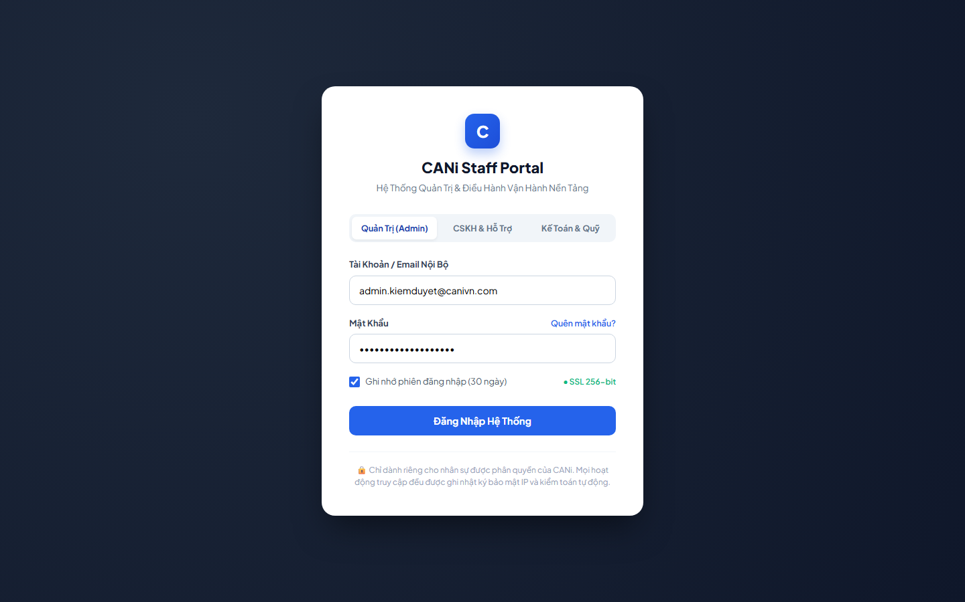
Figure 3.1: Wireframe Mockup of Screen #01 (User Login)
User Actions:
• User selects destination staff role tab (Admin, Customer Care, or Finance).
• User enters registered staff email address and account password.
• User toggles 'Ghi nhớ phiên đăng nhập' for persistent session token.
• The user clicks 'Đăng Nhập Hệ Thống' to authenticate and redirect to the authorized dashboard.
• User clicks 'Quên mật khẩu?' if credentials need to be reset.
• Optionally toggles 'Remember me' session retention.
• Click the 'Đăng Nhập' button to authenticate via JWT or OAuth2.
• The system redirects the user to the corresponding role dashboard upon successful authentication.
Field Description:
Field Name | Control / Type | Required | Description & Validation Rules
Role Selector Tab | Tab Selector | Yes | Allows switching destination portal between Admin, Customer Care, and Finance.
Email Address | Text Input | Yes | Valid corporate email address (format: name@canivn.com).
Password | Password Input | Yes | Masked password input with secure credential check against hashed secret.
Remember Session | Checkbox | No | Preserves active session authentication token for up to 30 days.

1.2 SCR-02: Password Reset
Mapped Use Cases: UC-04
Request a password reset link using the registered email address.
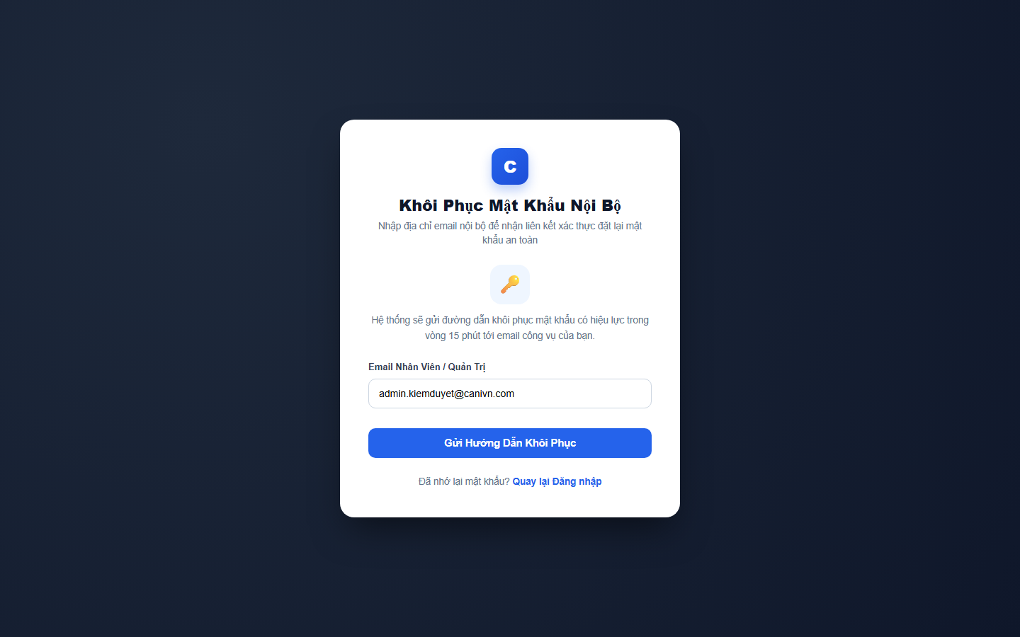
Figure 3.2: Wireframe Mockup of Screen #02 (Password Reset)
User Actions:
• User enters corporate email address registered on CANi system.
• User submits reset request to generate time-limited password recovery link.
• User checks internal inbox to proceed with security token verification.
• User clicks 'Quay lại Đăng nhập' to return to staff login portal.
• Interacts with available controls, search filters, and actionable buttons.
• Confirms action to commit changes to the backend API or navigate to related screens.
Field Description:
Field Name | Control / Type | Required | Description & Validation Rules
Staff Email Address | Text Input | Yes | Registered staff email address. Validates RFC 5322 format.
Submit Reset Button | Submit Button | Yes | Generates single-use signed cryptographic reset token valid for 15 minutes.
Back to Login Link | Hyperlink | No | Navigates back to the User Login authentication portal (SCR-01).
Security Notice | Information Card | No | Displays security instructions and 15-minute token expiry notice.

1.3 SCR-03: Set New Password
Mapped Use Cases: UC-04
Set a new password using a valid password reset token.
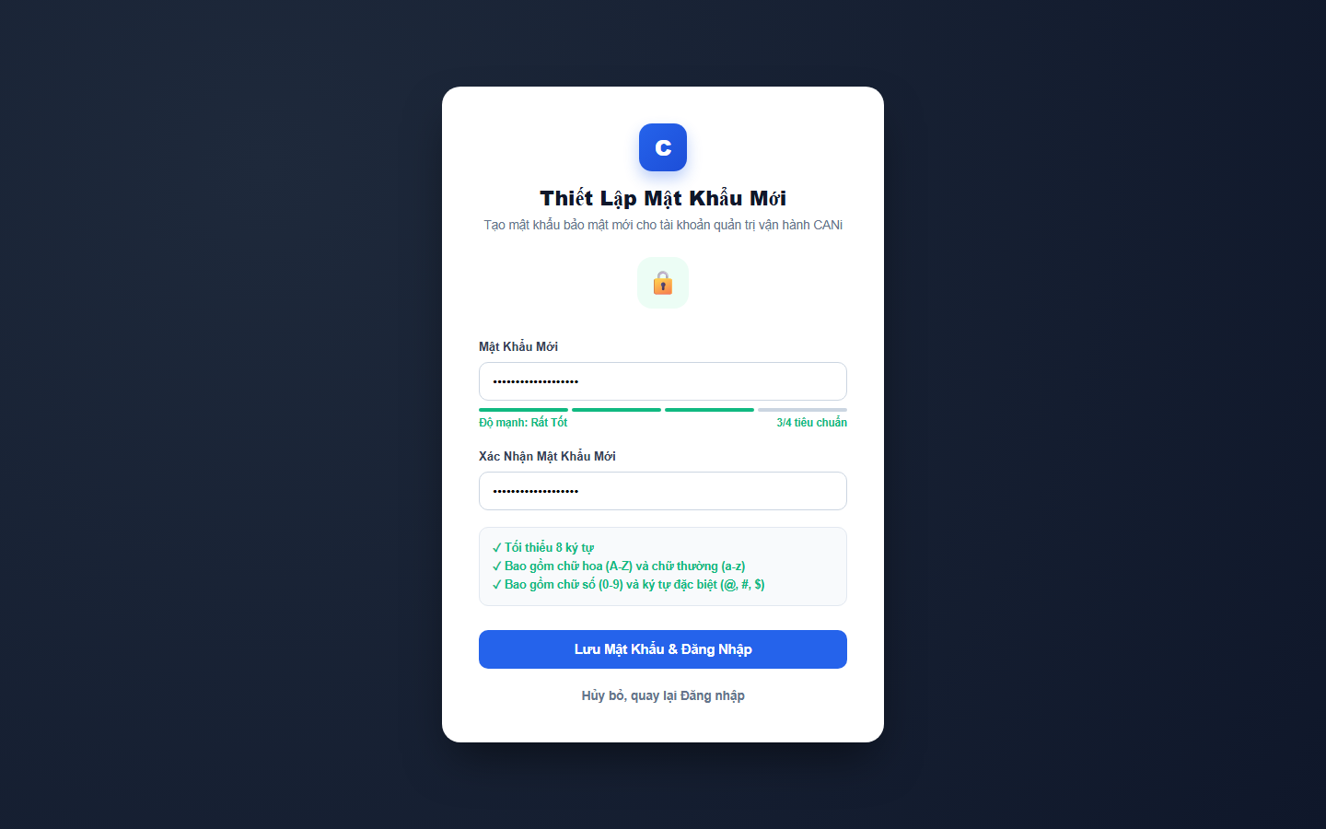
Figure 3.3: Wireframe Mockup of Screen #03 (Set New Password)
User Actions:
• User enters new password satisfying all enterprise security criteria.
• User verifies real-time password strength meter indicator.
• User re-types password in 'Xác Nhận Mật Khẩu Mới' field to avoid typos.
• User clicks 'Lưu Mật Khẩu & Đăng Nhập' to update credentials in database.
• Interacts with available controls, search filters, and actionable buttons.
• Confirms action to commit changes to the backend API or navigate to related screens.
Field Description:
Field Name | Control / Type | Required | Description & Validation Rules
New Password | Password Input | Yes | Masked input. Minimum 8 characters, requiring uppercase, digit, and symbol.
Strength Meter | Progress Meter | No | Visual real-time evaluation of password complexity (Weak, Good, Strong).
Confirm Password | Password Input | Yes | Must match exactly with the New Password field.
Save & Login Button | Submit Button | Yes | Updates salted hash in database and redirects to login portal.

1.4 SCR-04: Password Change
Mapped Use Cases: UC-04
Change the current password of the signed-in account.
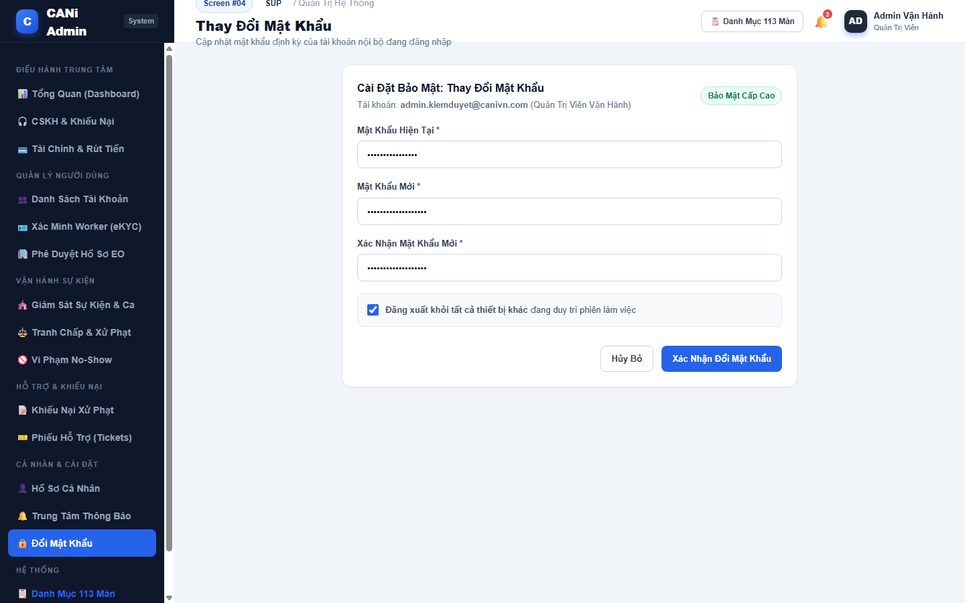
Figure 3.4: Wireframe Mockup of Screen #04 (Password Change)
User Actions:
• User enters current active password to authenticate modification authority.
• User inputs new password and matching confirmation password.
• User checks 'Đăng xuất khỏi tất cả thiết bị khác' to revoke existing JWT tokens.
• User clicks 'Xác Nhận Đổi Mật Khẩu' to apply updated credentials.
• Interacts with available controls, search filters, and actionable buttons.
• Confirms action to commit changes to the backend API or navigate to related screens.
Field Description:
Field Name | Control / Type | Required | Description & Validation Rules
Current Password | Password Input | Yes | Validates against active session credentials before permitting changes.
New Password | Password Input | Yes | Enforces 8+ character complexity rules.
Confirm Password | Password Input | Yes | Must match new password identically.
Revoke Sessions | Checkbox | No | Invalidates all active refresh tokens across other browsers and mobile devices.

1.5 SCR-05: Admin Dashboard
Mapped Use Cases: UC-08
View platform metrics and access administration, Customer Care and Finance functions with Admin permissions.
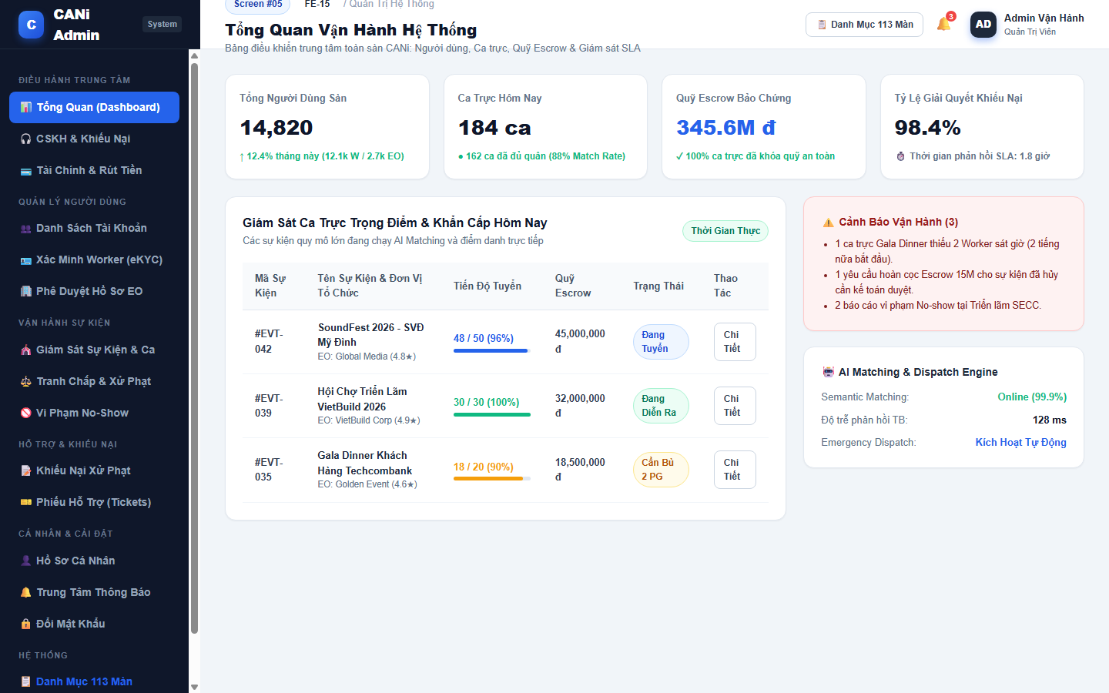
Figure 3.5: Wireframe Mockup of Screen #05 (Admin Dashboard)
User Actions:
• User inspects platform-wide KPI metrics (Total Users, Today's Shifts, Escrow Balance, SLA Rate).
• User monitors high-priority and emergency shifts requiring operational intervention.
• User reviews active operational alerts (e.g. shifts short of workers, pending escrow refunds).
• User monitors AI Matching Engine uptime, latency, and automated dispatch status.
• Monitors active queues, tasks, and system alerts.
• Clicks on quick action buttons or queue items to navigate directly to detailed management screens.
Field Description:
Field Name | Control / Type | Required | Description & Validation Rules
KPI Metric Cards | Metric Widget | No | Real-time summary of total users, active shifts, escrow pool, and resolution rate.
Priority Shifts Table | Data Grid | No | Displays high-stakes events, staffing percentages, and direct access buttons.
Operational Alerts | Alert Card | No | Lists critical operational exceptions needing immediate staff triage.
AI Engine Status Widget | Status Card | No | Monitors semantic matching uptime and emergency dispatch engine latency.

1.6 SCR-06: Customer Care Dashboard
Mapped Use Cases: UC-08
View support metrics and access verification, disputes, appeals, no-show cases and support activities.
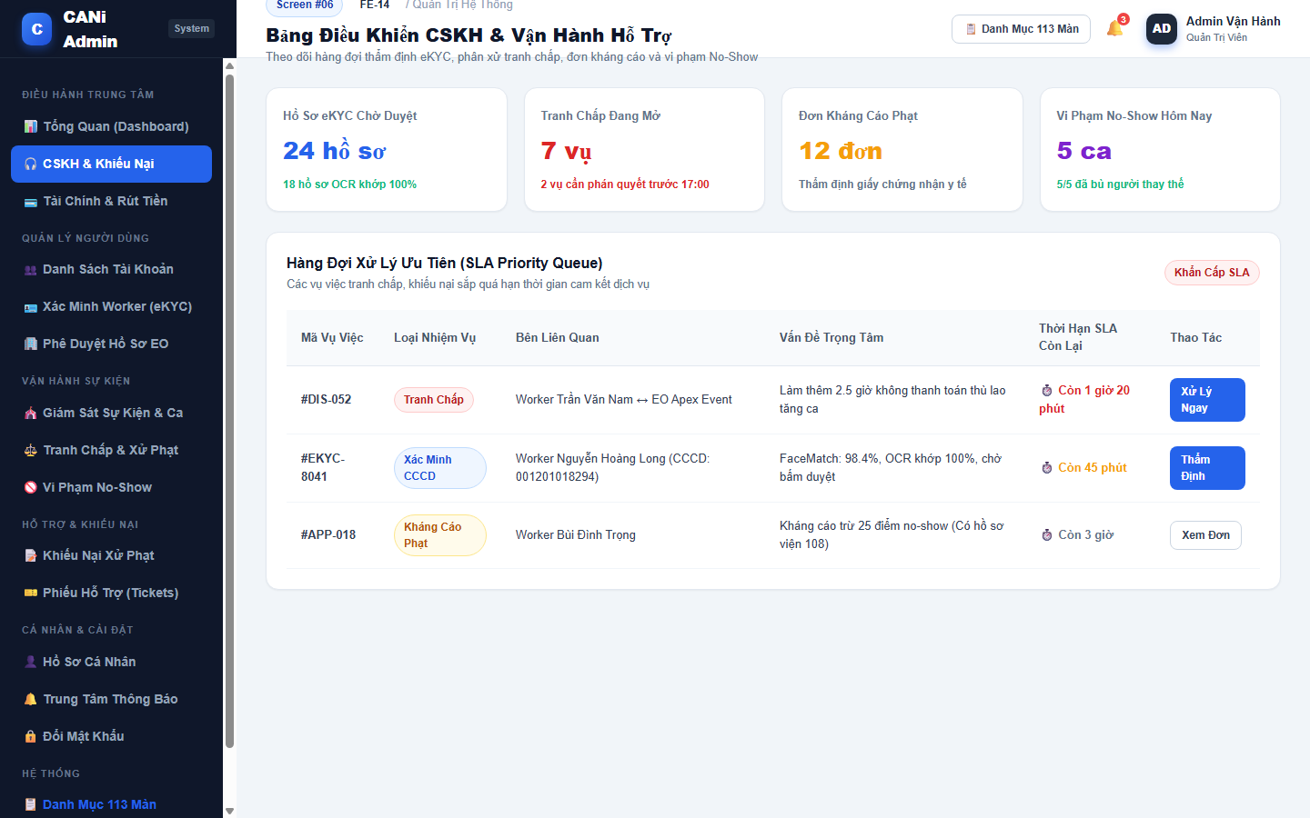
Figure 3.6: Wireframe Mockup of Screen #06 (Customer Care Dashboard)
User Actions:
• User tracks customer care workload metrics (eKYC queue, open disputes, penalty appeals, no-shows).
• User inspects SLA Priority Queue sorted by nearest deadline.
• User claims urgent disputes or eKYC verification requests.
• User monitors real-time resolution speed against SLA targets.
• Monitors active queues, tasks, and system alerts.
• Clicks on quick action buttons or queue items to navigate directly to detailed management screens.
Field Description:
Field Name | Control / Type | Required | Description & Validation Rules
Customer Care Workload Cards | Metric Widget | No | Displays counts of pending eKYC, open disputes, appeals, and no-show violations.
SLA Priority Queue | Data Grid | No | Chronological list of cases sorted by remaining time until SLA breach.
Remaining SLA Timer | Countdown Tag | No | Color-coded indicators: Red (<2h), Amber (<4h), Normal.
Case Type Badge | Tag Badge | No | Categorizes cases into Tranh chấp, Xác minh CCCD, or Kháng cáo.

1.7 SCR-07: Finance Dashboard
Mapped Use Cases: UC-08, UC-59, UC-71
View financial metrics, pending withdrawals and refunds, and Platform Escrow information in demo mode.
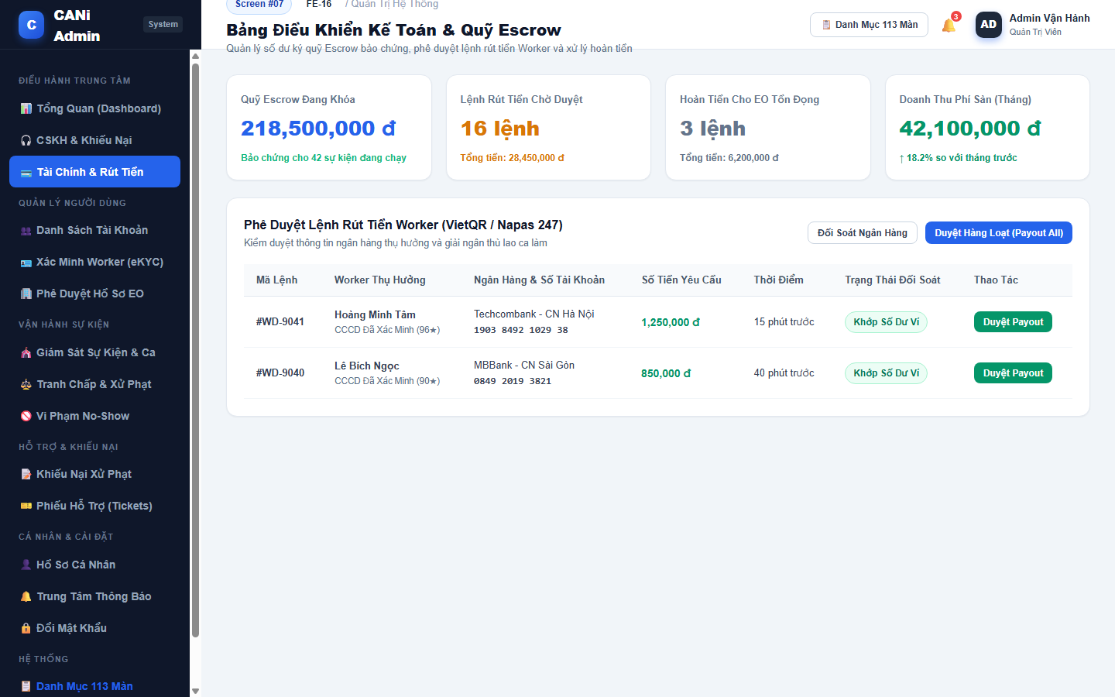
Figure 3.7: Wireframe Mockup of Screen #07 (Finance Dashboard)
User Actions:
• User monitors financial escrow balance, pending worker payouts, and platform fee revenues.
• User inspects individual worker payout withdrawal requests via VietQR/Napas.
• User verifies payout amounts against worker available wallet balances.
• User clicks 'Duyệt Payout' to initiate automated banking disbursement or 'Tạm Giữ' for audit.
• Monitors active queues, tasks, and system alerts.
• Clicks on quick action buttons or queue items to navigate directly to detailed management screens.
Field Description:
Field Name | Control / Type | Required | Description & Validation Rules
Escrow Balance Cards | Metric Widget | No | Monitors total locked escrow, pending withdrawals, refunds, and monthly commission.
Withdrawal Payout Table | Data Grid | No | Displays withdrawal ID, worker name, bank info, requested amount, and balance check.
Bank Account Details | Formatted Display | No | Beneficiary bank name, branch, and standardized account number.
Payout Status Badge | Tag Badge | No | Indicates wallet reconciliation status (Khớp Số Dư Ví / Cần Đối Soát).

1.8 SCR-08: My Profile
Mapped Use Cases: UC-05
View the signed-in user’s profile and account information.
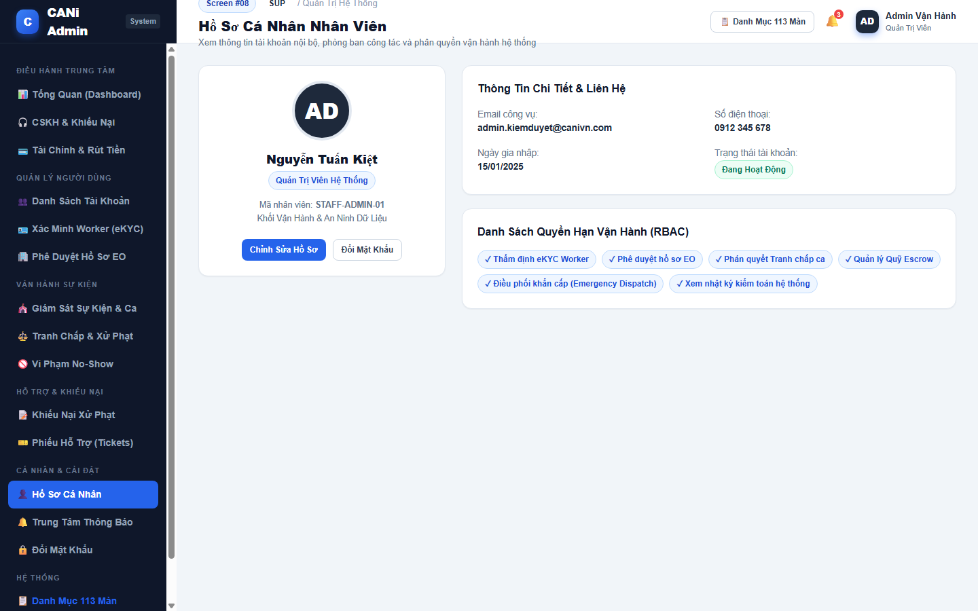
Figure 3.8: Wireframe Mockup of Screen #08 (My Profile)
User Actions:
• User reviews personal employee profile, department, and assigned role badge.
• User inspects official contact information and account registration date.
• User reviews granted Role-Based Access Control (RBAC) permissions.
• User navigates to Edit Profile (SCR-09) or Change Password (SCR-04).
• Interacts with available controls, search filters, and actionable buttons.
• Confirms action to commit changes to the backend API or navigate to related screens.
Field Description:
Field Name | Control / Type | Required | Description & Validation Rules
Profile Header | Avatar & Name | No | Displays staff avatar, full name, employee ID, and official system role tag.
Contact Information | Data Grid | No | Official email, emergency phone number, and departmental assignment.
RBAC Permissions List | Tag List | No | Badges showing specific operational authorizations granted to the staff account.
Account Status | Status Badge | No | Indicates account standing (Đang Hoạt Động, Tạm Khóa).

1.9 SCR-09: Edit Profile
Mapped Use Cases: UC-06
Edit personal profile information
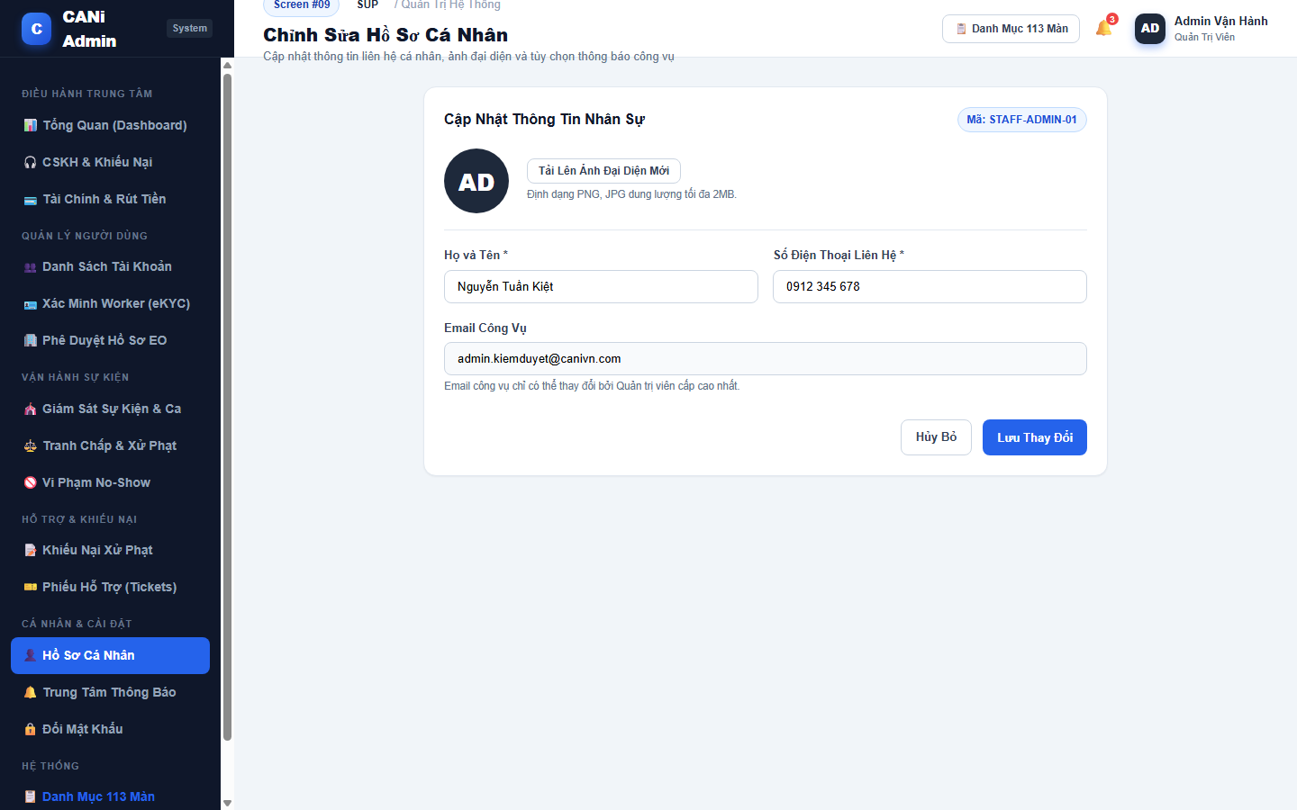
Figure 3.9: Wireframe Mockup of Screen #09 (Edit Profile)
User Actions:
• User uploads updated profile avatar image satisfying size criteria.
• User edits full name and emergency contact telephone number.
• User reviews read-only corporate email address managed by Super Admin.
• User clicks 'Lưu Thay Đổi' to persist updated profile data.
• Interacts with available controls, search filters, and actionable buttons.
• Confirms action to commit changes to the backend API or navigate to related screens.
Field Description:
Field Name | Control / Type | Required | Description & Validation Rules
Avatar Upload | File Input | No | Allows uploading PNG/JPG image file under 2MB.
Full Name Input | Text Input | Yes | Full legal name of the staff member.
Contact Telephone | Text Input | Yes | Standard 10-digit mobile phone number.
Corporate Email | Text Display | No | Read-only corporate address assigned by platform administrator.

1.10 SCR-10: Notifications
Mapped Use Cases: UC-07
View received notifications and open related screens within the signed-in user’s permissions.
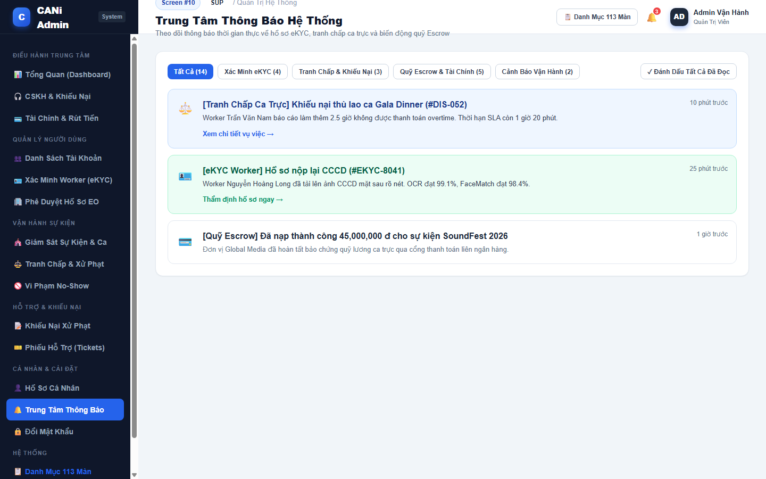
Figure 3.10: Wireframe Mockup of Screen #10 (Notifications)
User Actions:
• User reviews notifications categorized by domain (eKYC, Disputes, Escrow, Operations).
• User clicks category tabs to filter relevant notification items.
• User clicks notification link to jump directly to the target record.
• User clicks 'Đánh Dấu Tất Cả Đã Đọc' to clear unread notification counter.
• Interacts with available controls, search filters, and actionable buttons.
• Confirms action to commit changes to the backend API or navigate to related screens.
Field Description:
Field Name | Control / Type | Required | Description & Validation Rules
Category Filter Tabs | Tab Filter | No | Filters between All, eKYC, Disputes, Escrow, and System alerts.
Notification List Item | List Card | No | Displays notification domain icon, title, summary, timestamp, and target link.
Target Link | Hyperlink | No | Deep link redirecting directly to the relevant inspection or dispute screen.
Mark All Read Button | Action Button | No | Updates read status of all user notifications in database.

1.11 SCR-11: User Management
Mapped Use Cases: UC-09
Manage platform user accounts, account status and demo balance seeding.
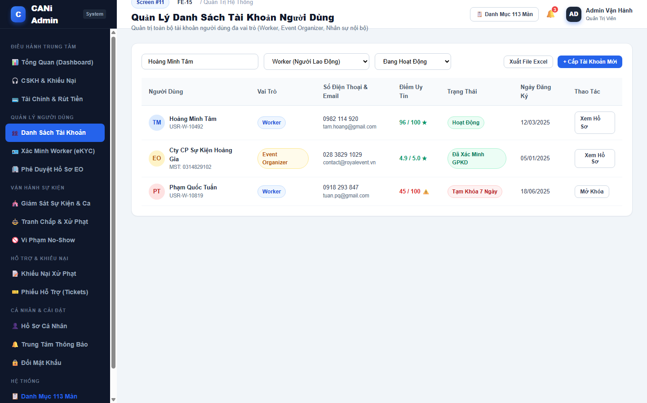
Figure 3.11: Wireframe Mockup of Screen #11 (User Management)
User Actions:
• User searches accounts by name, email, phone number, or citizen ID.
• User filters accounts by role (Worker, EO, Customer Care, Finance) and account status.
• User inspects user reliability rating and registration timestamp.
• User clicks 'Xem Hồ Sơ' to inspect comprehensive user details (SCR-12).
• User toggles temporary lock status for policy-violating accounts.
• Interacts with available controls, search filters, and actionable buttons.
• Confirms action to commit changes to the backend API or navigate to related screens.
Field Description:
Field Name | Control / Type | Required | Description & Validation Rules
Search Input Bar | Text Input | No | Real-time query across user names, emails, phone numbers, and IDs.
Role Filter Dropdown | Select Dropdown | No | Filters by Worker, Event Organizer, Customer Care Staff, or Finance Staff.
Status Filter Dropdown | Select Dropdown | No | Filters by Active, Pending eKYC, or Temporarily Locked.
User Summary Row | Data Row | No | Displays avatar, name, account ID, role badge, phone, reliability, and status.

1.12 SCR-12: User Details
Mapped Use Cases: UC-09
View user information and perform authorized account updates or status changes.
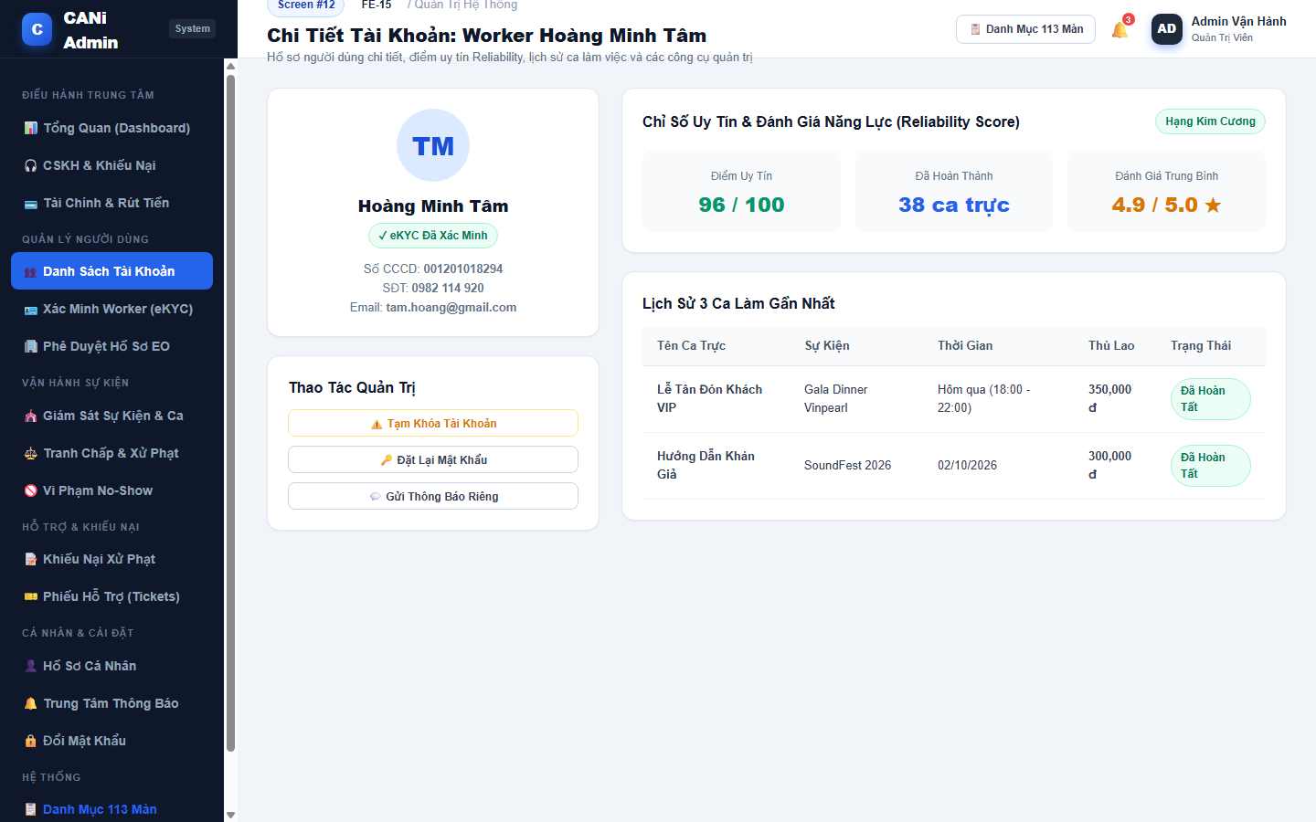
Figure 3.12: Wireframe Mockup of Screen #12 (User Details)
User Actions:
• User reviews detailed profile, citizen ID verification status, and contact info.
• User inspects Reliability Score breakdown (96/100, Tier Diamond, 38 shifts completed).
• User reviews chronological history of completed shifts and organizer star reviews.
• User applies administrative actions: lock account, trigger password reset, or send warning.
• Interacts with available controls, search filters, and actionable buttons.
• Confirms action to commit changes to the backend API or navigate to related screens.
Field Description:
Field Name | Control / Type | Required | Description & Validation Rules
User Identity Header | Info Card | No | Displays name, user code, verification badge, and citizen ID number.
Reliability Score Widget | Metric Card | No | Displays score out of 100, tier badge, completion count, and average stars.
Shift History Table | Data Grid | No | List of recent shifts, event names, timestamps, wages, and completion status.
Account Action Panel | Action Panel | No | Buttons to lock account, reset credentials, or issue formal notice.

1.13 SCR-13: Event Management
Mapped Use Cases: UC-10, UC-12
View and manage platform events with Admin permissions.
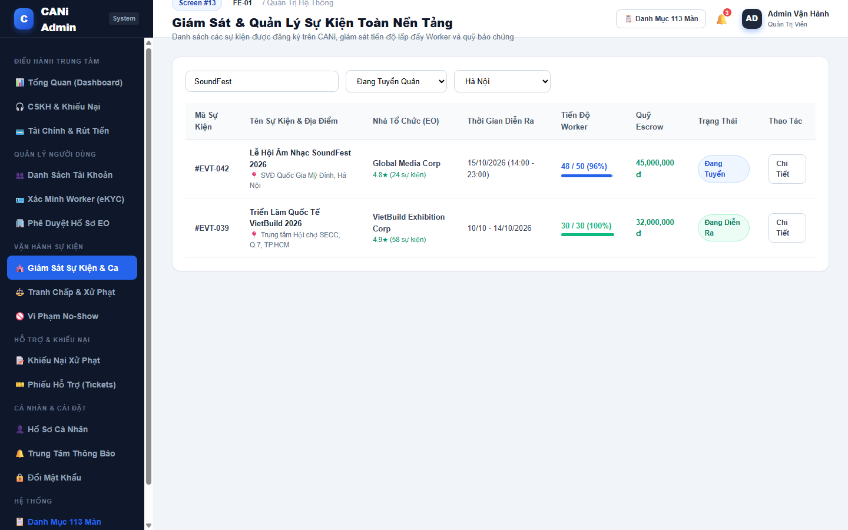
Figure 3.13: Wireframe Mockup of Screen #13 (Event Management)
User Actions:
• User searches platform events by name, location, or organizer name.
• User filters events by operational status (Recruiting, Ongoing, Completed, Suspended).
• User monitors worker fulfillment progress and escrow deposit status per event.
• User clicks 'Chi Tiết' to open detailed event operations screen (SCR-14).
• Interacts with available controls, search filters, and actionable buttons.
• Confirms action to commit changes to the backend API or navigate to related screens.
Field Description:
Field Name | Control / Type | Required | Description & Validation Rules
Event Search Bar | Text Input | No | Searches event title, organizer company, or venue.
Status Filter Dropdown | Select Dropdown | No | Filters by Recruiting, In Progress, Completed, or Suspended.
Event Summary Row | Data Row | No | Displays event ID, title, venue, organizer rating, date, staffing %, and escrow.
Staffing Progress Bar | Progress Meter | No | Visual bar showing confirmed workers vs required capacity (e.g. 48/50 - 96%).

1.14 SCR-14: Event Details
Mapped Use Cases: UC-10, UC-12
View event information, shifts, staffing and event status with Admin permissions.
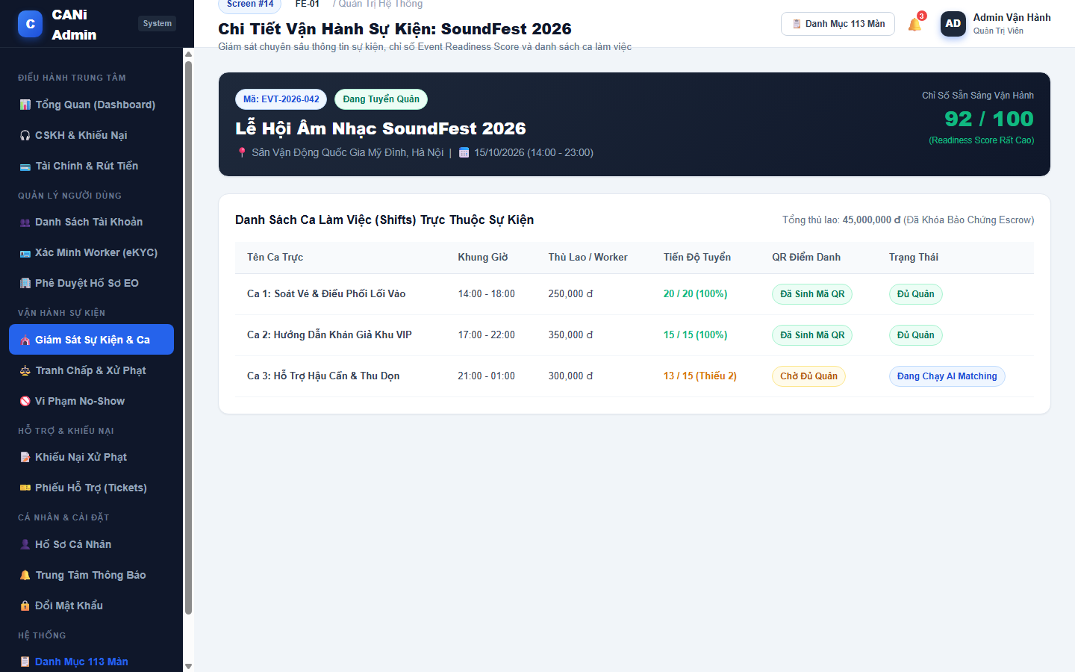
Figure 3.14: Wireframe Mockup of Screen #14 (Event Details)
User Actions:
• User reviews event overview, venue location, schedule, and organizer reputation.
• User inspects Event Readiness Score (92/100) and risk factors.
• User inspects shift breakdown table with staffing numbers, wages, and QR readiness.
• User identifies shifts requiring automated AI matching dispatch intervention.
• Interacts with available controls, search filters, and actionable buttons.
• Confirms action to commit changes to the backend API or navigate to related screens.
Field Description:
Field Name | Control / Type | Required | Description & Validation Rules
Event Banner Card | Banner Widget | No | Displays event title, code, venue, dates, and organizer credentials.
Readiness Score Meter | Score Widget | No | Real-time AI readiness calculation showing probability of smooth staffing.
Shifts Data Table | Data Grid | No | Lists all shifts, work hours, wage per worker, filled slots, and QR status.
Shift Status Tag | Status Tag | No | Displays whether shift is fully staffed or running AI Matching.

1.15 SCR-15: Event Organizer Registrations
Mapped Use Cases: UC-01, UC-09
Review EO registration requests; approval and rejection controls follow the finalized role permissions.
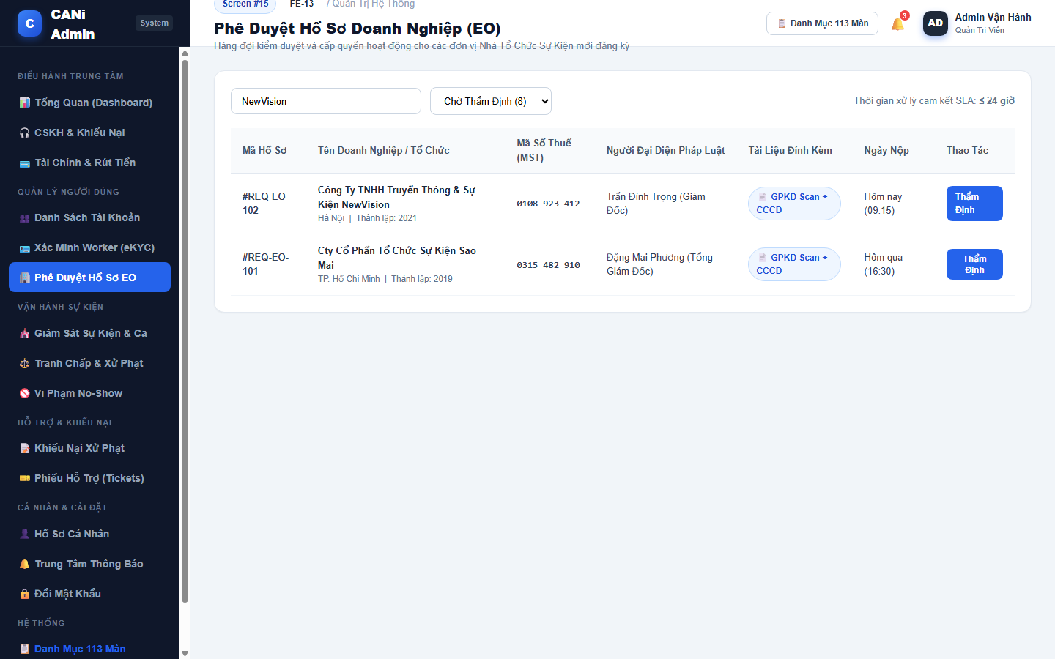
Figure 3.15: Wireframe Mockup of Screen #15 (Event Organizer Registrations)
User Actions:
• User inspects pending Event Organizer corporate registration queue.
• User reviews company tax identification number (MST), legal representative, and submission time.
• The user verifies attached business license scans and identity documents.
• User clicks 'Thẩm Định' to open detailed corporate verification screen (SCR-16).
• Interacts with available controls, search filters, and actionable buttons.
• Confirms action to commit changes to the backend API or navigate to related screens.
Field Description:
Field Name | Control / Type | Required | Description & Validation Rules
EO Search Bar | Text Input | No | Filters pending EO requests by company name or tax code.
Status Filter | Select Dropdown | No | Toggles between Pending Review, Approved, and Rejected.
EO Registration Table | Data Grid | No | Lists application ID, enterprise name, tax code, legal representative, and docs.
Document Badge | Tag Badge | No | Indicates attached business registration PDF and representative citizen ID.

1.16 SCR-16: Event Organizer Registration Details
Mapped Use Cases: UC-01, UC-09
Review the EO’s organization, contact information and CCCD documents for registration verification.
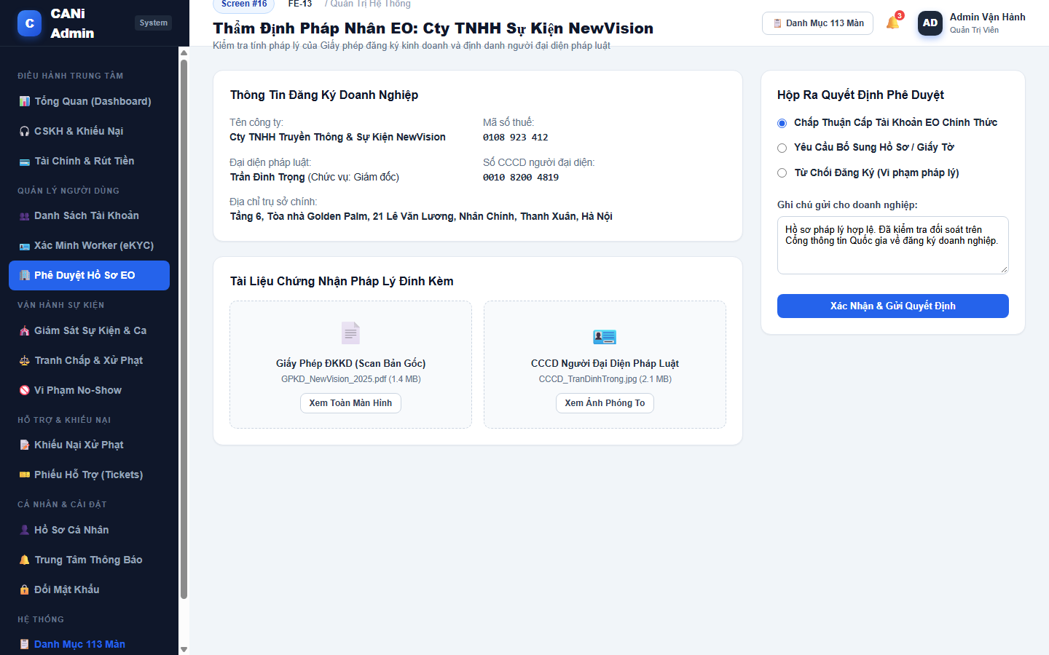
Figure 3.16: Wireframe Mockup of Screen #16 (Event Organizer Registration Details)
User Actions:
• User inspects legal enterprise registration details cross-referenced with National Business Portal.
• User views high-resolution scans of Business Registration Certificate and representative citizen ID.
• User selects adjudication decision: Approve EO account, Request more information, or Reject.
• User enters explanatory feedback note and confirms decision.
• Interacts with available controls, search filters, and actionable buttons.
• Confirms action to commit changes to the backend API or navigate to related screens.
Field Description:
Field Name | Control / Type | Required | Description & Validation Rules
Enterprise Info Grid | Data Display | No | Displays company name, tax code, issue date, legal representative, and HQ address.
Document Viewer Cards | Media Preview | No | Previews uploaded business license scan and representative ID card.
Decision Radio Options | Radio Group | Yes | Choice between Approve Account, Request Additional Documents, or Reject.
Adjudication Note Input | Textarea | No | Formal explanatory note dispatched to the organizer's registered email.

1.17 SCR-17: Worker Verification
Mapped Use Cases: UC-09, UC-25, UC-26
View Worker identity verification requests requiring review.
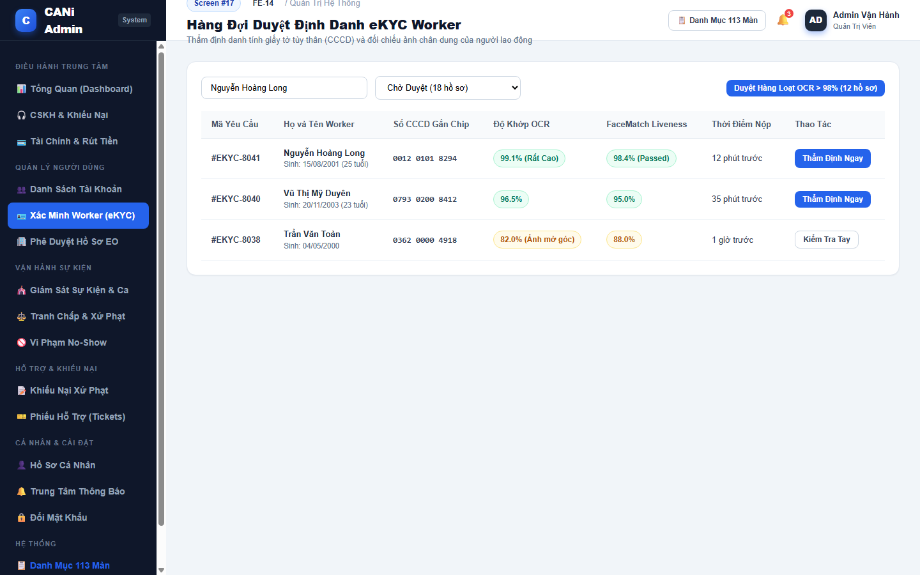
Figure 3.17: Wireframe Mockup of Screen #17 (Worker Verification)
User Actions:
• User reviews worker identity verification queue (eKYC).
• User inspects OCR confidence scores and facial liveness match percentages.
• User filters cases by status (Pending, Suspicious, Approved today).
• User clicks 'Thẩm Định Ngay' to inspect citizen ID documents (SCR-18).
• User utilizes batch approval for high-confidence OCR matches (>98%).
• Interacts with available controls, search filters, and actionable buttons.
• Confirms action to commit changes to the backend API or navigate to related screens.
Field Description:
Field Name | Control / Type | Required | Description & Validation Rules
Search Input Bar | Text Input | No | Searches pending worker verifications by name or citizen ID.
eKYC Queue Table | Data Grid | No | Lists request ID, worker name, age, citizen ID, OCR score, and FaceMatch %.
OCR Confidence Badge | Score Badge | No | Color-coded OCR text accuracy score (e.g. 99.1% Rất Cao).
FaceMatch Liveness Tag | Status Tag | No | Automated biometric facial matching result (Passed / Review).

1.18 SCR-18: Verification Details
Mapped Use Cases: UC-09, UC-25, UC-26
Review submitted Worker documents and approve or reject identity verification.
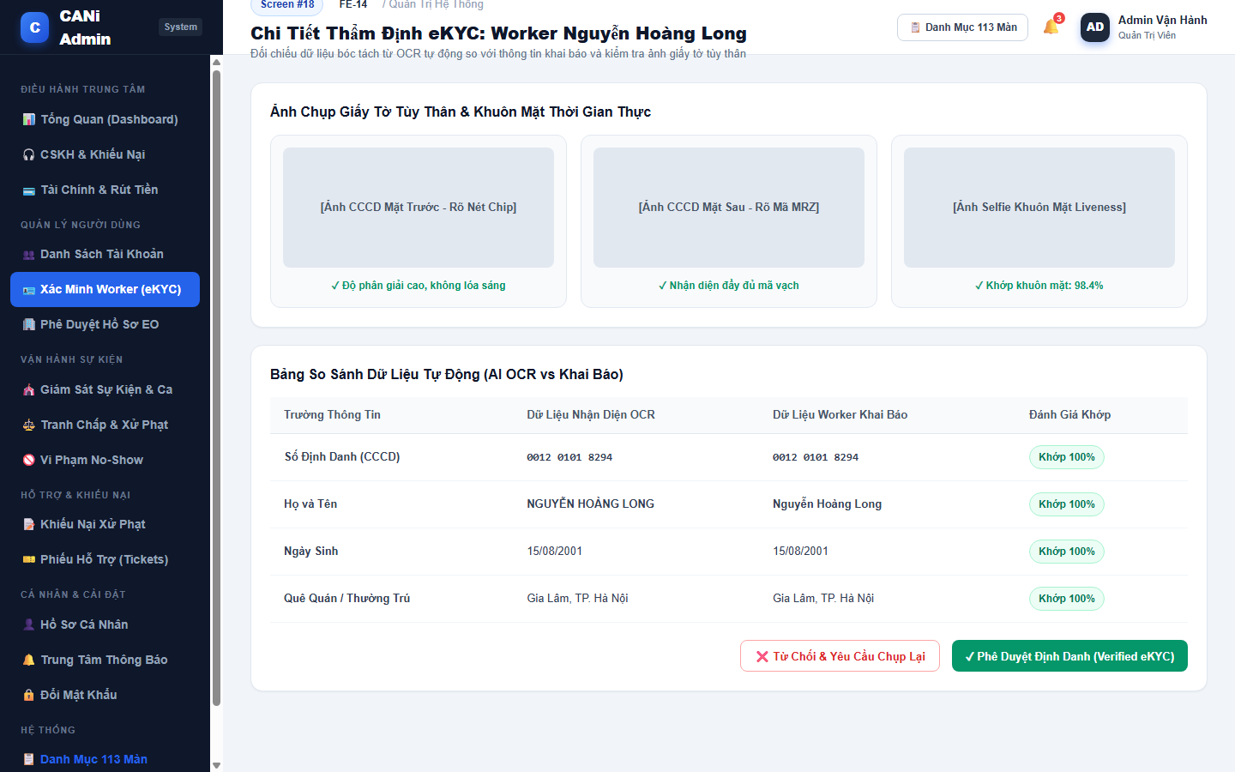
Figure 3.18: Wireframe Mockup of Screen #18 (Verification Details)
User Actions:
• User examines high-resolution images of Citizen ID Card (front chip, back MRZ, selfie photo).
• User audits automated field-by-field OCR comparison table against worker-entered data.
• User confirms complete alignment of ID number, full name, date of birth, and hometown.
• User clicks 'Phê Duyệt Định Danh (Verified)' or 'Từ Chối & Yêu Cầu Chụp Lại'.
• Interacts with available controls, search filters, and actionable buttons.
• Confirms action to commit changes to the backend API or navigate to related screens.
Field Description:
Field Name | Control / Type | Required | Description & Validation Rules
ID Card Image Viewer | Media Gallery | No | High-res viewers for front chip side, rear MRZ side, and real-time selfie.
OCR Comparison Table | Data Grid | No | Side-by-side audit of OCR extracted fields vs worker-submitted fields.
Match Status Badges | Status Tag | No | Green indicator tags confirming 100% field match.
Approve Button | Action Button | Yes | Marks worker identity as officially Verified and unlocks shift application.

1.19 SCR-19: Dispute Management
Mapped Use Cases: UC-65, UC-66
View and manage disputes; Customer Care handles behavior issues and escalates financial issues to Finance.
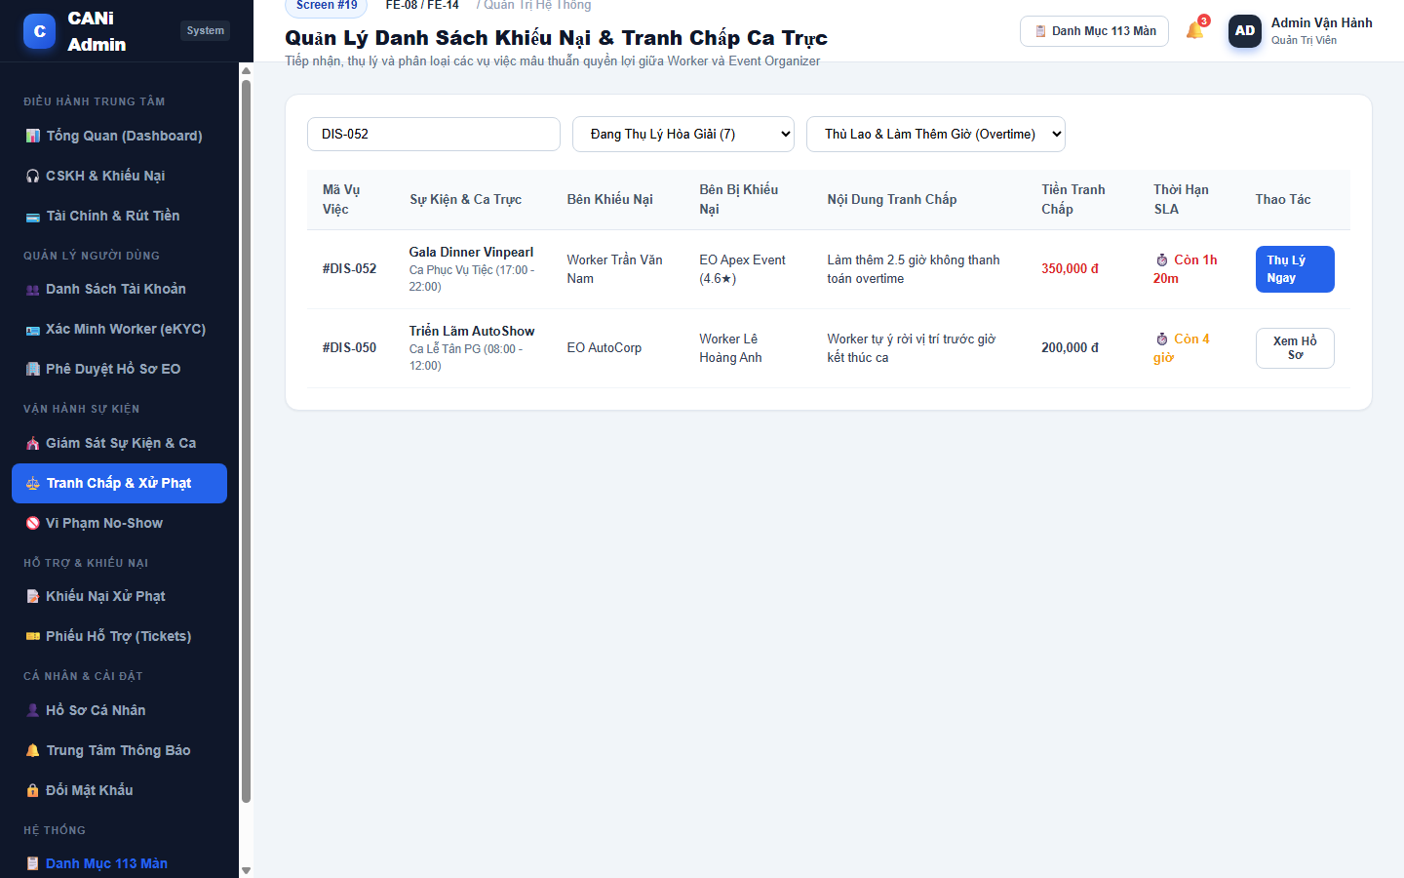
Figure 3.19: Wireframe Mockup of Screen #19 (Dispute Management)
User Actions:
• User reviews active dispute claims between workers and organizers.
• User filters disputes by category (Unpaid overtime, Scope mismatch, Conduct).
• User monitors dispute resolution SLA timers to prevent service breaches.
• User clicks 'Thụ Lý Ngay' to open dispute mediation adjudication file (SCR-20).
• Interacts with available controls, search filters, and actionable buttons.
• Confirms action to commit changes to the backend API or navigate to related screens.
Field Description:
Field Name | Control / Type | Required | Description & Validation Rules
Dispute Search Bar | Text Input | No | Searches dispute case code, event name, or worker name.
Dispute Category Filter | Select Dropdown | No | Filters by Overtime / Wages, Job Description, or Code of Conduct.
Disputes Data Table | Data Grid | No | Lists dispute ID, shift name, complainant, respondent, issue, and amount.
SLA Countdown Timer | Countdown Tag | No | Displays exact hours and minutes remaining before SLA breach.

1.20 SCR-20: Dispute Details
Mapped Use Cases: UC-65, UC-66, UC-72
Review a dispute and its evidence, record handling decisions, or escalate financial issues.
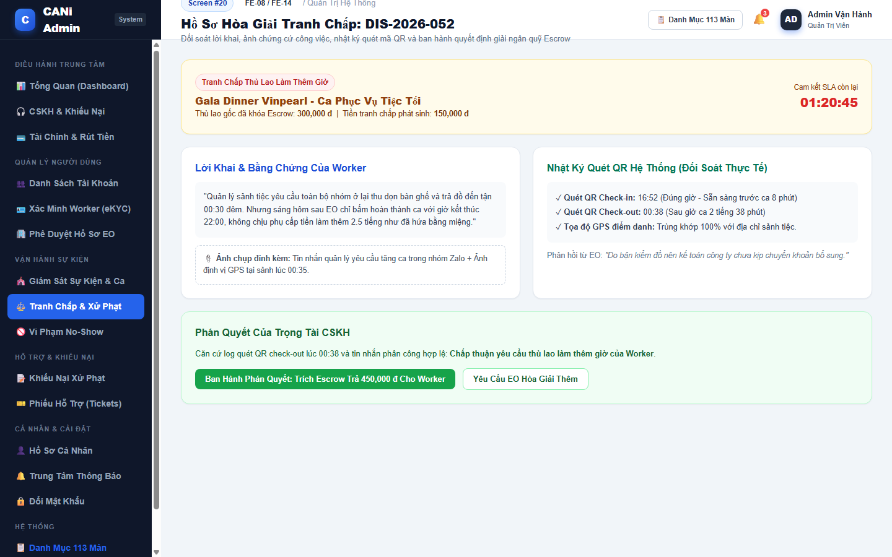
Figure 3.20: Wireframe Mockup of Screen #20 (Dispute Details)
User Actions:
• User examines dispute summary, shift wage locked in escrow, and contested overtime amount.
• User reviews worker testimony and attached Zalo message screenshots.
• User reviews organizer response and audits system QR check-in/out attendance logs.
• User renders formal customer care ruling: disburse overtime from escrow or dismiss claim.
• Interacts with available controls, search filters, and actionable buttons.
• Confirms action to commit changes to the backend API or navigate to related screens.
Field Description:
Field Name | Control / Type | Required | Description & Validation Rules
Dispute Summary Card | Alert Card | No | Displays shift title, locked escrow amount, and contested claim figure.
Worker Evidence Box | Info Card | No | Shows worker testimony and attached screenshots / GPS proof.
System QR Audit Log | Audit Display | No | Authoritative check-in (16:52) and check-out (00:38) attendance timestamps.
Execute Ruling Button | Submit Button | Yes | Applies escrow fund release and closes dispute case permanently.

1.21 SCR-21: Penalty Appeals
Mapped Use Cases: UC-55, UC-68
View Worker penalty appeals and their review status.
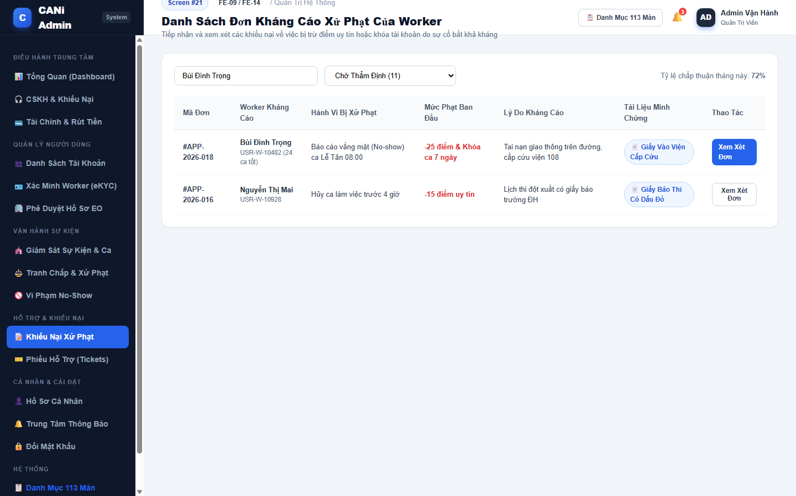
Figure 3.21: Wireframe Mockup of Screen #21 (Penalty Appeals)
User Actions:
• User reviews worker appeals contesting penalty score deductions or account suspensions.
• User inspects original violation (e.g. No-show, Late cancellation) and penalty magnitude (-25 pts).
• User reviews worker justification and attached force majeure evidence (e.g. hospital records).
• User clicks 'Xem Xét Đơn' to evaluate appeal validity (SCR-22).
• Interacts with available controls, search filters, and actionable buttons.
• Confirms action to commit changes to the backend API or navigate to related screens.
Field Description:
Field Name | Control / Type | Required | Description & Validation Rules
Appeals Search Bar | Text Input | No | Searches appeal code or worker name.
Status Filter | Select Dropdown | No | Toggles Pending Review, Approved (Restored), and Dismissed.
Appeals Data Table | Data Grid | No | Lists appeal ID, worker name, original violation, penalty, and justification.
Penalty Magnitude Tag | Alert Tag | No | Shows points deducted (e.g. -25 points & 7-day lock).

1.22 SCR-22: Appeal Details
Mapped Use Cases: UC-55, UC-68
Review appeal reasons and evidence and record an authorized penalty decision.
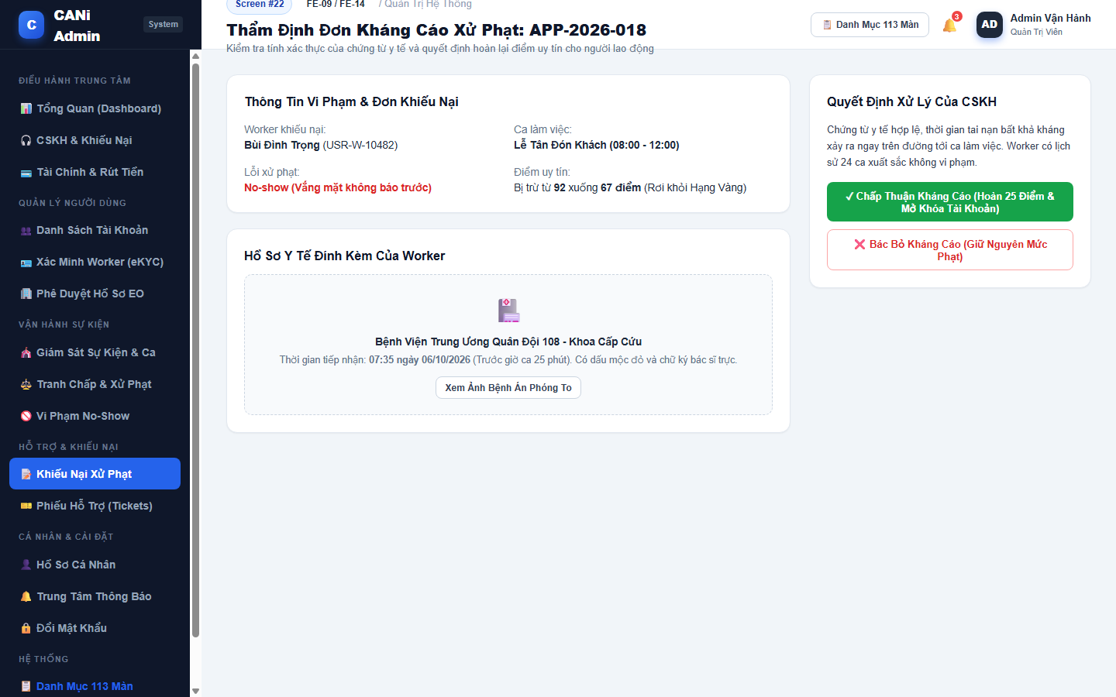
Figure 3.22: Wireframe Mockup of Screen #22 (Appeal Details)
User Actions:
• User reviews violation summary and reliability score drop (from 92 to 67 points).
• User inspects official hospital emergency admission records with timestamp matching shift.
• User evaluates force majeure authenticity and worker prior clean track record.
• User clicks 'Chấp Thuận Kháng Cáo' to restore 25 reliability points and lift account suspension.
• Interacts with available controls, search filters, and actionable buttons.
• Confirms action to commit changes to the backend API or navigate to related screens.
Field Description:
Field Name | Control / Type | Required | Description & Validation Rules
Violation Overview | Info Grid | No | Displays worker code, shift title, penalized violation, and score drop.
Medical Proof Viewer | Media Preview | No | Previews hospital emergency room admission document with official stamp.
Prior History Summary | Text Display | No | Worker past reliability history showing 24 completed clean shifts.
Approve Appeal Button | Action Button | Yes | Restores deducted points and instantly unlocks worker account.

1.23 SCR-23: No-show Cases
Mapped Use Cases: UC-51, UC-52
View reported or flagged no-show cases for staff review.
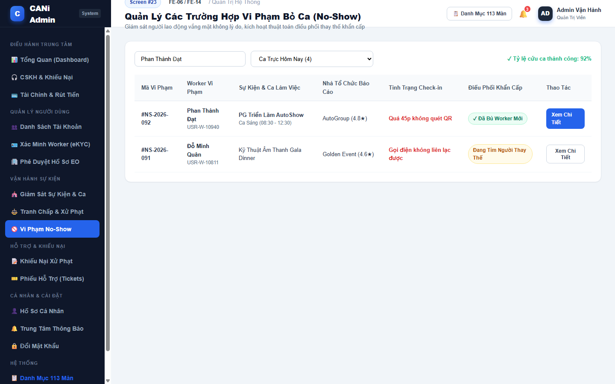
Figure 3.23: Wireframe Mockup of Screen #23 (No-show Cases)
User Actions:
• User reviews daily reported worker no-show incidents.
• User inspects absence timeline (over 45 minutes past shift start without QR check-in).
• User monitors automated Emergency Dispatch replacement success rate (92%).
• User clicks 'Xem Chi Tiết' to review incident logs and worker violation records (SCR-24).
• Interacts with available controls, search filters, and actionable buttons.
• Confirms action to commit changes to the backend API or navigate to related screens.
Field Description:
Field Name | Control / Type | Required | Description & Validation Rules
Incident Search Bar | Text Input | No | Searches no-show violation ID or worker name.
Timeframe Filter | Select Dropdown | No | Toggles Today's Shifts, This Week, or Replacement Successes.
No-Show Cases Table | Data Grid | No | Lists violation code, worker name, shift, organizer reporter, and check-in status.
Emergency Dispatch Tag | Status Tag | No | Indicates whether replacement worker was dispatched successfully.

1.24 SCR-24: No-show Details
Mapped Use Cases: UC-51, UC-52
Inspect attendance information and evidence and record the no-show review outcome.
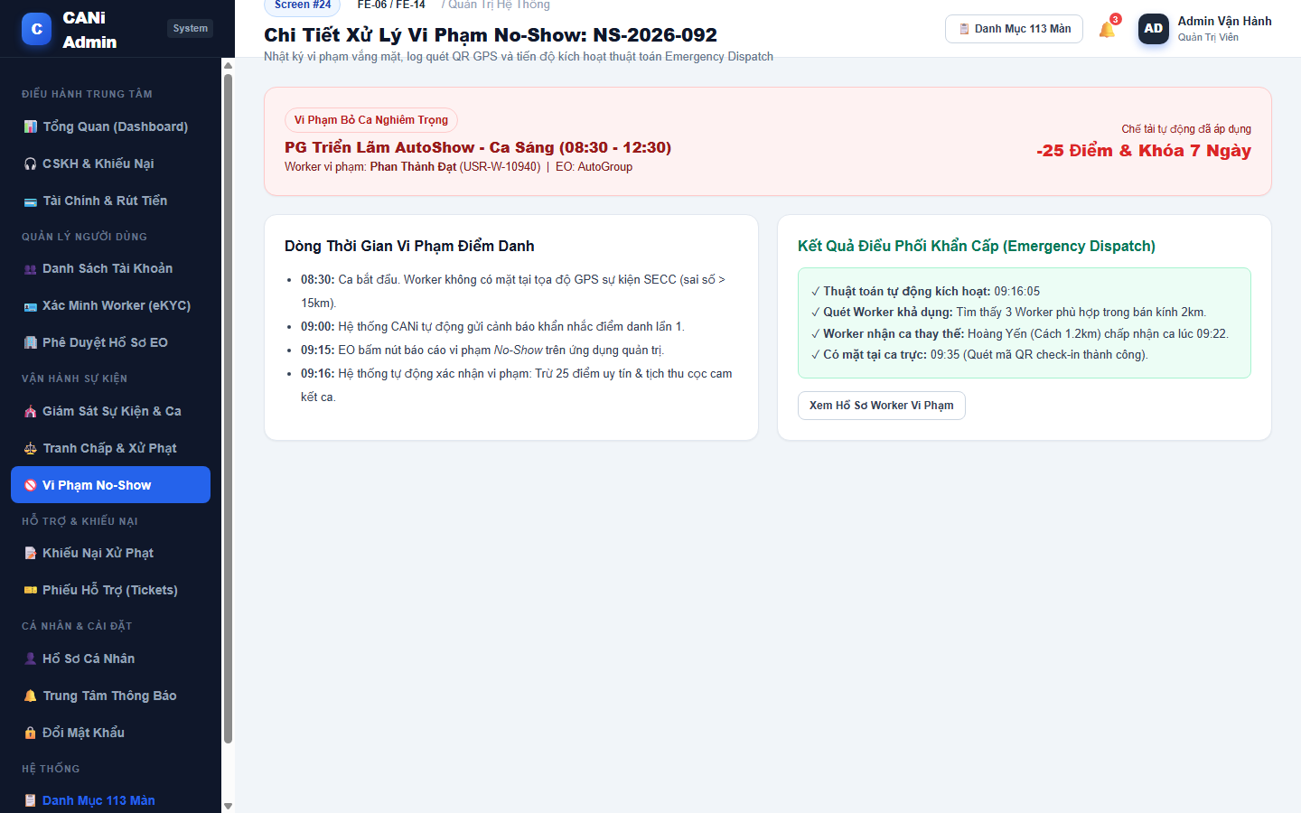
Figure 3.24: Wireframe Mockup of Screen #24 (No-show Details)
User Actions:
• User reviews no-show violation timeline, GPS coordinate mismatch, and missed check-in alerts.
• User verifies organizer absence report and automated penalty enforcement.
• User audits Emergency Dispatch Engine execution log (replacement worker matched in 6 minutes).
• User logs permanent infraction on worker profile.
• Interacts with available controls, search filters, and actionable buttons.
• Confirms action to commit changes to the backend API or navigate to related screens.
Field Description:
Field Name | Control / Type | Required | Description & Validation Rules
Violation Summary Card | Alert Card | No | Displays shift name, penalized worker, organizer, and penalty summary.
Attendance Audit Timeline | Timeline List | No | Step-by-step log of GPS check failure, warning notification, and organizer report.
Emergency Dispatch Log | Success Card | No | Audit of replacement algorithm: candidate scan, match acceptance, arrival time.
Penalties Applied | Tag List | No | Badges showing -25 reliability points, deposit forfeiture, and 7-day ban.

1.25 SCR-25: Support Tickets
Mapped Use Cases: UC-09
View general user support requests and their handling status.
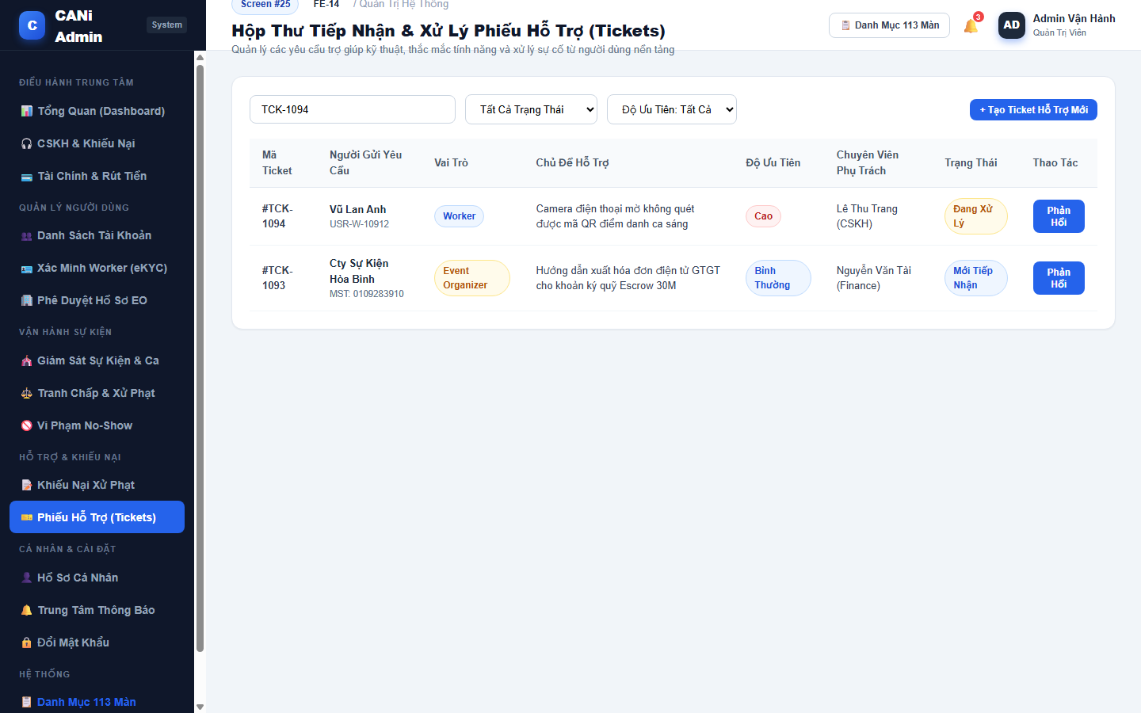
Figure 3.25: Wireframe Mockup of Screen #25 (Support Tickets)
User Actions:
• User reviews incoming general technical support tickets from workers and organizers.
• User filters tickets by urgency priority (High, Normal) and handling status.
• User inspects ticket subject (QR scanning issues, VAT invoice requests, bank account updates).
• User claims or responds to ticket to assist user resolution.
• Interacts with available controls, search filters, and actionable buttons.
• Confirms action to commit changes to the backend API or navigate to related screens.
Field Description:
Field Name | Control / Type | Required | Description & Validation Rules
Ticket Search Bar | Text Input | No | Searches ticket code, sender name, or subject keywords.
Status Filter Tabs | Select Dropdown | No | Toggles All, New (5), In Progress (8), and Resolved (142).
Priority Filter | Select Dropdown | No | Filters by High Urgency or Normal.
Support Ticket Table | Data Grid | No | Lists ticket ID, sender name, role badge, subject, priority, agent, and status.

1.26 SCR-26: Ticket Details
Mapped Use Cases: UC-72, UC-85
View a support request and record its response and handling information.
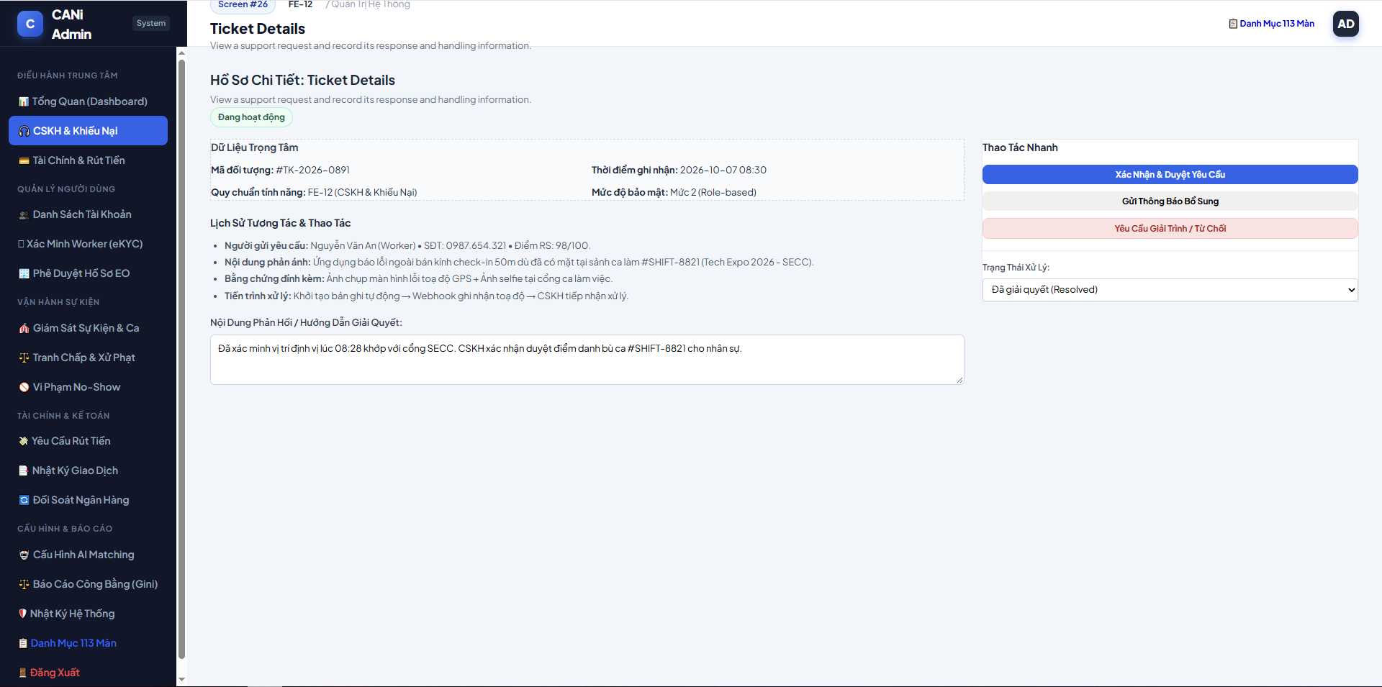
Figure 3.26: Wireframe Mockup of Screen #26 (Ticket Details)
User Actions:
• Customer Care representative inspects support ticket metadata, user contact details, submission channel, and inquiry category.
• Reviews contextual activity logs, prior ticket history, and relevant shift or financial reference IDs.
• Inputs resolution notes, updates ticket status, and sends direct response or escalates to Finance/Admin.

Field Description:
Field Name | Control / Type | Required | Description & Validation Rules
Ticket Reference Code | Text / Display | Yes | Unique support ticket code in format #TCK-YYYY-NNNN.
Requester Profile | Text / Display | Yes | Name, account type (Worker or Event Organizer), and verified email address.
Category & Priority | Badge / Dropdown | Yes | Issue category (Payment, Shift Attendance, Penalty Dispute) and priority level (CRITICAL, HIGH, NORMAL).
Ticket Status | Dropdown Select | Yes | Lifecycle status: Open (Moi tiep nhan), In Progress, Resolved, or Closed.
Related Reference ID | Text / Link | No | Linked entity code such as Shift #SH-XXXX, Transaction #TX-XXXX, or Dispute #DSP-XXXX.
Resolution Notes Input | Textarea | Yes | Detailed investigation findings, communication summary, and administrative determination.
Internal Notes Toggle | Checkbox | No | Flags response as private internal Customer Care log, hidden from requester view.
Update & Reply Button | Action Button | Yes | Commits resolution notes and triggers automated email/push notification to requester.

1.27 SCR-27: User Lookup
Mapped Use Cases: UC-87
Search users by identifier or email for Customer Care support.
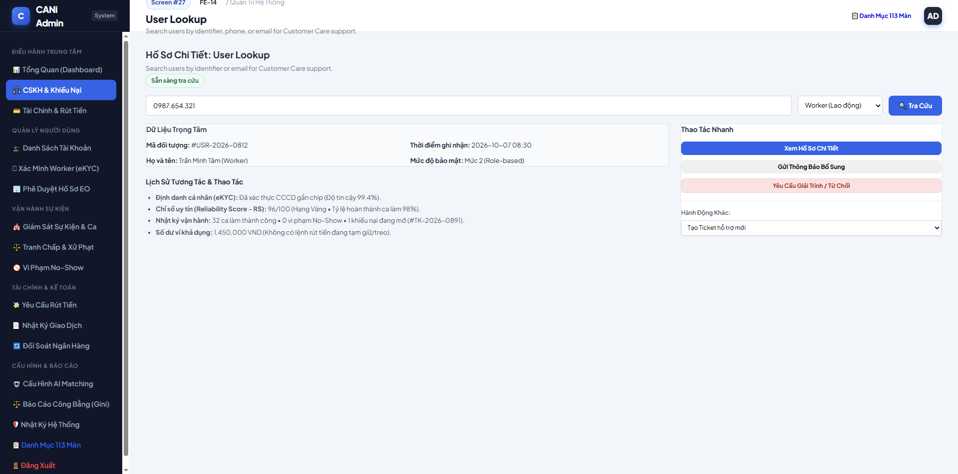
Figure 3.27: Wireframe Mockup of Screen #27 (User Lookup)
User Actions:
• Support agent searches user accounts across the platform by phone number, citizen ID (CCCD), email, or system user code.
• Reviews search query matches with account classification, eKYC verification status, and reliability score.
• Selects matching user card to navigate directly to the comprehensive User Support Profile.

Field Description:
Field Name | Control / Type | Required | Description & Validation Rules
Search Identifier Input | Text Input | Yes | Query string supporting Phone Number, Email, Citizen ID (CCCD), or User ID (#WK-XXXX, #EO-XXXX).
Account Type Filter | Dropdown Select | No | Filters search domain: All Accounts, Worker, Event Organizer.
Search Button | Action Button | Yes | Executes database query matching exact or partial user records.
User Reference Code | Text / Display | Yes | Unique platform user identifier formatted as #WK-XXXX or #EO-XXXX.
Full Name & Avatar | Text / Display | Yes | User registered legal name and verified portrait photo.
Contact Phone & Email | Text / Display | Yes | Masked or full contact information for customer service verification.
Verification State | Status Badge | Yes | eKYC state: Verified (Da xac minh), Pending (Cho duyet), Unverified.
Reliability Score | Text / Display | Yes | Current Worker Reliability Score (RS) or EO platform rating (1-5 stars).
View Profile Button | Action Button | Yes | Opens Screen #28 (User Support Details) for in-depth support operations.

1.28 SCR-28: User Support Details
Mapped Use Cases: UC-85, UC-87
View user information needed for support and perform actions allowed to the support role.
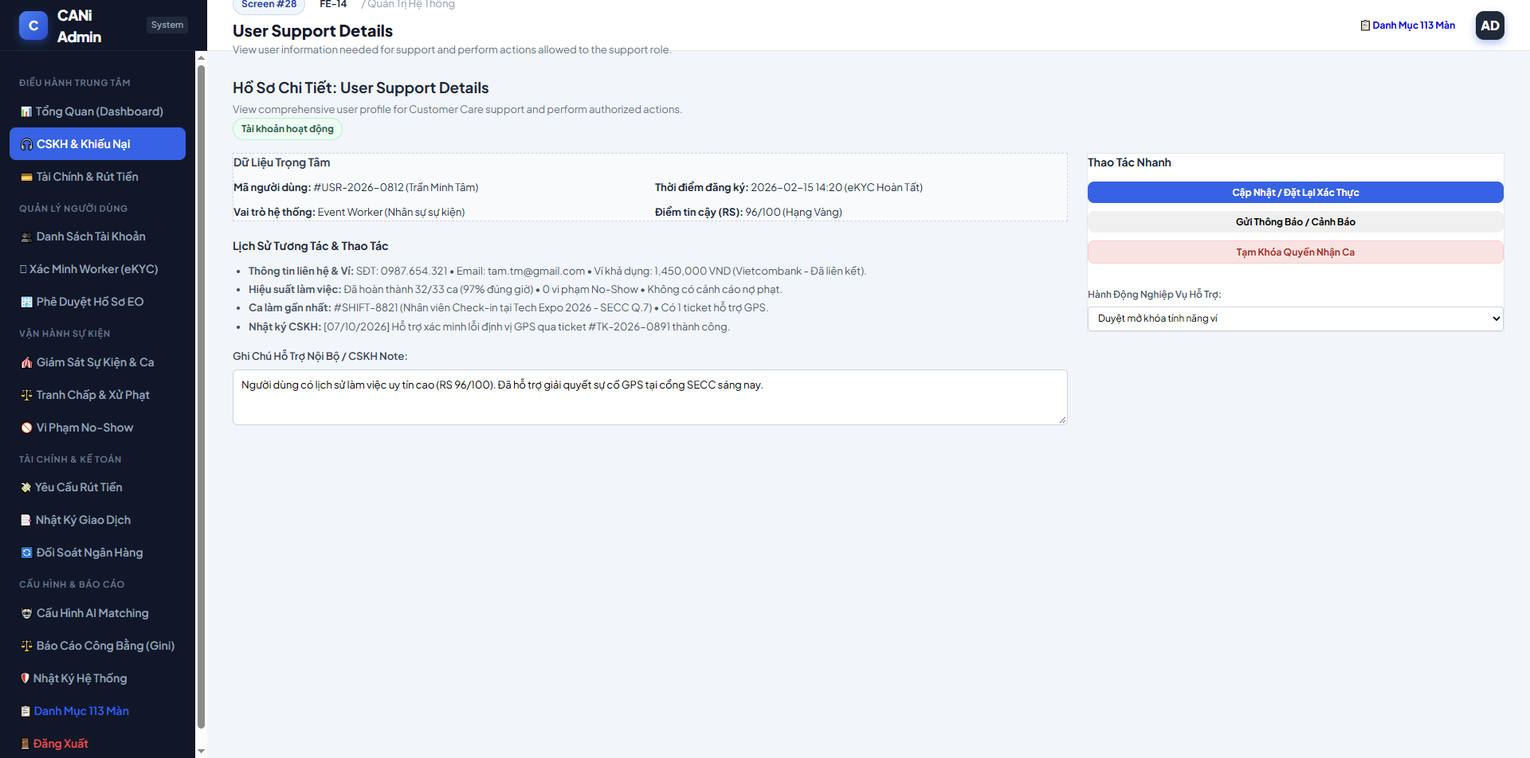
Figure 3.28: Wireframe Mockup of Screen #28 (User Support Details)
User Actions:
• Support agent examines comprehensive user standing, eKYC citizen identity, reliability score history, and wallet balance.
• Reviews recent shift participation, attendance check-in punctuality, and penalty infraction records.
• Performs authorized account interventions such as temporary unlock, issuing penalty warning, or resetting password lockout.

Field Description:
Field Name | Control / Type | Required | Description & Validation Rules
User ID & Account Type | Text / Display | Yes | Master account identifier #WK-XXXX or #EO-XXXX with role tag.
Citizen Identity (CCCD) | Text / Display | Yes | 12-digit national identity number with verified matching portrait.
Account Status | Status Badge | Yes | Current operational standing: Active, Temporary Lock, Cool-down (3 days), or Permanently Banned.
Reliability Score (RS) | Text / Display | Yes | Worker reliability metric on 0-100 scale (RS < 20 triggers automated ban).
Wallet Available Balance | Display Value | Yes | Real-time wallet balance in VND available for withdrawal.
Recent Shift Record | Data Table | No | Chronological summary of last 5 shifts (Shift name, date, attendance, rating).
Penalty & Dispute History | Data Table | No | List of prior infractions (No-Show, Late Arrival, Customer Complaints).
Administrative Action Note | Textarea | Yes | Rationale mandatory for performing any account state override.
Account State Controls | Action Buttons | Yes | Administrative action buttons.

1.29 SCR-29: My Activity
Mapped Use Cases: UC-85
View the signed-in staff member’s handled and resolved support cases.
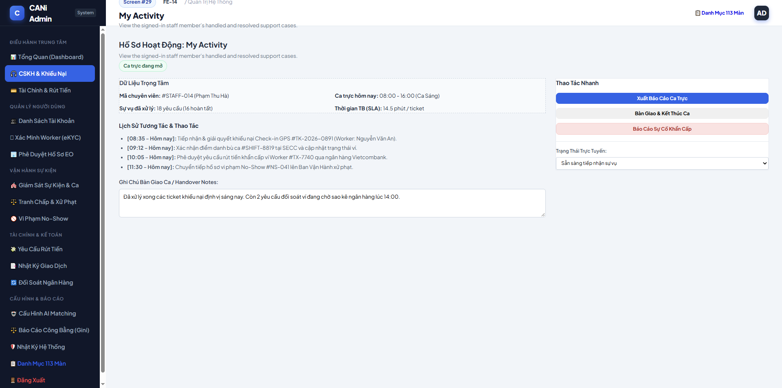
Figure 3.29: Wireframe Mockup of Screen #29 (My Activity)
User Actions:
• Customer Care or Support Staff reviews own daily shift productivity, processed ticket volume, and response SLAs.
• Inspects ongoing unresolved inquiries and pending verification escalations assigned to their workstation.
• Submits end-of-shift handover summary notes and transfers active incident queues to the next operational shift.

Field Description:
Field Name | Control / Type | Required | Description & Validation Rules
Staff Identifier & Duty Shift | Text / Display | Yes | Logged-in staff name, ID code #STF-XXXX, and operational shift time (Morning/Evening/Night).
Tickets Resolved Counter | Numeric Display | Yes | Count of support tickets successfully resolved during current shift.
Pending Cases Counter | Numeric Display | Yes | Number of ongoing tickets requiring handover to incoming shift staff.
Average Resolution Time | Text / Display | Yes | Mean handling duration per ticket measured against platform SLA benchmark (< 45 minutes).
Handover Notes Textarea | Textarea | Yes | Narrative description of critical pending incidents, high-risk disputes, and unresolved calls.
Urgent Escalation Checkbox | Checkbox | No | Flags handover items requiring immediate attention from shift supervisor.
Submit Handover Button | Action Button | Yes | Locks current staff duty shift logs and transmits queue transfer report to incoming duty team.

1.30 SCR-30: Withdrawal Requests
Mapped Use Cases: UC-91
View Worker withdrawal requests awaiting Finance or Admin review.
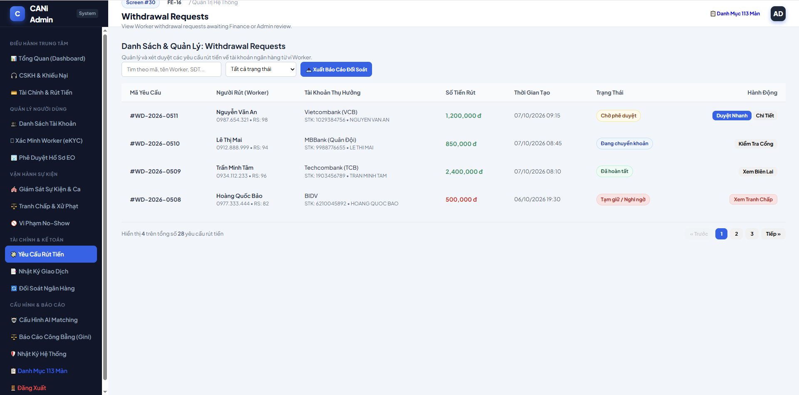
Figure 3.30: Wireframe Mockup of Screen #30 (Withdrawal Requests)
User Actions:
• Finance Officer reviews queued worker wallet payout requests, beneficiary bank information, and withdrawal amounts.
• Filters requests by settlement batch date, payout amount range, bank name, or verification status.
• Selects pending withdrawal batches to proceed with disbursement approval or open detailed banking
Field Description:
Field Name | Control / Type | Required | Description & Validation Rules
Date Range Filter | Date Picker | No | Filters queued withdrawal requests by submission date range.
Payout Status Filter | Dropdown Select | No | Filters requests: All, Pending (Cho duyet), Paid (Da giai ngan), Rejected (Tu choi).
Bank Filter | Dropdown Select | No | Filter by destination bank (Vietcombank, MB Bank, Techcombank, etc.).
Withdrawal ID | Text / Display | Yes | Unique withdrawal transaction code formatted as #WTD-YYYY-NNNN.
Worker Name & ID | Text / Display | Yes | Full legal name and account reference #WK-XXXX of the requesting worker.
Beneficiary Bank & Account | Text / Display | Yes | Beneficiary bank name, account number, and registered account holder name.
Requested Amount | Display Value | Yes | Requested withdrawal sum in VND (minimum threshold 50,000 VND).
Processing Status | Status Badge | Yes | Current review state: Pending, Transferring, Success, Failed.
Action Buttons | Action Buttons | Yes | Navigation trigger (Chi tiet, Duyet nhanh) opening Screen #31 for payout execution.

1.31 SCR-31: Withdrawal Details
Mapped Use Cases: UC-91
Review the withdrawal amount, bank information and request status; approve or reject in demo mode.
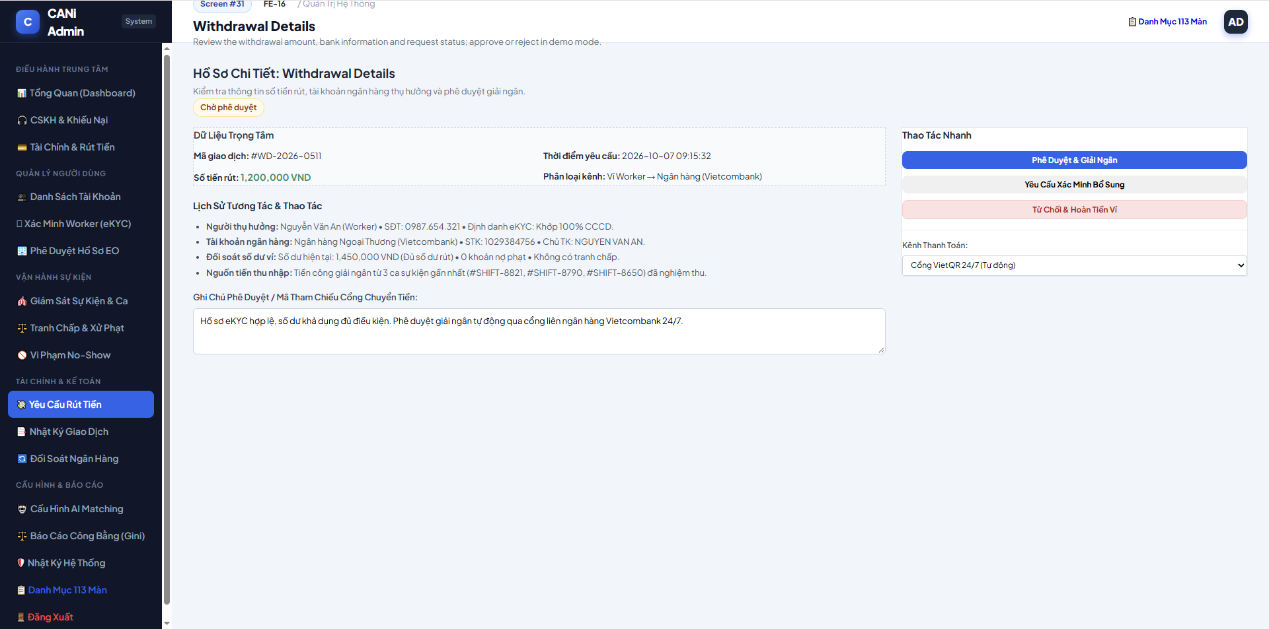
Figure 3.31: Wireframe Mockup of Screen #31 (Withdrawal Details)
User Actions:
• Finance Officer audits worker account balance legitimacy, completed shift earnings ledger, and bank account ownership.
• Cross-checks withdrawal against active dispute holds or fraud anomaly flags before disbursement.
• Executes payout via automated banking API (Napas 247) or confirms manual bank transfer with banking transaction reference.

Field Description:
Field Name | Control / Type | Required | Description & Validation Rules
Withdrawal Reference Code | Text / Display | Yes | Master withdrawal code #WTD-YYYY-NNNN.
Beneficiary Account Name | Text / Display | Yes | Name on destination bank account matching registered worker legal identity.
Beneficiary Account Number | Text / Display | Yes | Destination account number and Napas BIN code.
Withdrawal Payout Amount | Display Value | Yes | Net disbursement amount in VND transferred to bank.
Worker Total Wallet Balance | Display Value | Yes | Worker total accumulated wallet balance prior to deduction.
Shift Earnings Audit Log | Data Grid | Yes | Verification list of completed shift IDs funding the requested withdrawal amount.
Dispute Hold Verification | Status Badge | Yes | Confirms zero active dispute holds (Khong co phong toa).
Bank Transaction ID Input | Text Input | Yes | Core banking transaction reference code (FT number) upon transfer completion.
Disburse Payout Button | Action Button | Yes | Initiates automated API payout or commits verified disbursement status.
Reject Withdrawal Button | Action Button | No | Rejects request with mandatory explanation, returning funds to worker wallet balance.

1.32 SCR-32: Refund Requests
Mapped Use Cases: UC-92
View EO refund requests and their processing status.
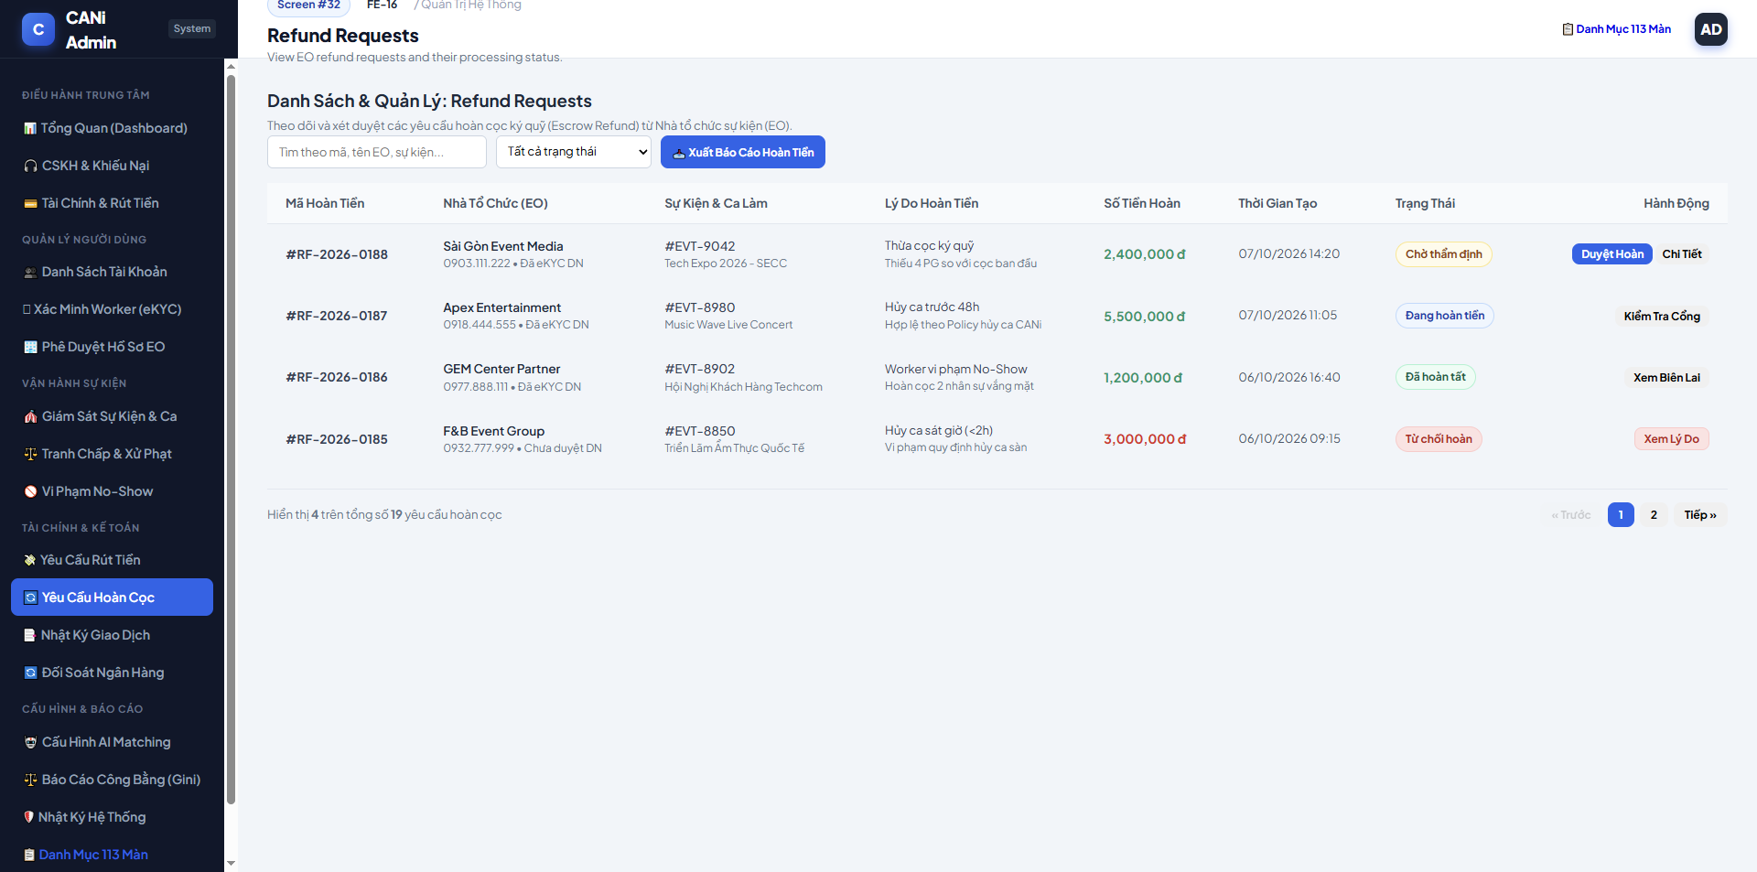
Figure 3.32: Wireframe Mockup of Screen #32 (Refund Requests)
User Actions:
• Finance Officer reviews Event Organizer escrow refund applications resulting from event cancellation or unfilled shifts.
• Inspects event contract cancellation timestamp relative to the 24-hour penalty threshold defined in Section 14 pricing rules.
• Selects pending refund requests to verify calculated refund percentage and approve escrow release.

Field Description:
Field Name | Control / Type | Required | Description & Validation Rules
Refund Batch Date Filter | Date Picker | No | Filters refund submissions by creation date.
Refund Policy Filter | Dropdown Select | No | Filter by policy tier: 100% Refund (>24h), 50% Refund (12-24h), 0% Refund (<12h).
Refund Request Code | Text / Display | Yes | Unique escrow refund identifier format #REF-YYYY-NNNN.
Event Organizer Entity | Text / Display | Yes | Company name and account code #EO-XXXX of the host organizer.
Event Title & Shift ID | Text / Display | Yes | Associated event title, shift date, and requested worker headcount.
Initial Escrow Deposit | Display Value | Yes | Total pre-paid escrow amount deposited for the canceled shifts in VND.
Applicable Refund Amount | Display Value | Yes | Calculated refund sum after deducting platform cancellation fee or worker compensations.
Refund Status | Status Badge | Yes | Processing status: Pending Review, Refunded, Rejected.
Review Details Button | Action Button | Yes | Navigates to Screen #33 (Refund Details) for financial audit.

1.33 SCR-33: Refund Details
Mapped Use Cases: UC-92
Review refund eligibility and amount; approval transfers the refund from Platform Escrow to EO Available Balance.
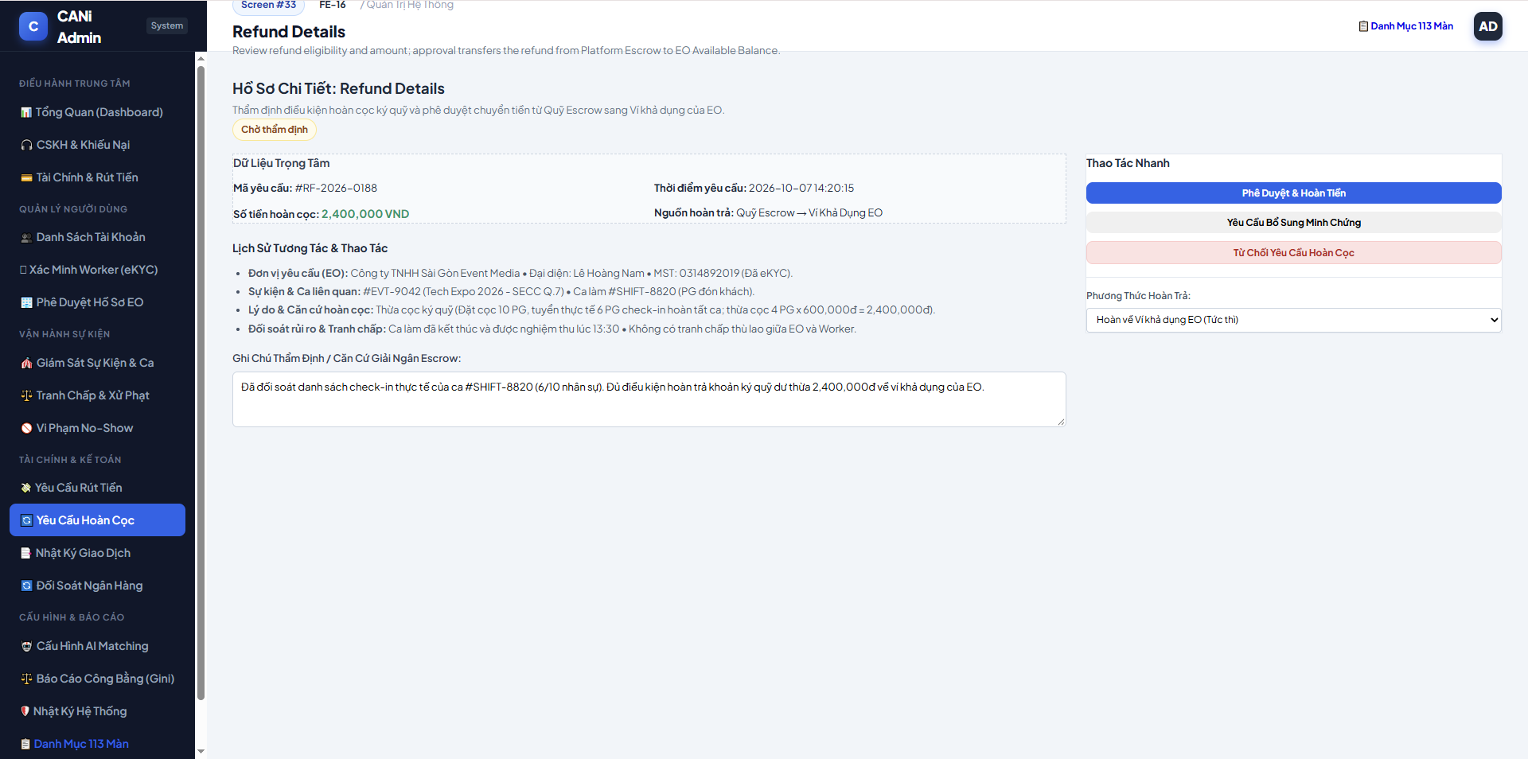
Figure 3.33: Wireframe Mockup of Screen #33 (Refund Details)
User Actions:
• Finance Officer verifies event cancellation timeline and validates adherence to platform refund matrices.
• Audits compensation deductions allocated to workers already dispatched or confirmed for the canceled shifts.
• Authorizes escrow refund release to Event Organizer payment wallet or original corporate bank account.

Field Description:
Field Name | Control / Type | Required | Description & Validation Rules
Refund Case ID | Text / Display | Yes | Master refund record identifier #REF-YYYY-NNNN.
Event Cancellation Timestamp | Text / Display | Yes | Exact cancellation log timestamp and time remaining before shift start.
Gross Escrow Deposit | Display Value | Yes | 100% original deposit held in CANi Escrow account.
Worker Compensation Deduction | Display Value | Yes | Compulsory compensation distributed to confirmed workers if canceled late.
Net Refundable Amount | Display Value | Yes | Final balance credited back to Event Organizer.
Refund Destination Method | Dropdown Select | Yes | Payout channel: Platform Wallet (Instant) or Linked Bank Account.
Audit Justification Notes | Textarea | Yes | Finance audit findings and policy validation reference.
Approve Refund Button | Action Button | Yes | Releases escrow funds and triggers notification E-N03 to Event Organizer.
Reject Refund Button | Action Button | No | Declines refund claim with violation reason.

1.34 SCR-34: Financial Cases
Mapped Use Cases: UC-72, UC-90
View financial disputes and cases escalated to Finance, as grouped in the supplied Screen Flow.
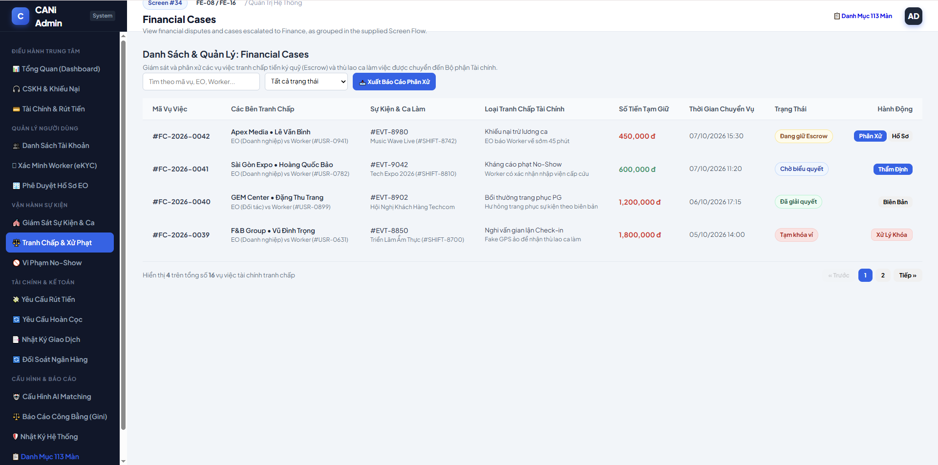
Figure 3.34: Wireframe Mockup of Screen #34 (Financial Cases)
User Actions:
• Finance specialist monitors unresolved disputes escalated from Customer Care involving salary deductions or escrow disputes.
• Filters monetary arbitration cases by claim category, disputed amount, priority level, and SLA deadline.
• Opens individual financial dispute files to conduct binding monetary arbitration and fund settlement.

Field Description:
Field Name | Control / Type | Required | Description & Validation Rules
Escalation Priority Filter | Dropdown Select | No | Filter by urgency: All, URGENT (SLA < 12h), NORMAL.
Dispute Type Filter | Dropdown Select | No | Category: Shift Wages, No-Show Fine, EO Compensation, Early Cancellation.
Dispute Case ID | Text / Display | Yes | Master arbitration identifier format #DSP-YYYY-NNNN.
Escalating Agent & Date | Text / Display | Yes | Customer Care agent name and escalation timestamp.
Disputing Parties | Text / Display | Yes | Worker legal name vs Event Organizer business entity.
Disputed Sum | Display Value | Yes | Total monetary value under dispute escrow lock in VND.
Remaining SLA Timer | Countdown Display | Yes | Time remaining before binding arbitration deadline (target <= 48 hours).
Arbitration Status | Status Badge | Yes | Status: Pending Finance, Auditing Evidence, Adjudicated.
Arbitrate Case Button | Action Button | Yes | Opens Screen #35 for final binding monetary determination.

1.35 SCR-35: Financial Case Details
Mapped Use Cases: UC-72, UC-90
Review related financial transactions and evidence and record the financial case outcome.
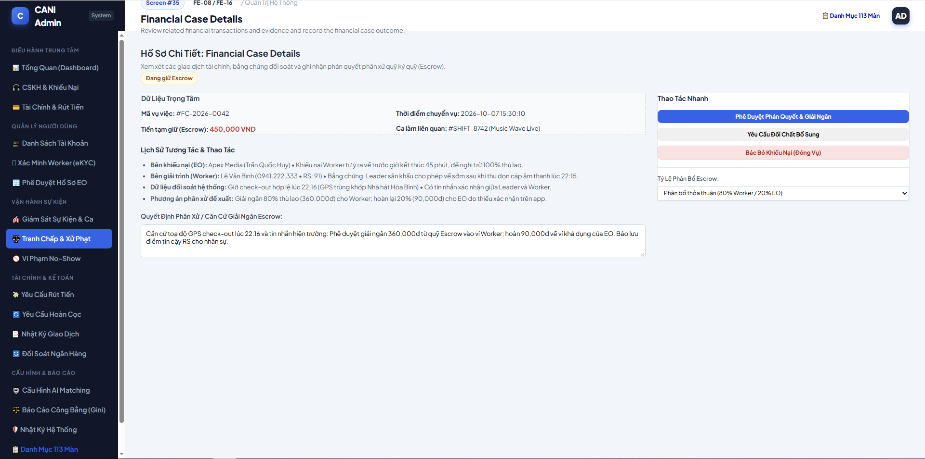
Figure 3.35: Wireframe Mockup of Screen #35 (Financial Case Details)
User Actions:
• Finance arbitrator evaluates photographic check-in timestamps, job checklist evidence, and statements from both parties.
• Determines fund distribution split between Worker and Event Organizer according to contract terms.
• Executes binding payout settlement, releases escrow lock, and closes dispute escalation ticket.

Field Description:
Field Name | Control / Type | Required | Description & Validation Rules
Arbitration Case Code | Text / Display | Yes | Unique case code #DSP-YYYY-NNNN.
Worker Claim & Evidence | Text / Media View | Yes | Worker statement, QR check-in log, and uploaded shift completion photos.
Organizer Claim & Evidence | Text / Media View | Yes | Event Organizer complaint statement and shift attendance report.
Escrow Locked Amount | Display Value | Yes | Total funds frozen in escrow pending resolution.
Worker Settlement Amount | Number Input | Yes | Final wage portion awarded to Worker (0% to 100% of shift fee).
Organizer Refund Amount | Number Input | Yes | Remaining portion refunded to Event Organizer.
Binding Decision Rationale | Textarea | Yes | Official arbitration explanation cited in dispute resolution notice.
Execute Settlement Button | Action Button | Yes | Executes automated double-entry ledger transfers and notifies both parties.

1.36 SCR-36: Transactions
Mapped Use Cases: UC-94
View transactions for EO transfers to Platform Escrow, Worker payments, refunds, withdrawals and fees.
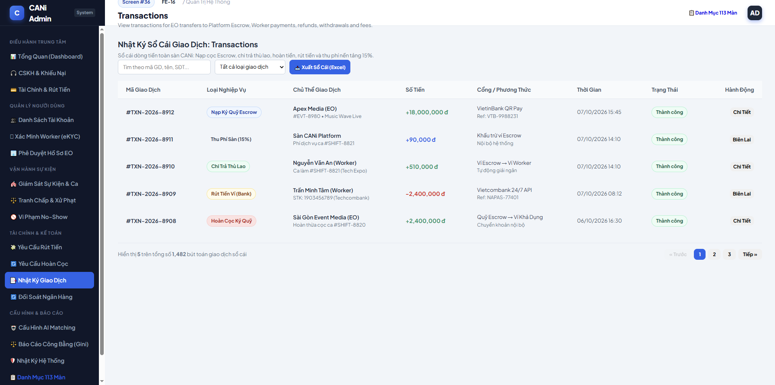
Figure 3.36: Wireframe Mockup of Screen #36 (Transactions)
User Actions:
• Finance auditor inspects immutable transaction journal entries across all platform wallets and escrow pools.
• Filters transactions by transaction classification, currency amount, originating entity, or payment channel.
• Searches specific ledger entries to trace fund lineage and verify mathematical double-entry balance integrity.

Field Description:
Field Name | Control / Type | Required | Description & Validation Rules
Transaction Date Filter | Date Picker | No | Date range filter for general ledger entries.
Transaction Type Filter | Dropdown Select | No | Filter: All, EO Escrow Deposit, Worker Wage Payout, 15% Platform Fee, Refund, No-Show Fine.
Payment Channel Filter | Dropdown Select | No | Channel: Internal Virtual Wallet, MoMo Gateway, Napas 247.
Transaction Reference ID | Text / Display | Yes | Unique ledger code format #TX-YYYY-NNNNNN.
Posting Timestamp | Text / Display | Yes | Exact timestamp formatted as DD/MM/YYYY HH:mm:ss.
Debit / Credit Entity | Text / Display | Yes | Source account and destination account entities.
Transaction Amount | Display Value | Yes | Transaction value in VND with color indicator (Green Credit, Red Debit).
Platform Service Fee | Display Value | Yes | 15% platform service fee component recognized as CANi operating revenue.
Ledger Verification State | Status Badge | Yes | Audit state: Verified (Da doi soat), Ledger Matched, Pending Verification.
View Journal Entry Button | Action Button | Yes | Opens Screen #37 (Transaction Details) for full journal voucher inspect.

1.37 SCR-37: Transaction Details
Mapped Use Cases: UC-94
View a transaction’s amount, type, affected accounts, references and processing status.
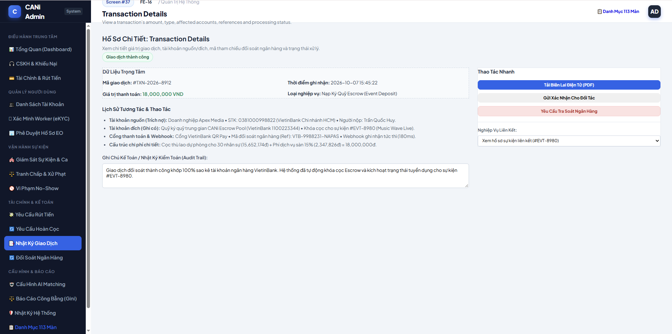
Figure 3.37: Wireframe Mockup of Screen #37 (Transaction Details)
User Actions:
• Auditor reviews balanced double-entry accounting records for a specific transaction voucher.
• Inspects upstream trigger events (Event ID, Shift ID, or Payout ID) associated with fund movement.
• Validates cryptographic SHA-256 integrity hash confirming voucher has not been tampered with.

Field Description:
Field Name | Control / Type | Required | Description & Validation Rules
Journal Entry ID | Text / Display | Yes | Master voucher identifier #TX-YYYY-NNNNNN.
Event Trigger Origin | Text / Link | Yes | Originating business process link (Shift #SH-XXXX, Event #EV-XXXX).
Debit Account (No) | Text / Display | Yes | Debited account ledger code (e.g., 1121 - Bank Deposit, 3388 - Escrow Fund).
Credit Account (Co) | Text / Display | Yes | Credited account ledger code (e.g., 5111 - Revenue, 3341 - Payable to Worker).
Gross Entry Value | Display Value | Yes | Total voucher monetary amount in VND.
External Gateway Trace ID | Text / Display | No | Bank transaction reference or MoMo payment gateway trace code.
Cryptographic SHA-256 Hash | Text / Display | Yes | 64-character SHA-256 tamper-evident digital signature.
Print Voucher Button | Action Button | Yes | Generates standard accounting voucher document in PDF format.

1.38 SCR-38: Reconciliation
Mapped Use Cases: UC-93
Compare escrow inflows, Worker payments, refunds, fees and withdrawal records; identify ledger discrepancies.
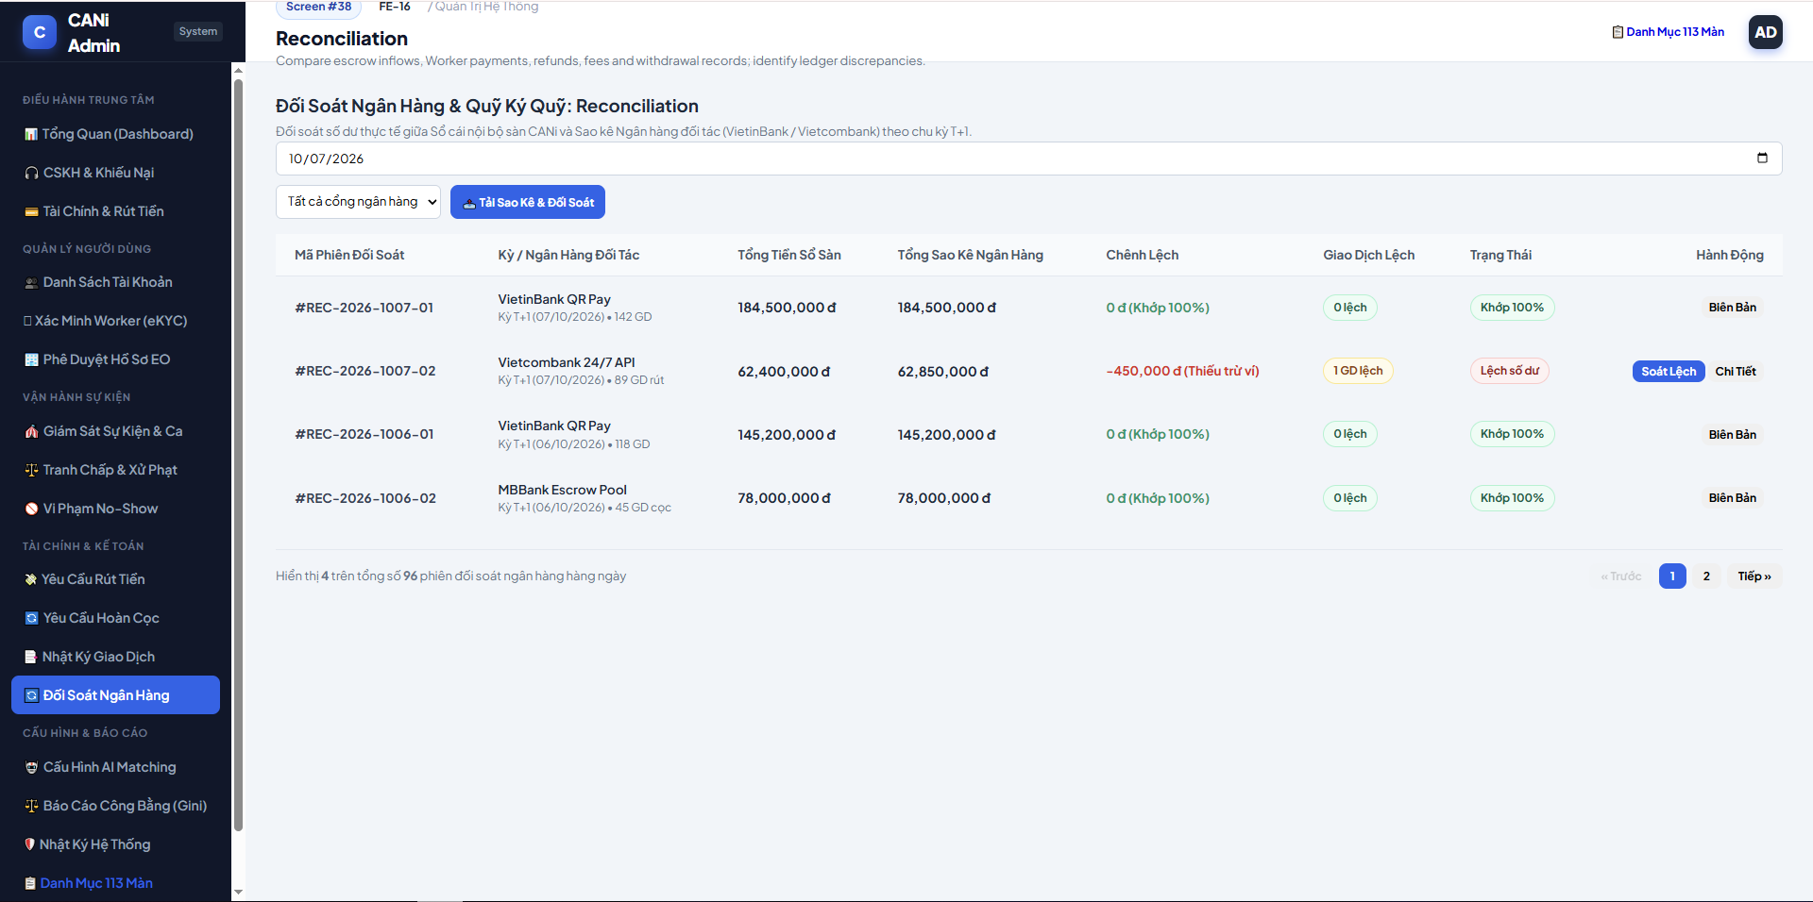
Figure 3.38: Wireframe Mockup of Screen #38 (Reconciliation)
User Actions:
• Finance Officer reviews daily T+1 automated bank reconciliation batches comparing internal balances with bank statements.
• Identifies discrepancy exceptions where bank payouts or deposits diverge from platform ledger records.
• Initiates manual adjustment journal entries or re-triggers settlement batch reconciliation for mismatched items.

Field Description:
Field Name | Control / Type | Required | Description & Validation Rules
Reconciliation Date Filter | Date Picker | Yes | Statement reconciliation date (defaults to T-1 business day).
Batch Reconciliation Code | Text / Display | Yes | Unique batch code in format #REC-YYYY-MM-DD.
System Internal Turnover | Display Value | Yes | Total platform ledger transaction volume recorded in VND.
Bank Statement Turnover | Display Value | Yes | Total transaction volume reported by banking partner statements.
Discrepancy Variance | Display Value | Yes | Net variance difference (0 VND denotes perfect balance; highlighted in Red if non-zero).
Reconciliation Match State | Status Badge | Yes | Status: 100% Matched (Khop 100%), Discrepancy (Lech so du), Pending.
Exception Item Count | Numeric Display | Yes | Number of pending unmatched transactions requiring manual investigation.
Reconcile Batch Button | Action Button | Yes | Triggers re-computation and exports official T+1 reconciliation statement.

1.39 SCR-39: Financial Reports
Mapped Use Cases: UC-90, UC-94
View financial summaries, including revenue and fees, payouts, refunds and escrow balance reporting.
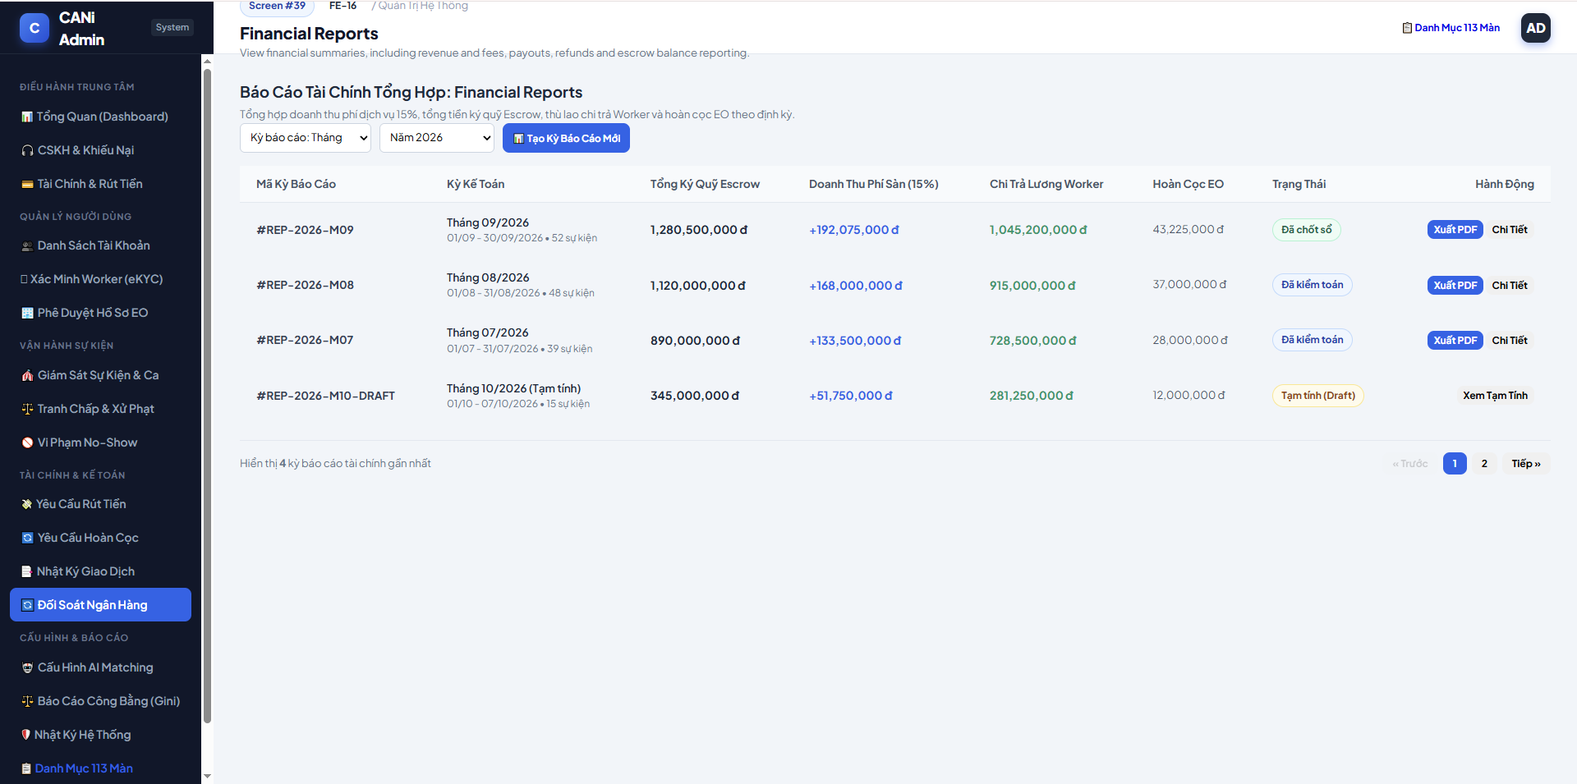
Figure 3.39: Wireframe Mockup of Screen #39 (Financial Reports)
User Actions:
• Chief Accountant reviews periodic financial reports aggregating platform Gross Merchandise Value (GMV), revenues, and escrow holdings.
• Selects periodic reporting cycle (Weekly, Monthly, Quarterly) and comparative benchmark intervals.
• Analyzes 15% platform service fee earnings, penalty forfeiture revenues, and unearned escrow liabilities.

Field Description:
Field Name | Control / Type | Required | Description & Validation Rules
Reporting Timeframe Selector | Dropdown Select | Yes | Aggregation cycle: Weekly, Monthly, Quarterly, Yearly.
Report Category Filter | Dropdown Select | Yes | Report category: 15% Platform Commission, Escrow Holdings, Worker Gross Earnings.
Gross Merchandise Value (GMV) | Display Value | Yes | Total contracted shift wages processed across platform in period.
Platform Service Revenue | Display Value | Yes | Net 15% revenue recognized by CANi platform.
Penalty Forfeiture Income | Display Value | Yes | Revenue collected from late cancellation and No-Show worker penalties.
Active Escrow Float | Display Value | Yes | Total customer funds held in escrow awaiting future shift completion.
Export Financial Report Button | Action Button | Yes | Generates consolidated financial audit report in Excel/PDF format.

1.40 SCR-40: Financial Alerts
Mapped Use Cases: UC-90, UC-93
View financial processing alerts and demo ledger discrepancies.
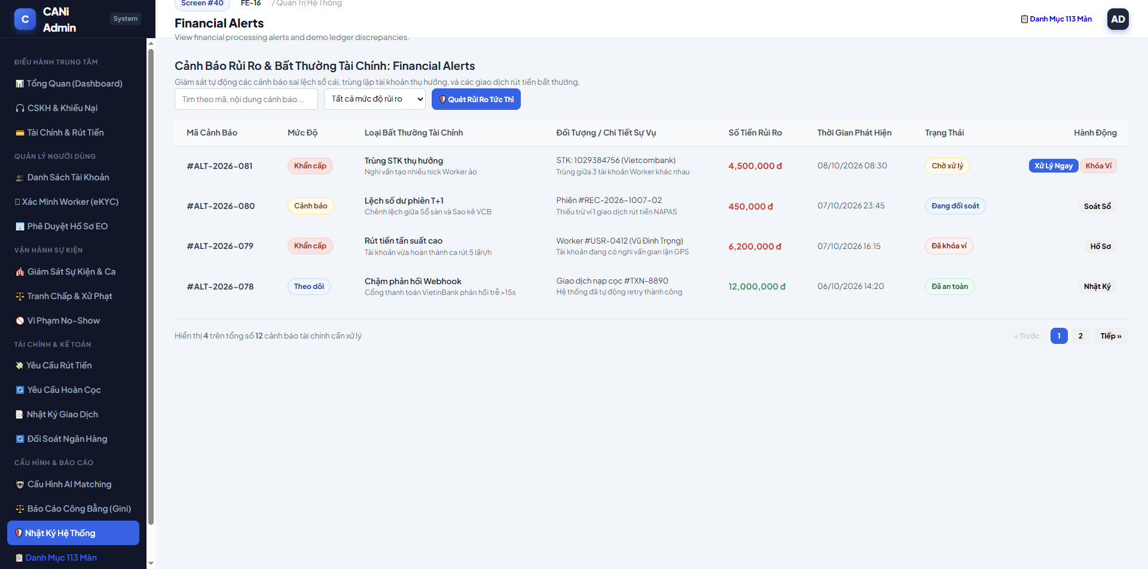
Figure 3.40: Wireframe Mockup of Screen #40 (Financial Alerts)
User Actions:
• Finance Risk Controller monitors automated risk alerts detecting sudden spikes in refund claims, velocity anomalies, or high-value withdrawals.
• Investigates accounts flagged for rapid consecutive withdrawals or suspicious dispute claim ratios.
• Places temporary security holds on flagged accounts or dismisses verified false-positive alerts.

Field Description:
Field Name | Control / Type | Required | Description & Validation Rules
Risk Severity Filter | Dropdown Select | No | Filter by alert tier: All, CRITICAL, HIGH, MEDIUM.
Risk Category Filter | Dropdown Select | No | Category: Abnormal Withdrawals, Escrow Imbalance, High Dispute Ratio.
Alert Reference Code | Text / Display | Yes | Unique alert identifier format #ALR-FIN-YYYY-NNNN.
Flagged Account / Entity | Text / Display | Yes | Flagged User ID, account type, and registered phone number.
Anomaly Description & Metrics | Text / Display | Yes | Technical trigger rationale (e.g., Withdrawals > 3 times/day, Wallet mismatch > 500k VND).
Trigger Timestamp | Text / Display | Yes | Exact anomaly detection timestamp.
Alert Status | Status Badge | Yes | Status: Active Alert, Wallet Frozen, Cleared.
Freeze Wallet Button | Action Button | Yes | Immediately freezes target wallet payout capabilities pending audit.

1.41 SCR-41: Financial Audit Trail
Mapped Use Cases: UC-94, UC-87
View recorded financial actions and their effects on the relevant accounts.
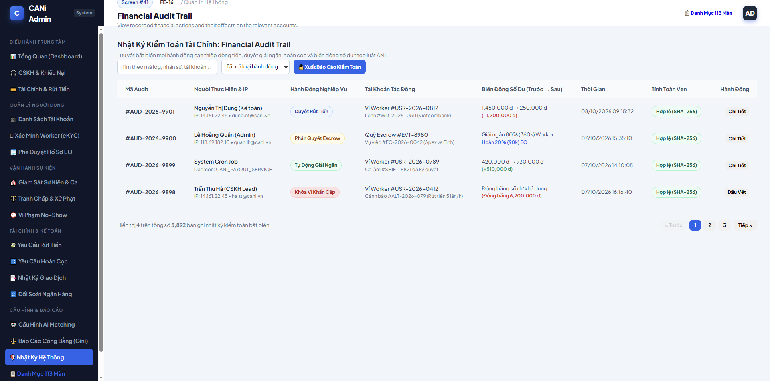
Figure 3.41: Wireframe Mockup of Screen #41 (Financial Audit Trail)
User Actions:
• Compliance Auditor verifies mathematical and cryptographic integrity of the immutable financial ledger.
• Inspects block-by-block cryptographic SHA-256 hash linkages to ensure zero historical record modifications.
• Executes ledger verification tool to validate unbroken chain of custody across all financial transactions.

Field Description:
Field Name | Control / Type | Required | Description & Validation Rules
Audit Block Height Filter | Text Input | No | Block sequence number lookup in forensic chain.
Block Sequence Number | Text / Display | Yes | Monotonically increasing block sequence number #BLK-NNNNNN.
Voucher Count per Block | Numeric Display | Yes | Number of financial journal vouchers packaged in audited block.
Previous Block Hash | Text / Display | Yes | 64-character hexadecimal SHA-256 hash of preceding block.
Current Block Merkle Root | Text / Display | Yes | 64-character Merkle root hash summarizing transactions in current block.
Block Timestamp | Text / Display | Yes | Block commitment timestamp.
Chain Verification Status | Status Badge | Yes | Integrity verification grade: 100% Valid (Unbroken Chain), Hash Mismatch Warning.
Verify Integrity Hash Button | Action Button | Yes | Recomputes full cryptographic tree to prove forensic immutability.

1.42 SCR-42: Pricing Rules
Mapped Use Cases: UC-78
Configure platform pricing, service fees and cancellation refund policies.
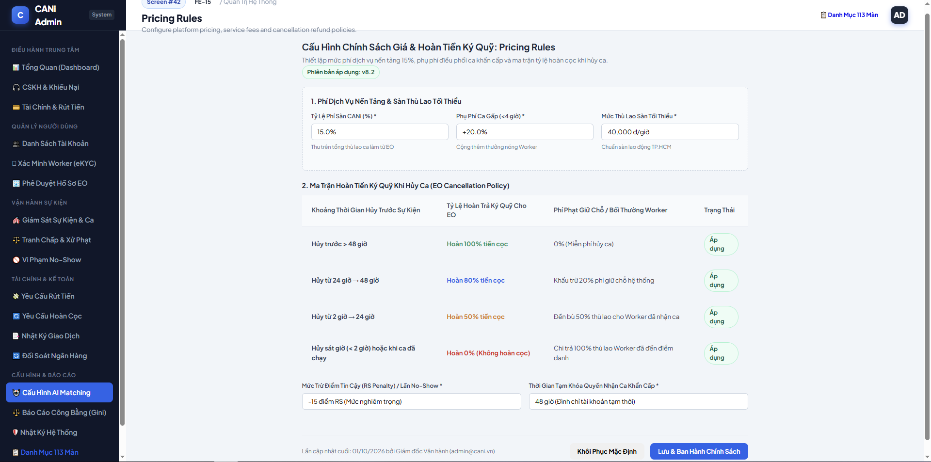
Figure 3.42: Wireframe Mockup of Screen #42 (Pricing Rules)
User Actions:
• System Administrator configures core platform revenue parameters, including 15% platform service commission fee.
• Updates late cancellation refund policy tiers and worker compensation rates (Section 14).
• Adjusts No-Show monetary penalty deductions applied against worker reliability score and wallet balance.

Field Description:
Field Name | Control / Type | Required | Description & Validation Rules
Platform Service Fee Percentage | Number Input | Yes | Default platform commission fee levied on completed shifts (fixed at 15.0%).
Matching Mode Base Fee | Number Input | Yes | Platform posting fee per event in Matching Mode (default 20,000 VND).
Matching Mode Per-Head Fee | Number Input | Yes | Additional hiring fee per worker position (default 5,000 VND).
Invite Mode Flat Fee Tier 1 | Number Input | Yes | Event management fee for events under 20 workers (default 50,000 VND).
Invite Mode Flat Fee Tier 2 | Number Input | Yes | Event management fee for events with 20 or more workers (default 100,000 VND).
Cancellation Tier 1 (>24h) | Number Input | Yes | Refund percentage for EO cancellation over 24 hours prior (100% refund).
Cancellation Tier 2 (12-24h) | Number Input | Yes | Refund percentage for EO cancellation 12 to 24 hours prior (50% refund).
Cancellation Tier 3 (<12h) | Number Input | Yes | Refund percentage for EO cancellation under 12 hours prior (0% refund).
Worker No-Show Penalty Amount | Number Input | Yes | Fixed fine deducted from worker balance upon confirmed No-Show (default 100,000 VND).
Save Pricing Matrix Button | Action Button | Yes | Commits configuration updates to master system parameters with audit trail logging.

1.43 SCR-43: AI Configuration
Mapped Use Cases: UC-88
Configure AI feature availability and parameters for wage recommendations and event planning.
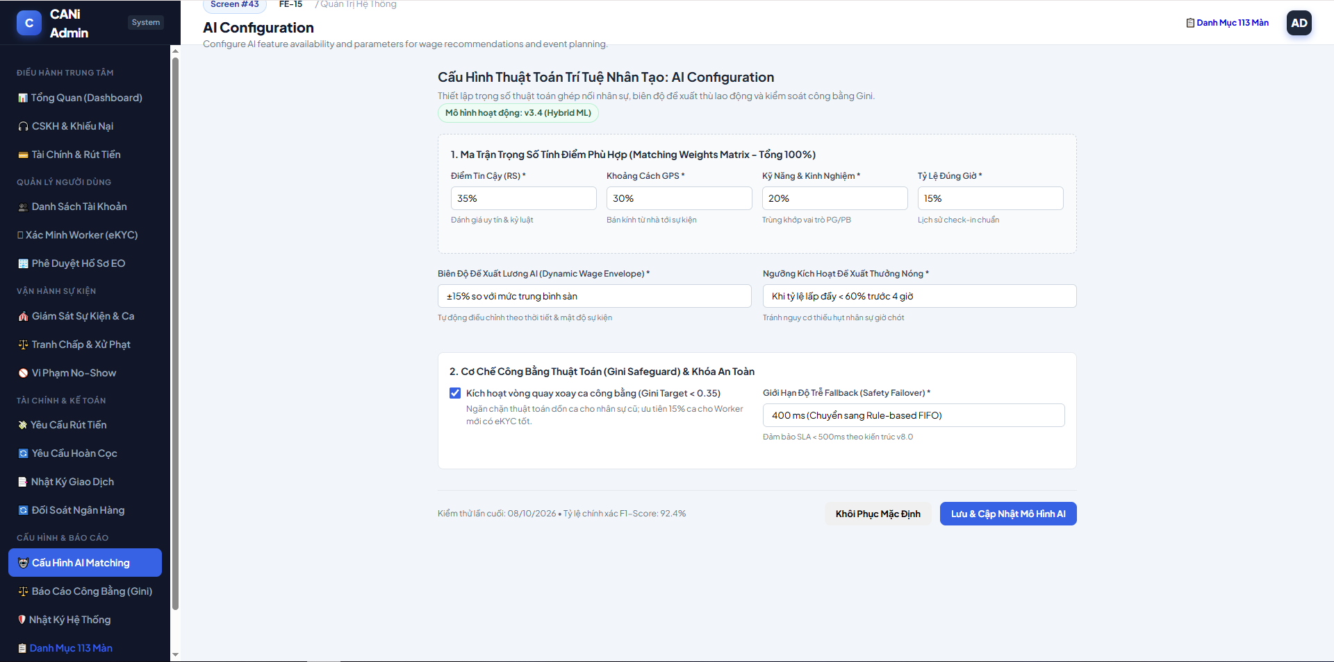
Figure 3.43: Wireframe Mockup of Screen #43 (AI Configuration)
User Actions:
• Administrator configures relative weights for the AI Worker Matching and Dispatch Engine (Distance, Skills, Experience, Reliability).
•Sets sub-400ms inference latency SLA threshold and defines automatic failover to heuristic rule-based dispatch.
•Configures training dataset parameters and minimum completed shift volume for automated wage recommendations (Section 16).

Field Description:
Field Name | Control / Type | Required | Description & Validation Rules
Distance Weight Parameter | Slider / Number | Yes | Proximity weight percentage in matching objective function (default 35%).
Skill Relevance Weight | Slider / Number | Yes | Worker verified skill tags relevance weight (default 25%).
Reliability Score Weight | Slider / Number | Yes | Historical reliability score (RS) weight (default 25%).
Experience & Rating Weight | Slider / Number | Yes | Past completed shifts and star rating weight (default 15%).
AI Inference Latency SLA | Number Input | Yes | Maximum acceptable response time in milliseconds (default 400 ms).
Automated Fallback Toggle | Toggle Switch | Yes | Automatically switches to Rule-based matching engine when latency exceeds SLA.
Wage Recommendation Model | Dropdown Select | Yes | Machine learning model version (e.g., XGBoost Wage Regressor v2.4).
Save AI Configuration Button | Action Button | Yes | Commits hyperparameter weights to active Redis inference configuration cache.

1.44 SCR-44: AI Logs
Mapped Use Cases: UC-89
Review logged AI inputs, outputs, recommendations and user decisions.
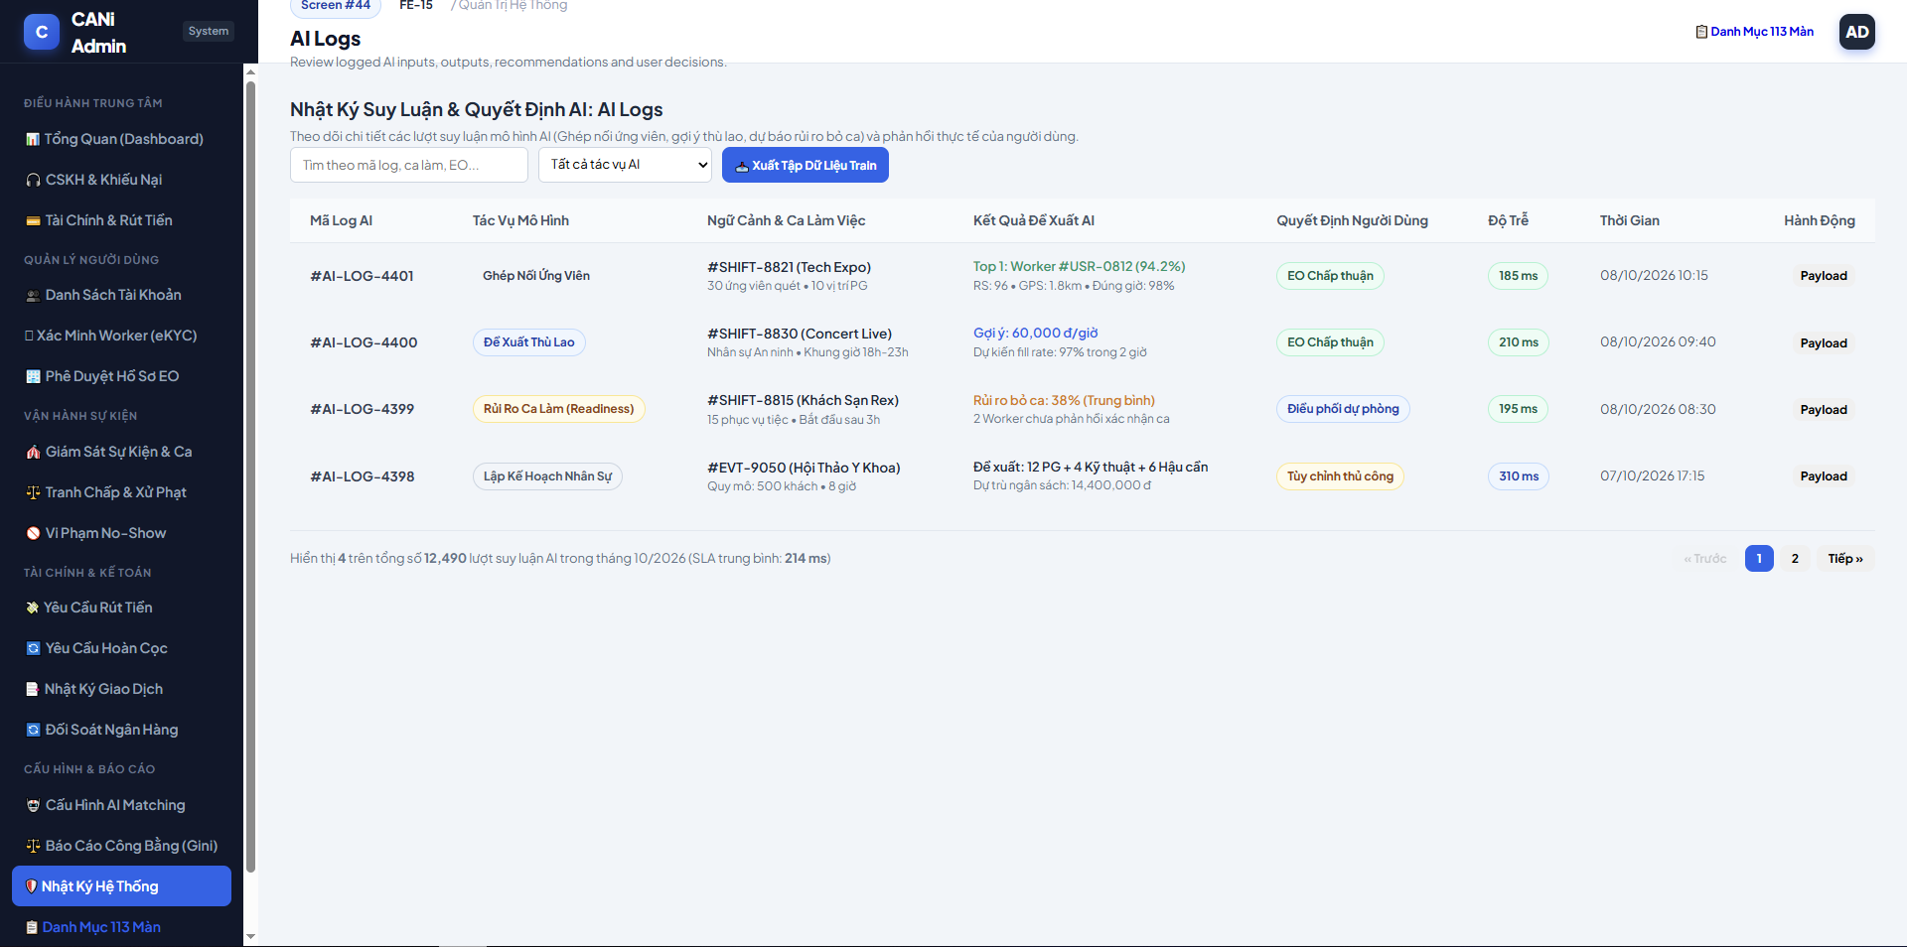
Figure 3.44: Wireframe Mockup of Screen #44 (AI Logs)
User Actions:
• Machine learning engineer or Administrator inspects granular logs of AI matching decisions and dispatch proposals.
• Evaluates inference execution latency against the 400ms SLA and monitors recommendation acceptance rates by Event Organizers.
• Flags inaccurate wage recommendations or mismatched shift proposals to retrain the underlying machine learning models.

Field Description:
Field Name | Control / Type | Required | Description & Validation Rules
Inference Log ID | Text / Display | Yes | Unique AI decision tracking code format #AI-LOG-YYYY-NNNNNN.
Inference Timestamp | Text / Display | Yes | Model execution timestamp with millisecond precision.
AI Model Module | Text / Display | Yes | Subsystem model: Worker Matching Engine, Wage Recommendation Regressor, Shift Planning LLM.
Execution Latency | Text / Display | Yes | Round-trip inference latency in milliseconds (flagged in Red if > 400ms).
Engine Mode Executed | Status Badge | Yes | Operational engine used: AI Model (XGBoost) or Rule-Based Fallback.
Recommendation Acceptance | Status Badge | Yes | Outcome: Accepted (Chap thuan), Overridden (Tu choi), Pending.
Input Feature Vector | Text / Display | Yes | Key input features summary (District, Event Category, Requested Skills, Wage).
View Full JSON Payload | Action Button | Yes | Opens modal with raw JSON feature vector, prediction confidence, and SHAP feature importance.

1.45 SCR-45: Fairness Rules
Mapped Use Cases: UC-82
Configure opportunity distribution rules and Worker matching fairness parameters.
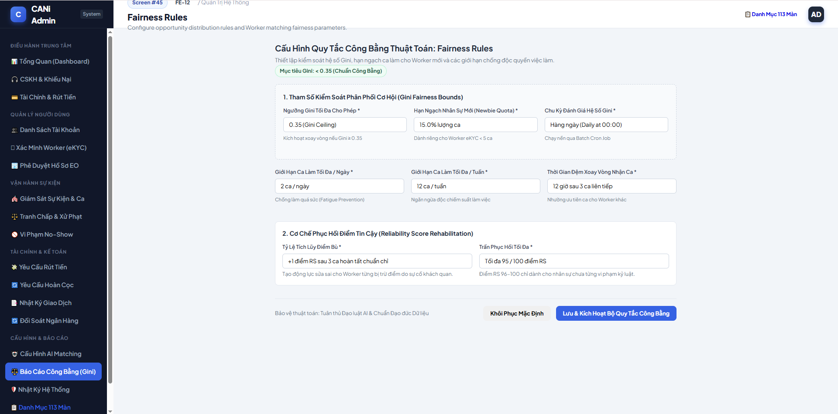
Figure 3.45: Wireframe Mockup of Screen #45 (Fairness Rules)
User Actions:
• Administrator configures algorithmic fairness rules defined in Section 15 of CANi_Flow_v8.txt to prevent shift proposal monopoly.
• Sets Gini coefficient monitoring thresholds (G < 0.20 Excellent, G < 0.30 Target, G < 0.40 Acceptable, G >= 0.40 Unfair Alert).
• Adjusts points bonuses for Idle Worker Boost, New Worker Priority, and the 40% weekly Proposal Cap for top-rated workers.

Field Description:
Field Name | Control / Type | Required | Description & Validation Rules
Gini Target Threshold | Number Input | Yes | Maximum target Gini coefficient before raising warning (default 0.30).
Gini Unfair Alert Threshold | Number Input | Yes | Critical threshold triggering admin alert and dispatch recalibration (default 0.40).
Idle Worker Boost Points | Number Input | Yes | Score bonus points granted to workers idle over 7 days (default +20 points).
New Worker Priority Points | Number Input | Yes | Score bonus points granted to workers with under 3 shifts/week (default +10 points).
Top Worker Proposal Cap | Number Input | Yes | Maximum proposal allocation percentage cap per week for top-tier workers (default 40.0%).
Rotation Among Equals Threshold | Number Input | Yes | Score difference delta threshold prioritizing workers with fewer shifts (default 3.0%).
Emergency Exemption Toggle | Toggle Switch | Yes | Temporarily suspends fairness caps during Emergency Dispatch (Risk Score < 20%).
Save Fairness Rules Button | Action Button | Yes | Commits updated fairness parameters to dispatch optimizer with immediate effect.

1.46 SCR-46: Fairness Report
Mapped Use Cases: UC-81, UC-83
View opportunity distribution, fairness indicators and the Gini coefficient.
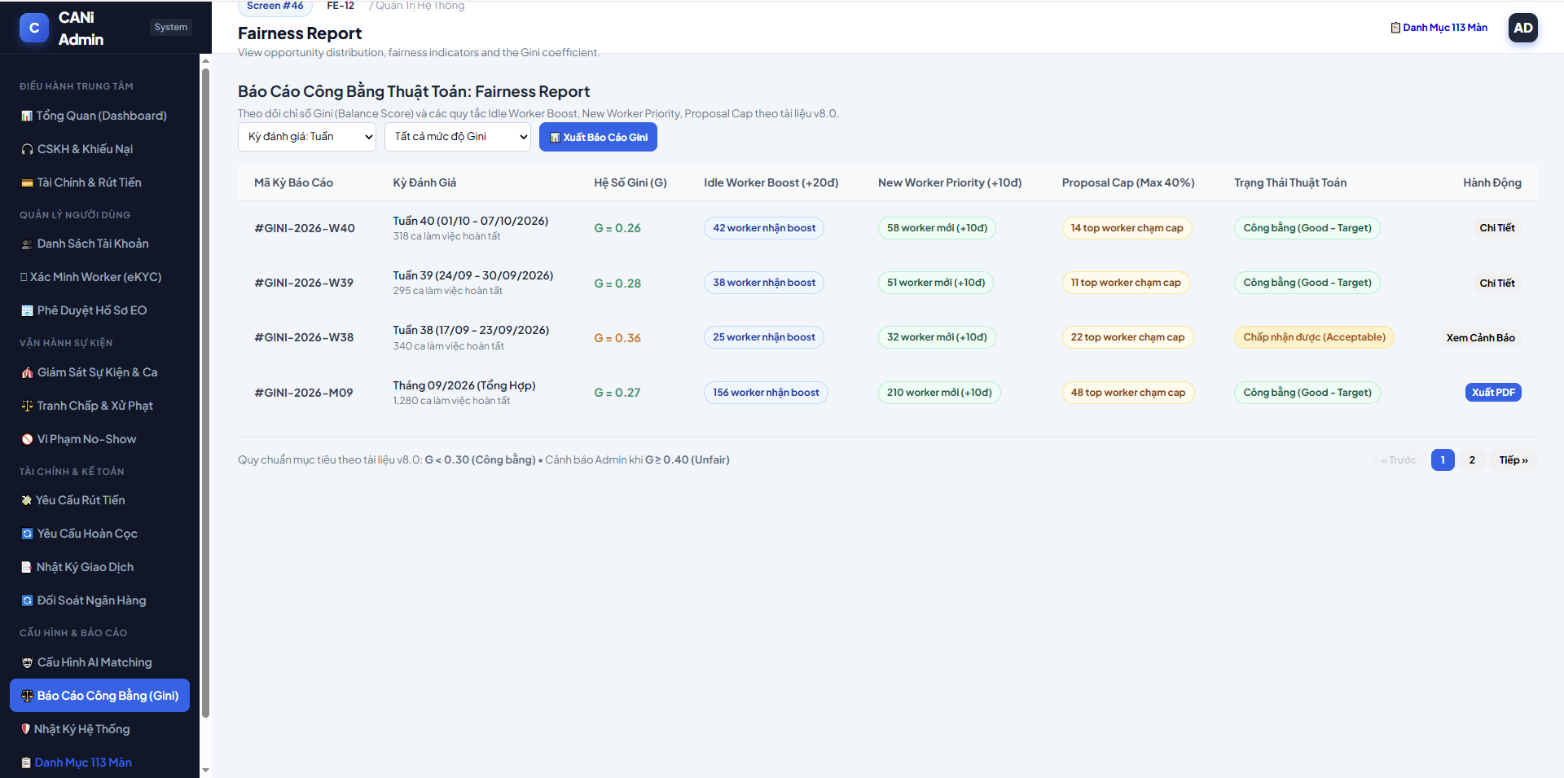
Figure 3.46: Wireframe Mockup of Screen #46 (Fairness Report)
User Actions:
• Administrator monitors weekly Gini coefficient balance scores across job categories and municipal districts.
• Identifies job sectors where shift allocation is concentrated among veteran workers (G >= 0.40).
• Triggers dispatch rebalancing or inspects individual opportunity distribution statistics to resolve worker fairness complaints.

Field Description:
Field Name | Control / Type | Required | Description & Validation Rules
Reporting Timeframe Filter | Dropdown Select | Yes | Balance score evaluation period: Weekly (Theo Tuan) or Monthly (Theo Thang).
Job Category Filter | Dropdown Select | No | Filter by sector: F&B Service, Event Reception, Logistics & Setup, PG/PB.
Job Sector & Region | Text / Display | Yes | Evaluated sector name alongside geographic operational district.
Active Worker Pool Size | Numeric Display | Yes | Total count of active verified workers available in category.
Mean Shifts per Worker | Text / Display | Yes | Average shift proposals received per worker during period (mu).
Calculated Gini Score (G) | Status Badge | Yes | Formula-derived Gini coefficient with status badge (G < 0.20 Excellent, G < 0.30 Good, G >= 0.40 Unfair).
Proposal Cap Compliance | Status Badge | Yes | Status of 40% weekly proposal cap enforcement (Compliant, Breached).
Action Controls | Action Buttons | Yes | Contextual drill-down triggers (Chinh Rule, Chi tiet).

1.47 SCR-47: Platform Reports
Mapped Use Cases: UC-86
View platform-wide operational reports and analytics.
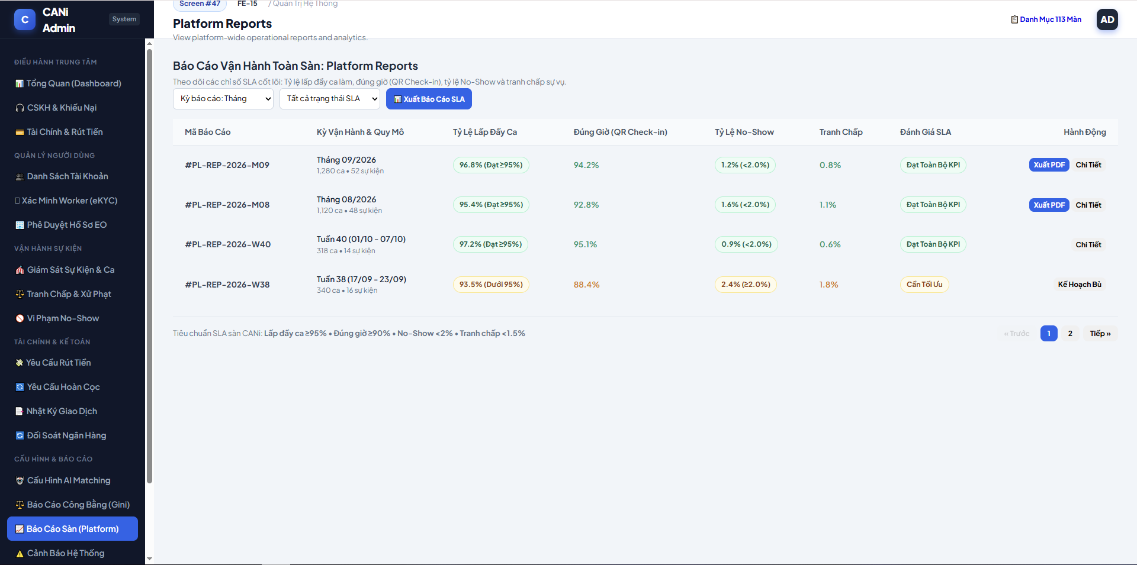
Figure 3.47: Wireframe Mockup of Screen #47 (Platform Reports)
User Actions:
• Administrator selects reporting timeframe filters (Monthly, Weekly, Quarterly) and SLA compliance criteria to evaluate platform fulfillment health.
• Reviews aggregated operational metrics across shifts, including shift fill rate, on-time QR check-in rate, no-show rate, and dispute incident rate.
• Triggers operational contingency plans for sub-threshold periods or exports comprehensive audit reports in PDF format.

Field Description:
Field Name | Control / Type | Required | Description & Validation Rules
Reporting Period Filter | Dropdown / Select | Yes | Operational aggregation timeframe: Monthly, Weekly, or Quarterly.
SLA Compliance Filter | Dropdown / Select | No | Filters batch records by SLA fulfillment status: All SLA Statuses, All KPIs Met, or Optimization Needed.
Export SLA Report Button | Action Button | Yes | Compiles and downloads aggregated operational SLA records in standard PDF format.
Report Batch ID | Text / Display | Yes | Unique batch identifier in system format #PL-REP-YYYY-M/WXX.
Operating Period & Volume | Text / Display | Yes | Aggregation period label alongside total processed shifts and host events (e.g., 1,280 shifts â€¢ 52 events).
Shift Fill Rate | Status Badge | Yes | Proportion of requested worker positions successfully filled against platform target (>= 95%).
On-time Check-in Rate | Text / Display | Yes | Percentage of workers verifying attendance via QR check-in within standard start-time grace period (>= 90%).
No-Show Rate | Status Badge | Yes | Proportion of confirmed workers failing to attend shifts without approved notice (< 2.0%).
Dispute Rate | Text / Display | Yes | Proportion of completed shifts resulting in behavioral or monetary arbitration claims (< 1.5%).
SLA Evaluation Grade | Status Badge | Yes | High-level compliance grading: All KPIs Met (Green) or Optimization Needed (Amber).
Action Controls | Action Buttons | Yes | Contextual drill-down or corrective action trigger (Export PDF, View Details, Contingency Plan).

1.48 SCR-48: System Alerts
Mapped Use Cases: UC-85, UC-55
View system warnings and operational alerts.
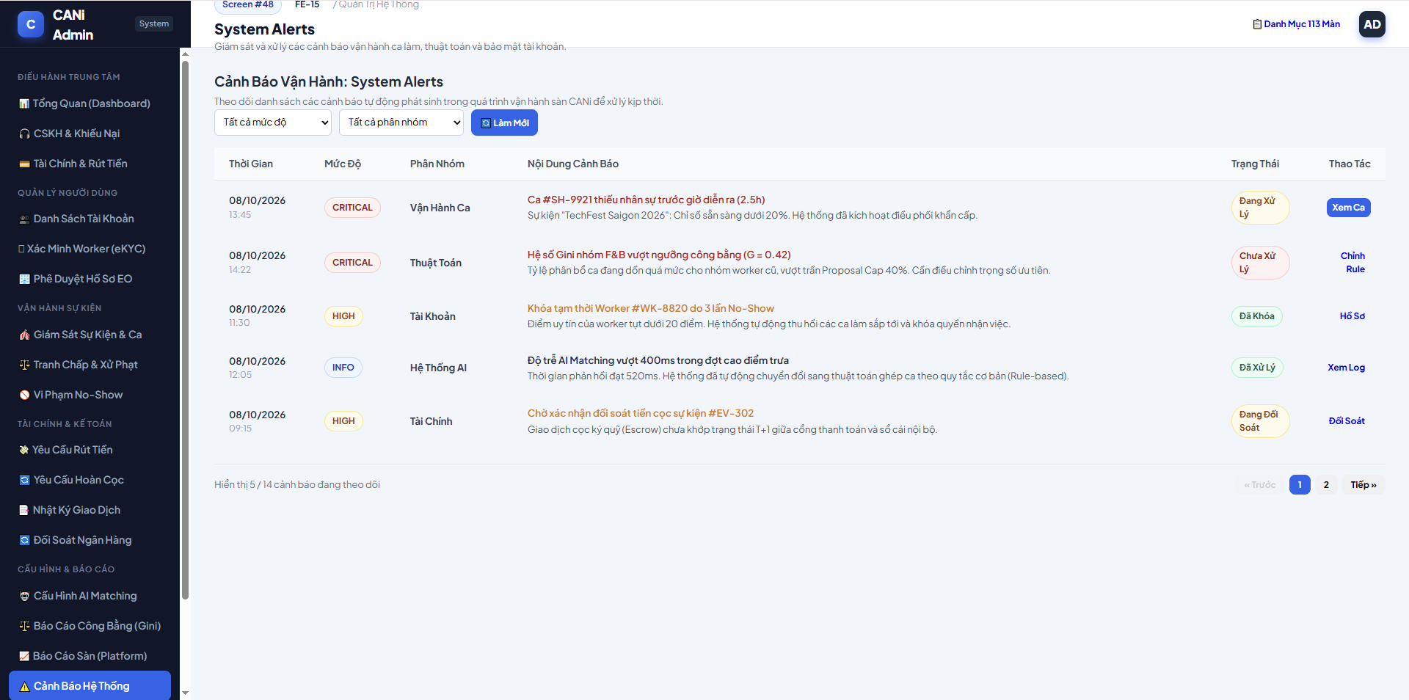
Figure 3.48: Wireframe Mockup of Screen #48 (System Alerts)
User Actions:
• System Administrator views real-time operational alerts regarding shift readiness, fairness balance, and account penalties.
• Filters alerts by severity classification (CRITICAL, HIGH, INFO) or functional operational category (Shift Operations, Algorithm, Account, Finance).
• Clicks contextual action shortcuts to immediately resolve issues (such as viewing understaffed shifts, tuning fairness rules, or inspecting accounts).

Field Description:
Field Name | Control / Type | Required | Description & Validation Rules
Severity Filter | Dropdown / Select | No | Filters alerts by severity level: All, CRITICAL (Nghiem trong), HIGH (Canh bao), or INFO (Thong tin).
Category Filter | Dropdown / Select | No | Filters alerts by operational subsystem: Shift Operations, Fairness Algorithm, Account Security, or Finance.
Refresh Alerts Button | Action Button | Yes | Refreshes the operational alerts queue with latest system notifications.
Alert Timestamp | Text / Display | Yes | Date and time when the operational alert occurred in format DD/MM/YYYY HH:mm.
Severity Level | Status Badge | Yes | Color-coded severity grade: CRITICAL (Red), HIGH (Amber), or INFO (Blue).
Alert Category | Text / Display | Yes | Subsystem category label (e.g., Shift Operations, Fairness Algorithm, Account, Finance).
Alert Description | Text / Display | Yes | Clear summary of the operational incident, threshold violation, or system trigger.
Handling Status | Status Badge | Yes | Current resolution state: Unresolved (Chua xu ly), In Progress, or Resolved.
Action Shortcut | Action Button | Yes | Contextual navigation shortcut to resolve the incident (e.g., View Shift, Adjust Rule, View Account).

1.49 SCR-49: Audit Logs
Mapped Use Cases: UC-87, UC-89
View the audit history of platform and administrative actions.
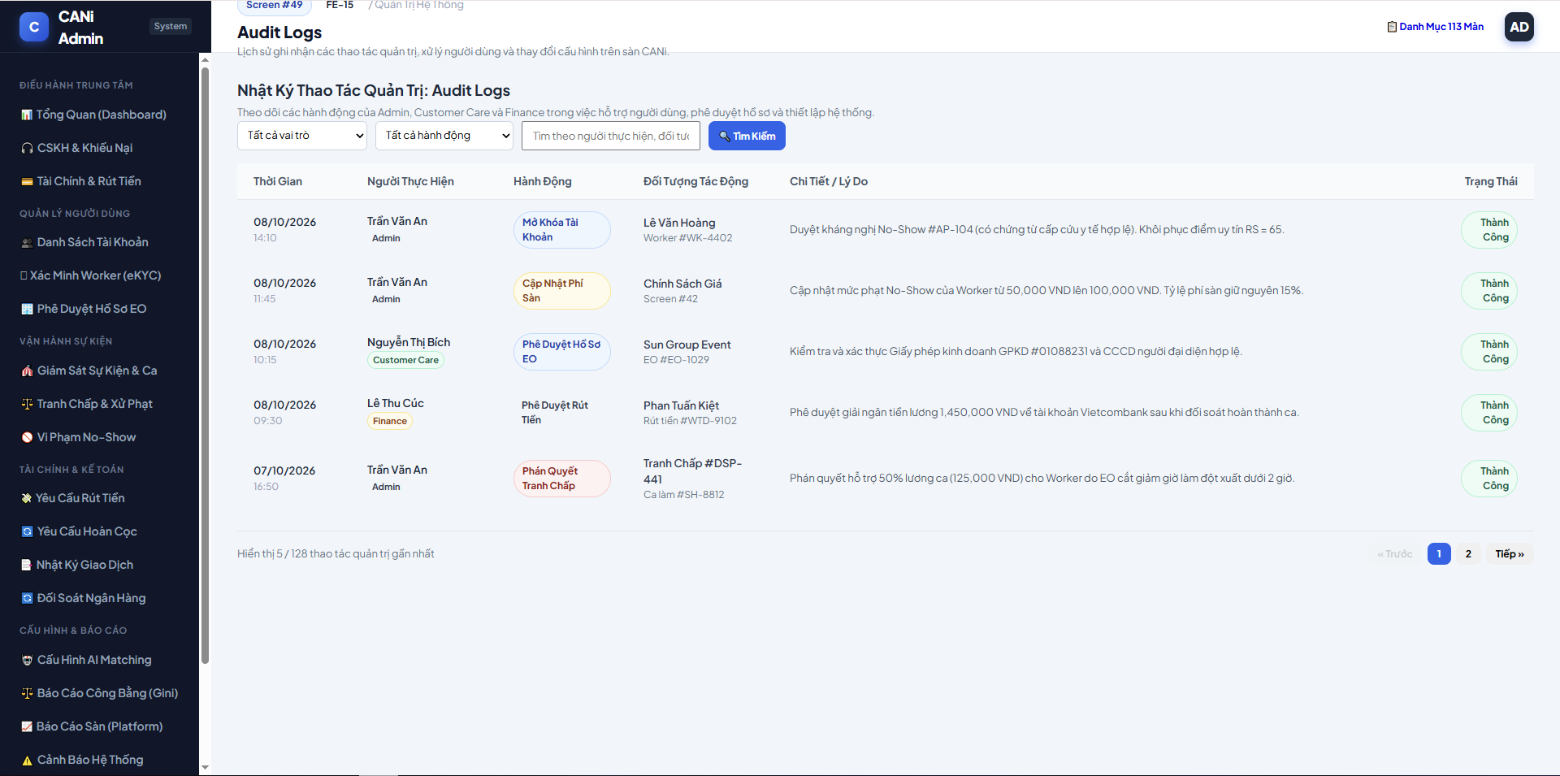
Figure 3.49: Wireframe Mockup of Screen #49 (Audit Logs)
User Actions:
• System Administrator views chronological logs of administrative actions, user account interventions, and configuration updates.
• Filters audit records by staff role (Admin, Customer Care, Finance) or action category (Account Management, Profile Verification, Payout Approval, Dispute Arbitration).
• Searches specific actions by staff name or affected user entity to review operational rationale and outcomes.

Field Description:
Field Name | Control / Type | Required | Description & Validation Rules
Staff Role Filter | Dropdown / Select | No | Filters logs by performing role: All, Admin, Customer Care, or Finance.
Action Category Filter | Dropdown / Select | No | Filters logs by operation type: Account Management, Verification, Finance & Payout, or Configuration.
Search Query Input | Text Input | No | Searches by staff name, user code, or target entity identifier.
Action Timestamp | Text / Display | Yes | Date and time when the administrative action occurred in format DD/MM/YYYY HH:mm.
Staff Name & Role | Text / Display | Yes | Full name and administrative role badge of the staff member performing the action.
Action Type | Status Badge | Yes | Administrative action tag (e.g., Unlock Account, Approve EO, Approve Payout, Update Pricing).
Target Entity | Text / Display | Yes | Affected user or platform entity (e.g., Worker #WK-4402, EO #EO-1029, Pricing Policy).
Action Details & Reason | Text / Display | Yes | Concise operational summary and justification for the action performed.
Execution Status | Status Badge | Yes | Final execution outcome: Success (Thanh cong) or Failed (That bai).

2. Event Organizer (EO) Web Portal Screens
This subsection details the functional specifications for the 27 event organizer screens comprising the CANi Event-Staffing Portal.

2.1 SCR-50: Login
Mapped Use Cases: UC-02
Authenticate an approved Event Organizer and open the EO dashboard.
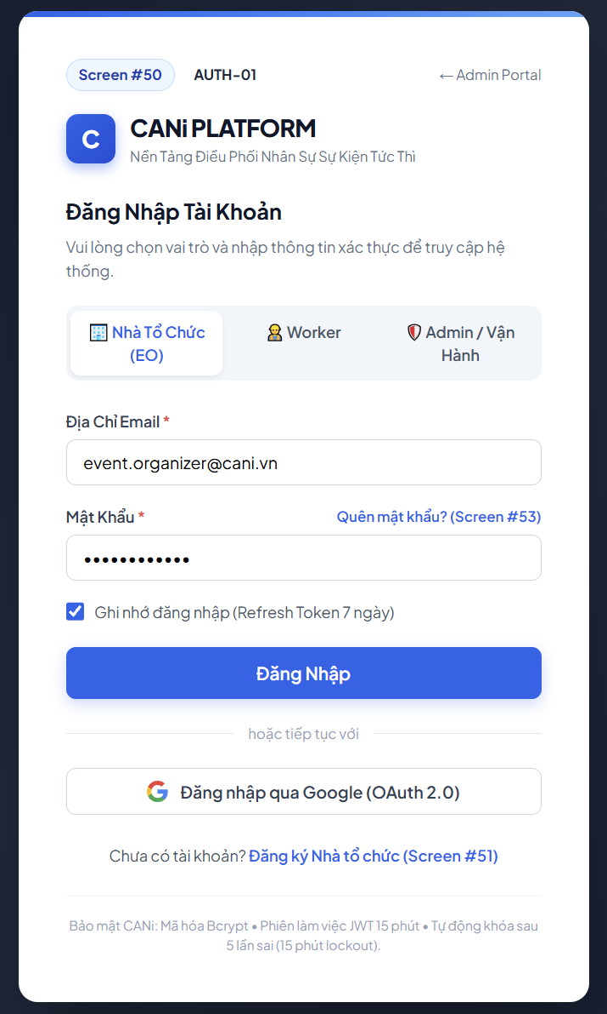
Figure 3.50: Wireframe Mockup of Screen #50 (Login)
User Actions:
• User selects the target portal role tab ( Event Organizer, Woker or Administrator) and enters registered authentication credentials (email address and password).
• Optionally toggles the “Remember me” checkbox to extend JWT refresh token session retention to 7 days, or click “ Continue with Google” for OAuth 2.0 single sign-on.
• Clicks the “Log In” button to submit credentials for Bcrypt verification; upon successful authentication, the system issues a scoped JWT access token and redirects to the role-specific dashboard.

Field Description:
Field Name | Control / Type | Required | Description & Validation Rules
Portal Role Tab | Tab/Selector | Yes | Selects the target workspace portal: Event Organizer(EO), Worker, or System Admin/Staff. Defaults to Event Organizer.
Email Address | Text Input | Yes | Registered user email address. Validates non-empty and standard RFC 5322 format. Maximum 255 characters
Password | Password Input | Yes | Masked input field. Minimum 8 characters, requiring at least one uppercase letter, one number, and one special character. Verified against Bcrypt hashed DB secret.
Remember Me | Check box | No | Toggles persistent session storage; when checked issues an HTTP-only Refresh Token valid for 7 days. Defaults to unchecked.
Forgot Password Link | Navigation Link | No | Contextual link redirecting users unable to log in to the Password Reset screen ( Screen #53 ).
Login Button | Action Button | Yes | Submit authentication payload to /api/v1/auth/login. On HTTP 200, receives 15-minute JWT Access Token and redirects to the corresponding dashboard. Auto-locks account for 15 minutes after 5 consecutive failed attempts.
Google SSO Button | Action Button | No | Initiates federated Google OAuth 2.0 authentication workflow.
Register EO Account Link | Navigation Link | No | Navigation hyperlink directing new enterprise organizers to the Event Organizer Registration screen ( Screen #51)

2.2 SCR-51: User Register
Mapped Use Cases: UC-01
Submit EO email, password, phone, organization and CCCD information for registration and staff review.
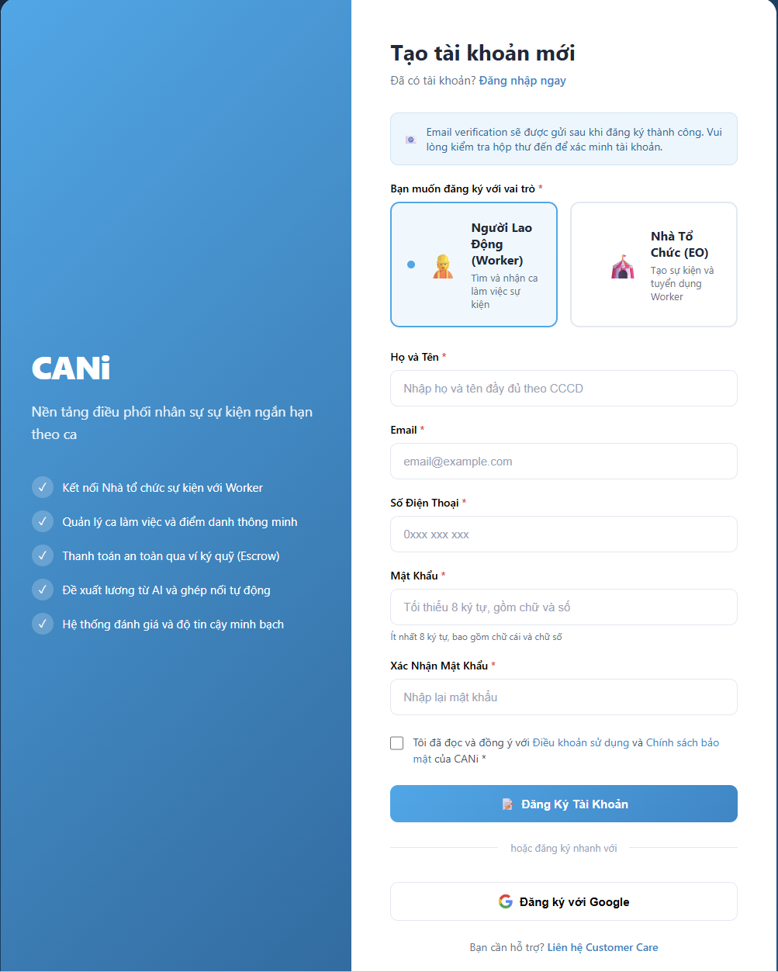
Figure 3.51: Wireframe Mockup of Screen #51 (User Register)
User Actions:
• The user enters required account registration details (email, password, phone).
• Accepts terms of service and platform privacy policy.
• Submits registration form to trigger email OTP verification.
Field Description:
Field Name | Control / Type | Required | Description & Validation Rules
Account Role | Radio Button Group | Yes | Select registration role: Worker or Event Organizer. Role determines onboarding flow and post-registration access permissions.
Email Address | Text Input | Yes | Unique email address for account activation. Must be valid format (RFC 5322) and not already registered. System sends 6-digit OTP valid for 15 minutes.
Password | Password Input | Yes | Strong password with uppercase (A-Z), lowercase (a-z), digit (0-9), and special character (!@#$%^&*). Minimum 8 characters. Password is hashed with BCrypt before storage.
Phone Number | Text Input | Yes | Valid 10-digit Vietnamese phone format (03/05/07/08/09).
Terms Agreement | Checkbox | Yes | Mandatory acceptance of platform terms and privacy guidelines.
Full Name / Org | Text Input | Yes | Full legal name per identification document (Worker) or registered organization name (EO). 2-100 characters, no special characters except Vietnamese diacritics.
Confirm Password | Password Input | Yes | Re-enter password to confirm. Must exactly match the Password field.

2.3 SCR-52: Email Verification
Mapped Use Cases: UC-01
Verify the registration email with an OTP; EO access remains subject to staff approval.
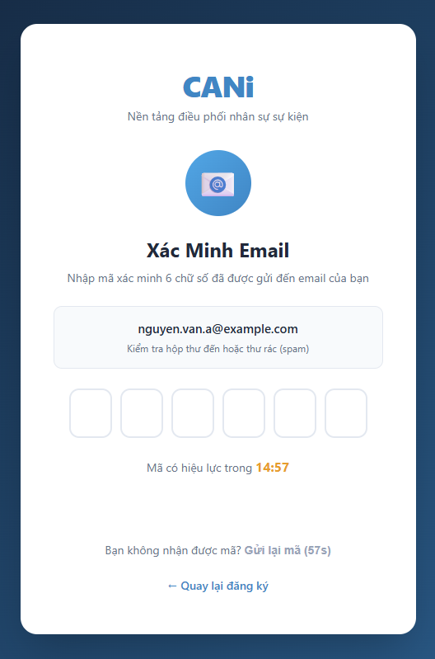
Figure 3.52: Wireframe Mockup of Screen #52 (Email Verification)
User Actions:
• The user checks the registered email inbox for a 6-digit verification code.
• Enters OTP into input fields with auto-focus progression.
• User can request to resend OTP if not received.
Field Description:
Field Name | Control / Type | Required | Description & Validation Rules
OTP Digit | OTP Inputs | Yes | 6-digit numeric One-Time Password sent to registered email. Valid for 15 minutes. Each digit entered in separate input field with auto-focus navigation.
Resend OTP | Button | No | Button to request new OTP. Disabled for 60 seconds after each send to prevent abuse.

2.4 SCR-53: Password Reset
Mapped Use Cases: UC-04
Request a password reset link using the registered email address.
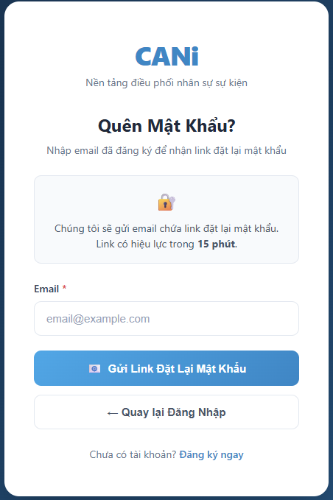
Figure 3.53: Wireframe Mockup of Screen #53 (Password Reset)
User Actions:
• User enters registered email address to request password reset
• User receives email with reset link valid for 15 minutes.
• User clicks link in email to proceed to set new password.
Field Description:
Field Name | Control / Type | Required | Description & Validation Rules
Email Address | Text Input | Yes | Registered email address. Must be valid format (RFC 5322) and exist in the system. Reset link is sent to this email.

2.5 SCR-54: Set New Password
Mapped Use Cases: UC-04
Set a new password using a valid password reset token.
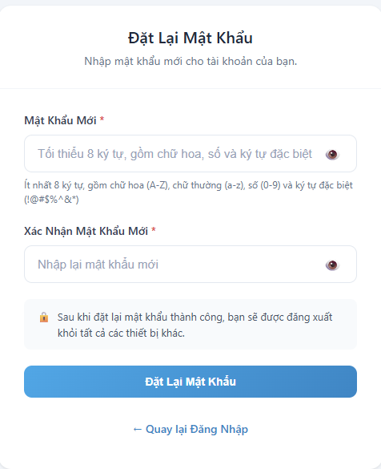
Figure 3.54: Wireframe Mockup of Screen #54 (Set New Password)
User Actions:
• User opens and reviews the Set New Password interface.
• Interacts with available controls, search filters, and actionable buttons.
• Confirms action to commit changes to the backend API or navigate to related screens.
Field Description:
Field Name | Control / Type | Required | Description & Validation Rules
Set New Password Identifier | Text / Display | Yes | Unique system reference code for record in SUP.
Primary Action / Form Input | Interactive Input | Yes | Primary input or control configured for Set New Password.
Filter / Status Indicator | Badge / Dropdown | No | Displays current operational state or filters results.
Confirmation Action | Action Button | Yes | Executes primary business operation for SUP.

2.6 SCR-55: Password Change
Mapped Use Cases: UC-04
Change the current password of the signed-in account.

Figure 3.55: Wireframe Mockup of Screen #55 (Password Change)
User Actions:
• User enters current password for verification.
• User enters new password and confirms it.
• User submits to update password and receive confirmation.
Field Description:
Field Name | Control / Type | Required | Description & Validation Rules
Current Password | Password Inpu | Yes | User's current password for verification. Must match stored hash. Includes show/hide toggle.
New Password | Password Input | Yes | New password with uppercase (A-Z), lowercase (a-z), digit (0-9), and special character (!@#$%^&*). Minimum 8 characters. Includes show/hide toggle and real-time strength indicator (4 levels: Yếu, Trung bình, Khá, Mạnh).
Confirm New Password | Password Input | Yes | Re-enter new password. Must exactly match New Password field. Includes show/hide toggle and match status indicator.
Confirmation Action | Action Button | Yes | Executes primary business operation for SUP.

2.7 SCR-56: Event Organizer Dashboard
Mapped Use Cases: UC-08
View event summaries and quick actions; search and filter events by keyword, dates or status.
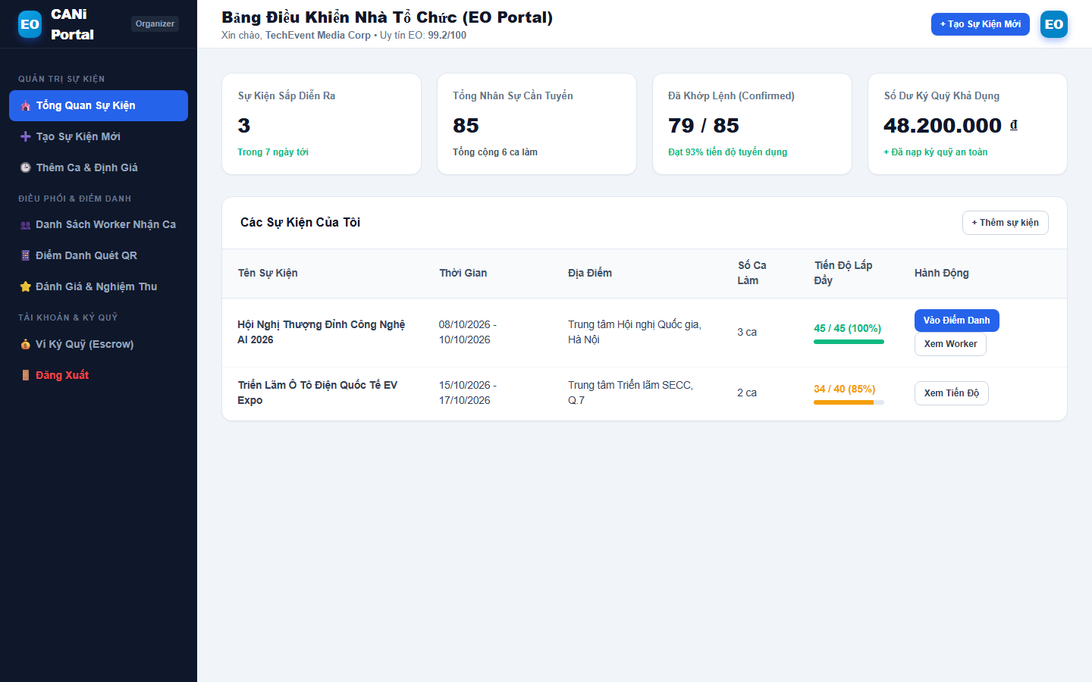
Figure 3.56: Wireframe Mockup of Screen #56 (Event Organizer Dashboard)
User Actions:
• User views real-time operational statistics and key performance indicators.
• Monitors active queues, tasks, and system alerts.
• Clicks on quick action buttons or queue items to navigate directly to detailed management screens.
Field Description:
Field Name | Control / Type | Required | Description & Validation Rules
KPI Stat Cards | Metric Widget | No | Displays real-time counts, percentages, and performance metrics.
Date / Filter Bar | Dropdown / Date | No | Filters dashboard summaries by day, week, month, or custom range.
Task Queue List | Data Grid / List | No | Presents top pending items requiring administrative or user attention.
Navigation Action | Action Button | No | Deep links to dedicated feature workflows.

2.8 SCR-57: My Profile
Mapped Use Cases: UC-05
View EO profile, organization and account information; update permitted profile fields.
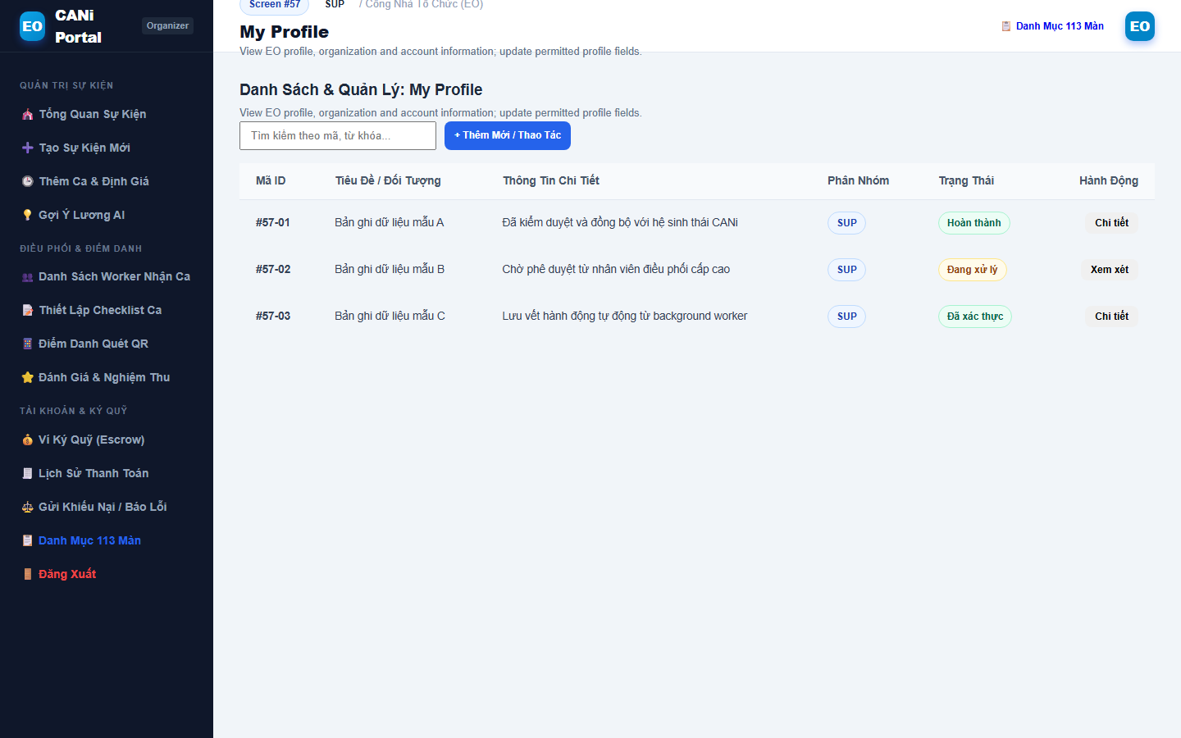
Figure 3.57: Wireframe Mockup of Screen #57 (My Profile)
User Actions:
• User opens and reviews the My Profile interface.
• Interacts with available controls, search filters, and actionable buttons.
• Confirms action to commit changes to the backend API or navigate to related screens.
Field Description:
Field Name | Control / Type | Required | Description & Validation Rules
My Profile Identifier | Text / Display | Yes | Unique system reference code for record in SUP.
Primary Action / Form Input | Interactive Input | Yes | Primary input or control configured for My Profile.
Filter / Status Indicator | Badge / Dropdown | No | Displays current operational state or filters results.
Confirmation Action | Action Button | Yes | Executes primary business operation for SUP.

2.9 SCR-58: Notifications
Mapped Use Cases: UC-07
View received notifications and open related screens within the signed-in user’s permissions.
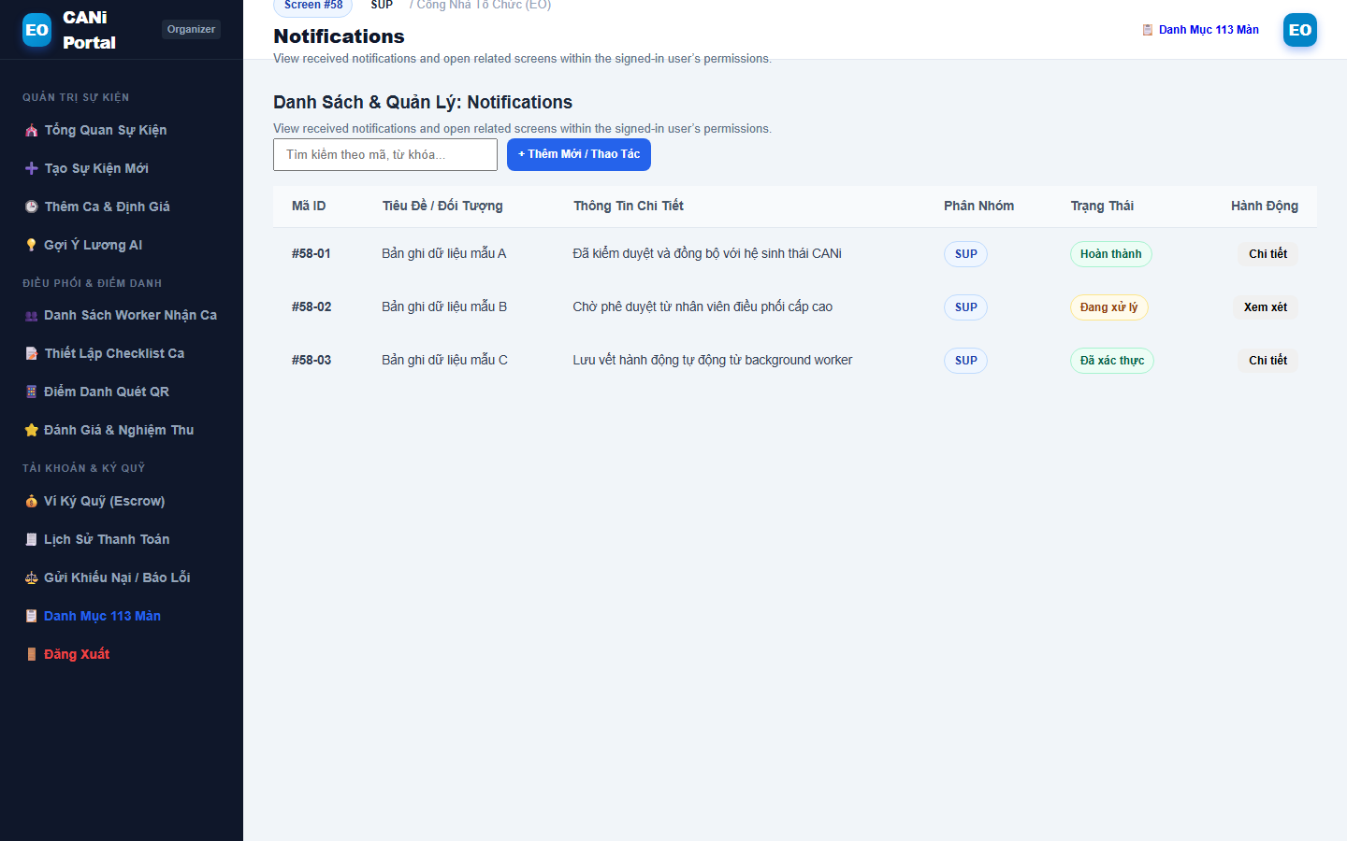
Figure 3.58: Wireframe Mockup of Screen #58 (Notifications)
User Actions:
• User opens and reviews the Notifications interface.
• Interacts with available controls, search filters, and actionable buttons.
• Confirms action to commit changes to the backend API or navigate to related screens.
Field Description:
Field Name | Control / Type | Required | Description & Validation Rules
Notifications Identifier | Text / Display | Yes | Unique system reference code for record in SUP.
Primary Action / Form Input | Interactive Input | Yes | Primary input or control configured for Notifications.
Filter / Status Indicator | Badge / Dropdown | No | Displays current operational state or filters results.
Confirmation Action | Action Button | Yes | Executes primary business operation for SUP.

2.10 SCR-59: Create Event
Mapped Use Cases: UC-12, UC-86
Create a draft event, select Matching or Invite mode, and review or edit AI-generated event suggestions when used.
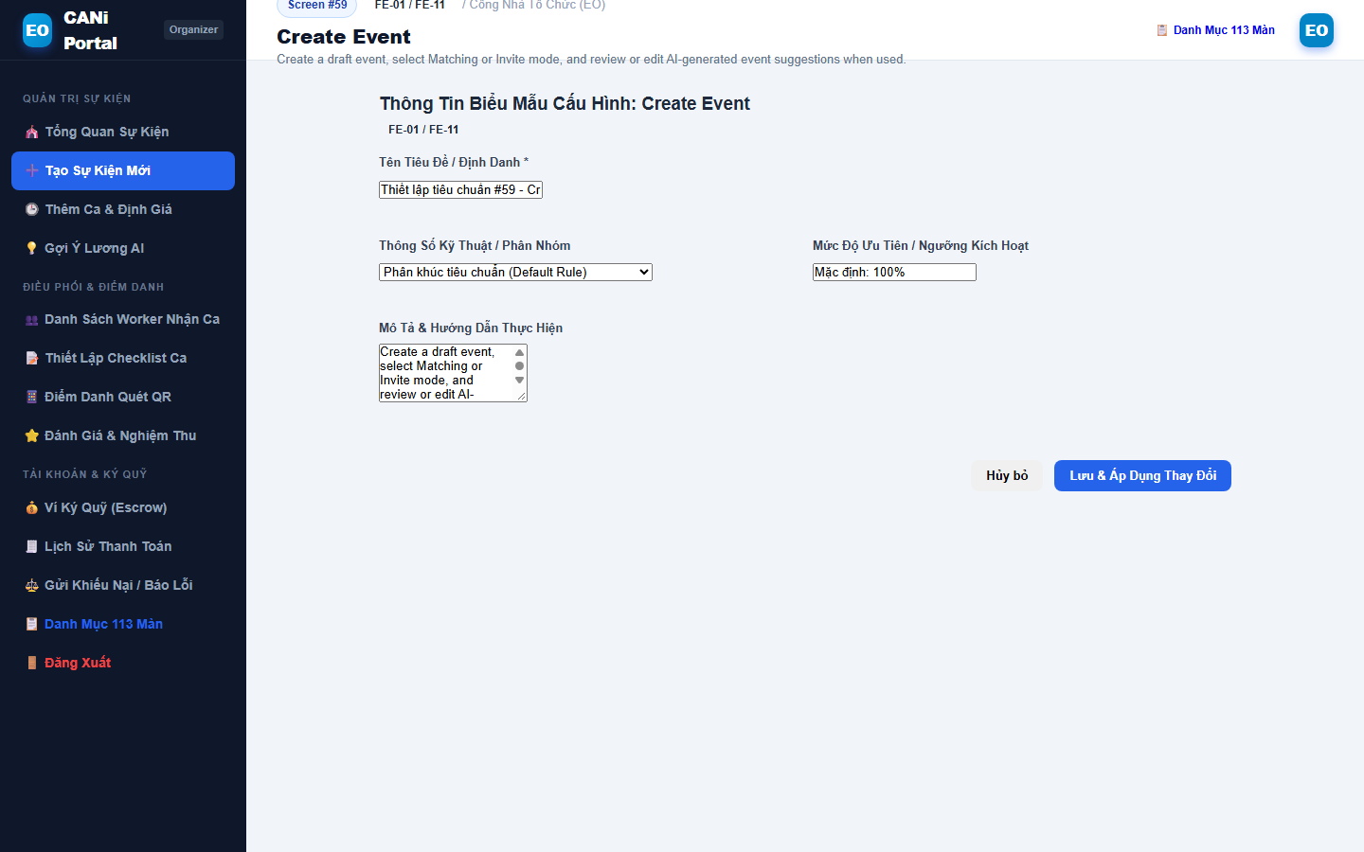
Figure 3.59: Wireframe Mockup of Screen #59 (Create Event)
User Actions:
• User initiates creation workflow for Create Event.
• Fills in all mandatory fields, configuration settings, and requirements.
• Reviews preview and submits to commit new record to the database.
Field Description:
Field Name | Control / Type | Required | Description & Validation Rules
Create Event Identifier | Text / Display | Yes | Unique system reference code for record in FE-01 / FE-11.
Primary Action / Form Input | Interactive Input | Yes | Primary input or control configured for Create Event.
Filter / Status Indicator | Badge / Dropdown | No | Displays current operational state or filters results.
Confirmation Action | Action Button | Yes | Executes primary business operation for FE-01 / FE-11.

2.11 SCR-60: Event Details
Mapped Use Cases: UC-10
View shifts, staffing and readiness; access prepayment, activation, cancellation, cloning, archiving and invite information.
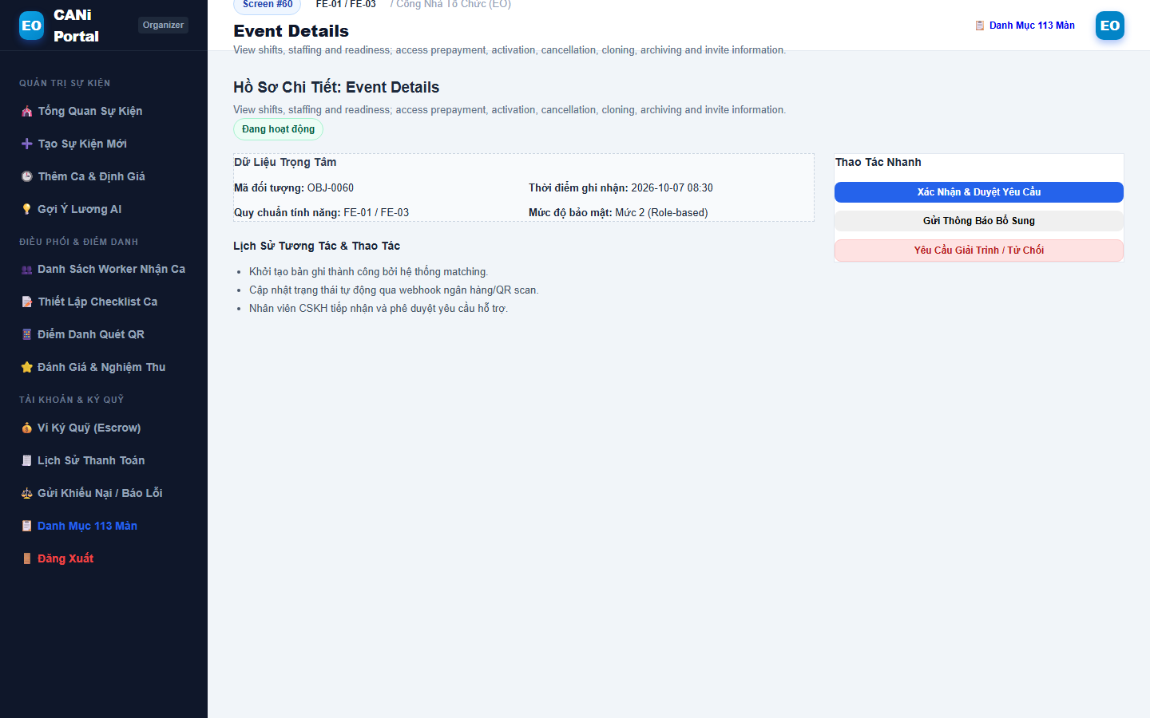
Figure 3.60: Wireframe Mockup of Screen #60 (Event Details)
User Actions:
• User opens and reviews the Event Details interface.
• Interacts with available controls, search filters, and actionable buttons.
• Confirms action to commit changes to the backend API or navigate to related screens.
Field Description:
Field Name | Control / Type | Required | Description & Validation Rules
Event Details Identifier | Text / Display | Yes | Unique system reference code for record in FE-01 / FE-03.
Primary Action / Form Input | Interactive Input | Yes | Primary input or control configured for Event Details.
Filter / Status Indicator | Badge / Dropdown | No | Displays current operational state or filters results.
Confirmation Action | Action Button | Yes | Executes primary business operation for FE-01 / FE-03.

2.12 SCR-61: Edit Event
Mapped Use Cases: UC-13
Modify event details for events not started
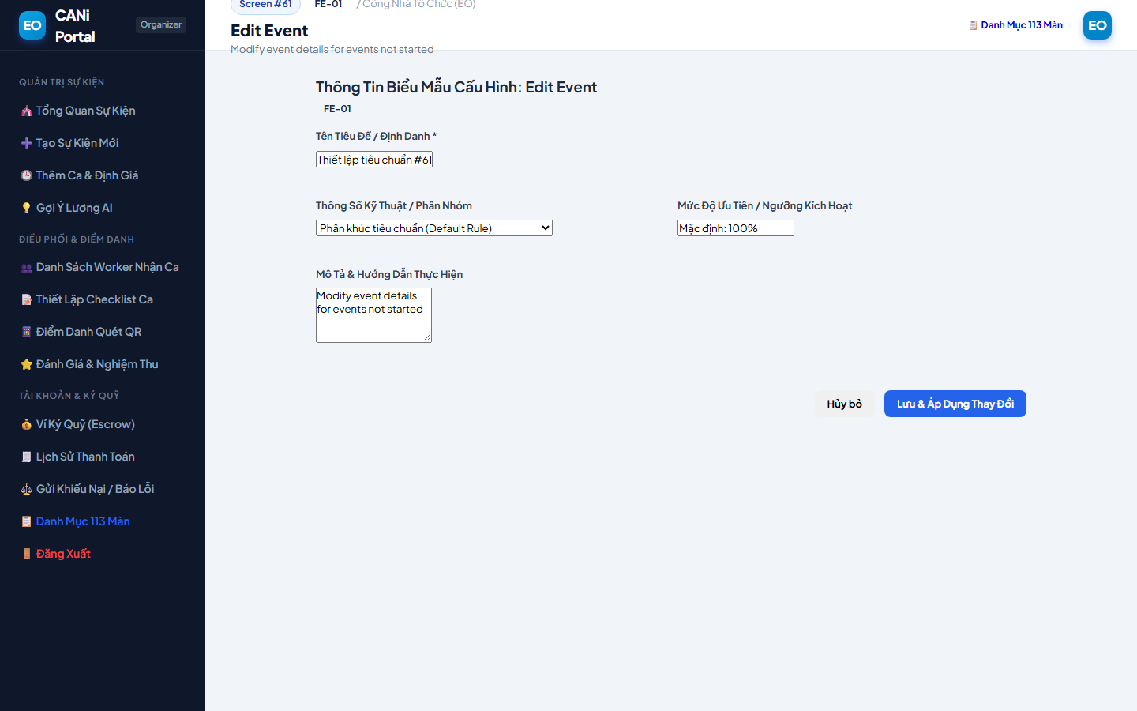
Figure 3.61: Wireframe Mockup of Screen #61 (Edit Event)
User Actions:
• User opens and reviews the Edit Event interface.
• Interacts with available controls, search filters, and actionable buttons.
• Confirms action to commit changes to the backend API or navigate to related screens.
Field Description:
Field Name | Control / Type | Required | Description & Validation Rules
Edit Event Identifier | Text / Display | Yes | Unique system reference code for record in FE-01.
Primary Action / Form Input | Interactive Input | Yes | Primary input or control configured for Edit Event.
Filter / Status Indicator | Badge / Dropdown | No | Displays current operational state or filters results.
Confirmation Action | Action Button | Yes | Executes primary business operation for FE-01.

2.13 SCR-62: Create Shift
Mapped Use Cases: UC-14, UC-78
Create a single shift or use bulk creation with time, role, skills, headcount, hourly wage and allowances.
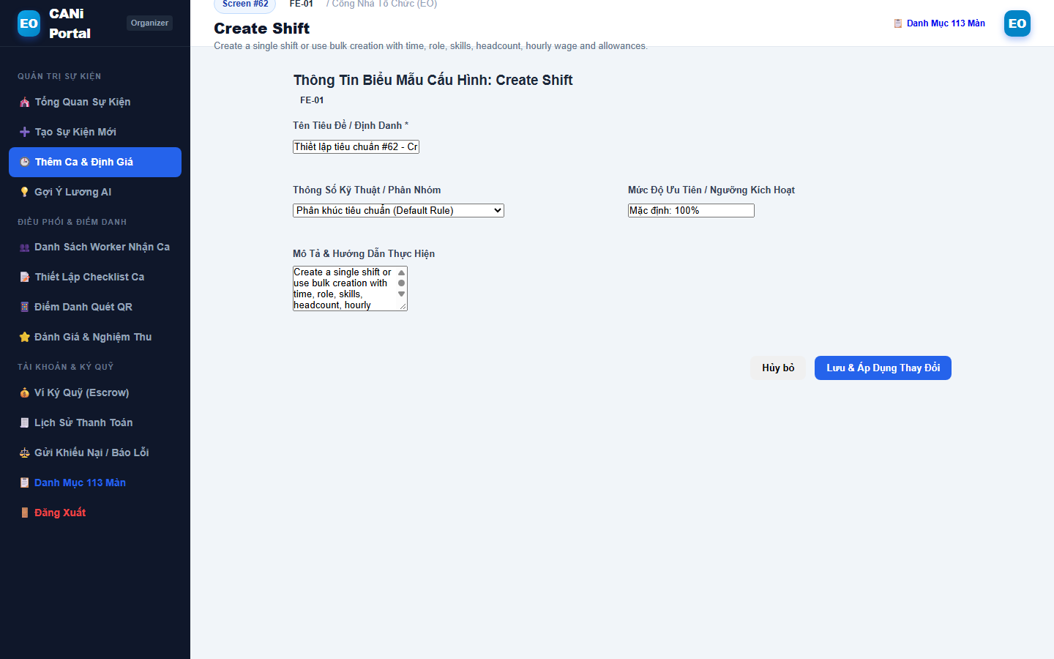
Figure 3.62: Wireframe Mockup of Screen #62 (Create Shift)
User Actions:
• User initiates creation workflow for Create Shift.
• Fills in all mandatory fields, configuration settings, and requirements.
• Reviews preview and submits to commit new record to the database.
Field Description:
Field Name | Control / Type | Required | Description & Validation Rules
Create Shift Identifier | Text / Display | Yes | Unique system reference code for record in FE-01.
Primary Action / Form Input | Interactive Input | Yes | Primary input or control configured for Create Shift.
Filter / Status Indicator | Badge / Dropdown | No | Displays current operational state or filters results.
Confirmation Action | Action Button | Yes | Executes primary business operation for FE-01.

2.14 SCR-63: Edit Shift
Mapped Use Cases: UC-15
Modify shift details for shifts not started
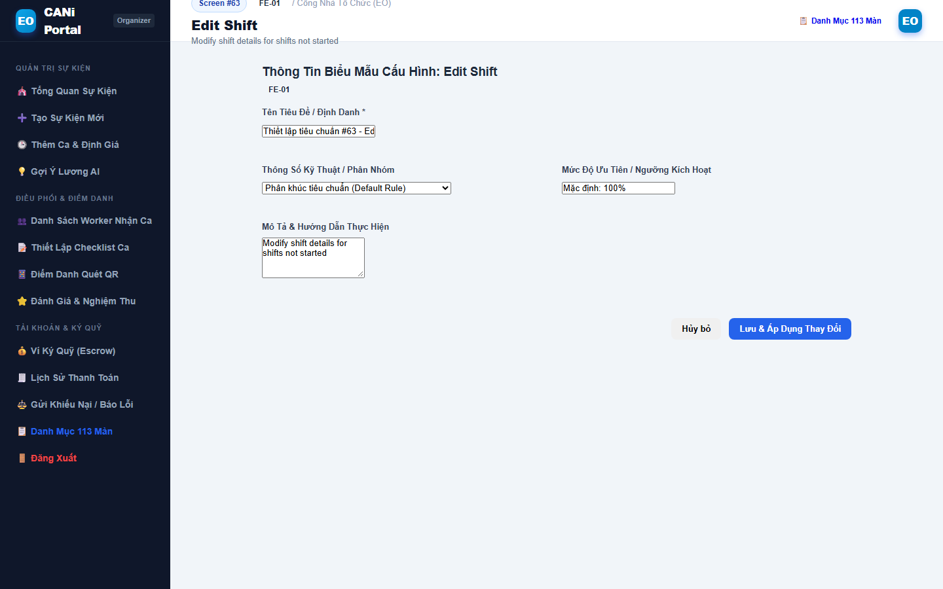
Figure 3.63: Wireframe Mockup of Screen #63 (Edit Shift)
User Actions:
• User opens and reviews the Edit Shift interface.
• Interacts with available controls, search filters, and actionable buttons.
• Confirms action to commit changes to the backend API or navigate to related screens.
Field Description:
Field Name | Control / Type | Required | Description & Validation Rules
Edit Shift Identifier | Text / Display | Yes | Unique system reference code for record in FE-01.
Primary Action / Form Input | Interactive Input | Yes | Primary input or control configured for Edit Shift.
Filter / Status Indicator | Badge / Dropdown | No | Displays current operational state or filters results.
Confirmation Action | Action Button | Yes | Executes primary business operation for FE-01.

2.15 SCR-64: Shift Details
Mapped Use Cases: UC-16
View shift requirements, staffing and readiness; access assigned workers, attendance, checklist and cancellation actions.
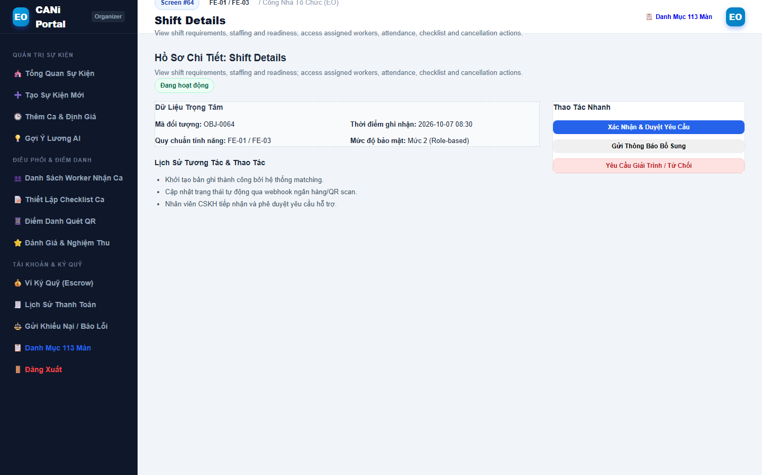
Figure 3.64: Wireframe Mockup of Screen #64 (Shift Details)
User Actions:
• User opens and reviews the Shift Details interface.
• Interacts with available controls, search filters, and actionable buttons.
• Confirms action to commit changes to the backend API or navigate to related screens.
Field Description:
Field Name | Control / Type | Required | Description & Validation Rules
Shift Details Identifier | Text / Display | Yes | Unique system reference code for record in FE-01 / FE-03.
Primary Action / Form Input | Interactive Input | Yes | Primary input or control configured for Shift Details.
Filter / Status Indicator | Badge / Dropdown | No | Displays current operational state or filters results.
Confirmation Action | Action Button | Yes | Executes primary business operation for FE-01 / FE-03.

2.16 SCR-65: Wage Recommendation
Mapped Use Cases: UC-78, UC-87
View a suggested hourly wage and set the final shift wage.
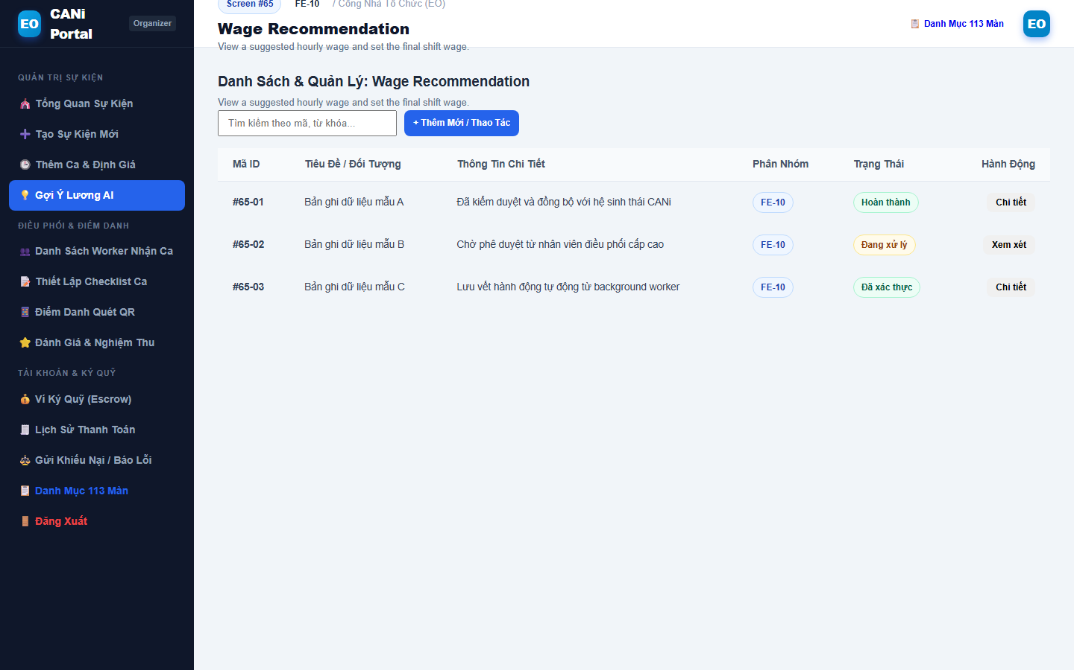
Figure 3.65: Wireframe Mockup of Screen #65 (Wage Recommendation)
User Actions:
• User opens and reviews the Wage Recommendation interface.
• Interacts with available controls, search filters, and actionable buttons.
• Confirms action to commit changes to the backend API or navigate to related screens.
Field Description:
Field Name | Control / Type | Required | Description & Validation Rules
Wage Recommendation Identifier | Text / Display | Yes | Unique system reference code for record in FE-10.
Primary Action / Form Input | Interactive Input | Yes | Primary input or control configured for Wage Recommendation.
Filter / Status Indicator | Badge / Dropdown | No | Displays current operational state or filters results.
Confirmation Action | Action Button | Yes | Executes primary business operation for FE-10.

2.17 SCR-66: Create Job Checklist
Mapped Use Cases: UC-40
Create required checklist for shift
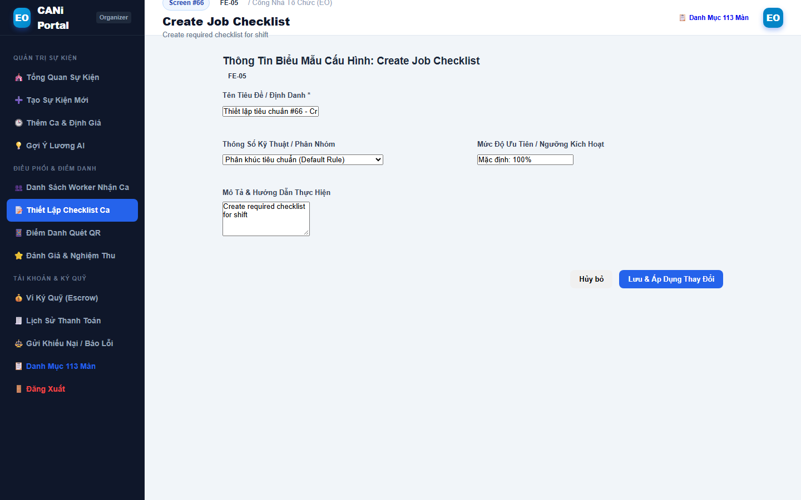
Figure 3.66: Wireframe Mockup of Screen #66 (Create Job Checklist)
User Actions:
• User initiates creation workflow for Create Job Checklist.
• Fills in all mandatory fields, configuration settings, and requirements.
• Reviews preview and submits to commit new record to the database.
Field Description:
Field Name | Control / Type | Required | Description & Validation Rules
Create Job Checklist Identifier | Text / Display | Yes | Unique system reference code for record in FE-05.
Primary Action / Form Input | Interactive Input | Yes | Primary input or control configured for Create Job Checklist.
Filter / Status Indicator | Badge / Dropdown | No | Displays current operational state or filters results.
Confirmation Action | Action Button | Yes | Executes primary business operation for FE-05.

2.18 SCR-67: Assigned Workers
Mapped Use Cases: UC-35, UC-47
View and filter assigned workers; access ratings, payment status, disputes and permitted assignment cancellation.
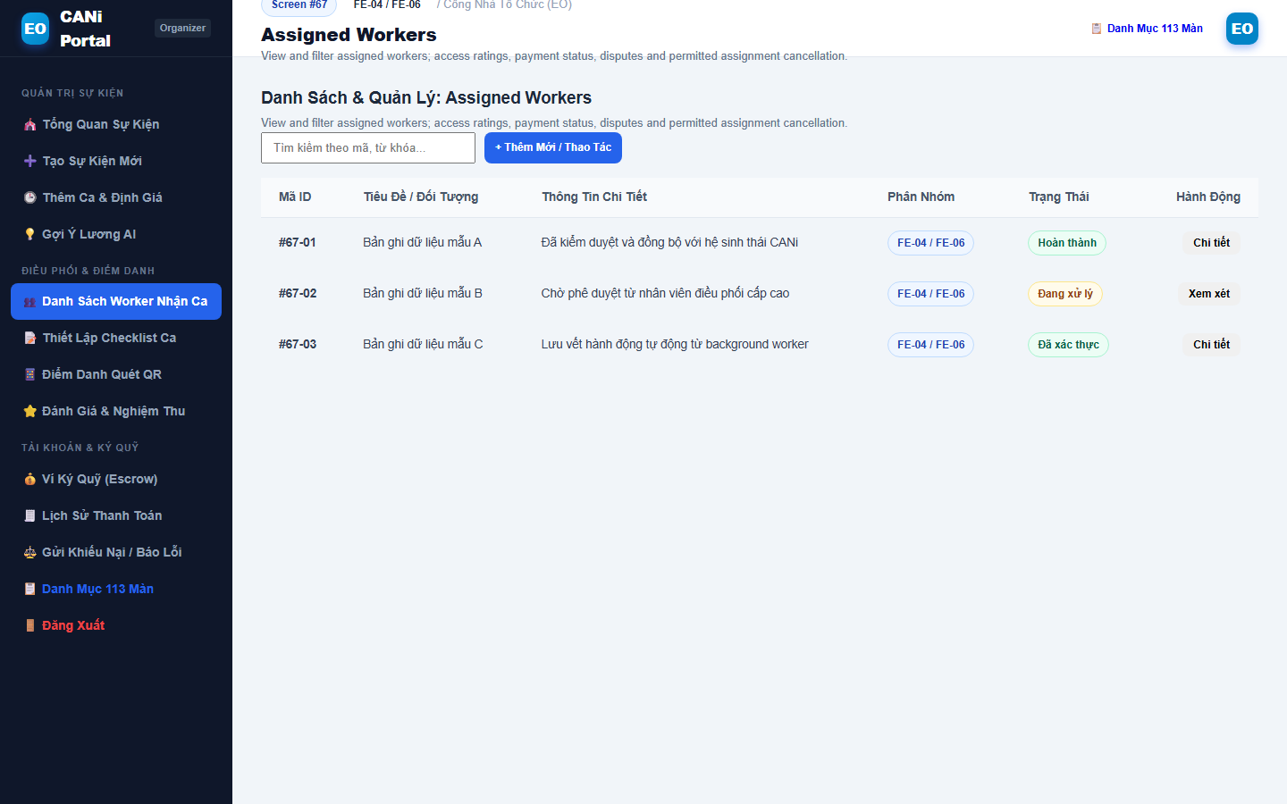
Figure 3.67: Wireframe Mockup of Screen #67 (Assigned Workers)
User Actions:
• User opens and reviews the Assigned Workers interface.
• Interacts with available controls, search filters, and actionable buttons.
• Confirms action to commit changes to the backend API or navigate to related screens.
Field Description:
Field Name | Control / Type | Required | Description & Validation Rules
Assigned Workers Identifier | Text / Display | Yes | Unique system reference code for record in FE-04 / FE-06.
Primary Action / Form Input | Interactive Input | Yes | Primary input or control configured for Assigned Workers.
Filter / Status Indicator | Badge / Dropdown | No | Displays current operational state or filters results.
Confirmation Action | Action Button | Yes | Executes primary business operation for FE-04 / FE-06.

2.19 SCR-68: View Worker Ratings
Mapped Use Cases: UC-65
View worker ratings and reviews
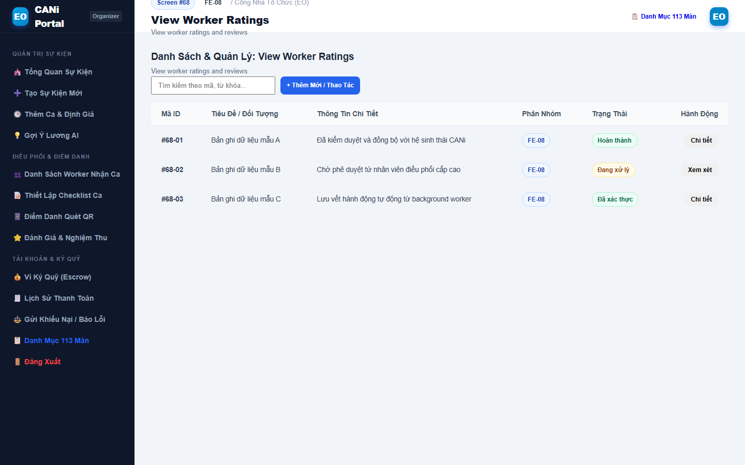
Figure 3.68: Wireframe Mockup of Screen #68 (View Worker Ratings)
User Actions:
• User opens and reviews the View Worker Ratings interface.
• Interacts with available controls, search filters, and actionable buttons.
• Confirms action to commit changes to the backend API or navigate to related screens.
Field Description:
Field Name | Control / Type | Required | Description & Validation Rules
View Worker Ratings Identifier | Text / Display | Yes | Unique system reference code for record in FE-08.
Primary Action / Form Input | Interactive Input | Yes | Primary input or control configured for View Worker Ratings.
Filter / Status Indicator | Badge / Dropdown | No | Displays current operational state or filters results.
Confirmation Action | Action Button | Yes | Executes primary business operation for FE-08.

2.20 SCR-69: Attendance Management
Mapped Use Cases: UC-41, UC-42
Display attendance QR codes, review attendance and checklist evidence, confirm completion, report incomplete work and review early checkout.
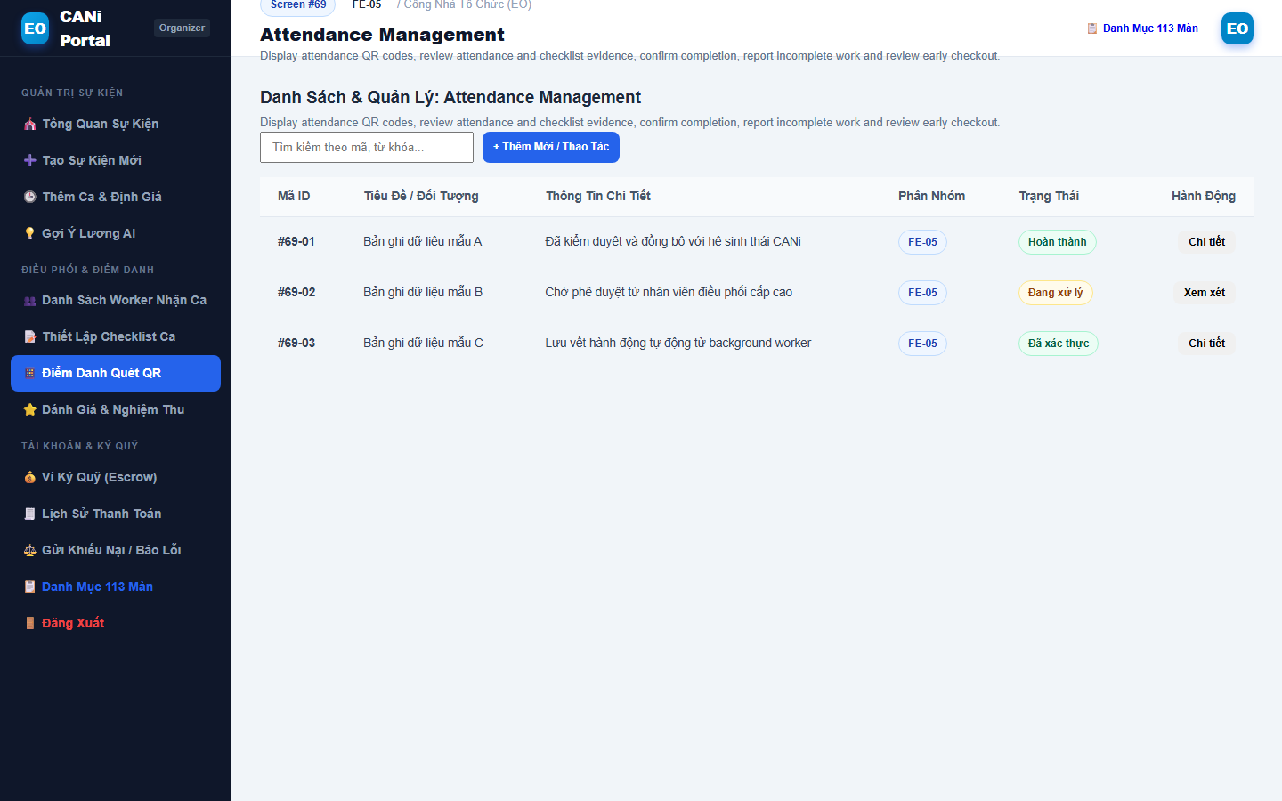
Figure 3.69: Wireframe Mockup of Screen #69 (Attendance Management)
User Actions:
• User opens and reviews the Attendance Management interface.
• Interacts with available controls, search filters, and actionable buttons.
• Confirms action to commit changes to the backend API or navigate to related screens.
Field Description:
Field Name | Control / Type | Required | Description & Validation Rules
Attendance Management Identifier | Text / Display | Yes | Unique system reference code for record in FE-05.
Primary Action / Form Input | Interactive Input | Yes | Primary input or control configured for Attendance Management.
Filter / Status Indicator | Badge / Dropdown | No | Displays current operational state or filters results.
Confirmation Action | Action Button | Yes | Executes primary business operation for FE-05.

2.21 SCR-70: Rate Worker
Mapped Use Cases: UC-64
Rate worker after shift completion
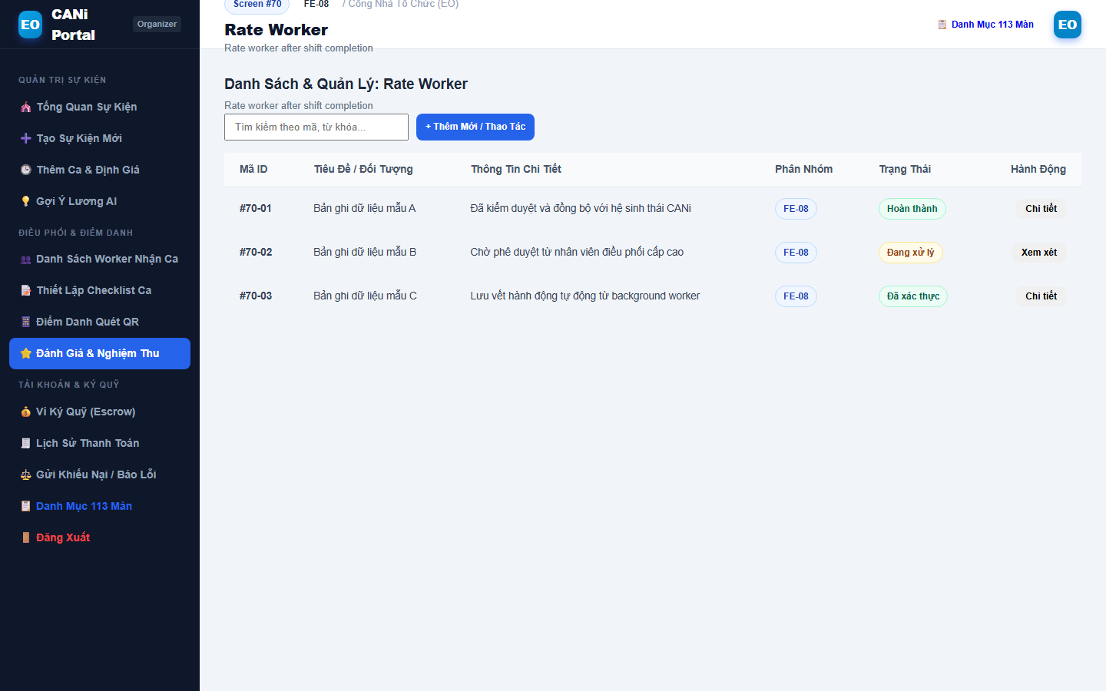
Figure 3.70: Wireframe Mockup of Screen #70 (Rate Worker)
User Actions:
• User opens and reviews the Rate Worker interface.
• Interacts with available controls, search filters, and actionable buttons.
• Confirms action to commit changes to the backend API or navigate to related screens.
Field Description:
Field Name | Control / Type | Required | Description & Validation Rules
Rate Worker Identifier | Text / Display | Yes | Unique system reference code for record in FE-08.
Primary Action / Form Input | Interactive Input | Yes | Primary input or control configured for Rate Worker.
Filter / Status Indicator | Badge / Dropdown | No | Displays current operational state or filters results.
Confirmation Action | Action Button | Yes | Executes primary business operation for FE-08.

2.22 SCR-71: Submit Dispute
Mapped Use Cases: UC-69
Submit a dispute concerning an assignment or Worker, with a description and supporting evidence.
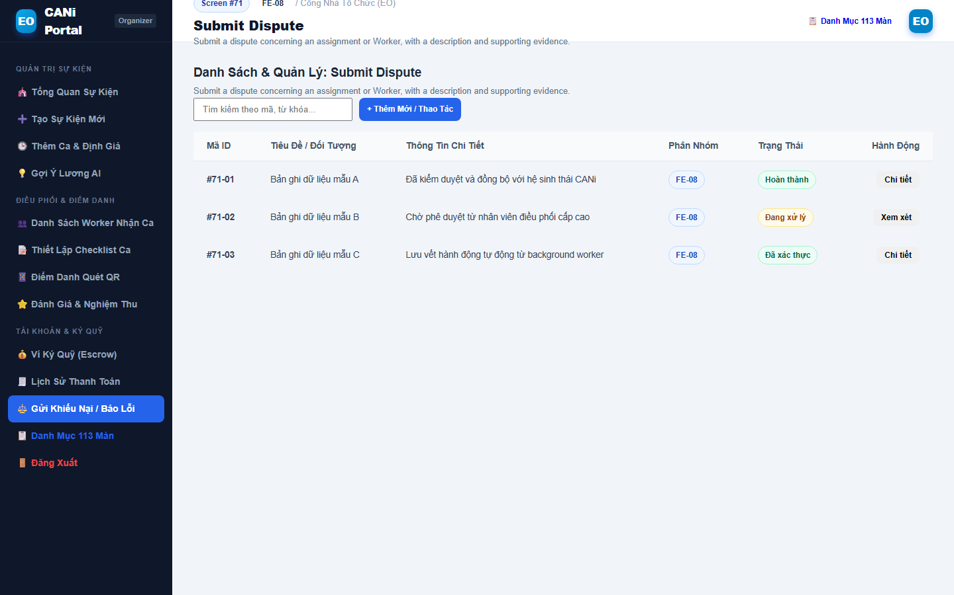
Figure 3.71: Wireframe Mockup of Screen #71 (Submit Dispute)
User Actions:
• User opens and reviews the Submit Dispute interface.
• Interacts with available controls, search filters, and actionable buttons.
• Confirms action to commit changes to the backend API or navigate to related screens.
Field Description:
Field Name | Control / Type | Required | Description & Validation Rules
Submit Dispute Identifier | Text / Display | Yes | Unique system reference code for record in FE-08.
Primary Action / Form Input | Interactive Input | Yes | Primary input or control configured for Submit Dispute.
Filter / Status Indicator | Badge / Dropdown | No | Displays current operational state or filters results.
Confirmation Action | Action Button | Yes | Executes primary business operation for FE-08.

2.23 SCR-72: Dispute Details (EO)
Mapped Use Cases: UC-71
View an EO-related dispute, evidence, handling status and resolution, including disputes submitted by either party.
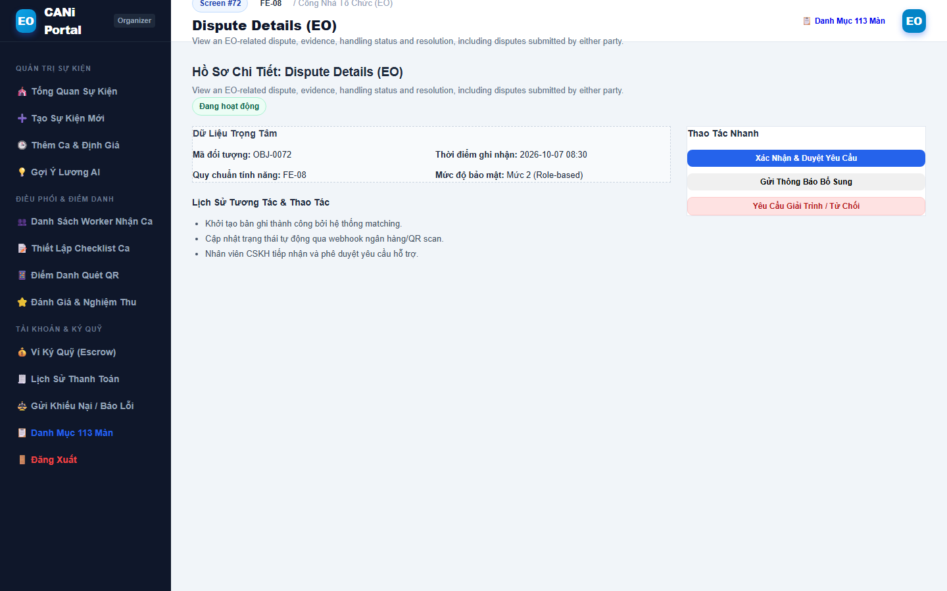
Figure 3.72: Wireframe Mockup of Screen #72 (Dispute Details (EO))
User Actions:
• User opens and reviews the Dispute Details (EO) interface.
• Interacts with available controls, search filters, and actionable buttons.
• Confirms action to commit changes to the backend API or navigate to related screens.
Field Description:
Field Name | Control / Type | Required | Description & Validation Rules
Dispute Details (EO) Identifier | Text / Display | Yes | Unique system reference code for record in FE-08.
Primary Action / Form Input | Interactive Input | Yes | Primary input or control configured for Dispute Details (EO).
Filter / Status Indicator | Badge / Dropdown | No | Displays current operational state or filters results.
Confirmation Action | Action Button | Yes | Executes primary business operation for FE-08.

2.24 SCR-73: Dispute Response
Mapped Use Cases: UC-72
Provide a response and supporting evidence for a dispute involving the EO.
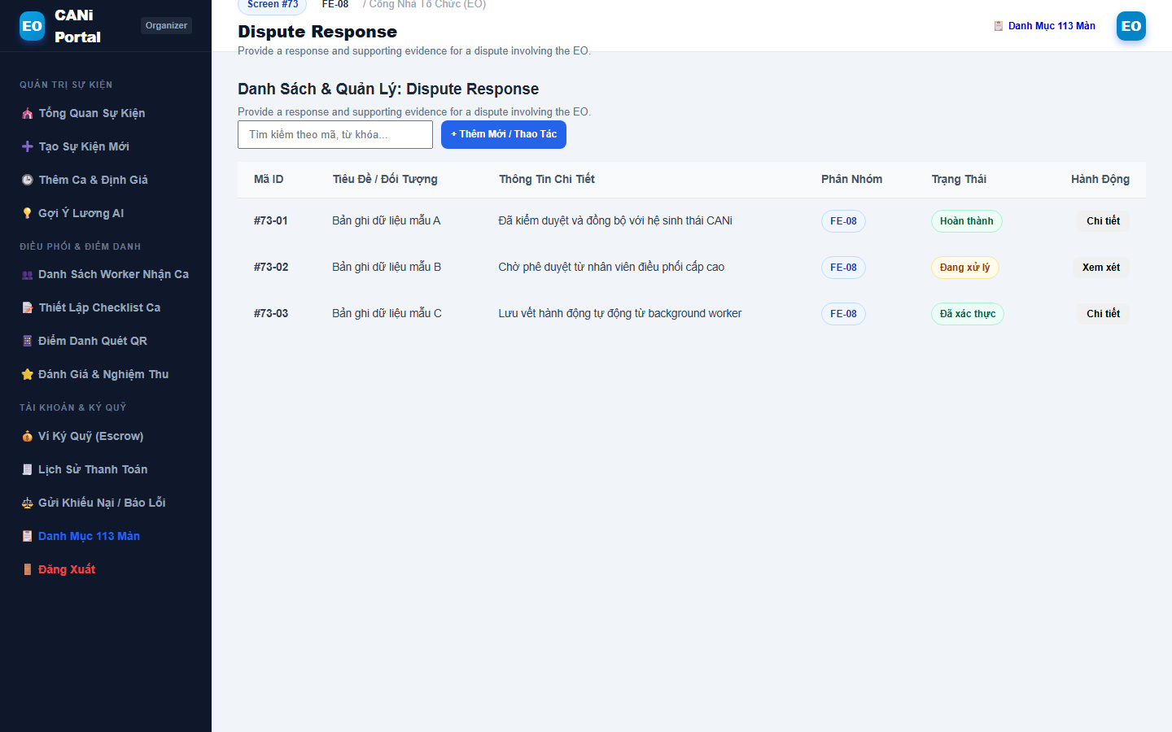
Figure 3.73: Wireframe Mockup of Screen #73 (Dispute Response)
User Actions:
• User opens and reviews the Dispute Response interface.
• Interacts with available controls, search filters, and actionable buttons.
• Confirms action to commit changes to the backend API or navigate to related screens.
Field Description:
Field Name | Control / Type | Required | Description & Validation Rules
Dispute Response Identifier | Text / Display | Yes | Unique system reference code for record in FE-08.
Primary Action / Form Input | Interactive Input | Yes | Primary input or control configured for Dispute Response.
Filter / Status Indicator | Badge / Dropdown | No | Displays current operational state or filters results.
Confirmation Action | Action Button | Yes | Executes primary business operation for FE-08.

2.25 SCR-74: EO Payment Account
Mapped Use Cases: UC-49
View EO payment records and available-balance information; initiate demo prepayment to Platform Escrow for an event.
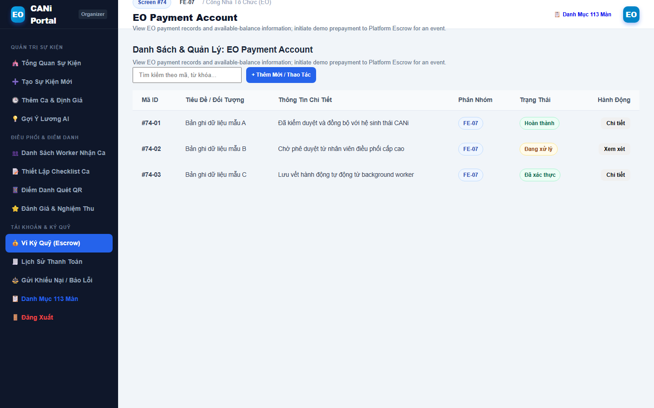
Figure 3.74: Wireframe Mockup of Screen #74 (EO Payment Account)
User Actions:
• User opens and reviews the EO Payment Account interface.
• Interacts with available controls, search filters, and actionable buttons.
• Confirms action to commit changes to the backend API or navigate to related screens.
Field Description:
Field Name | Control / Type | Required | Description & Validation Rules
EO Payment Account Identifier | Text / Display | Yes | Unique system reference code for record in FE-07.
Primary Action / Form Input | Interactive Input | Yes | Primary input or control configured for EO Payment Account.
Filter / Status Indicator | Badge / Dropdown | No | Displays current operational state or filters results.
Confirmation Action | Action Button | Yes | Executes primary business operation for FE-07.

2.26 SCR-75: Payment History
Mapped Use Cases: UC-50
View EO financial history, including transfers to Platform Escrow, Worker payments, fees and refunds.
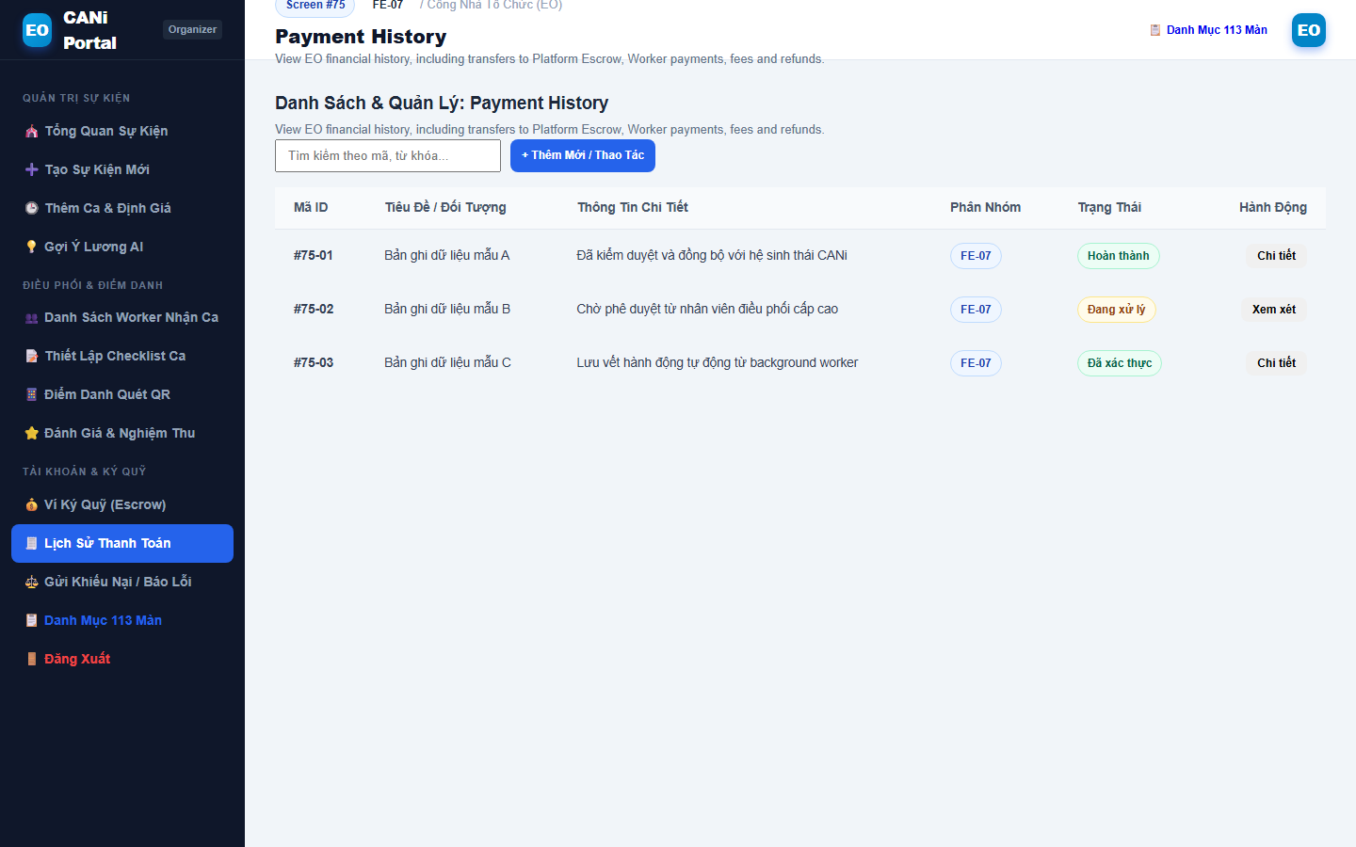
Figure 3.75: Wireframe Mockup of Screen #75 (Payment History)
User Actions:
• User opens and reviews the Payment History interface.
• Interacts with available controls, search filters, and actionable buttons.
• Confirms action to commit changes to the backend API or navigate to related screens.
Field Description:
Field Name | Control / Type | Required | Description & Validation Rules
Payment History Identifier | Text / Display | Yes | Unique system reference code for record in FE-07.
Primary Action / Form Input | Interactive Input | Yes | Primary input or control configured for Payment History.
Filter / Status Indicator | Badge / Dropdown | No | Displays current operational state or filters results.
Confirmation Action | Action Button | Yes | Executes primary business operation for FE-07.

2.27 SCR-76: Payment Status
Mapped Use Cases: UC-51
View Platform-to-Worker payment status for a selected shift assignment, distinct from EO prepayment for the event.
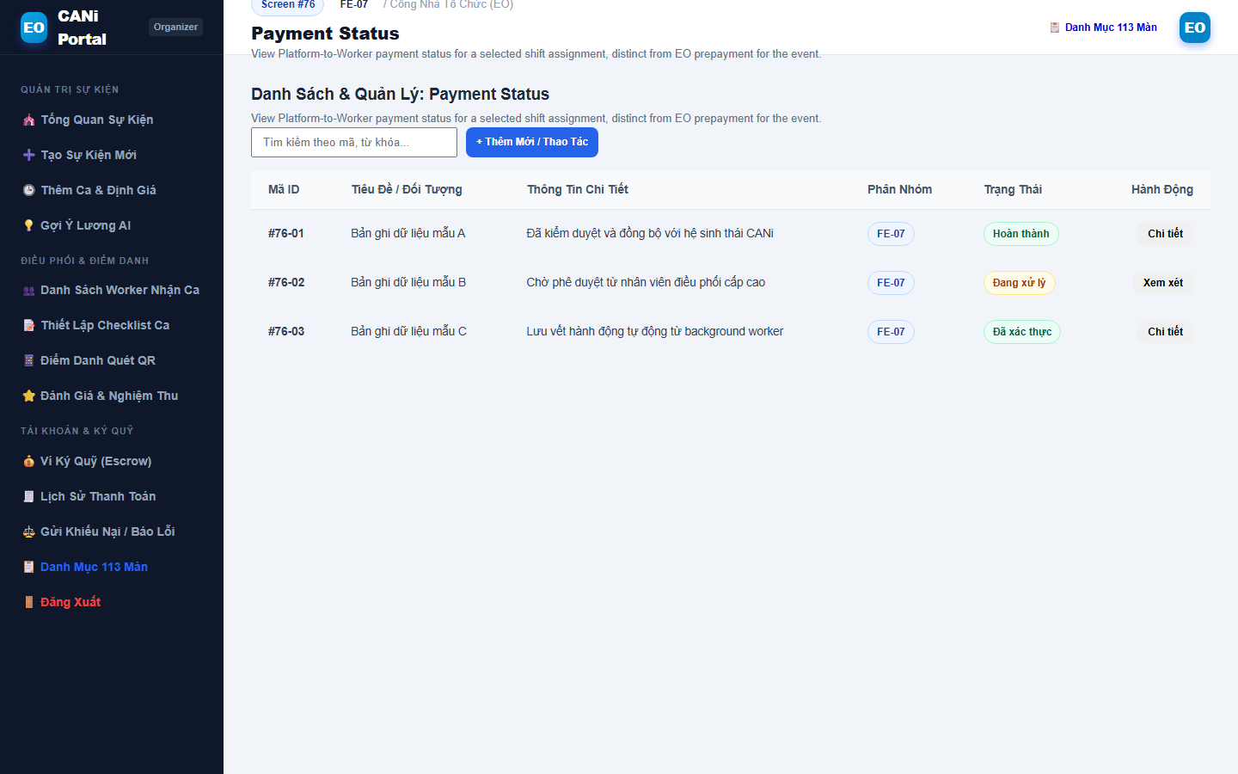
Figure 3.76: Wireframe Mockup of Screen #76 (Payment Status)
User Actions:
• User opens and reviews the Payment Status interface.
• Interacts with available controls, search filters, and actionable buttons.
• Confirms action to commit changes to the backend API or navigate to related screens.
Field Description:
Field Name | Control / Type | Required | Description & Validation Rules
Payment Status Identifier | Text / Display | Yes | Unique system reference code for record in FE-07.
Primary Action / Form Input | Interactive Input | Yes | Primary input or control configured for Payment Status.
Filter / Status Indicator | Badge / Dropdown | No | Displays current operational state or filters results.
Confirmation Action | Action Button | Yes | Executes primary business operation for FE-07.

3. CANi Partner Mobile App Screens (Worker App)
This subsection details the functional specifications for the 37 mobile partner screens comprising the CANi Worker application.

3.1 SCR-77: User Login
Mapped Use Cases: UC-02
Authenticate a Worker and open Worker Home.
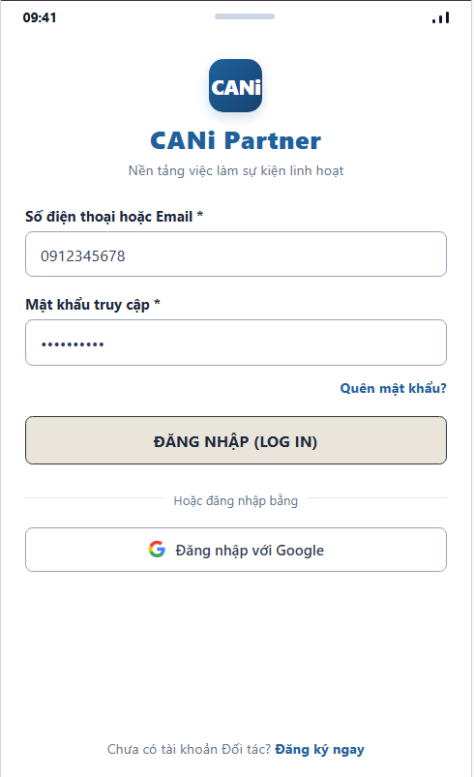
Figure 3.77: Wireframe Mockup of Screen #77 (User Login)
User Actions:
• Worker enters registered phone number or email address and password.
• Clicks 'Đăng Nhập' button to authenticate via JWT, or optionally clicks 'Đăng nhập với Google' for OAuth2 SSO.
• System validates credentials, issues authentication token, and redirects worker to Worker Home dashboard upon successful authentication.
Field Description:
Field Name | Control / Type | Required | Description & Validation Rules
Phone / Email | Text Input | Yes | Valid registered mobile phone number or email. Validates non-empty and standard syntax.
Password | Password Input | Yes | Masked input. Minimum 8 characters. Validates against hashed database secret.
Forgot Password Link | Hyperlink / Text | No | Redirects worker to Password Reset screen (SCR-80).
Submit Button | Action Button | Yes | Triggers JWT authentication endpoint; redirects to Worker Home on HTTP 200.
Google Sign-In Button | OAuth Button | No | Initiates Google OAuth2 authentication flow.
Register Link | Hyperlink / Text | No | Navigates unregistered user to User Register screen (SCR-78).

3.2 SCR-78: User Register
Mapped Use Cases: UC-01
Register a Worker account with email and password and accept the required terms.
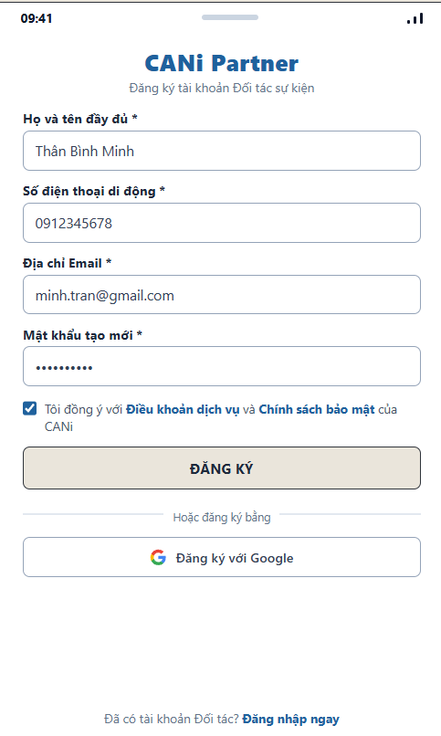
Figure 3.78: Wireframe Mockup of Screen #78 (User Register)
User Actions:
• Worker enters full legal name, active mobile phone number, email address, and new password.
• Checks the mandatory agreement to Platform Terms of Service and Privacy Policy.
• Clicks 'ĐĂNG KÝ' button to submit registration and proceed to email OTP verification (SCR-79), or optionally clicks 'Đăng ký với Google' for Google OAuth2 registration.
• If already registered, clicks 'Đăng nhập ngay' hyperlink to return to User Login screen (SCR-77).
Field Description:
Field Name | Control / Type | Required | Description & Validation Rules
Full Name | Text Input | Yes | Worker's full legal name matching Citizen ID card. Validates non-empty string.
Phone Number | Text Input | Yes | Active Vietnamese mobile phone number (10 digits). Validates uniqueness and standard format.
Email Address | Text Input | Yes | Valid email address for OTP delivery and contracts. Validates RFC 5322 syntax and uniqueness.
Password | Password Input | Yes | Masked input. Minimum 8 characters, containing letters and numbers.
Terms & Policy Checkbox | Checkbox | Yes | Mandatory acceptance of Platform Terms of Service and Privacy Policy before submission.
Submit Button | Action Button | Yes | Validates form inputs and initiates email OTP dispatch; navigates to Screen SCR-79.
Google Sign-Up Button | OAuth Button | No | Initiates Google OAuth2 registration and auto-fills profile details.
Login Link | Hyperlink / Text | No | Redirects user to User Login screen (SCR-77).

3.3 SCR-79: Email Verification
Mapped Use Cases: UC-01
Verify the Worker registration email using an OTP.
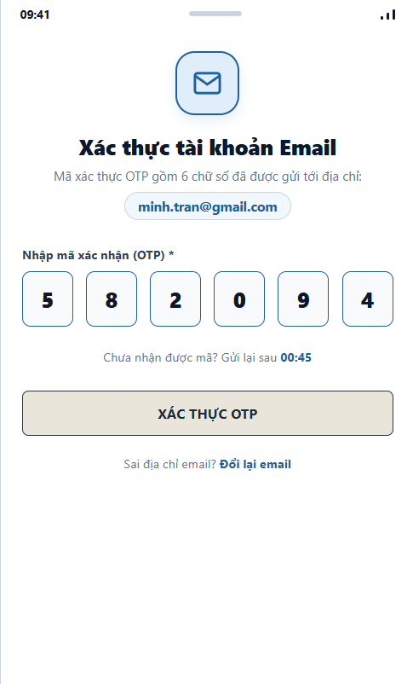
Figure 3.79: Wireframe Mockup of Screen #79 (Email Verification)
User Actions:
• Worker receives a 6-digit verification code in the registered email inbox.
• Enters the 6 numerical OTP digits into the input boxes.
• Clicks 'XÁC THỰC OTP' button to complete email confirmation and activate the Worker account.
• If code is not received or expired, waits for the 60-second cooldown timer and clicks 'Gửi lại mã' to request a new OTP.
• If email was entered incorrectly, clicks 'Đổi lại email' to return to User Register screen (SCR-78).
Field Description:
Field Name | Control / Type | Required | Description & Validation Rules
Recipient Email | Display Text | No | Displays the target email address where the verification OTP was dispatched.
OTP Code (Digit 1-6) | PIN Inputs | Yes | 6 individual numeric inputs for OTP digits. Validates exactly 6 digits (0-9).
Resend Timer | Timer / Link | No | 60-second cooldown timer before enabling resend OTP request link.
Submit Button | Action Button | Yes | Submits entered OTP to backend auth service; redirects to Worker Home on success.
Change Email Link | Hyperlink / Text | No | Navigates user back to User Register screen (SCR-78) to modify email.

3.4 SCR-80: Password Reset
Mapped Use Cases: UC-04
Request a password reset link using the registered email address.
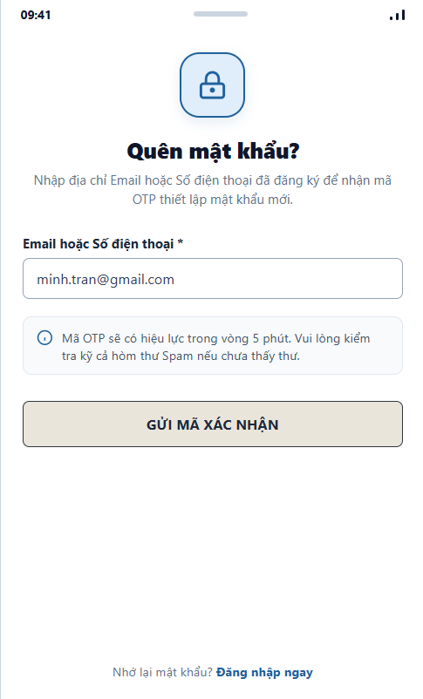
Figure 3.80: Wireframe Mockup of Screen #80 (Password Reset)
User Actions:
• Worker navigates to Password Reset screen by clicking 'Quên mật khẩu?' on User Login screen (SCR-77).
• Enters registered email address or mobile phone number associated with the Worker account.
• Clicks 'GỬI MÃ XÁC NHẬN' button to trigger OTP generation and dispatch.
• System verifies account existence, dispatches reset OTP code to registered email, and redirects worker to Set New Password screen (SCR-81).
• If worker remembers password, clicks 'Đăng nhập ngay' hyperlink to return to User Login screen (SCR-77).
Field Description:
Field Name | Control / Type | Required | Description & Validation Rules
Email / Phone Number | Text Input | Yes | Registered mobile phone number or email. Validates non-empty string and standard syntax.
Security Notice | Information Card | No | Displays security guidance regarding 5-minute OTP validity and spam folder check.
Submit Button | Action Button | Yes | Validates account existence and dispatches reset OTP; navigates to Screen SCR-81.
Back to Login Link | Hyperlink / Text | No | Redirects user back to User Login screen (SCR-77).

3.5 SCR-81: Set New Password
Mapped Use Cases: UC-04
Set a new password using a valid password reset token.
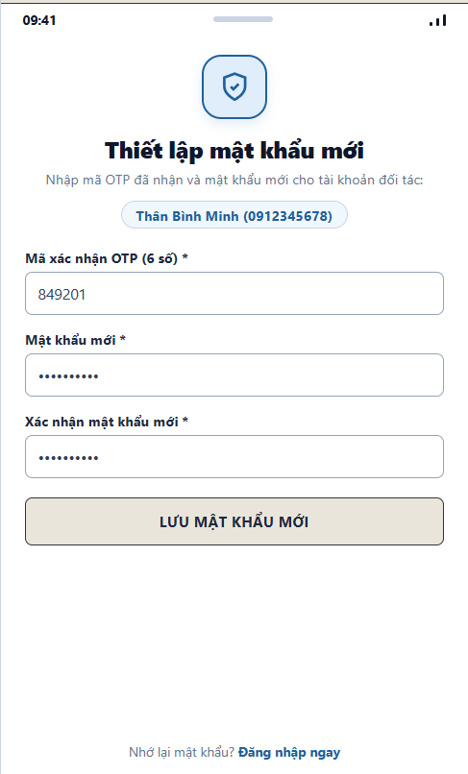
Figure 3.81: Wireframe Mockup of Screen #81 (Set New Password)
User Actions:
• Worker receives password reset OTP via registered email and navigates to Set New Password screen.
• Enters the 6-digit OTP verification code.
• Enters a new password (minimum 8 characters) and re-enters it into the confirmation field.
• Clicks 'LƯU MẬT KHẨU MỚI' button to submit new credentials.
• System validates OTP code and password matching, updates password hash in database, invalidates existing sessions, and redirects worker to User Login screen (SCR-77).
• Alternatively, clicks 'Đăng nhập ngay' to return to User Login screen (SCR-77).
Field Description:
Field Name | Control / Type | Required | Description & Validation Rules
Worker Account | Display Text | No | Displays worker identity (Thân Bình Minh - 0912345678) undergoing password reset.
OTP Verification Code | Text Input | Yes | 6-digit numeric OTP code dispatched via email. Validates exactly 6 digits.
New Password | Password Input | Yes | Masked input. Minimum 8 characters, containing uppercase, lowercase, and numbers.
Confirm New Password | Password Input | Yes | Masked input. Must match New Password exactly.
Submit Button | Action Button | Yes | Submits reset payload, updates password hash, and redirects to SCR-77 on HTTP 200.
Back to Login Link | Hyperlink / Text | No | Redirects user to User Login screen (SCR-77).

3.6 SCR-82: Password Change
Mapped Use Cases: UC-04, UC-06
Change the current password of the signed-in account.
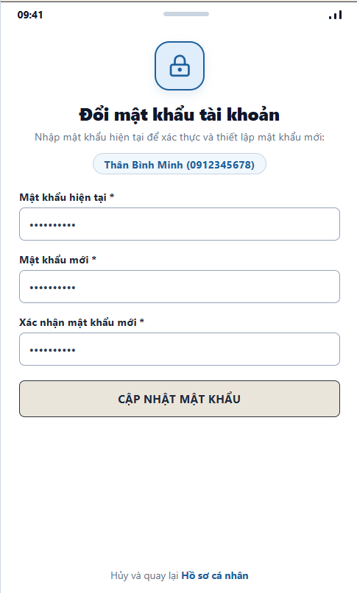
Figure 3.82: Wireframe Mockup of Screen #82 (Password Change)
User Actions:
• Authenticated Worker navigates to Password Change screen from Profile settings (SCR-85).
• Enters current password to verify account ownership.
• Enters new password (minimum 8 characters) and re-enters it into the confirmation field.
• Clicks 'CẬP NHẬT MẬT KHẨU' button to submit password change request.
• System verifies current password against hashed database secret, validates that new password differs from current, updates password hash, and redirects worker back to Worker Profile (SCR-85).
• Alternatively, clicks 'Hồ sơ cá nhân' to cancel and return to Profile screen (SCR-85).
Field Description:
Field Name | Control / Type | Required | Description & Validation Rules
Worker Account | Display Text | No | Displays authenticated worker identity (Thân Bình Minh - 0912345678).
Current Password | Password Input | Yes | Masked input. Validates against stored database hash for account verification.
New Password | Password Input | Yes | Masked input. Minimum 8 characters. Must differ from current password.
Confirm New Password | Password Input | Yes | Masked input. Must match New Password exactly.
Submit Button | Action Button | Yes | Submits password change payload to backend; updates secret and navigates to SCR-85.
Cancel Link | Hyperlink / Text | No | Aborts change and navigates back to Worker Profile (SCR-85).

3.7 SCR-83: Worker Home
Mapped Use Cases: UC-08, UC-35, UC-40
View work summaries and navigation options; switch online status to start or stop receiving new proposals.
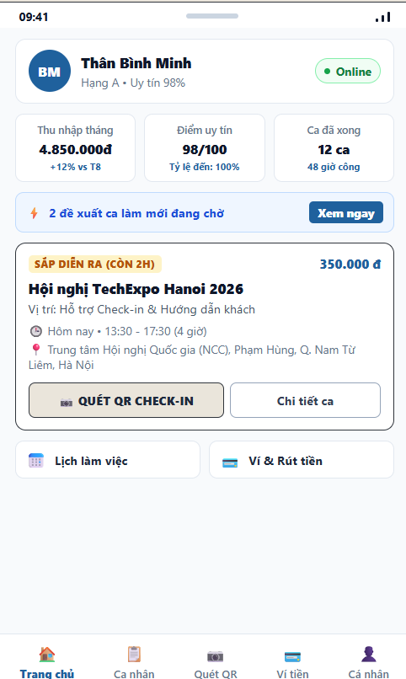
Figure 3.83: Wireframe Mockup of Screen #83 (Worker Home)
User Actions:
• Worker accesses Worker Home dashboard to review operational summary, earnings metrics, and work commitments.
• Checks or switches online availability status (Online/Offline) to receive or pause incoming event shift proposals.
• Clicks 'Xem ngay' on New Proposals Banner to review pending shift offers in Shift Proposals feed (SCR-90).
• Reviews upcoming shift card and clicks 'QUÉT QR CHECK-IN' to open QR Scanner (SCR-98) or 'Chi tiết ca' for Assignment Details (SCR-97).
• Uses quick navigation cards or persistent bottom navigation bar to switch between Home (SCR-83), Assignments (SCR-96), QR Scan (SCR-98), Wallet (SCR-103), and Profile (SCR-85).
• Clicks notification bell icon in top header to view Mobile Notifications Center (SCR-84).
Field Description:
Field Name | Control / Type | Required | Description & Validation Rules
Worker Profile Header | Profile Card | No | Displays worker avatar, name (Thân Bình Minh), tier level (Tier A), and reliability score.
Online Availability Status | Status Pill / Toggle | Yes | Indicates worker availability state (Online/Offline) for AI matching engine dispatch.
Monthly Earnings Metric | Metric Card | No | Displays cumulative earned income for the current calendar month (e.g., 4.850.000 đ).
Reliability Score Metric | Metric Card | No | Displays current reliability score (98/100) and on-time arrival rate (100%).
Completed Shifts Metric | Metric Card | No | Displays count of successfully completed shifts (12 shifts) and total billable hours (48h).
New Proposals Banner | Action Banner | No | Alerts worker of pending shift offers awaiting response; navigates to Screen SCR-90.
Upcoming Shift Card | Information Card | No | Summarizes next confirmed shift (event title, position, date/time, venue address, pay rate).
QR Check-In Button | Action Button | No | Direct primary button launching QR Scanner (SCR-98) for shift attendance verification.
Shift Details Button | Action Button | No | Secondary button opening Assignment Details screen (SCR-97).
Quick Shortcuts Grid | Grid Buttons | No | Quick navigation shortcuts to Availability Calendar (SCR-87) and Wallet & Withdrawal (SCR-103).
Bottom Navigation Bar | Persistent Tab Bar | Yes | 5-tab persistent bottom bar with active indicator on 'Trang chủ' (SCR-83).

3.8 SCR-84: Notifications
Mapped Use Cases: UC-07
View received notifications and open related screens within the signed-in user’s permissions.
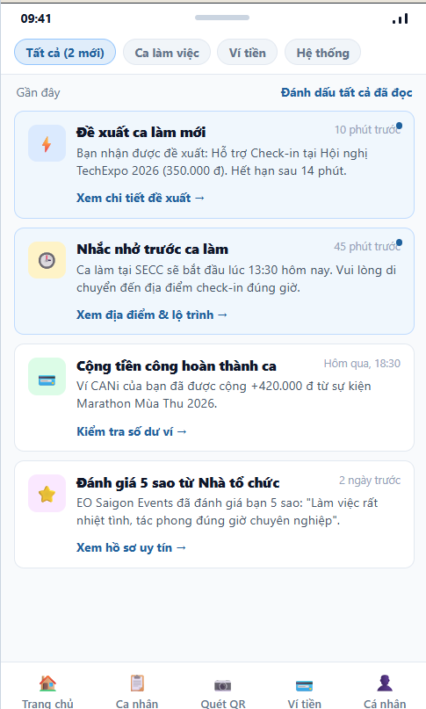
Figure 3.84: Wireframe Mockup of Screen #84 (Notifications)
User Actions:
• Worker accesses Mobile Notifications Center from top header bell icon on Worker Home (SCR-83).
• Views incoming notifications categorized by operational event (Shift Proposals, Shift Reminders, Wallet Credits, and EO Ratings).
• Clicks category filter tabs (Tất cả, Ca làm việc, Ví tiền, Hệ thống) to filter displayed notifications.
• Clicks directly on a notification card to navigate to its related operational screen (e.g., clicks proposal alert to open SCR-90, or payment alert to open SCR-103).
• Clicks 'Đánh dấu tất cả đã đọc' to bulk mark all unread notifications as read.
• Clicks '← Trang chủ' or bottom navigation bar to return to Worker Home (SCR-83).
Field Description:
Field Name | Control / Type | Required | Description & Validation Rules
Category Filter Tabs | Segmented Tabs | No | Filters notification list by type (All, Shifts, Wallet, System).
Notification Item Card | List Item Card | No | Displays category icon, alert title, message body, and relative timestamp.
Unread Indicator Dot | Status Indicator | No | Visual indicator distinguishing unread notifications from read items.
Deep-link Action | Hyperlink / Text | No | Direct link navigating to relevant target screen (SCR-90, SCR-97, SCR-103, SCR-94).
Mark All as Read Action | Text Button | No | Bulk action updating all unread notifications to read status.
Bottom Navigation Bar | Persistent Tab Bar | Yes | 5-tab persistent app navigation (Home, Assignments, QR Scan, Wallet, Profile).

3.9 SCR-85: Worker Profile
Mapped Use Cases: UC-05
View personal profile information
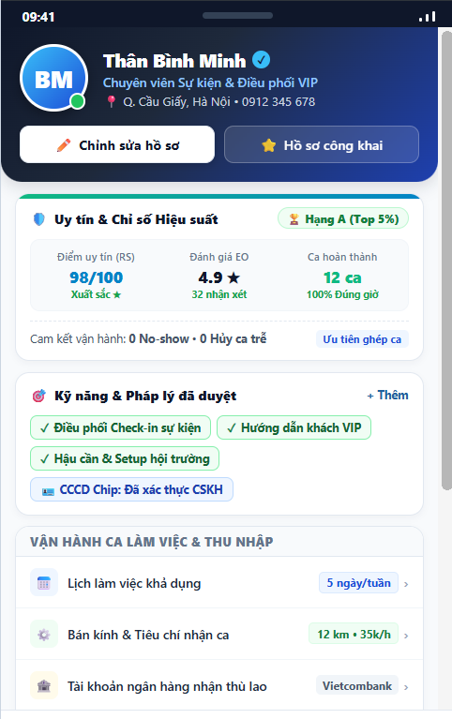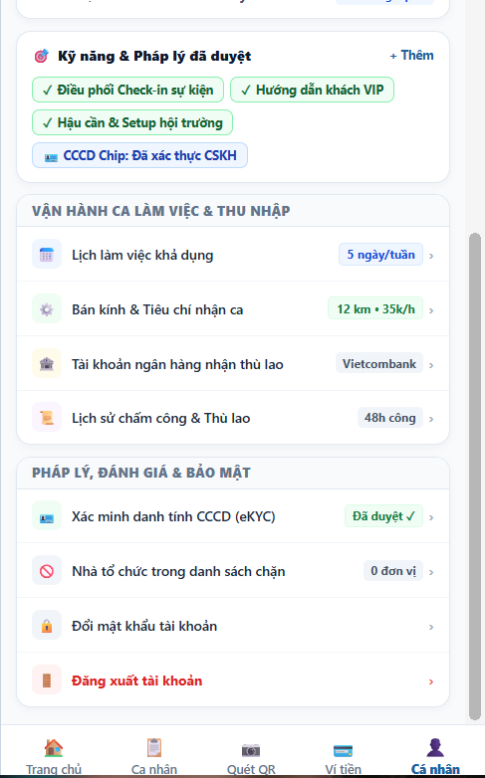
Figure 3.85: Wireframe Mockup of Screen #85 (Worker Profile)
User Actions:
• Worker accesses Worker Profile by clicking 'Cá nhân' tab on bottom navigation bar or from Worker Home (SCR-83).
• Reviews personal identity information, verified eKYC badge, and active event service skill tags.
• Reviews professional track record metrics including Reliability Score (98/100), EO Rating (4.9★), and completed shifts.
• Clicks 'CHỈNH SỬA HỒ SƠ' button to open Edit Profile & Skills screen (SCR-86).
• Selects account management menu items to configure eKYC (SCR-89), Availability Calendar (SCR-87), Bank Account (SCR-108), or Password Change (SCR-82).
• Clicks 'Đăng xuất tài khoản' to terminate authentication session and return to User Login screen (SCR-77).
Field Description:
Field Name | Control / Type | Required | Description & Validation Rules
Profile Hero Card | Hero Card | No | Displays worker avatar, legal name (Thân Bình Minh), contact info, and eKYC verified badge.
Edit Profile Button | Action Button | No | Primary button navigating to Edit Profile & Skills screen (SCR-86).
Reliability Metric | Metric Card / Link | No | Displays current reliability score (98/100, Tier A); links to Screen SCR-112.
Rating Metric | Metric Card / Link | No | Displays average rating (4.9★, 32 reviews); links to View EO Ratings (SCR-94).
Completed Shifts Metric | Metric Card | No | Displays total completed shifts count (12 shifts) and total billable hours (48h).
Personal Details Group | Information List | No | Displays date of birth, gender, primary working district, and active event skills.
Account Menu Navigation | List Menu | No | Navigation shortcuts to eKYC (SCR-89), Schedule (SCR-87), Bank (SCR-108), and Password (SCR-82).
Logout Action | Action Link | No | Ends current authenticated session and redirects to User Login screen (SCR-77).
Bottom Navigation Bar | Persistent Tab Bar | Yes | 5-tab persistent app navigation bar with active indicator on 'Cá nhân' (SCR-85).

3.10 SCR-86: Edit Profile
Mapped Use Cases: UC-06, UC-21,UC-22
Update personal profile information, skills and work experience.
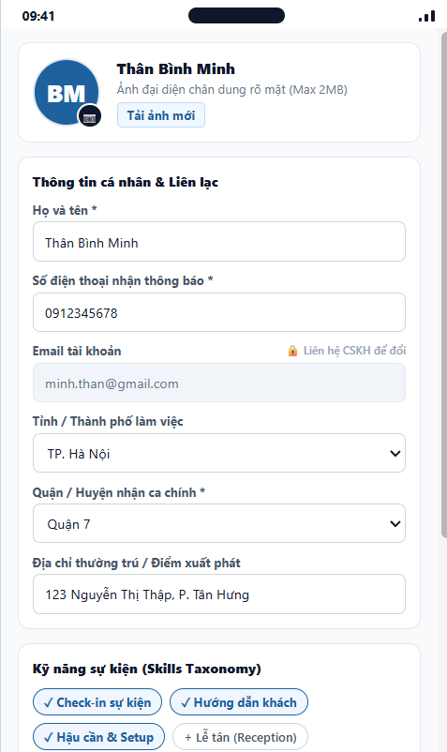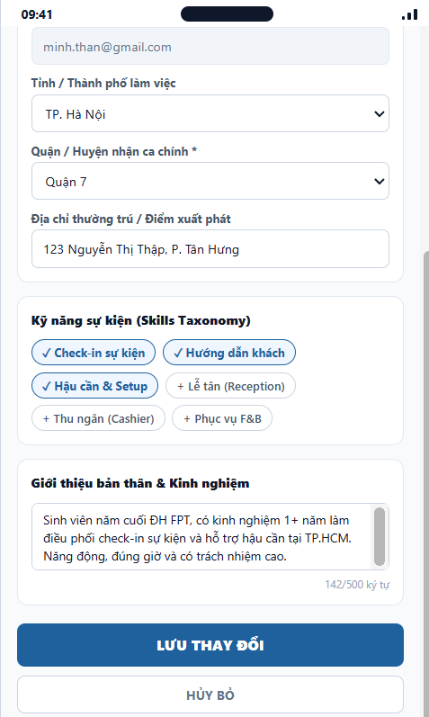

Figure 3.86: Wireframe Mockup of Screen #86 (Edit Profile)
User Actions:
• Worker opens Edit Profile from Worker Profile (SCR-85) to update contact details, dispatch location, skills, and summary.
• Clicks 'Tải ảnh mới' to upload a new portrait avatar photo (maximum file size 2MB, format JPEG/PNG).
• Modifies full name, contact phone number, selects primary work city and operating district from administrative dropdown lists.
• Selects or deselects event capability tags from the standardized skill taxonomy (UC-21) to tune dispatch matching algorithms.
• Enters or refines self-introduction bio and background event experience details (maximum 500 characters).
• Clicks 'LƯU THAY ĐỔI' to validate data format and commit updates to the worker profile repository.
• Clicks 'HỦY BỎ' or back navigation arrow to discard pending changes and return to Worker Profile (SCR-85).
Field Description:
Field Name | Control / Type | Required | Description & Validation Rules
Avatar Image Upload | Image Picker / Button | No | Allows worker to upload a clear portrait image. Max 2MB, formats: JPG/PNG.
Full Name | Input Text | Yes | Worker full display name (Thân Bình Minh). Length 2-50 characters.
Phone Number | Input Tel | Yes | Worker contact phone number (0912345678). Must be a valid 10-digit Vietnamese mobile number.
Account Email | Input Text (Read-only) | Yes | Registered account email (minh.than@gmail.com). Locked to prevent account takeover.
Work Province / City | Dropdown Select | Yes | Primary operational metropolitan area (e.g., TP. Hà Nội).
Primary District | Dropdown Select | Yes | Main operating district (e.g., Quận Cầu Giấy). Determines base point for matching radius.
Detailed Address | Input Text | No | Residential address or departure base (e.g., 123 Xuân Thủy, P. Dịch Vọng Hậu). Max 150 chars.
Skills Taxonomy Tags | Interactive Chips / Multiselect | Yes | Standardized event skill checkboxes (Check-in, Hướng dẫn, Hậu cần, Lễ tân...). Updates matching index.
Bio & Experience Summary | Textarea Input | No | Brief self-introduction and hospitality/event experience. Max 500 characters.
Save Changes Button | Action Button | Yes | Validates form constraints and persists modifications to the backend profile service.
Cancel Button | Action Link / Button | No | Discards edits and redirects user back to Worker Profile (SCR-85).

3.11 SCR-87: Availability Calendar
Mapped Use Cases: UC-25, UC-35
Declare and update available working time slots.
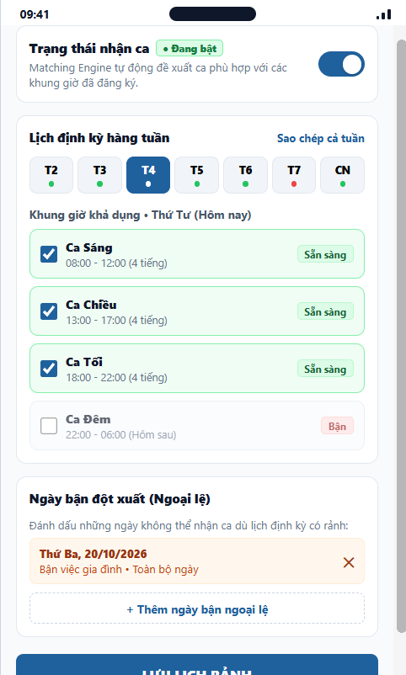
Figure 3.87: Wireframe Mockup of Screen #87 (Availability Calendar)
User Actions:
• Worker accesses Availability Calendar from Worker Profile (SCR-85) to configure recurring shifts and off-day exceptions.
• Toggles the master 'Trạng thái nhận ca' switch to enable or pause automated matching proposals.
• Selects any day of the week (Monday through Sunday) from the horizontal day selector strip.
• Checks or unchecks recurring shift intervals (Morning 08:00-12:00, Afternoon 13:00-17:00, Evening 18:00-22:00, Night 22:00-06:00).
• Clicks 'Sao chép cả tuần' to propagate the active day's shift preferences to all other weekdays.
• Adds or removes specific off-day exceptions with date picker and description to block unexpected busy dates.
• Clicks 'LƯU LỊCH RẢNH' to validate time intervals (BR-65, BR-66) and persist availability in the matching engine.
• Clicks 'QUAY LẠI' or header back arrow to discard uncommitted changes and return to Worker Profile (SCR-85).
Field Description:
Field Name | Control / Type | Required | Description & Validation Rules
Auto-Dispatch Switch | Toggle Switch | Yes | Enables or disables automatic matching eligibility. When OFF, worker receives no new shift proposals.
Day Selector Strip | Segmented Day Pills | Yes | Selects active day of week (T2 through CN). Visual status dot indicates day availability state.
Morning Shift Slot | Checkbox / Row | No | Morning shift interval (08:00 - 12:00, 4 hours). Checked = Available, Unchecked = Busy.
Afternoon Shift Slot | Checkbox / Row | No | Afternoon shift interval (13:00 - 17:00, 4 hours). Checked = Available, Unchecked = Busy.
Evening Shift Slot | Checkbox / Row | No | Evening shift interval (18:00 - 22:00, 4 hours). Checked = Available, Unchecked = Busy.
Night Shift Slot | Checkbox / Row | No | Night shift interval (22:00 - 06:00 next day). Checked = Available, Unchecked = Busy.
Copy Week Schedule | Action Link | No | Clones current day's shift selections to all other 6 days of the week for rapid configuration.
Calendar Exceptions List | List / Card | No | Displays date-specific off days (e.g., 20/10/2026). Overrides recurring weekly schedule.
Add Exception Button | Action Button | No | Opens modal/picker to declare a specific busy calendar date and optional reason.
Save Availability Button | Action Button | Yes | Validates intervals, stores schedule in database, and updates matching index (BR-65, BR-66).
Back Button | Action Link / Button | No | Discards uncommitted schedule adjustments and navigates back to Worker Profile (SCR-85).

3.12 SCR-88: Matching Preferences
Mapped Use Cases: UC-26, UC-34
Configure preferred working areas, wage and commute preferences and applicable matching options.
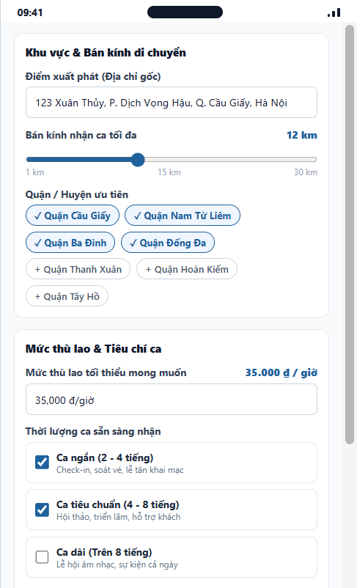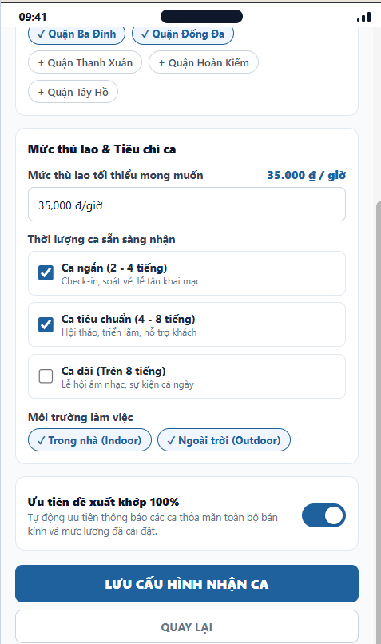
Figure 3.88: Wireframe Mockup of Screen #88 (Matching Preferences)
User Actions:
• Worker accesses Matching Preferences from Worker Profile (SCR-85) to configure dispatch criteria and commute boundaries.
• Updates departure base address used by backend geospatial services to calculate transit distances.
• Adjusts commute distance slider to establish maximum shift travel radius (1 km to 30 km).
• Toggles preferred operating districts within the registered municipality to focus shift recommendations.
• Sets minimum acceptable hourly wage threshold (BR-79, BR-80) below which proposals are automatically filtered out.
• Selects acceptable shift durations (short shifts 2-4h, standard shifts 4-8h, long shifts 8h+).
• Configures work environment preferences (Indoor air-conditioned vs Outdoor festival environments).
• Toggles priority dispatch switch for perfect criteria matches.
• Clicks 'LƯU CẤU HÌNH NHẬN CA' to persist preferences to the Matching & Dispatch Engine (FE-03).
• Clicks 'QUAY LẠI' or header back arrow to discard unsaved adjustments and return to Worker Profile (SCR-85).
Field Description:
Field Name | Control / Type | Required | Description & Validation Rules
Home Base Address | Input Text | Yes | Primary starting address for commute calculation (123 Xuân Thủy, P. Dịch Vọng Hậu, Q. Cầu Giấy, Hà Nội).
Commute Radius Slider | Range Slider | Yes | Maximum acceptable commute distance from base (1 km to 30 km). Current value: 12 km.
Preferred Districts | Chips / Multiselect | Yes | Target operating administrative districts (Cầu Giấy, Nam Từ Liêm, Ba Đình, Đống Đa...).
Minimum Hourly Wage | Input Text / Number | Yes | Minimum acceptable pay rate (e.g. 35,000 đ/h). Proposals below threshold are filtered (BR-79).
Shift Duration Options | Checkbox Group | Yes | Preferred shift lengths: Short (2-4h), Standard (4-8h), Long (8h+). At least one must be checked.
Working Environment | Chips / Multiselect | Yes | Workplace conditions: Indoor (Máy lạnh) and/or Outdoor (Ngoài trời).
Priority Match Toggle | Toggle Switch | No | Enables priority push alerts for proposals satisfying 100% of defined criteria.
Save Preferences Button | Action Button | Yes | Commits location and wage criteria to matching service and recalculates dispatch queue weights.
Back Button | Action Link / Button | No | Discards uncommitted criteria changes and redirects back to Worker Profile (SCR-85).

3.13 SCR-89: Identity Verification
Mapped Use Cases: UC-23, UC-24
Upload CCCD images when required, submit identity verification and view its status.
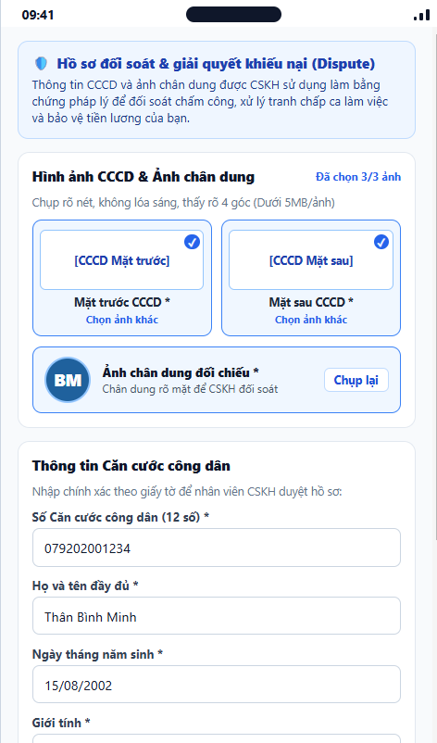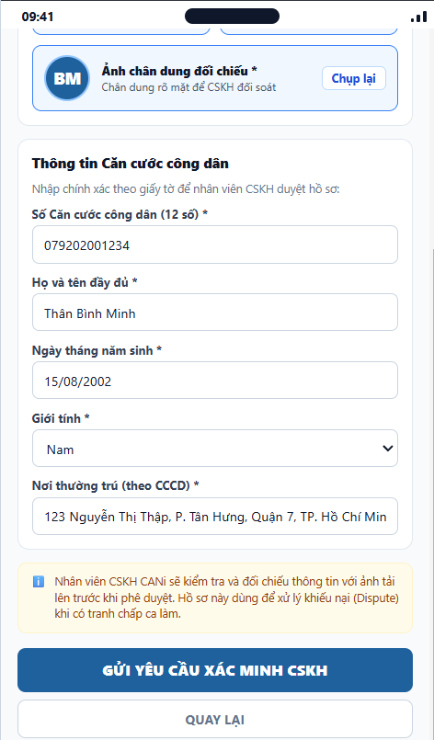
Figure 3.89: Wireframe Mockup of Screen #89 (Identity Verification)
User Actions:
• Worker accesses Identity Verification from Worker Profile (SCR-85) to submit citizen identity details and photo documentation for Customer Care (Customer Care) verification, serving as legal baseline for dispute resolution (UC-71, UC-72).
• Uploads clear front and back photos of Citizen Identity Card (CCCD) with size below 5MB (JPG/PNG).
• Uploads or captures a clear front-facing live facial portrait photo for Customer Care manual cross-reference with the citizen ID photo.
• Enters citizen identity information into input fields: 12-digit Citizen ID number, Legal Full Name, Date of Birth, Gender, and Permanent Residence.
• Reviews notice stating that documents will be verified by Customer Care agents to protect worker rights during assignment disputes.
• Clicks 'GỬI YÊU CẦU XÁC MINH Customer Care' to dispatch verification dossier to the Customer Care operational queue.
• Clicks 'QUAY LẠI' or header back arrow to exit and return to Worker Profile (SCR-85).
Field Description:
Field Name | Control / Type | Required | Description & Validation Rules
Dispute Policy Banner | Information Banner | No | Explains that identity verification documents are used by Customer Care to resolve work disputes (UC-71/UC-72).
CCCD Front Photo Upload | File Picker / Button | Yes | Uploads front side photo of citizen ID card. Max 5MB JPG/PNG (BR-57).
CCCD Back Photo Upload | File Picker / Button | Yes | Uploads back side photo of citizen ID card showing barcode/chip. Max 5MB JPG/PNG (BR-57).
Portrait Photo Upload | File Picker / Button | Yes | Clear face portrait photo used by Customer Care staff to match face against ID card photo.
Citizen ID Number | Input Text | Yes | 12-digit national citizen identification number (079202001234). Unique per worker (BR-60).
Full Legal Name | Input Text | Yes | Full citizen name matching identity document (Thân Bình Minh). Max 70 characters.
Date of Birth | Input Text / Date | Yes | Date of birth (15/08/2002). Validates worker meets minimum legal working age of 18.
Gender | Dropdown Select | Yes | Gender identifier as printed on citizen ID card (Nam / Nữ).
Permanent Residence | Input Text | Yes | Permanent address printed on citizen ID card (123 Xuân Thủy, P. Dịch Vọng Hậu, Q. Cầu Giấy, TP. Hà Nội).
Submit Request Button | Action Button | Yes | Validates mandatory photos and fields, then submits request to Customer Care verification queue (UC-24).
Back Button | Action Link / Button | No | Discards unsubmitted inputs and redirects back to Worker Profile (SCR-85).

3.14 SCR-90: Shift Proposals
Mapped Use Cases: UC-29, UC-30
View and filter received shift proposals with time, location, wage, match information and expiry status.
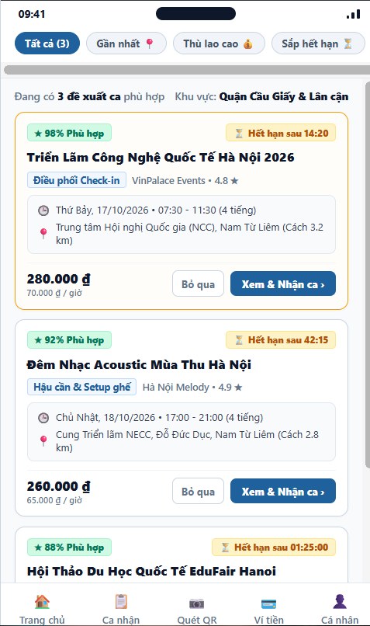
Figure 3.90: Wireframe Mockup of Screen #90 (Shift Proposals)
User Actions:
• Worker accesses Shift Proposals from Worker Home alert banner (SCR-83) or via push notification.
• Views dispatched shift proposals where status is PENDING and expiration timestamp > current time (UC-29).
• Reviews proposal metadata: Matching percentage badge (e.g. 98%), countdown timer (e.g. ⏳ 14:20), role, EO name, date/time, location, distance, and total compensation.
• Interacts with filter pills (Tất cả, Gần nhất, Thù lao cao, Sắp hết hạn) to adjust proposal display (UC-30).
• Clicks 'Bỏ qua' to decline a proposal with reason logging to refine future matching weights.
• Clicks 'Xem & Nhận ca' to open Proposal Details screen (SCR-91) to review work instructions and accept the shift.
• Clicks header back arrow or bottom navigation tabs to navigate to other application modules.
Field Description:
Field Name | Control / Type | Required | Description & Validation Rules
Filter & Sort Pills | Horizontal Tab Bar | No | Filters proposal list: Tất cả, Gần nhất (km), Thù lao cao (VND), Sắp hết hạn (UC-30).
Proposal Card | Card Container | Yes | Interactive container displaying event shift opportunity and summary details.
Matching Score Badge | Badge / Tag | Yes | Semantic match rating calculated by dispatch engine (e.g. 98% Phù hợp).
Expiration Countdown Timer | Countdown Badge | Yes | Time remaining before proposal expires automatically via Background Job JOB-01 (BR-76).
Event Name & Role | Text Display | Yes | Event title and assigned shift role (e.g. Điều phối Check-in).
EO Organization & Rating | Text Display | Yes | Name of Event Organizer and their platform rating score (e.g. VinPalace Events • 4.8★).
Shift Time & Date | Text Display | Yes | Start/end schedule and total shift duration (e.g. 07:30 - 11:30, 4 tiếng).
Location & Commute Distance | Text Display | Yes | Venue address and calculated distance from worker departure base (e.g. NCC, Cách 3.2 km).
Compensation Display | Text Display | Yes | Total gross pay and calculated hourly wage (e.g. 280.000 ₫ • 70.000 ₫/h).
Decline Action | Action Button / Link | No | Declines proposal and prompts for feedback reason (Schedule Conflict, Low Wage, etc.).
View & Accept Action | Action Button | Yes | Navigates to Proposal Details screen (SCR-91) to complete shift acceptance.
Bottom Navigation Bar | Persistent Tab Bar | Yes | 5-tab persistent application navigation bar (Trang chủ, Ca nhận, Quét QR, Ví tiền, Cá nhân).

3.15 SCR-91: Proposal Details
Mapped Use Cases: UC-31, UC-32, UC-33
View shift and EO information, matching details and proposal validity; accept or reject the proposal.
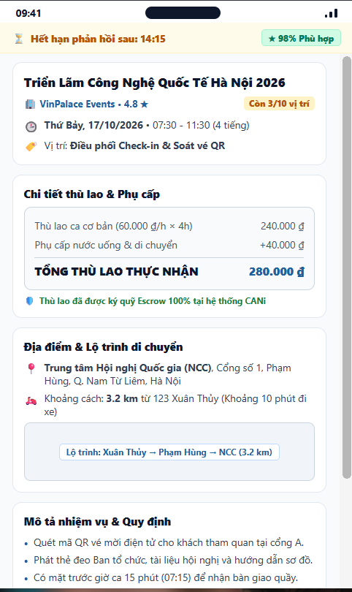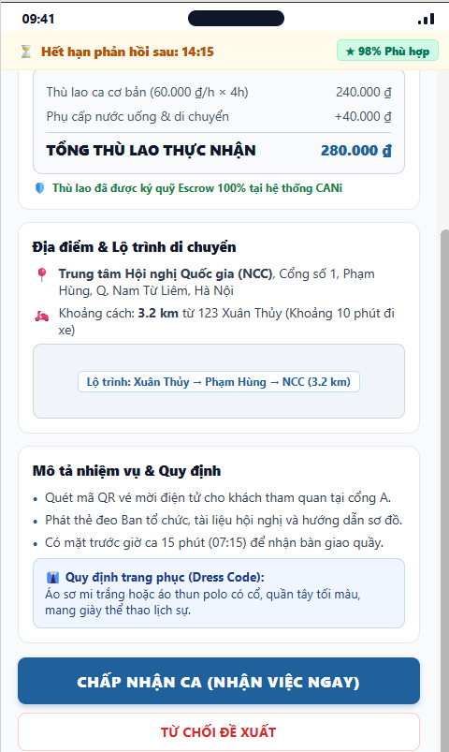
Figure 3.91: Wireframe Mockup of Screen #91 (Proposal Details)
User Actions:
• Worker accesses Proposal Details by tapping an active proposal card from Shift Proposals (SCR-90).
• Monitors dynamic countdown timer (e.g. ⏳ 14:15) indicating remaining window before automated proposal forfeiture (JOB-01).
• Reviews event title, Organizer reputation (VinPalace Events • 4.8★), shift schedule, and remaining vacancy count (3/10 slots).
• Inspects itemized remuneration breakdown: Base shift pay (240.000 ₫), allowance (+40.000 ₫), guaranteed total (280.000 ₫), and Escrow protection badge.
• Examines exact event location (NCC, Phạm Hùng, Q. Nam Từ Liêm, Hà Nội), commute distance (3.2 km from 123 Xuân Thủy), and route map preview.
• Reads specific operational duties (QR scanning, badge distribution), arrival requirement (15 minutes early), and mandatory dress code.
• Clicks 'CHẤP NHẬN CA (NHẬN VIỆC NGAY)' (UC-32) to claim the open slot via atomic concurrency lock, creating a Confirmed Assignment (SCR-96).
• Clicks 'TỪ CHỐI ĐỀ XUẤT' (UC-33) to decline the shift with optional reason logging, immediately freeing the proposal for candidate dispatch.
• Clicks header back arrow to return to Shift Proposals list (SCR-90).
Field Description:
Field Name | Control / Type | Required | Description & Validation Rules
Countdown Timer Strip | Sticky Header Bar | Yes | Displays remaining time before proposal expires (JOB-01); dims screen and disables accept when expired (BR-76).
Match Score Tag | Badge / Indicator | Yes | Calculated semantic compatibility between worker profile and shift criteria (e.g. 98% Phù hợp).
Event Title & EO Info | Information Card | Yes | Event headline, organizer brand, verified star rating (4.8★), and remaining vacancies (3/10 vị trí).
Shift Datetime & Role | Text Display | Yes | Confirmed calendar date, operational hours (07:30 - 11:30), and assigned role (Điều phối Check-in).
Itemized Wage Breakdown | Information Card | Yes | Detailed pay breakdown: Base hourly wage, meal/commute allowance, and total guaranteed payout (280.000 ₫).
Escrow Assurance Badge | Status Tag | Yes | Verifies organizer has deposited 100% wage escrow into platform balance before dispatching shift (BR-45).
Venue Address & Distance | Map & Text Display | Yes | Exact event address (NCC, Phạm Hùng, Nam Từ Liêm) and calculated commute distance (3.2 km from 123 Xuân Thủy).
Route Preview Box | Static Map Graphic | No | Visual schematic preview of commuting path from worker base to venue.
Job Duties & Arrival Time | Bullet List | Yes | Itemized operational tasks and requirement to arrive 15 minutes prior to shift start for handover.
Dress Code Requirement | Callout Box | Yes | Mandatory attire policy (White shirt/polo, dark trousers, polite sneakers). Non-compliance risks check-in denial.
Accept Shift Action | Action Button | Yes | Primary CTA triggering atomic slot booking, calendar update, and transition to My Assignments (UC-32).
Decline Shift Action | Action Button / Link | No | Secondary button to refuse proposal with optional feedback reason, releasing soft-hold slot (UC-33).

3.16 SCR-92: Enter Invite Code
Mapped Use Cases: UC-36
Enter an EO invitation code or scan an invitation QR code to access the invitation.
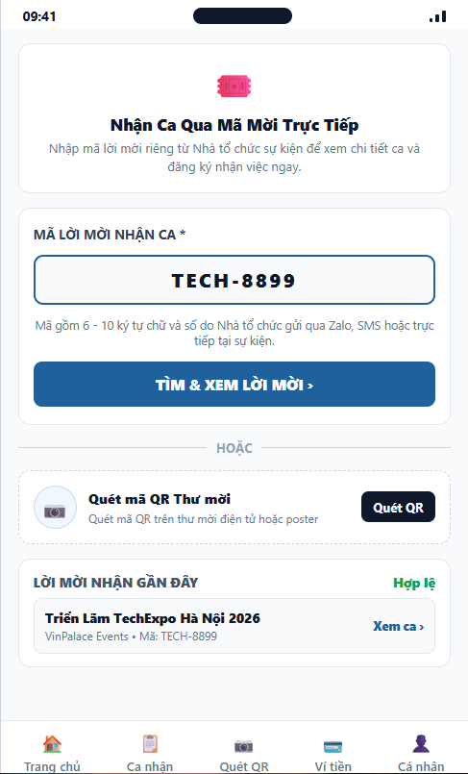
Figure 3.92: Wireframe Mockup of Screen #92 (Enter Invite Code)
User Actions:
• Worker accesses Enter Invite Code from Worker Home (SCR-83) to unlock direct, private event invitations.
• Inputs 6-10 character alphanumeric invitation token (e.g. TECH-8899) provided by Event Organizers via direct communications.
• Clicks 'TÌM & XEM LỜI MỜI' to query backend token registry and transition to Invitation Details screen (SCR-93).
• Clicks 'Quét QR' to launch camera QR Scanner (SCR-98) to read digital invitation barcodes instantly.
• Reviews recent valid invitation history and taps 'Xem ca ›' to inspect job specifications.
• Uses bottom navigation bar or header back arrow to return to Worker Home (SCR-83).
Field Description:
Field Name | Control / Type | Required | Description & Validation Rules
Hero Info Card | Information Card | No | Explains private direct shift booking via Organizer invite codes.
Invite Code Input | Input Text | Yes | Alphanumeric code (e.g. TECH-8899). Length 6-12 chars, uppercase formatted.
Verify Code Action | Action Button | Yes | Validates invite code with backend API; redirects to Invitation Details (SCR-93) if valid.
Scan QR Option Card | Action Container | No | Alternative entry point linking to QR Scanner (SCR-98) to parse invitation barcodes.
Scan QR Button | Action Button / Link | No | Launches camera scanner interface to read invite QR codes directly.
Recent Invites List | Card / List | No | Displays previously used or recently received invite codes and validity status.
Bottom Navigation Bar | Persistent Tab Bar | Yes | 5-tab persistent app navigation bar (Trang chủ, Ca nhận, Quét QR, Ví tiền, Cá nhân).

3.17 SCR-93: Invitation Details
Mapped Use Cases: UC-31, UC-32, UC-36
View the invitation and related work information, review any schedule conflict warning and confirm joining.
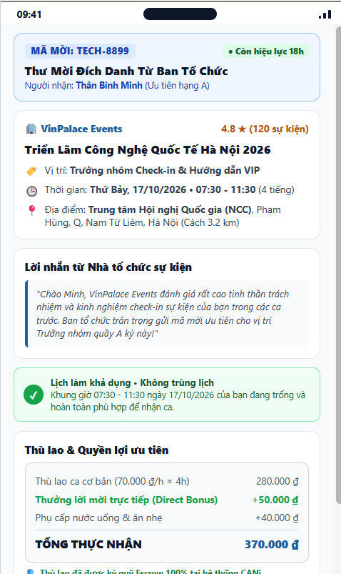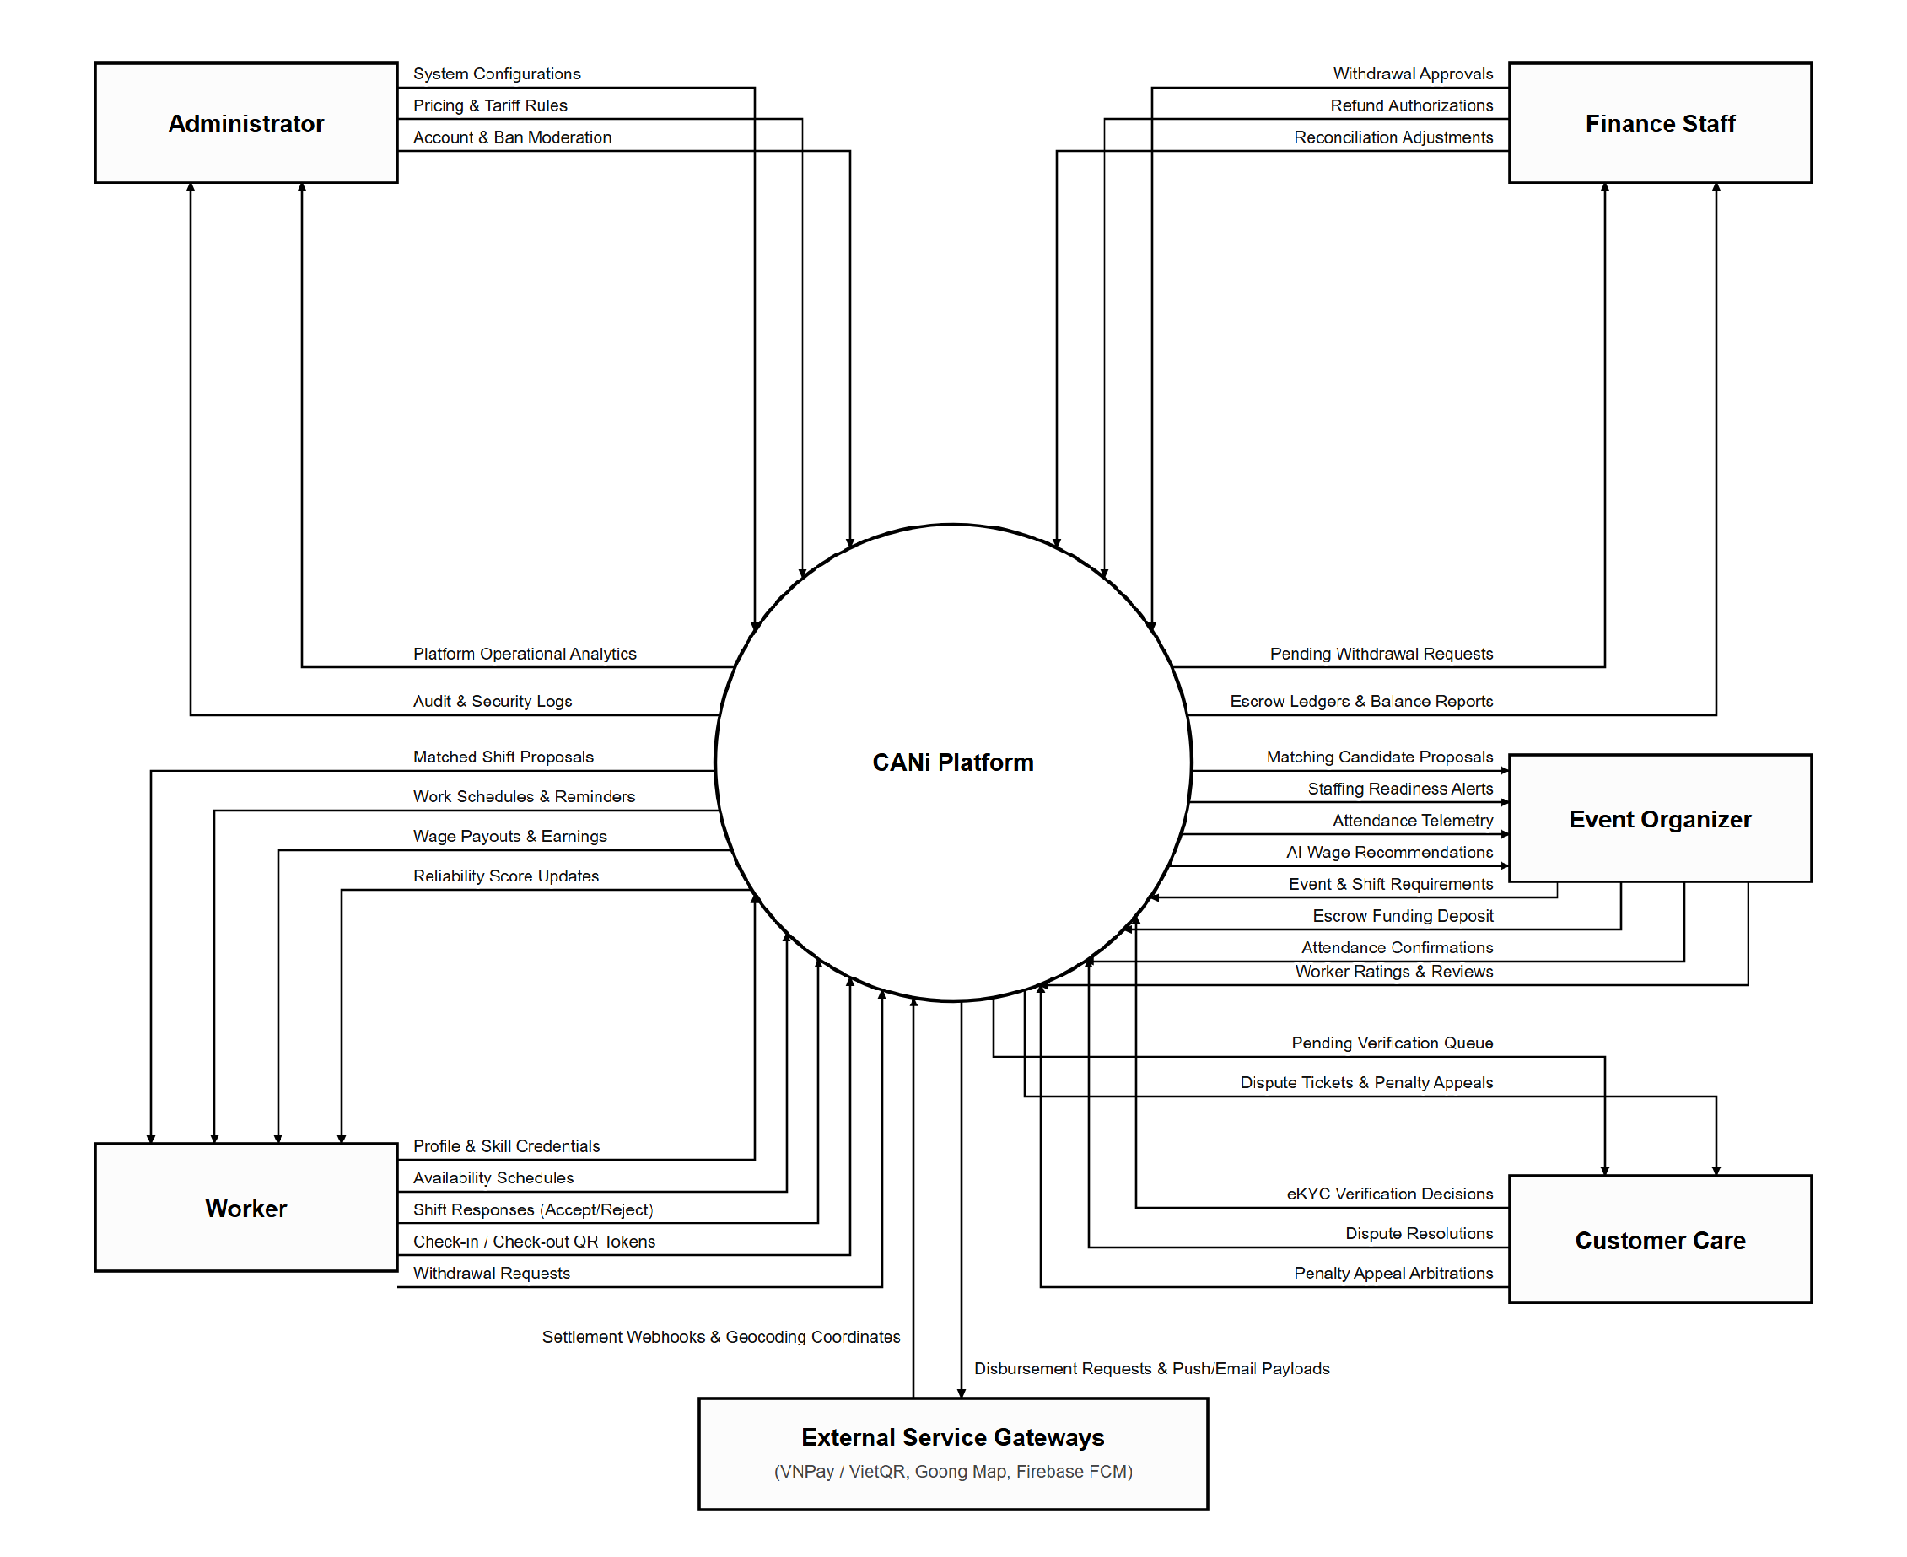
Figure 3.93: Wireframe Mockup of Screen #93 (Invitation Details)
User Actions:
• Worker accesses Invitation Details after successfully validating an invite token in Enter Invite Code (SCR-92) or scanning an invitation QR.
• Reviews invitation banner showing unique token (TECH-8899), validity window (18h remaining), and named recipient (Thân Bình Minh).
• Inspects event title, organizer credentials (VinPalace Events • 4.8★), VIP team leader role, shift timing, and venue location (NCC, Nam Từ Liêm, Hà Nội).
• Reads direct personal invitation message from the organizer acknowledging worker's high reliability score and track record.
• Reviews schedule conflict validation banner confirming zero overlap with existing assignments on the calendar (BR-104).
• Evaluates financial breakdown including direct invite bonus (+50.000 ₫), meal allowance, and guaranteed escrow protection (370.000 ₫ total).
• Clicks 'XÁC NHẬN THAM GIA CA LÀM' to accept the private shift, creating a Confirmed Assignment in My Assignments (SCR-96).
• Clicks 'TỪ CHỐI LỜI MỜI' or header back arrow to decline and return to Enter Invite Code (SCR-92).
Field Description:
Field Name | Control / Type | Required | Description & Validation Rules
Invitation Token Banner | Status Card | Yes | Displays validated invitation token (TECH-8899), remaining validity window, and recipient name.
Event & Organizer Header | Information Card | Yes | Event title, organizer profile (VinPalace Events • 4.8★), priority role, shift date and operational hours.
Venue Location & Commute | Text Display | Yes | Exact event address (NCC, Phạm Hùng, Q. Nam Từ Liêm, Hà Nội) and distance (3.2 km).
Organizer Personal Note | Callout Box | No | Custom message from organizer commending worker track record and detailing incentive reasons.
Schedule Conflict Check | Status Box / Alert | Yes | Automated calendar verification ensuring worker has no concurrent bookings during shift window (BR-104).
Remuneration Breakdown | Card / Table | Yes | Itemized payout: Base shift pay (280.000 ₫), direct bonus (+50.000 ₫), meal allowance (+40.000 ₫), total 370.000 ₫.
Escrow Assurance Badge | Status Tag | Yes | Confirms 100% total shift wage and bonus have been locked in CANi platform escrow balance.
Accept Invitation Action | Action Button | Yes | Primary CTA confirming worker enrollment and creating a Confirmed Assignment record (UC-32).
Decline Invitation Action | Action Button / Link | No | Declines private invitation and returns user to Enter Invite Code screen (SCR-92).

3.18 SCR-94: View EO Ratings
Mapped Use Cases: UC-70
View EO ratings and reviews
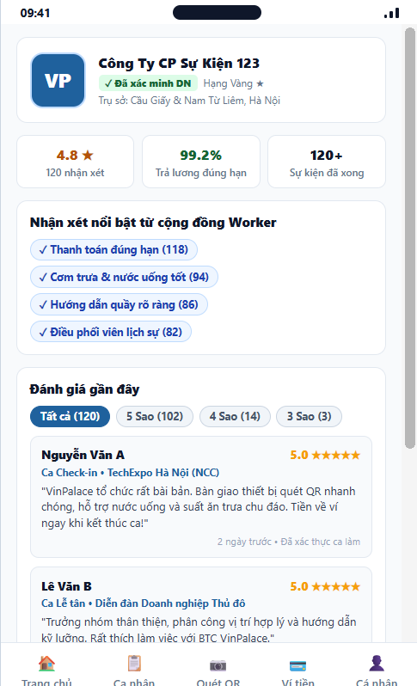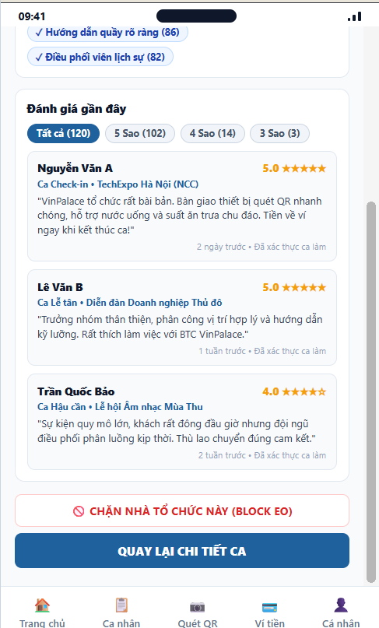
Figure 3.94: Wireframe Mockup of Screen #94 (View EO Ratings)
User Actions:
• Worker accesses View EO Ratings by tapping Organizer rating elements in Proposal Details (SCR-91) or Worker Profile (SCR-85).
• Inspects Event Organizer business profile, verified company badge, and base of operations (Hà Nội).
• Reviews key employer reliability metrics: Aggregate star rating (4.8★), on-time payment rate (99.2%), and completed event count (120+).
• Reads positive worker feedback keyword cloud (Thanh toán đúng hạn, Chu đáo, Hướng dẫn rõ ràng).
• Filters and reads detailed reviews written by peer workers across past verified shifts (UC-70).
• Clicks 'CHẶN NHÀ TỔ CHỨC NÀY' to initiate blocking procedure (SCR-95), suppressing future proposals from this organizer (UC-27).
• Clicks 'QUAY LẠI CHI TIẾT CA' or header back arrow to return to Proposal Details (SCR-91).
Field Description:
Field Name | Control / Type | Required | Description & Validation Rules
Organizer Hero Profile | Profile Card | Yes | Displays company name (VinPalace Events), verified corporate badge, and operating location.
Overall Star Rating | Metric Box | Yes | Calculated weighted average star rating (4.8★ based on 120 reviews, BR-202).
On-Time Payment Metric | Metric Box | Yes | Percentage of completed shifts where organizer approved payout without dispute (99.2%).
Total Events Metric | Metric Box | Yes | Cumulative number of successfully concluded events hosted on the platform (120+).
Feedback Tags Cloud | Tag Chips | No | Aggregated positive sentiment tags endorsed by workers in post-shift reviews.
Star Filter Tabs | Horizontal Pill Bar | No | Filters review feed by star rating tier (Tất cả, 5 Sao, 4 Sao, 3 Sao).
Peer Reviews Feed | List / Cards | Yes | Scrollable list of verified worker reviews, ratings, shift titles, and timestamps.
Block Organizer Action | Action Button / Link | No | Navigates to Blocked Event Organizers (SCR-95) to blacklist this employer (UC-27).
Back Button | Action Button / Link | No | Returns user to referring Proposal Details (SCR-91) or Worker Profile (SCR-85).
Bottom Navigation Bar | Persistent Tab Bar | Yes | 5-tab persistent app navigation bar (Trang chủ, Ca nhận, Quét QR, Ví tiền, Cá nhân).

3.19 SCR-95: Blocked Event Organizers
Mapped Use Cases: UC-27, UC-28
View and manage blocked Event Organizers and remove blocks when desired.
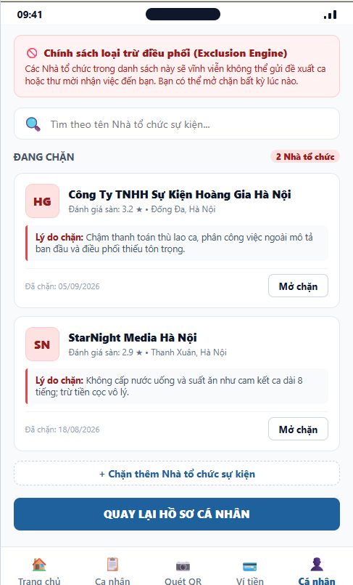
Figure 3.95: Wireframe Mockup of Screen #95 (Blocked Event Organizers)
User Actions:
• Worker navigates to Blocked Event Organizers from Worker Profile (SCR-85) or after blocking an employer from View EO Ratings (SCR-94).
• Reads policy banner explaining the platform Exclusion Engine (BR-68) that automatically suppresses matching proposals and direct invitations from blacklisted organizers.
• Uses search input to filter blocked organizers by company name in real time.
• Reviews list of currently blocked Event Organizers in Hà Nội, showing avatar initials, company name, platform rating, recorded blocking reason, and blocked date.
• Taps 'Mở chặn' button next to a blocked organizer to remove them from blacklist, re-enabling job matching with them (UC-28).
• Taps '+ Thêm Nhà tổ chức vào danh sách chặn' to manually search and block another organizer (UC-27).
• Taps 'Quay lại trang Cá nhân' or header back arrow to return to Worker Profile (SCR-85).
• Interacts with 5-tab bottom navigation to switch to other app modules.
Field Description:
Field Name | Control / Type | Required | Description & Validation Rules
Policy Banner | Info Card / Banner | Yes | Informs worker that blocked organizers cannot send proposals or direct shift invites (BR-68).
Search Organizer Input | Search Input | No | Text filter to quickly search through blocked organizers by company name.
Blocked Counter Badge | Counter Badge | Yes | Displays total count of currently blacklisted organizers (e.g., '2 Nhà tổ chức').
Organizer Card Item | List Item / Card | Yes | Card displaying company avatar, business name, rating, and district location in Hà Nội.
Blocking Reason Note | Text Box / Note | Yes | Recorded rationale for blocking (e.g., wage dispute, disrespectful coordination, out-of-scope tasks).
Blocked Date Display | Timestamp Display | Yes | Date when the block action was committed to the database (DD/MM/YYYY).
Unblock Action Button | Action Button | No | Triggers unblock confirmation and removes organizer from blacklist (UC-28).
Add Block Button | Dashed Action Button | No | Opens search interface to find and add a new organizer to blocked list (UC-27).
Back to Profile Action | Primary Action Button | Yes | Commits changes and returns worker to Worker Profile screen (SCR-85).
Bottom Navigation Bar | Persistent Tab Bar | Yes | 5-tab persistent app navigation bar (Trang chủ, Ca nhận, Quét QR, Ví tiền, Cá nhân).

3.20 SCR-96: My Assignments
Mapped Use Cases: UC-40, UC-42
View the worker's assigned shifts in status tabs (Upcoming, Ongoing, Completed, Cancelled) and filter or search
them by date range, status or Event Organizer.

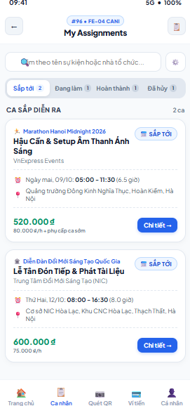

Figure 3.96: Wireframe Mockup of Screen #96 (My Assignments)
User Actions:
• Worker opens My Assignments and reviews assigned shifts grouped by status tab (Sắp tới, Đang làm, Hoàn thành, Đã hủy), each tab showing a count badge.
• Searches by event name or organizer name, or opens the filter panel to narrow the list by date range, organizer or assignment status.
• Reviews each assignment card (event, shift title, organizer, date/time, location and expected payout).
• Taps "Chi tiết" on a card to open Assignment Details (SCR-97).
• Uses the bottom navigation bar to move to other worker modules.
Field Description:
Field Name | Control / Type | Required | Description & Validation Rules
Search Input | Text Input | No | Searches assignments by event name or organizer name (placeholder "Tìm theo tên sự kiện hoặc nhà tổ chức…"). The list refreshes as the worker types; an empty-state message is shown when nothing matches.
Filter Button | Icon Button | No | Opens the filter panel to filter by date range, Event Organizer or status (UC-42). Active filters stay applied until cleared.
Status Tabs | Tab Bar with Count Badges | Yes | Four tabs: Sắp tới (Upcoming), Đang làm (Ongoing), Hoàn thành (Completed), Đã hủy (Cancelled). Default tab is Sắp tới; each badge shows the number of assignments in that status.
Section Header | Text / Display | Yes | Group label for the current tab (e.g., "Ca sắp diễn ra") with the number of shifts listed.
Event Name | Text / Display | Yes | Name of the event that the shift belongs to, shown with the event category icon.
Shift Title & Organizer | Text / Display | Yes | Shift title and the name of the Event Organizer that created the shift.
Assignment Status Badge | Status Badge | Yes | Current assignment status: Sắp tới, Đang diễn ra, Hoàn thành or Đã hủy.
Shift Date & Time | Text / Display | Yes | Shift date, start–end time and total paid hours (e.g., "Ngày mai, 09/10: 05:00 - 11:30 (6.5 giờ)").
Shift Location | Text / Display | Yes | Venue address where the worker must check in.
Total Payout | Currency / Display | Yes | Total expected pay for the shift in VND (e.g., 520.000đ) with the hourly rate and allowances (e.g., "80.000đ/h + phụ cấp ca sớm").
Detail Button | Primary Button | Yes | Opens Assignment Details (SCR-97) for the selected assignment.
Bottom Navigation Bar | Persistent Tab Bar | Yes | 5-tab persistent app navigation bar (Trang chủ, Ca nhận, Quét QR, Ví tiền, Cá nhân); highlights the current module.

3.21 SCR-97: Assignment Details
Mapped Use Cases: UC-41, UC-44, UC-51, UC-53
View assignment, attendance, checklist, payment and rating information; access related actions and cancellation when permitted.
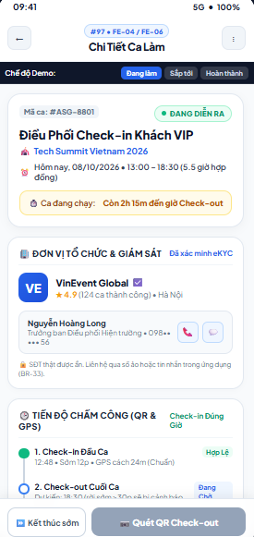

Figure 3.97: Wireframe Mockup of Screen #97 (Assignment Details)
User Actions:
• Worker reviews the shift summary: assignment code, status, event, shift title, date/time and the time remaining until check-out.
• Reviews the supervising Event Organizer (eKYC verified badge, rating, completed shifts) and contacts the supervisor only through the masked phone or in-app message; direct contact details stay hidden per BR-33.
• Follows the attendance timeline (check-in and check-out with GPS validation status), checklist progress and payment status of the assignment.
• Taps "Quét QR Check-out" to open the QR Scanner (SCR-98) or "Kết thúc sớm" to open the Shift Completion Request (SCR-100); both actions are enabled only when the current assignment state permits.
• Opens the more-options menu (⋮) to cancel the assignment when permitted; the system shows the reliability penalty warning before the worker confirms (UC-53).
Field Description:
Field Name | Control / Type | Required | Description & Validation Rules
Assignment Code | Text / Display | Yes | Unique assignment reference (e.g., #ASG-8801).
Assignment Status Badge | Status Badge | Yes | Current state: Sắp tới, Đang diễn ra, Hoàn thành or Đã hủy.
Shift Title & Event | Text / Display | Yes | Shift title with the name of the event it belongs to.
Shift Date & Time | Text / Display | Yes | Shift date, start–end time and contracted hours (e.g., "Hôm nay, 08/10/2026 • 13:00 - 18:30 (5.5 giờ hợp đồng)").
Shift Countdown Banner | Info Banner | No | Shows remaining time until check-out while the shift is running (e.g., "Còn 2h15m đến giờ Check-out"), or time until start for upcoming shifts.
Organizer Name & Verification | Text / Badge | Yes | Event Organizer name with the "Đã xác minh eKYC" badge, average rating, number of completed shifts and city.
Supervisor Contact | Contact Card with Buttons | No | Supervisor name, role and masked phone number with call and message buttons. Real phone numbers are hidden until the unmasking window (BR-33).
Attendance Timeline | Timeline / Display | Yes | Check-in and check-out milestones ("Tiến độ chấm công (QR & GPS)") with recorded time, GPS distance and status (Hợp lệ, Đang chờ).
Checklist & Payment Summary | Summary Cards | Yes | Checklist progress, evidence status and payment status (expected pay, escrow or released) for the assignment.
Early Checkout Button | Secondary Button | No | "Kết thúc sớm" – opens Shift Completion Request (SCR-100). Enabled only while the shift is in progress.
Check-out Button | Primary Button | No | "Quét QR Check-out" – opens QR Scanner (SCR-98). Disabled until checklist and evidence requirements are met (BR-37).
More Options Menu | Icon Button / Menu | No | Contains "Cancel assignment"; shown only for upcoming assignments. A reliability penalty warning must be confirmed before cancelling.
Demo Scenario Switch | Segmented Tab | No | Prototype-only control to preview mockup states (Đang làm, Sắp tới, Hoàn thành). Switches the screen between assignment states. Not part of the production UI.

3.22 SCR-98: QR Scanner
Mapped Use Cases: UC-43, UC-44
Scan the shift attendance QR code for check-in or check-out.
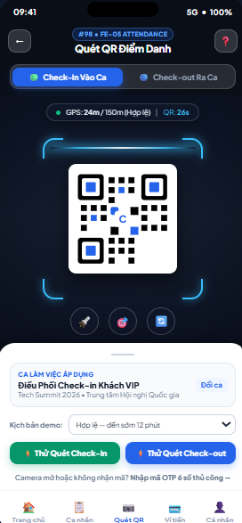
Figure 3.98: Wireframe Mockup of Screen #98 (QR Scanner)
User Actions:
• Worker selects the mode "Check-In Vào Ca" or "Check-out Ra Ca" according to the current attendance step.
• Confirms that the GPS chip shows a valid distance to the shift location and watches the QR countdown timer.
• Positions the camera over the Event Organizer's dynamic QR code; the system decodes the payload, validates its HMAC signature, expiry and the worker's confirmed assignment, and captures the GPS position and timestamp.
• Turns on the flashlight in low light, or enters the 6-digit OTP manually when the camera cannot read the QR code.
• Receives instant success or error feedback; check-in is marked on time or late, and check-out notifies the Event Organizer for completion confirmation.
Field Description:
Field Name | Control / Type | Required | Description & Validation Rules
Attendance Mode Toggle | Segmented Control | Yes | Switches between "Check-In Vào Ca" (UC-43) and "Check-out Ra Ca" (UC-44). Defaults to the next valid attendance step.
GPS Status Chip | Status Chip | Yes | Shows current distance to the shift location against the allowed radius (e.g., "GPS: 24m / 150m (Hợp lệ)"). Scanning is rejected when the worker is outside the radius.
QR Countdown | Timer / Display | Yes | Seconds left before the current QR code refreshes (e.g., "QR: 26s"). QR codes refresh every 30 seconds.
Camera Viewfinder | Camera Stream | Yes | Active camera feed with scan frame, scanning for ISO/IEC 18004 QR codes.
Camera Control Buttons | Icon Buttons | No | Flashlight toggle for low-light environments and additional camera controls under the viewfinder.
Active Shift Card | Info Card with Button | Yes | Shift the scan applies to (title, event, organizer venue) with a "Đổi ca" button to switch when the worker has several active shifts.
Manual OTP Entry | Hyperlink / Text | No | Fallback link "Nhập mã OTP 6 số thủ công" for entering a 6-digit code when the camera is blurred or cannot recognize the QR.
Help Button | Icon Button | No | Opens scanning instructions and troubleshooting tips.
Demo Scan Controls | Dropdown & Buttons | No | "Kịch bản demo" dropdown (e.g., Hợp lệ – đến sớm 12 phút) with "Thử Quét Check-in" and "Thử Quét Check-out" buttons to simulate a scan in demo mode. Not part of the production UI.
Bottom Navigation Bar | Persistent Tab Bar | Yes | 5-tab persistent app navigation bar (Trang chủ, Ca nhận, Quét QR, Ví tiền, Cá nhân); highlights the current module.

3.23 SCR-99: Job Checklist & Evidence
Mapped Use Cases: UC-45, UC-46, UC-48
View the job checklist, mark tasks as done and submit required work evidence.
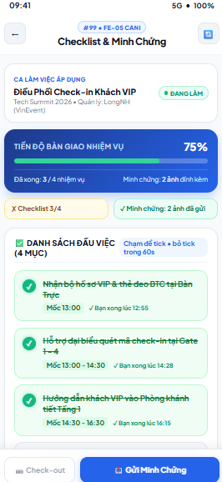
Figure 3.99: Wireframe Mockup of Screen #99 (Job Checklist & Evidence)
User Actions:
• Worker reviews the shift header and the overall task handover progress (percentage, completed/total tasks, number of evidence photos).
• Reads the checklist assigned by the Event Organizer, including the milestone time of each task.
• Taps a task to mark it completed (the system records the completion timestamp); a task can be unticked within 60 seconds.
• Attaches and submits on-site photo evidence for tasks that require it by tapping "Gửi Minh Chứng"; the Event Organizer is notified for verification.
• Taps "Check-out" once every required task is done and evidence is submitted to continue to the QR Scanner (SCR-98); the button stays disabled until then (BR-37).
Field Description:
Field Name | Control / Type | Required | Description & Validation Rules
Active Shift Card | Info Card | Yes | Shift title, event, supervisor and status badge (e.g., "Đang làm") of the assignment the checklist belongs to.
Handover Progress Card | Progress Bar / Display | Yes | Percentage of completed tasks (e.g., 75%), completed vs. total tasks (3/4) and the number of attached evidence photos.
Checklist & Evidence Status Chips | Status Chips | Yes | Quick status of the checklist (e.g., "Checklist 3/4") and evidence (e.g., "2 ảnh đã gửi"), showing what is still missing for check-out.
Checklist Item | Checkbox List Item | Yes | Task name, milestone time window and completion time. Tap to tick; can be unticked within 60 seconds. Completed items are shown struck through.
Evidence Upload | Photo Upload | Conditional | Camera or gallery photos attached to a task. Required when the Event Organizer set a photo requirement; at least one on-site photo is needed before check-out (BR-37).
Refresh Button | Icon Button | No | Reloads the latest checklist and verification status from the Event Organizer.
Check-out Button | Secondary Button | Yes | Opens QR Scanner (SCR-98) for check-out. Disabled until 100% of required tasks are done and evidence is submitted.
Submit Evidence Button | Primary Button | Yes | "Gửi Minh Chứng" – saves the evidence linked to the assignment and notifies the Event Organizer.

3.24 SCR-100: Shift Completion Request
Mapped Use Cases: UC-44, UC-49, UC-51
Request shift completion or early checkout with a reason,verified working hours determine the prorated payment.

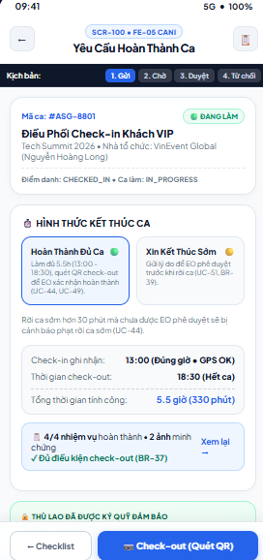
Figure 3.100: Wireframe Mockup of Screen #100 (Shift Completion Request)
User Actions:
• Worker reviews the assignment summary, current attendance status and recorded check-in time.
• Chooses the completion type: "Hoàn Thành Đủ Ca" (full shift, finished by scanning the check-out QR) or "Xin Kết Thúc Sớm" (early checkout).
• For early checkout, enters the mandatory reason and submits the request to the Event Organizer.
• Tracks the request status (Gửi, Chờ, Duyệt, Từ chối) and reads the Event Organizer's feedback; if approved, pay is prorated by verified minutes (BR-39).
• Reviews the checklist and evidence summary (taps "Xem lại" if needed), then goes back to the checklist or taps "Check-out (Quét QR)".
Field Description:
Field Name | Control / Type | Required | Description & Validation Rules
Assignment Summary | Info Card | Yes | Assignment code (e.g., #ASG-8801), status badge, shift title, event, organizer name and attendance/shift state (CHECKED_IN / IN_PROGRESS).
Request Status Stepper | Segmented Tab / Status | Yes | Request lifecycle: 1. Gửi (submitted), 2. Chờ (waiting for Event Organizer), 3. Duyệt (approved), 4. Từ chối (rejected). In the mockup it also lets reviewers preview each state.
Completion Type Selector | Radio Card Group | Yes | Choose one: "Hoàn Thành Đủ Ca" or "Xin Kết Thúc Sớm". Leaving more than 30 minutes early without approval triggers an early-leave penalty warning.
Early Checkout Reason | Text Area | Conditional | Required when "Xin Kết Thúc Sớm" is selected; cannot be empty. Explains why early departure is necessary (UC-51).
Check-in Record | Text / Display | Yes | Recorded check-in time with on-time/late status and GPS result (e.g., "13:00 (Đúng giờ • GPS OK)").
Check-out Time | Text / Display | Yes | Scheduled or actual check-out time (e.g., "18:30 (Hết ca)").
Total Worked Time | Text / Display | Yes | Total payable time in hours and minutes (e.g., "5.5 giờ (330 phút)"); prorated by verified minutes for approved early checkout (BR-39).
Checklist & Evidence Summary | Summary Card with Link | Yes | Completed tasks and evidence count, with eligibility message (e.g., "Đủ điều kiện check-out", BR-37) and "Xem lại" link to SCR-99.
Escrow Notice | Info Banner | No | Confirms the shift payment is held in escrow and will be released after completion is confirmed.
Event Organizer Feedback | Text / Display | No | Approval or rejection message from the Event Organizer for the early checkout request (UC-49, UC-51).
Back to Checklist Button | Secondary Button | Yes | Returns to Job Checklist & Evidence (SCR-99).
Check-out Button | Primary Button | Yes | "Check-out (Quét QR)" – opens QR Scanner (SCR-98); for early checkout it is enabled after the request is approved.

3.25 SCR-101: Attendance History
Mapped Use Cases: UC-41, UC-42, UC-43, UC-44
View recorded check-in and check-out times and open the related assignment.
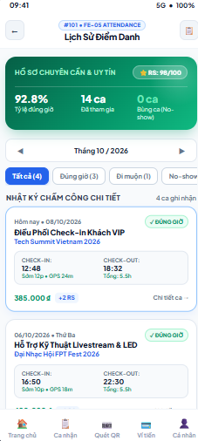
Figure 3.101: Wireframe Mockup of Screen #101 (Attendance History)
User Actions:
• Worker opens Attendance History and reviews the reliability and attendance summary (reliability score, on-time rate, shifts attended, no-show count).
• Moves between months with the previous/next arrows.
• Filters the attendance log by result: Tất cả, Đúng giờ, Đi muộn or No-show.
• Reviews each attendance record (check-in and check-out times, GPS distance, total hours, earnings and reliability points gained or lost).
• Taps "Chi tiết ca" on a record to open the related assignment (SCR-97).
Field Description:
Field Name | Control / Type | Required | Description & Validation Rules
Reliability Score | Badge / Display | Yes | Current reliability score shown as RS value out of 100 (e.g., RS: 98/100).
On-time Rate | Percentage / Display | Yes | Percentage of shifts in the selected period on which the worker checked in on time (e.g., 92.8%).
Shifts Attended | Number / Display | Yes | Number of shifts the worker attended in the selected period (e.g., 14 ca).
No-show Count | Number / Display | Yes | Number of confirmed no-shows in the period (e.g., 0 ca); highlighted when greater than zero.
Month Selector | Date Navigator | Yes | Shows the selected month (e.g., Tháng 10 / 2026) with previous and next arrows. Defaults to the current month; future months are not selectable.
Result Filter Chips | Filter Chips with Counts | No | Tất cả, Đúng giờ, Đi muộn and No-show, each with the number of matching records.
Attendance Date & Result | Text / Status Badge | Yes | Shift date and attendance result badge (Đúng giờ, Đi muộn or No-show).
Shift Title & Event | Text / Display | Yes | Shift title and the event it belongs to.
Check-in Record | Text / Display | Yes | Check-in time with early/late offset and GPS distance (e.g., "12:48 • Sớm 12p • GPS 24m").
Check-out Record | Text / Display | Yes | Check-out time and total worked hours (e.g., "18:32 • Tổng: 5.5h").
Earnings & Reliability Change | Currency / Badge | Yes | Pay earned for the shift (e.g., 385.000đ) and reliability points gained or lost (e.g., +2 RS).
Detail Link | Hyperlink | Yes | "Chi tiết ca →" opens the related assignment in Assignment Details (SCR-97).
Bottom Navigation Bar | Persistent Tab Bar | Yes | 5-tab persistent app navigation bar (Trang chủ, Ca nhận, Quét QR, Ví tiền, Cá nhân); highlights the current module.

3.26 SCR-102: Rate Event Organizer
Mapped Use Cases: UC-69
Rate EO after shift completion
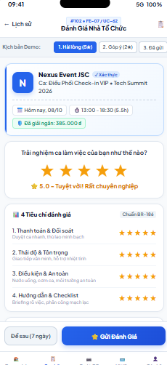
Figure 3.102: Wireframe Mockup of Screen #102 (Rate Event Organizer)
User Actions:
• Worker opens the rating form after a shift is completed and reviews the Event Organizer and shift summary, including the released payment.
• Selects an overall rating from one to five stars; a descriptive label updates with the selection (e.g., "5.0 - Tuyệt vời!").
• Rates the four criteria individually from one to five stars: payment and reconciliation, attitude and respect, working conditions and safety, guidance and checklist.
• Optionally adds a text comment about the shift experience.
• Taps "Gửi Đánh Giá" to submit the rating, or "Để sau (7 ngày)" to postpone it within the 7-day rating window.
Field Description:
Field Name | Control / Type | Required | Description & Validation Rules
Event Organizer Info | Info Card | Yes | Event Organizer name, avatar and verified badge.
Shift Summary | Text / Display | Yes | Shift title and event name, date, time and total hours of the rated shift.
Payment Release Chip | Status Chip | No | Shows the amount already released to the worker for the shift (e.g., "Đã giải ngân: 385.000đ").
Overall Rating | Star Rating (1–5) | Yes | Overall experience from 1 to 5 stars. A matching text label is shown; submission is blocked until a rating is selected.
Criteria Ratings (4) | Star Rating (1–5) ×4 | Yes | Separate 1–5 star ratings for: Thanh toán & Đối soát, Thái độ & Tôn trọng, Điều kiện & An toàn, Hướng dẫn & Checklist.
Comment | Text Area | No | Optional free-text feedback about the Event Organizer and shift; a character limit applies.
Remind Later Button | Secondary Button | No | "Để sau (7 ngày)" – closes the form and keeps the rating pending for up to 7 days.
Submit Rating Button | Primary Button | Yes | "Gửi Đánh Giá" – saves the rating, updates the Event Organizer's average score and shows a confirmation.
Demo Scenario Switch | Segmented Tab | No | Prototype-only control to preview mockup states (1. Hài lòng (5★), 2. Góp ý (2★), 3. Đã gửi). Pre-fills the form with sample ratings. Not part of the production UI.

3.27 SCR-103: Worker Wallet
Mapped Use Cases: UC-60, UC-61, UC-64, UC-65
View available balance, pending escrow earnings and lifetime earnings, with shortcuts to request a withdrawal and manage the linked bank account.

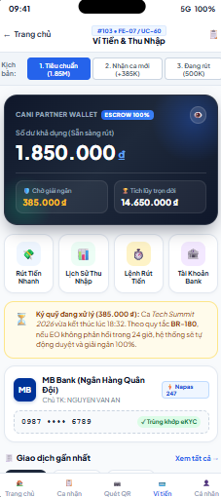
Figure 3.103: Wireframe Mockup of Screen #103 (Worker Wallet)
User Actions:
• Worker opens the wallet and reviews the available balance, pending disbursement and lifetime earnings; can hide or show amounts with the eye icon.
• Uses the quick actions to withdraw money (SCR-105), view income history (SCR-104), view withdrawal orders (SCR-106) or manage bank accounts (SCR-108).
• Reads the escrow processing notice for shifts whose payment is waiting for Event Organizer confirmation.
• Reviews the linked bank account (masked number, eKYC match status) used for withdrawals.
• Scrolls to the recent transactions list and taps "Xem tất cả" to open the full transaction history.
Field Description:
Field Name | Control / Type | Required | Description & Validation Rules
Available Balance | Currency / Display | Yes | Balance ready for withdrawal in VND (e.g., 1.850.000đ), with an "ESCROW 100%" badge showing funds are secured.
Balance Visibility Toggle | Icon Button | No | Hides or reveals the balance amounts on screen.
Pending Disbursement | Currency / Display | Yes | Total pay waiting for release from escrow after shift completion (e.g., 385.000đ).
Lifetime Earnings | Currency / Display | Yes | Total income earned since joining the platform (e.g., 14.650.000đ).
Quick Action Buttons | Icon Button Group | Yes | Four shortcuts: "Rút Tiền Nhanh" (SCR-105), "Lịch Sử Thu Nhập" (SCR-104), "Lệnh Rút Tiền" (SCR-106) and "Tài Khoản Bank" (SCR-108).
Escrow Processing Notice | Info Banner | No | Shown while a shift payment is in escrow processing: amount, shift name, end time and the rule that payment is auto-approved and released if the Event Organizer does not respond within 24 hours.
Linked Bank Account Card | Info Card | Yes | Bank name, masked account number, account holder and verification badge ("Trùng khớp eKYC", "Napas 247") for the default withdrawal account.
Recent Transactions | List | No | Latest income and withdrawal transactions with amount, date and status.
View All Link | Hyperlink | No | "Xem tất cả →" opens full history (SCR-104).
Demo Scenario Switch | Segmented Tab | No | Prototype-only control to preview mockup states (1. Tiêu chuẩn, 2. Nhận ca mới, 3. Đang rút). Shows the wallet in different balance conditions. Not part of the production UI.
Bottom Navigation Bar | Persistent Tab Bar | Yes | 5-tab persistent app navigation bar (Trang chủ, Ca nhận, Quét QR, Ví tiền, Cá nhân); highlights the current module.

3.28 SCR-104: Income History
Mapped Use Cases: UC-60, UC-64
View the list of shift payouts (event, date, hours, hourly rate, allowances, net payout, status) by month and open a detailed paystub.

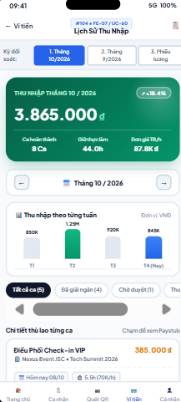
Figure 3.104: Wireframe Mockup of Screen #104 (Income History)
User Actions:
• Worker opens Income History and reviews the monthly income summary (total income, completed shifts, worked hours, average hourly rate).
• Switches between periods (current month, previous month or payslips) and uses the arrows to move between months.
• Reads the weekly income bar chart to compare earnings across weeks.
• Filters the shift payout list by status (all shifts, disbursed, pending approval).
• Taps a payout item to view the payslip (paystub) with the pay breakdown and platform fee.
Field Description:
Field Name | Control / Type | Required | Description & Validation Rules
Period Tabs | Tab Bar | Yes | Reconciliation period: Tháng 10/2026, Tháng 9/2026 and Phiếu lương (payslips). Defaults to the current month.
Monthly Income | Currency / Display | Yes | Total income for the selected month in VND (e.g., 3.865.000đ) with the change versus the previous month (e.g., +18.4%).
Completed Shifts | Number / Display | Yes | Number of shifts completed in the month (e.g., 8 ca).
Worked Hours | Number / Display | Yes | Total hours worked in the month (e.g., 44.0h).
Average Hourly Rate | Currency / Display | Yes | Average hourly wage in the month (e.g., 87.8K đ).
Month Navigator | Date Navigator | Yes | Previous/next arrows and the selected month label (e.g., Tháng 10 / 2026); future months are disabled.
Weekly Income Chart | Bar Chart | Yes | Income per week of the month in VND (T1–T4) with the highest and current weeks highlighted.
Status Filter Chips | Filter Chips with Counts | No | Tất cả, Đã giải ngân (disbursed), Chờ duyệt (pending approval) and other statuses, each with a count.
Shift Payout Item | List Item | Yes | Shift name, payout amount (e.g., 385.000đ), organizer and event, date, worked hours and hourly rate (e.g., 5.5h (70K/h)). Tap to open the payslip.
Payslip Hint | Text / Display | No | "Chạm để xem Paystub" – indicates a payout item opens the payslip detail.
Bottom Navigation Bar | Persistent Tab Bar | Yes | 5-tab persistent app navigation bar (Trang chủ, Ca nhận, Quét QR, Ví tiền, Cá nhân); highlights the current module.

3.29 SCR-105: Request Withdrawal
Mapped Use Cases: UC-61, UC-65
Request withdrawal of an eligible amount using bank information for Finance review.
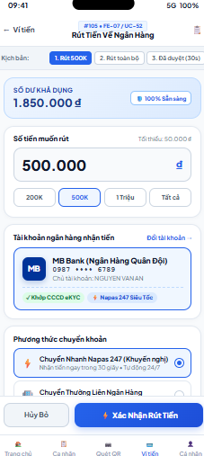
Figure 3.105: Wireframe Mockup of Screen #105 (Request Withdrawal)
User Actions:
• Worker reviews the available balance shown at the top of the form.
• Enters the withdrawal amount or taps a quick amount (200K, 500K, 1 Triệu, Tất cả).
• Checks the receiving bank account and taps "Đổi tài khoản →" to choose another account in SCR-108.
• Selects the transfer method: Napas 247 fast transfer (recommended, within about 30 seconds) or normal interbank transfer.
• Taps "Xác Nhận Rút Tiền" to create the withdrawal request, or "Hủy Bỏ" to leave; the system validates balance and bank information, then creates a request with pending status for Finance review (UC-61).
Field Description:
Field Name | Control / Type | Required | Description & Validation Rules
Available Balance | Currency / Display | Yes | Balance the worker can withdraw (e.g., 1.850.000đ) with a "100% Sẵn sàng" badge.
Withdrawal Amount | Numeric Input (VND) | Yes | Amount to withdraw. Minimum 50.000đ and not greater than the available balance; digits only, shown with thousand separators.
Quick Amount Chips | Chip Buttons | No | 200K, 500K, 1 Triệu and Tất cả; fill the amount field ("Tất cả" fills the full available balance).
Receiving Bank Account | Info Card with Link | Yes | Default bank account (bank, masked account number, holder name, eKYC match and Napas 247 badges). "Đổi tài khoản →" opens Bank Account Details (SCR-108). Withdrawal is blocked when no valid account is linked.
Transfer Method | Radio Group | Yes | "Chuyển Nhanh Napas 247" (recommended, received within 30 seconds, 24/7) or "Chuyển Thường Liên Ngân Hàng". Default is Napas 247.
Cancel Button | Secondary Button | Yes | "Hủy Bỏ" – discards the form and returns to the previous screen.
Confirm Button | Primary Button | Yes | "Xác Nhận Rút Tiền" – validates the form and creates the withdrawal request (pending Finance review), then opens Withdrawal Details (SCR-107).
Demo Scenario Switch | Segmented Tab | No | Prototype-only control to preview mockup states (1. Rút 500K, 2. Rút toàn bộ, 3. Đã duyệt (30s)). Pre-fills different withdrawal cases. Not part of the production UI.

3.30 SCR-106: Withdrawal History
Mapped Use Cases: UC-60, UC-61
View previous withdrawal requests and their processing status.
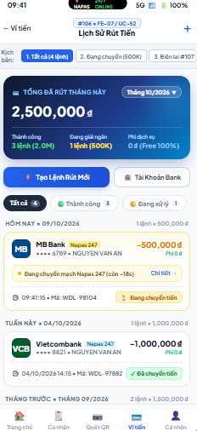
Figure 3.106: Wireframe Mockup of Screen #106 (Withdrawal History)
User Actions:
• Worker opens Withdrawal History and reviews the month's totals: total withdrawn, successful orders, processing orders and service fees.
• Changes the month with the month dropdown.
• Filters withdrawal orders by status (Tất cả, Thành công, Đang xử lý).
• Reviews withdrawal orders grouped by period (Hôm nay, Tuần này, Tháng trước), including live transfer progress for orders still being processed.
• Taps an order or "Chi tiết" to open Withdrawal Details (SCR-107), taps "Tạo Lệnh Rút Mới" (or +) to open Request Withdrawal (SCR-105), or "Tài Khoản Bank" to manage bank accounts (SCR-108).
Field Description:
Field Name | Control / Type | Required | Description & Validation Rules
Monthly Summary Card | Summary Card | Yes | Total amount withdrawn in the selected month (e.g., 2,500,000đ) with count and amount of successful orders, processing orders and service fees (e.g., 0đ, Free 100%).
Month Dropdown | Dropdown / Select | No | Selects the month for the summary and list; defaults to the current month.
Create Withdrawal Button | Primary Button | Yes | "Tạo Lệnh Rút Mới" – opens Request Withdrawal (SCR-105). The "+" icon in the header does the same.
Bank Account Button | Secondary Button | No | "Tài Khoản Bank" – opens Bank Account Details (SCR-108).
Status Filter Chips | Filter Chips with Counts | No | Tất cả, Thành công (completed) and Đang xử lý (processing), each with the number of orders.
Period Group Header | Text / Display | Yes | Groups orders by Hôm nay, Tuần này and Tháng trước with the date, order count and total amount.
Withdrawal Order Item | List Item | Yes | Bank name and logo, transfer channel badge (Napas 247), masked account and holder name, amount (e.g., −500,000đ), fee, order creation time and code (e.g., WDL-98104).
Order Status Badge | Status Badge | Yes | Order state such as Đang chuyển tiền (processing) or Đã chuyển tiền (completed).
Transfer Progress Banner | Info Banner | No | Live progress for orders in transit (e.g., "Đang chuyển mạch Napas 247 (còn ~18s)") with a "Chi tiết" link.
Demo Scenario Switch | Segmented Tab | No | Prototype-only control to preview mockup states (1. Tất cả, 2. Đang chuyển, 3. Biên lai). Previews list states. Not part of the production UI.
Bottom Navigation Bar | Persistent Tab Bar | Yes | 5-tab persistent app navigation bar (Trang chủ, Ca nhận, Quét QR, Ví tiền, Cá nhân); highlights the current module.

3.31 SCR-107: Withdrawal Details
Mapped Use Cases: UC-60, UC-61
View a withdrawal’s amount, bank information,tracking code, processing status and review outcome.
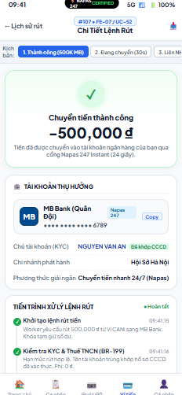
Figure 3.107: Wireframe Mockup of Screen #107 (Withdrawal Details)

User Actions:

• The worker opens a withdrawal order and reads the result banner showing the status, amount and transfer channel.

• Reviews the beneficiary account (bank, masked number, holder name, KYC match, branch and disbursement method), and copies the account number when needed.

• Follows the processing timeline step by step (order created, KYC and tax check, transfer, completion) with timestamps.

• Exports or downloads the receipt with the icon in the header.

• Returns to Withdrawal History using the back button.

Field Description:
Field Name | Control / Type | Required | Description & Validation Rules
Result Banner | Status Banner | Yes | Order outcome and message (e.g., "Chuyển tiền thành công"), withdrawn amount (e.g., −500,000đ) and the channel and processing time used (e.g., Napas 247 Instant, 24 seconds). Shows processing or failure states with matching colors.
Withdrawal Code | Text / Display | Yes | Unique order reference (e.g., WDL-98104).
Beneficiary Account | Info Card | Yes | Receiving bank name and logo, channel badge (Napas 247) and masked account number.
Copy Account Button | Button | No | "Copy" – copies the account number to the clipboard.
Account Holder (KYC) | Text / Badge | Yes | Account holder name with the "Đã khớp CCCD" badge indicating a match with the eKYC identity.
Issuing Branch | Text / Display | Yes | Bank branch that issued the account.
Disbursement Method | Text / Display | Yes | Transfer method used (e.g., Chuyển tiền nhanh 24/7 (Napas)).
Processing Timeline | Timeline / Display | Yes | Ordered steps with time and note: order created and balance temporarily held, KYC and personal income tax check, bank transfer, and completion. Failed steps show the reason and refund of the held balance.
Export Receipt Button | Icon Button | No | Downloads or shares the withdrawal receipt.
Demo Scenario Switch | Segmented Tab | No | Prototype-only control to preview mockup states (1. Thành công, 2. Đang chuyển, 3. Liên ngân hàng). Previews each order state. Not part of the production UI.

3.32 SCR-108: Bank Account Details
Mapped Use Cases: UC-65
View and update bank information used for withdrawals.
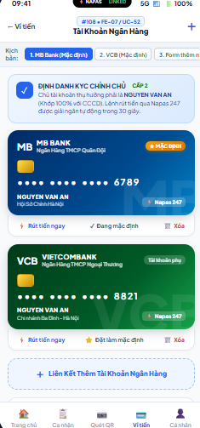
Figure 3.108: Wireframe Mockup of Screen #108 (Bank Account Details)
User Actions:

• Worker reviews the eKYC identity banner explaining that the receiving account holder must match the verified identity.

• Views linked bank accounts displayed as cards (default and secondary), each with masked number, holder name and branch.

• Taps "Rút tiền ngay" on a card to withdraw to that account (SCR-105).

• Taps "Đặt làm mặc định" to change the default account or "Xóa" to remove an account after confirmation.

• Taps "Liên Kết Thêm Tài Khoản Ngân Hàng" (or +) to add a new account; the system validates the details against the eKYC identity before saving.

Field Description:
Field Name | Control / Type | Required | Description & Validation Rules
KYC Identity Banner | Info Banner | Yes | Shows the verification level (e.g., Cấp 2) and the rule that the account holder name must match the CCCD. Napas 247 withdrawals are disbursed within about 30 seconds.
Bank Account Card | Info Card | Yes | Bank name and logo, account type, masked account number, holder name in capitals, branch and Napas 247 badge.
Default Badge | Status Badge | Yes | "Mặc định" marks the default withdrawal account; other accounts show "Tài khoản phụ". Exactly one default account exists.
Withdraw Now Link | Hyperlink | No | "Rút tiền ngay" – opens Request Withdrawal (SCR-105) with this account preselected.
Set Default Link | Hyperlink | No | "Đặt làm mặc định" – makes the account the default; the current default shows "Đang mặc định".
Delete Link | Hyperlink | No | "Xóa" – removes the account after confirmation; the default account cannot be removed while it is the only one.
Add Bank Account Button | Dashed Action Button | No | "Liên Kết Thêm Tài Khoản Ngân Hàng" – opens the add-account form. The "+" icon in the header does the same.
Add Account Form | Dropdown & Text Inputs | Yes (when adding) | Bank selection, account number (digits only) and account holder name. The holder name must match the eKYC name; the account is saved only after validation passes.
Demo Scenario Switch | Segmented Tab | No | Prototype-only control to preview mockup states (1. MB Bank (Mặc định), 2. VCB (Mặc định), 3. Form thêm mới). Previews account list and add form. Not part of the production UI.

3.33 SCR-109: My Disputes
Mapped Use Cases: UC-71, UC-72
View list of disputes
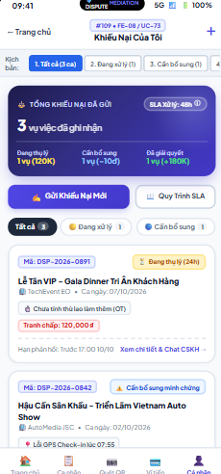
Figure 3.109: Wireframe Mockup of Screen #109 (My Disputes)
User Actions:
• Worker opens My Disputes and reviews the summary of submitted disputes by status (in progress, needs more evidence, resolved) and the 48-hour handling SLA.
• Filters the list by status (Tất cả, Đang xử lý, Cần bổ sung).
• Reviews each dispute card (code, status, shift, organizer, issue, disputed amount and response deadline).
• Taps "Xem chi tiết & Chat Customer Care" to open Dispute Details (SCR-110) and follow Customer Care handling (UC-72).
• Taps "Gửi Khiếu Nại Mới" (or +) to open Submit Dispute (SCR-111), or "Quy Trình SLA" to read the dispute handling process.
Field Description:
Field Name | Control / Type | Required | Description & Validation Rules
Dispute Summary Card | Summary Card | Yes | Total disputes submitted (e.g., 3 vụ việc), the "SLA xử lý: 48h" badge and counts by status: Đang thụ lý, Cần bổ sung, Đã giải quyết, each with the amount or points at stake.
Submit New Dispute Button | Primary Button | Yes | "Gửi Khiếu Nại Mới" – opens Submit Dispute (SCR-111). The "+" icon in the header does the same.
SLA Process Button | Secondary Button | No | "Quy Trình SLA" – shows how disputes are received, investigated and resolved and the time limits.
Status Filter Chips | Filter Chips with Counts | No | Tất cả, Đang xử lý and Cần bổ sung (and Đã giải quyết), each with the number of disputes.
Dispute Code | Text / Display | Yes | Unique dispute reference (e.g., DSP-2026-0891).
Dispute Status Badge | Status Badge | Yes | Current state such as Đang thụ lý (with remaining handling time) or Cần bổ sung minh chứng.
Shift & Organizer | Text / Display | Yes | Shift title, Event Organizer and shift date the dispute relates to.
Issue Tag | Tag / Display | Yes | Dispute reason (e.g., "Chưa tính thù lao làm thêm (OT)").
Disputed Amount | Currency / Display | Yes | Amount under dispute in VND (e.g., Tranh chấp: 120,000đ).
Response Deadline | Text / Display | No | Deadline to respond or supply evidence (e.g., "Hạn phản hồi: Trước 17:00 10/10").
Detail Link | Hyperlink | Yes | "Xem chi tiết & Chat Customer Care →" – opens Dispute Details (SCR-110).
Demo Scenario Switch | Segmented Tab | No | Prototype-only control to preview mockup states (1. Tất cả, 2. Đang xử lý, 3. Cần bổ sung). Previews list states. Not part of the production UI.
Bottom Navigation Bar | Persistent Tab Bar | Yes | 5-tab persistent app navigation bar (Trang chủ, Ca nhận, Quét QR, Ví tiền, Cá nhân); highlights the current module.

3.34 SCR-110: Dispute Details
Mapped Use Cases: UC-71, UC-72
View dispute details
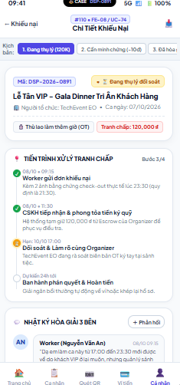
Figure 3.110: Wireframe Mockup of Screen #110 (Dispute Details)
User Actions:
• Worker opens a dispute and reviews its code, status, shift, organizer, issue and disputed amount.
• Follows the resolution timeline (submitted, received by Customer Care with escrow held, reconciliation with the Event Organizer, final decision and refund) and the current step.
• Reads the three-party mediation log containing messages from the worker, Customer Care and the Event Organizer.
• Taps "+ Phản hồi" to reply or add information or evidence requested by Customer Care.
• Saves or shares the dispute record with the icon in the header and returns to My Disputes with the back button.
Field Description:
Field Name | Control / Type | Required | Description & Validation Rules
Dispute Code | Text / Display | Yes | Unique dispute reference (e.g., DSP-2026-0891).
Dispute Status Badge | Status Badge | Yes | Current state (e.g., Đang thụ lý đối soát, Cần bổ sung minh chứng, Đã hòa giải).
Shift & Organizer | Text / Display | Yes | Shift title, Event Organizer and shift date.
Issue Tag | Tag / Display | Yes | Dispute reason (e.g., "Thù lao làm thêm giờ (OT)").
Disputed Amount | Currency / Display | Yes | Amount under dispute in VND (e.g., Tranh chấp: 120,000đ).
Resolution Timeline | Step Timeline | Yes | Handling steps with date, time and note, and a step counter (e.g., Bước 3/4): worker submission, Customer Care receipt and escrow hold, reconciliation with the Event Organizer (with deadline), final decision and refund (estimated time).
Mediation Log | Message Thread | Yes | Chronological messages from Worker, Customer Care and Event Organizer with sender, time and content.
Reply Button | Button | No | "+ Phản hồi" – opens a reply box to add a message or evidence. Disabled once the dispute is closed.
Export Button | Icon Button | No | Downloads or shares the dispute record.
Demo Scenario Switch | Segmented Tab | No | Prototype-only control to preview mockup states (1. Đang thụ lý, 2. Cần minh chứng, 3. Đã hòa giải). Previews each dispute state. Not part of the production UI.

3.35 SCR-111: Submit Dispute
Mapped Use Cases: UC-71
Submit new dispute
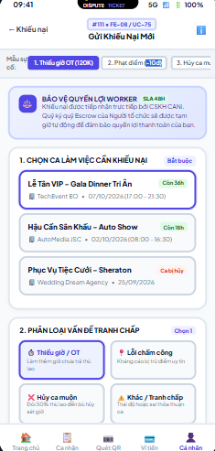
Figure 3.111: Wireframe Mockup of Screen #111 (Submit Dispute)
User Actions:
• Worker reads the worker protection notice (disputes are handled directly by Customer Care within 48 hours and the organizer's escrow stays held while a case is open).
• Selects the shift to dispute from the recent shifts list; each item shows the time left to dispute.
• Chooses the dispute category (Thiếu giờ / OT, Lỗi chấm công, Hủy ca muộn, Khác / Tranh chấp).
• Enters a detailed description and attaches supporting evidence (photos, screenshots or documents).
• Submits the dispute; the system validates the required fields and evidence (BR-64) and notifies Customer Care for mediation.
Field Description:
Field Name | Control / Type | Required | Description & Validation Rules
Worker Protection Notice | Info Banner | No | Explains that disputes go directly to Customer Care with a 48-hour SLA and that the organizer's escrow stays held for fair settlement.
Disputed Shift | Selectable List | Yes | Shift the dispute concerns: title, event/organizer, date and time, and the remaining time to dispute (e.g., "Còn 36h"). Shifts outside the dispute window or cancelled can be marked accordingly. Exactly one shift must be selected.
Dispute Category | Option Cards (single choice) | Yes | Thiếu giờ / OT, Lỗi chấm công, Hủy ca muộn, Khác / Tranh chấp. Exactly one must be chosen.
Description | Text Area | Yes | Detailed factual narrative of the issue. Minimum 30 characters and maximum 500 characters; a live counter is shown.
Evidence Upload | File Upload / Camera | Yes | At least one verifiable item (screenshots, incident photos, time logs) per BR-64. Accepted formats JPG, PNG, PDF; up to 5MB per file.
Submit Dispute Button | Primary Button | Yes | Validates all required fields and evidence, creates the dispute with a unique code and sends it to Customer Care.
Quick Fill Templates | Segmented Tab | No | Demo shortcuts (1. Thiếu giờ OT (120K), 2. Phạt điểm (−10đ), 3. Hủy ca muộn) that pre-fill the form. Not part of the production UI.

3.36 SCR-112: Reliability Score
Mapped Use Cases: UC-73, UC-74, UC-75
View the current reliability score and tier, tier privileges and score history; open penalty appeal or request account unlock
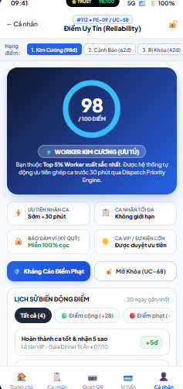
Figure 3.112: Wireframe Mockup of Screen #112 (Reliability Score)
User Actions:
• Worker opens Reliability Score and reviews the current score on the gauge, the reliability tier label and its status message.
• Reads the privileges that apply to the current tier (priority shift access, shift limit, escrow deposit, VIP and large-event priority).
• Taps "Kháng Cáo Điểm Phạt" to open Penalty Appeal (SCR-113) for a recent penalty (UC-74).
• Taps "Mở Khóa" to request account unlock; available only when the penalty period has expired or an appeal was approved (UC-75).
• Reviews the score history of the last 30 days and filters it by all, points gained or points deducted.
Field Description:
Field Name | Control / Type | Required | Description & Validation Rules
Reliability Score Gauge | Circular Gauge | Yes | Current reliability score out of 100 (e.g., 98 / 100 điểm).
Reliability Tier Badge | Status Badge | Yes | Tier derived from the score range (UC-73: Tốt 80–100, Bình Thường 60–79, Cảnh Báo 40–59, Nguy Hiểm 20–39, Cấm below 20), shown with the matching rank label (e.g., "Worker Kim Cương").
Tier Status Message | Text / Display | Yes | Short explanation of the worker's standing (e.g., Top 5% of workers) and effects on dispatch priority.
Privilege Tiles | Info Tiles | Yes | Four benefit tiles that change with the tier: Ưu tiên nhận ca, Ca nhận tối đa, Bảo đảm ví (ký quỹ) and Ca VIP / Sự kiện lớn.
Appeal Penalty Button | Primary Button | No | "Kháng Cáo Điểm Phạt" – opens Penalty Appeal (SCR-113). Available within 48 hours of a penalty.
Unlock Button | Secondary Button | No | "Mở Khóa (UC-75)" – requests account unlock. Enabled only when the account is locked and the penalty period has expired or an appeal was approved.
History Period Label | Text / Display | Yes | Time range of the history list (30 ngày gần nhất).
History Filter Chips | Filter Chips with Counts | No | Tất cả, Điểm cộng (points gained) and Điểm phạt (points deducted), each with its total.
Score History Item | List Item | Yes | Reason for the change (e.g., "Hoàn thành ca tốt & nhận 5 sao"), related shift and date, and points gained (+5đ) or deducted.
Demo Scenario Switch | Segmented Tab | No | Prototype-only control to preview mockup states (1. Kim Cương (98đ), 2. Cảnh Báo (62đ), 3. Bị Khóa (42đ)). Previews each reliability tier. Not part of the production UI.
Bottom Navigation Bar | Persistent Tab Bar | Yes | 5-tab persistent app navigation bar (Trang chủ, Ca nhận, Quét QR, Ví tiền, Cá nhân); highlights the current module.

3.37 SCR-113: Penalty Appeal
Mapped Use Cases: UC-74
Submit an appeal with reasons and evidence and view the appeal outcome.
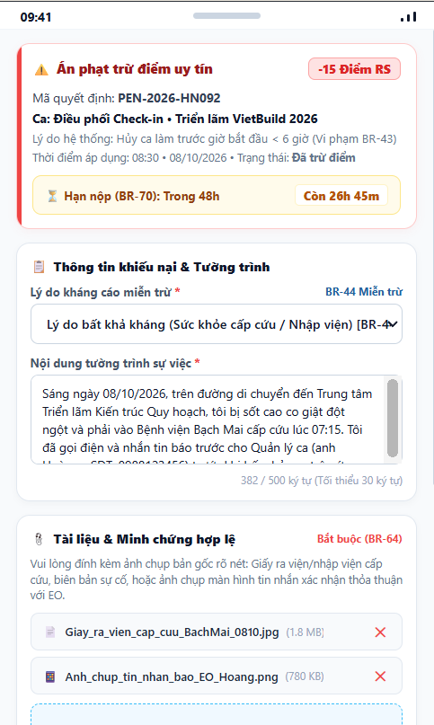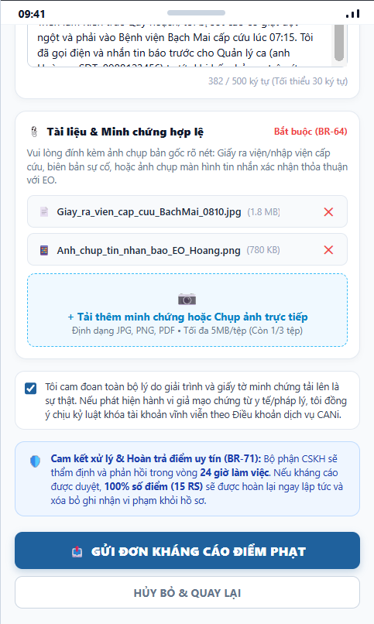
Figure 3.113: Wireframe Mockup of Screen #113 (Penalty Appeal)
User Actions:
• Worker opens the appeal form for a penalty (within 48 hours of the penalty) and reviews the penalty being appealed.
• Writes a detailed justification explaining why the penalty is unjustified.
• Attaches supporting evidence (e.g., hospital documents, incident record, or a message screenshot) by uploading files or taking a photo directly.
• Ticks the declaration that all reasons and documents are truthful.
• Taps "Gửi Đơn Kháng Cáo Điểm Phạt" to submit, or "Hủy Bỏ & Quay Lại" to leave; Customer Care reviews the appeal within the 24-business-hour SLA and restores or maintains the score (BR-71).
Field Description:
Field Name | Control / Type | Required | Description & Validation Rules
Penalty Information | Info Card | Yes | Penalty being appealed (reason, shift, points deducted and date), shown at the top of the form. An appeal is accepted only within 48 hours of the penalty (UC-74).
Appeal Reason | Text Area | Yes | Detailed justification. Minimum 30 characters and maximum 500 characters; a live counter is shown (e.g., 382 / 500).
Evidence Upload | File Upload / Camera | Yes | At least one valid document is mandatory (BR-64). Accepted formats JPG, PNG, PDF; up to 5MB per file and up to 3 files. Each file shows its name and size and can be removed with the ✕ button.
Add Evidence Button | Dashed Upload Area | No | "+ Tải thêm minh chứng hoặc Chụp ảnh trực tiếp" – adds files from the device or camera while the 3-file limit has not been reached.
Truthfulness Declaration | Checkbox | Yes | Worker confirms the reasons and documents are truthful and accepts account suspension under the Terms of Service for forged evidence. Must be ticked to submit.
Commitment Notice | Info Banner | No | Reminds the worker that Customer Care responds within 24 working hours and that an approved appeal restores 100% of deducted points and removes the infraction record (BR-71).
Submit Appeal Button | Primary Button | Yes | "Gửi Đơn Kháng Cáo Điểm Phạt" – validates the form and sends the appeal to Customer Care; the appeal status then appears in the score history.
Cancel Button | Secondary Button | Yes | "Hủy Bỏ & Quay Lại" – discards the form and returns to Reliability Score (SCR-112).

4. Background Job Inventory

5.1 Shift Proposal Expiry (JOB-01)
Trigger: Scheduled — every 1 minute
Purpose: Scans all active shift proposals, identifies proposals whose timeout window has elapsed without worker response, marks them as EXPIRED, and releases any associated soft-holds.
Processing steps:
1. Query database for all Shift Proposals with status = PENDING and expiration_timestamp <= CURRENT_TIMESTAMP.
2. For each expired proposal: update status to EXPIRED.
3. Release soft-hold lock on the Worker for the corresponding Shift.
4. Trigger Dispatch Priority Engine (FE-08) to evaluate candidate queue and dispatch replacement proposal to next ranked worker.
5. Log the total number of expired proposals and subsequent dispatches executed in this run.
Failure behavior:
Scenario | System behavior
Database connection timeout | Job retries with exponential backoff up to 3 times. Unprocessed proposals remain PENDING and are handled on next run.
Zero expired proposals found | Job completes immediately with no database mutation — normal expected behavior.

5.2 Soft-Hold Release (JOB-02)
Trigger: Scheduled — every 2 minutes
Purpose: Releases temporary soft-hold reservations placed on Workers who were eligible for multiple shifts within an event, ensuring workers do not remain locked indefinitely.
Processing steps:
1. Query all active Soft-Hold records where hold_expiration_timestamp <= CURRENT_TIMESTAMP.
2. For each expired hold: delete the reservation record and set Worker availability state back to UNLOCKED.
3. Re-evaluate Event-level dispatch queues for waiting shifts.
4. Log number of released soft-holds.
Failure behavior:
Scenario | System behavior
Lock release contention | Uses row-level pessimistic locking (`SELECT FOR UPDATE SKIP LOCKED`) to prevent race conditions with concurrent worker acceptances.
Database unreachable | Soft-holds expire naturally on the next successful job run; max impact is a 2-minute delay in re-dispatch.

5.3 Event Readiness Check & Alert (JOB-03)
Trigger: Scheduled — every 30 minutes
Purpose: Calculates the aggregated Event Readiness Score across all shifts for upcoming events starting within 72 hours, sending automated warning alerts when staffing falls below safety thresholds.
Processing steps:
1. Find all active Events scheduled to start within the next 72 hours.
2. For each event: calculate Confirmed Workers / Required Workers ratio across all shifts.
3. Compute composite Event Readiness Score factoring time-to-start and remaining vacant slots.
4. If readiness score < 70% within 24h of start: generate HIGH_PRIORITY alert to Event Organizer via FCM push notification and email.
5. Record readiness metrics in daily operational analytics ledger.
Failure behavior:
Scenario | System behavior
FCM push delivery failure | Alert is logged in system notification inbox regardless of push gateway status; email fallback is dispatched.
No events in 72h window | Job completes with zero alerts logged.

5.4 Worker Reliability Score Recalculation (JOB-04)
Trigger: Event-driven / Scheduled hourly
Purpose: Recalculates Worker Reliability reputation scores (0-100) based on historical performance, shift completion records, bilateral ratings, late cancellations, and confirmed no-shows.
Processing steps:
1. Identify all Workers who completed a shift, cancelled an assignment, or had a no-show confirmed within the last hour.
2. Retrieve historical 90-day activity records for each worker.
3. Compute weighted Reliability Score: Base (50) + Completion Bonus (+2/shift) + Rating Bonus (+/-) - Late Cancellation Penalty (-10) - No-Show Penalty (-25).
4. Clamp score between 0 and 100 points.
5. If score falls below 50: automatically transition worker account to LOCKED status and send warning notification.
6. Update Worker record and record audit entry in ReliabilityLog table.
Failure behavior:
Scenario | System behavior
Worker record locked by concurrent transaction | Job retries after 5 seconds; updates persist accurately without data loss.
Database transaction failure | Rolls back calculation for affected worker; scheduled retry executes on next hourly run.

5.5 Unlock Expired Locked Accounts (JOB-05)
Trigger: Scheduled — every 15 minutes
Purpose: Automatically unlocks user accounts that were temporarily locked due to 5 consecutive failed login attempts once the 30-minute lockout period has elapsed.
Processing steps:
1. Query database for accounts with status = LOCKED and locked_until_timestamp <= CURRENT_TIMESTAMP.
2. For each account: reset failed login attempt counter to 0 and set status to ACTIVE.
3. Log the total number of unlocked accounts in the security audit trail.
Failure behavior:
Scenario | System behavior
Database unreachable | Job retries up to 3 times with 30-second intervals. Accounts remain locked until next successful run.
No locked accounts found | Job completes immediately with no action.

5. External API Inventory

5.1 VnPay Payment Webhook (API-01)
URL | POST: /api/v1/payment/webhook/vnpay
Purpose | Receives instant payment confirmation (IPN) from the VNPay payment gateway when an Event Organizer funds an event escrow deposit.
Caller | VNPay Payment Gateway
Auth | HMAC-SHA512 checksum validation against shared secret key

5.2 SePay Bank Transfer Webhook (API-02)
URL | POST: /api/v1/payment/webhook/sepay
Purpose | Receives automated bank transfer notifications from SePay when organizers or workers deposit funds via bank transfer.
Caller | SePay Banking Automation Gateway
Auth | API Token verification via HTTP Header (Authorization: Bearer <token>)

5.3 Firebase Cloud Messaging Push API (API-03)
URL | POST: https://fcm.googleapis.com/v1/projects/{project_id}/messages:send
Purpose | Outbound API called by CANi backend to dispatch real-time push notifications to the CANi Partner App (proposals, attendance alerts, cancellations).
Caller | CANi Backend Notification Service
Auth | Google OAuth2 Bearer Token (Service Account credentials)

5.4 SMTP Email Notification Service (API-04)
URL | SMTP / STARTTLS: smtp.sendgrid.net:587
Purpose | Outbound email service used to send 6-digit email verification OTP codes, password reset links, and formal dispute resolution decisions.
Caller | CANi Backend Mailer Service
Auth | SMTP Authentication (Username / API Key)

IV. Non-Functional Requirements

1. External Interfaces
This section specifies the hardware, software, and communication interfaces required to ensure that the CANi platform communicates reliably and seamlessly with external users, physical devices, third-party cloud services, and payment infrastructure.

1.1 User Interfaces (UI)
• Customer & Organizer Web Portal: Developed using modern responsive web design principles to support desktop and tablet viewports (optimal resolution 1920x1080, minimum supported resolution 1024x768). The interface provides intuitive dashboard navigation, real-time event staffing meters, drag-and-drop shift creation, interactive wage sliders, and dispute evidence viewers. Compatible with Google Chrome 110+, Microsoft Edge 110+, Mozilla Firefox 115+, and Apple Safari 16+.
• CANi Partner Mobile App: Native mobile application targeting iOS 15.0+ and Android 10.0+ (API level 29+). Designed for fast on-the-go interactions, the mobile UI features single-hand reachability, high-contrast shift proposal cards, instant countdown timers, one-tap accept/reject controls, camera-assisted QR check-in viewfinder, and clear earnings ledgers. High-contrast display mode is supported for outdoor event operations in bright sunlight.
• System Administration & Customer Care (Customer Care) Portal: Dedicated web console providing role-segregated controls for dispute arbitration, dynamic pricing rule configuration, soft-hold override controls, and audit log inspection.

1.2 Hardware Interfaces
• Worker Mobile Device Sensors: The CANi Partner App requires integration with the mobile device's native GPS / GNSS sensor (accurate within a 10–20 meter threshold) to perform geofence boundary validation upon event check-in. It also utilizes the device's auto-focus camera (minimum 5.0 Megapixels) for dynamic attendance QR scanning and document image capture during eKYC verification.
• On-site Organizer Check-in Terminal: A standard tablet or laptop device with continuous display output and active internet connectivity, situated at the event reception desk to present the dynamic, rotating QR check-in token (refreshed every 30 seconds).
• Production Server Infrastructure: Cloud virtual machine clusters (minimum configuration: 4 vCPU, 16 GB RAM per backend node, redundant SSD storage) hosted in tier-3 cloud data centers with automated horizontal scaling and multi-zone failover.

1.3 Software & Communications Interfaces
• Database & Caching Services: PostgreSQL 15+ relational database management system for ACID-compliant transactional consistency across user identities, event shifts, escrow allocations, and attendance logs. Redis 7+ in-memory data store for sub-millisecond session caching, soft-hold proposal locks, and dynamic QR token expiration countdowns.
• Secure Network Communications (HTTPS / TLS 1.3): All client-to-server and server-to-server data transfers are strictly encrypted using Transport Layer Security (TLS 1.3) over port 443 with HTTP Strict Transport Security (HSTS) enforced.
• Real-time Bi-directional Messaging (WebSocket / WSS): Persistent WebSocket connection channels for instant push updates of proposal acceptance countdowns, dynamic check-in counter increments, and soft-hold releases.
• External Gateway & Service APIs:
- VNPay & SePay Payment Gateways: RESTful HTTPS and Instant Payment Notification (IPN) webhooks with HMAC-SHA512 cryptographic signature validation for instant escrow top-ups and bank disbursements.
- Firebase Cloud Messaging (FCM): Outbound HTTP/v1 push notification API delivering automated shift proposal dispatches, attendance reminders, and schedule updates to mobile workers within 2 seconds.
- SendGrid SMTP Service: Encrypted SMTP/STARTTLS mail relay service for account verification OTP codes, password recovery tokens, and formal dispute resolution notices.

2. Quality Attributes
This section specifies the qualitative non-functional capabilities of the CANi system, encompassing usability, response performance, information security, and platform reliability.

2.1 Usability Requirements
• Learnability & Onboarding: A novice Event Organizer shall be capable of creating an account, defining an event, configuring a shift, and depositing escrow within 3 minutes without formal training. A freelance worker shall be able to complete identity verification within 4 minutes.
• Task Operational Efficiency: Freelance workers shall be able to inspect a shift proposal and accept or decline it within 2 screen interactions (under 5 seconds). The on-site attendance QR check-in process shall take no more than 15 seconds from camera activation to confirmed green checkmark.
• Error Tolerance & Input Guardrails: All form inputs (shift dates, headcounts, wage values) must enforce instant client-side validation with explicit inline guidance to prevent invalid submissions (e.g., negative wages, start times in the past, or empty required fields).
• Accessibility Standards: All web and mobile interfaces shall adhere to WCAG 2.1 Level AA accessibility guidelines, ensuring a minimum contrast ratio of 4.5:1 for normal text and supporting screen magnification up to 200% without loss of content.

2.2 Performance Requirements
The CANi platform must deliver rapid response times, handle peak concurrency during major weekend events, and process dispatch matching without latency bottlenecks. The key performance metrics are specified in the table below:

Requirement ID | Performance Metric | Target Threshold | Workload / Operational Condition
NFR-PER-01 | Web Page Initial Load Time | ≤ 1.5 seconds | 95th percentile under 500 concurrent active users
NFR-PER-02 | Core REST API Response Latency | ≤ 400 milliseconds | Standard CRUD queries (event details, user profile, shift roster)
NFR-PER-03 | Dispatch Proposal Engine Latency | ≤ 3.0 seconds | Ranking and dispatching proposals to up to 200 eligible workers (FE-03/FE-08)
NFR-PER-04 | Dynamic QR Code Generation & Refresh | ≤ 500 milliseconds | Automated token rotation cycle every 30 seconds at check-in station
NFR-PER-05 | Check-in Validation & Geofence Scan | ≤ 1.0 second | Mobile camera QR decode + GPS coordinates distance calculation
NFR-PER-06 | System Peak Concurrency | 2,000 active sessions | Concurrent platform users during peak Friday-evening event staffing
NFR-PER-07 | Database Transaction Throughput | ≥ 500 TPS | ACID transactional writes for escrow operations and check-in logs
NFR-PER-08 | Mobile Push Notification Delivery | ≤ 2.0 seconds | From proposal trigger to worker device banner via Firebase FCM

2.3 Security Requirements
Information security, financial transaction integrity, and identity fraud prevention are paramount to the CANi platform. The mandatory security specifications are detailed in the table below:
Requirement ID | Security Dimension | Specification & Protection Standard
NFR-SEC-01 | User Authentication & Credential Storage | User passwords must be cryptographically hashed using bcrypt (work factor ≥ 12) or Argon2id with unique salts. Plaintext passwords must never be stored, logged, or transmitted. Sessions use signed JSON Web Tokens (JWT, HMAC-SHA256, 15-minute lifespan) paired with rotating refresh tokens (7-day lifespan).
NFR-SEC-02 | Brute-Force & Lockout Policy | Accounts are automatically locked for 15 minutes following 5 consecutive failed login attempts. Rate limiting is strictly enforced on all public authentication and OTP endpoints (maximum 5 requests per minute per IP address).
NFR-SEC-03 | Role-Based Access Control (RBAC) | Server-side authorization verifies role permissions on every request. Organizers can only inspect and manage their own events; Workers can only access their dispatched shifts and personal wallet; Customer Care can only mediate assigned disputes; Platform Admin has system-wide access. Insecure Direct Object References (IDOR) are prohibited.
NFR-SEC-04 | Data Encryption at Rest & in Transit | All external data transit requires HTTPS / TLS 1.3 with strong ciphers. Sensitive user personally identifiable information (worker CCCD numbers, bank account numbers, eKYC photos) is encrypted at rest using AES-256 in compliance with privacy regulations.
NFR-SEC-05 | Financial Escrow Integrity & Non-repudiation | All monetary transactions (deposits, escrow locks, payouts, refunds, dispute arbitrations) are recorded in an immutable, append-only double-entry bookkeeping ledger with cryptographic checksums.
NFR-SEC-06 | Anti-Spoofing & Geolocation Integrity | The mobile client enforces native mock-location detection. The server verifies that GPS coordinates fall within the organizer's 100m geofence radius and checks dynamic QR token validity within its 30-second window to prevent attendance fraud.
NFR-SEC-07 | Input Validation & Vulnerability Defense | All input parameters are sanitized and validated against whitelist rules. Parameterized SQL queries (prepared statements) prevent SQL Injection. Content Security Policy (CSP), CORS, and HttpOnly/SameSite cookie flags mitigate XSS and CSRF attacks.

2.4 Reliability, Availability & Maintainability
• High Availability SLA: The platform shall maintain an operational uptime SLA of at least 99.5% during core operating hours (06:00 to 24:00 GMT+7 daily), corresponding to less than 5.4 hours of unscheduled downtime per month.
• Fault Tolerance & Resilient Background Tasks: Transient failures in external payment webhooks (VNPay/SePay) or push notifications (FCM) shall be handled by asynchronous worker retry queues employing exponential backoff with a Dead Letter Queue (DLQ), ensuring zero transaction loss.
• Database Backup & Disaster Recovery: Automated daily full database backups with hourly transaction log replication. The system ensures a Recovery Point Objective (RPO) ≤ 1 hour and a Recovery Time Objective (RTO) ≤ 2 hours in the event of an infrastructure outage.
• Modularity & Code Maintainability: Built on a modular service architecture with comprehensive OpenAPI/Swagger documentation, Docker containerization, and centralized application telemetry logging for rapid diagnostics and independent component scaling.

V. Requirement Appendix

1. Business Rules
This section compiles the comprehensive catalog of business rules governing the operations, state transitions, matching logic, financial transactions, attendance integrity, and dispute resolutions across the CANi platform. Each rule is assigned a unique identifier (BR-01 through BR-265) and directly referenced within the Use Case Specifications in Part II to ensure full requirements traceability.

ID | Rule Name | Rule Definition
BR-01 | Account Identity Uniqueness | Each email address and phone number must be uniquely registered to a single user account. A natural person may not hold both Worker and Event Organizer roles under the same email.
BR-02 | Password Security Standards | Passwords must be at least 8 characters with one uppercase letter, one digit, and one special character. Stored as bcrypt hash; plaintext storage is prohibited.
BR-03 | EO Account Approval | EO accounts are PENDING after email verification. CC must review organization details and documents before account is set to ACTIVE. EO cannot create events or post shifts until ACTIVE.
BR-04 | OTP Security | Email OTPs are 6-digit, valid for 10 minutes, and single-use. Maximum 3 resend requests per 10-minute window. 5 failed OTP attempts within 10 minutes triggers a 15-minute cooldown.
BR-05 | Soft Delete Policy | Users, Events, Shifts, and Assignments are never hard-deleted. Deletion sets status to DELETED or ARCHIVED. Deleted records are excluded from all search results and public views.
BR-06 | Session Limits | One active session per user on Partner App. Web App permits up to 3 concurrent sessions. Admin may force-terminate all sessions for any account.
BR-07 | Event Scheduling Horizon | Event start time must be at least 24 hours after creation. Only ACTIVE events that have not yet started appear in search results and Worker Job Feed.
BR-08 | Subscription Quota Enforcement | The number of active Events and total Shifts an EO may maintain simultaneously is determined by their subscription package. Quota is enforced at Event creation and Shift creation time.
BR-09 | Data Ownership | All user-uploaded content is stored on platform infrastructure. Users retain intellectual property rights but grant the platform a non-exclusive licence to store, process, and display content for platform purposes.
BR-10 | Wage Floor | Minimum wage for any shift is 25,000 VND per hour. EOs may not post shifts below this floor. Admin may update the floor value via System Configuration.
BR-11 | Wage Matrix Lookup | Wage recommendations are derived from a 4-dimensional matrix: City × Job Type × Time Slot × Lead Time. Fallback order: drop Lead Time → drop Time Slot → drop Job Type → use platform default. Admin manages matrix via Wage Matrix page.
BR-12 | EO Wage Authority | EOs have full authority to set the final shift wage regardless of the system recommendation. Set wage must be ≥ wage floor. Once a shift is ACTIVE with accepted assignments, wage may not be reduced.
BR-13 | Verification Requirement for Dispatch | Workers with at least Self-Declared verification on one or more relevant skill tags are eligible to receive shift proposals. CCCD verification is required for account activation but does not block dispatch. Higher tiers improve Match Score and Tier badge.
BR-14 | CCCD Requirement for Account Activation | Workers must pass eKYC verification during registration. PENDING accounts cannot receive proposals or check in. eKYC must pass before account moves to ACTIVE.
BR-15 | Profile Completeness | Platform computes Profile Completeness from: avatar, bio, skill tags, availability, working area, and portfolio. Profiles below 60% display a completion prompt on Worker Home. Completeness improves Match Score but does not block dispatch.
BR-16 | Skill Taxonomy & Verification Tiers | All skill tags are drawn from the platform-managed taxonomy. Three verification tiers: (1) Self-Declared — Worker marks own skills, no review, SP_verify = 0; (2) AI Document — Worker uploads credential, AI extracts, medium-confidence queued for CC review, SP_verify += 25 per skill; (3) Platform-Proven — CC reviews completed-shift evidence, SP_verify += 50 per skill.
BR-17 | Verification Expiry | Self-Declared verification does not expire. AI Document verification expires 24 months after approval. Platform-Proven is permanent unless Admin revokes. Expired verifications are downgraded to Self-Declared and SP_verify recalculated.
BR-18 | Online/Offline Dispatch Mode | Workers in ONLINE status receive proposals in the Job Feed when the app opens. Workers in OFFLINE status receive proposals via email at configured frequency (Immediate/Hourly/Daily). Switching to OFFLINE requires email address and frequency to be pre-configured. Dispatch routes based on status at dispatch time.
BR-19 | Match Score Formula | Match Score is computed on a 100-point scale using WSM: SkillMatch 40%, Reliability Score 20%, Experience 15%, Location 15%, Rating 10%. Adjusted by worker preferences (minimum wage filter, preferred roles). Fairness Boost may apply additional adjustments.
BR-20 | Proposal Expiry | A shift proposal expires after 24 hours if not accepted or rejected. Expired proposals are returned to the dispatch pool. Workers may not accept expired proposals.
BR-21 | Concurrent Proposals Cap | A worker may not have more than 10 open (un-responded) proposals at any time. New proposals are queued until an existing proposal expires or is responded to.
BR-22 | Shift Slot Capacity | Accepted assignments for a shift role may not exceed the slot capacity defined at shift creation. System prevents acceptance when capacity is full. EO may increase capacity by editing the shift until shift start.
BR-23 | Emergency Dispatch | When a shift's Readiness Score falls below 40% within 12 hours of start, system automatically triggers emergency dispatch. EO may also manually trigger from Event Readiness Dashboard. Emergency dispatch temporarily bypasses standard proposal limits.
BR-24 | Fairness Guardrails | Matching Engine applies: (1) New Worker Boost — workers with <5 completed shifts receive +10 score points; (2) Idle Boost — workers with no shift in past 14 days receive +5 points; (3) Star Worker Cap — top 10% workers may not receive more than 30% of proposals within any 7-day window. Parameters are Admin-configurable.
BR-25 | Worker Block List | Workers may block specific EOs. Blocked EO's shifts are excluded from the worker's Job Feed and email proposals. EOs cannot see which workers have blocked them. Block does not affect existing active assignments.
BR-26 | Proposal Source Transparency | Each proposal card in the Partner App displays a source badge: 'Job Feed' (received while Online) or 'From Email' (received while Offline). Proposal Details shows full proposal origin history.
BR-27 | Schedule Overlap Prevention | Platform prevents a worker from accepting two shifts with overlapping time windows. Minimum rest buffer of 45 minutes is required between consecutive shifts at the same venue. Enforced at proposal acceptance.
BR-28 | My Team Priority | EOs may maintain a personal list of preferred workers. Workers on My Team receive +5 Match Score bonus for that EO's shifts. Maximum 200 workers per EO My Team list.
BR-29 | Invite Link & QR Validity | Group recruitment invite links and QR codes are valid for 48 hours after generation and for the configured slot count. Once either limit is reached the link/QR is invalidated. EO may regenerate at any time.
BR-30 | Group Assignment Confirmation | Group invites create Pending assignments for all joining workers. EO must confirm within 24 hours; unconfirmed pending assignments expire and workers are notified.
BR-31 | Bulk Invite Limits | EO may send bulk invites to up to 50 workers at once from My Team. Each worker receives a standard individual proposal. Maximum 3 bulk sends per shift per EO.
BR-32 | Attendance QR Token | EO generates a unique, time-scoped QR token per shift session. Token is valid for shift duration plus 30-minute checkout grace window. Each token encodes: shift_id, session_id, expiry_timestamp, HMAC signature.
BR-33 | QR Code Validity | Each QR code is single-scan-per-worker. Re-scanning the same code by the same worker is rejected. Platform validates scan origin via GPS coordinates at scan time.
BR-34 | Attendance Status Computation | Scan within check-in window → ON_TIME; scan after window but before shift end → LATE; no scan by 30 minutes after start → ABSENT with no-show handling initiated. Check-out recorded on second scan within shift duration.
BR-35 | Geo-fence Enforcement | Worker GPS at scan time must be within 150 metres of shift venue epicentre. Scans outside geo-fence are rejected with an error message. Venue epicentre is set by EO at shift creation.
BR-36 | Check-in Time Window | Workers may check in from 30 minutes before to 15 minutes after shift start time. Check-ins outside this window are rejected. EO may extend the window per shift via Shift Settings.
BR-37 | Checklist Completion Requirement | All mandatory checklist items must be marked complete with required evidence before system allows worker to request checkout or EO to confirm completion.
BR-38 | Work Evidence Submission | Workers may submit evidence (photos, notes) per assignment. Maximum 10 files, each ≤ 20 MB. Accepted formats: JPG, PNG, PDF, MP4. Evidence is linked to assignment and visible to EO, CC, and Admin in dispute cases.
BR-39 | EO Completion Confirmation Window | EO must confirm or flag incomplete work within 48 hours after shift end. If no action is taken, system auto-confirms completion and the assignment moves to COMPLETED. Auto-confirmation is logged.
BR-40 | Early Checkout | Workers may request early checkout with a stated reason. EO approves or rejects. If approved, reference compensation = (verified minutes / 60) × hourly wage, minimum 30 minutes service. EO declares actual amount in Payment Status.
BR-41 | Payment Declaration Model | Payment is settled directly between EO and Worker outside the platform. Platform records payment status only: EO declares amount, method, reference, and optional receipt upload. Worker confirms or disputes. CANi does not hold, transfer, or intermediate any funds.
BR-42 | Payment Declaration Deadline | EO must declare payment status within 7 days of shift completion. If undeclared, assignment moves to UNVERIFIED and CC is notified. CC may manually update status with evidence.
BR-43 | Payment Status State Machine | Payment state: NOT_DECLARED → DECLARED_PENDING_WORKER → (CONFIRMED_FULL | CONFIRMED_PARTIAL | DISPUTED | UNVERIFIED). CONFIRMED_FULL is terminal. DISPUTED triggers Dispute Resolution. UNVERIFIED requires CC intervention.
BR-44 | Reference Payment Calculation | System computes reference payment = (check_out − check_in in minutes / 60) × hourly_wage. Displayed to both parties as a non-binding reference. EO declares actual amount paid.
BR-45 | EO Shift Cancellation | EOs may cancel a shift up to 3 hours before start. Cancellations within 3 hours require Admin approval. All workers with accepted assignments are notified immediately. Cancellations are logged in EO profile for CC visibility.
BR-46 | Worker Cancellation Penalty | Workers cancelling an accepted assignment incur: >24h before start = 0 RS penalty (logged only); 6–24h before start = −5 RS points; <6h before start = −15 RS points. Three or more cancellations within 30 days trigger a CC review notification.
BR-47 | No-Show Detection & Penalty | If worker has not checked in by 30 minutes after shift start, system flags assignment as ABSENT. RS penalty: −25 points. Account restriction: 0 active shifts for 3 days (first offence), 7 days (repeat within 90 days). CC/Admin may override with evidence.
BR-48 | Repeated No-Show Account Lock | Accounts accumulating 3 or more no-shows within 60 days are suspended for 7 days. On restoration, RS = max(current RS − 25, 0). A fourth no-show within 60 days triggers permanent lock pending Admin review.
BR-49 | Post-Shift Rating Window | EOs may rate workers and workers may rate EOs within 7 days of shift completion. No ratings are accepted after the window closes. Reminder sent at Day 5 if not yet rated.
BR-50 | Rating Criteria | Worker ratings by EO: 5 criteria (Punctuality, Skills, Attitude, Professionalism, Communication), each 1–5 stars. EO ratings by Worker: 3 criteria (Communication, Work Environment, Payment Reliability), each 1–5 stars. Optional text review, max 500 characters.
BR-51 | Rating Immutability | Once submitted, ratings cannot be edited or deleted by users. CC/Admin may remove a rating only if it violates community guidelines. Removed ratings are flagged in the audit log.
BR-52 | Dispute Eligibility & Window | Disputes may be raised by EO or Worker within 14 days of shift completion. Minimum description: 50 characters. Evidence upload required for Worker-initiated payment disputes. Disputes after 14 days are rejected.
BR-53 | Dispute Investigation SLA | CC must acknowledge a new dispute within 1 business day. Decision must be rendered within 7 business days. Unresolved disputes auto-escalate to Admin and are flagged in Customer Care Console.
BR-54 | Dispute Escalation Right | Either party may escalate a CC decision to Admin within 7 days of the CC decision. After 7 days, CC decision is final. Admin decision is binding and cannot be further appealed.
BR-55 | Dispute RS Penalty | Where a dispute ruling finds a worker at fault, −10 RS points is automatically applied upon CC or Admin issuing the decision. CC/Admin may waive the penalty with written justification.
BR-56 | Dispute Evidence Retention | All dispute evidence is retained for 36 months from dispute closure. Parties may not delete submitted evidence. CC/Admin may seal evidence in cases involving legal proceedings.
BR-57 | Dispute Queue Priority | Disputes ordered by: (1) Escalation-to-Admin flag (highest priority); (2) SLA risk (<1 day remaining); (3) Submission date (oldest first). CC agents may self-assign disputes.
BR-58 | Support Ticket SLA | Tickets classified: High (payment, safety, account lock) — first response within 4 hours; Medium (verification, dispute-adjacent) — within 1 business day; Low (general queries) — within 3 business days. SLA breach triggers auto-escalation to CC Team Lead.
BR-59 | CC Jurisdiction & Escalation Path | CC has jurisdiction over Level 1 dispute decisions, verification approvals, EO account approval, no-show overrides, and ticket handling. Final binding decisions, RS lock/unlock, and user banning escalate to Admin.
BR-60 | Reliability Score Scale & Bands | RS is a 0–100 integer. Bands: Good (80–100) — no restrictions; Normal (60–79) — full access; Warning (40–59) — CC notified, reduced priority; Restricted (20–39) — max 1 active shift per week; Locked (0–19) — suspended, no proposals.
BR-61 | RS Penalty Events | RS deductions: No-show = −25; Late cancellation (<6h) = −15; Cancellation (6–24h) = −5; Dispute ruling against worker = −10. Recovery: +2 RS per completed shift with rating ≥ 4.0 stars. RS floor is 0, ceiling is 100.
BR-62 | RS Appeal Process | Workers may appeal an RS penalty within 7 days of imposition. Requires written reason (≥ 50 characters) and optional evidence. CC reviews and may reverse penalty in full or partially. Admin may override CC on further appeal. Each event appealable once only.
BR-63 | RS Penalty Transparency | Workers view full RS history: event type, date, RS delta, outcome. EOs may view worker's current RS band (not exact score) on Worker Public Profile. Exact score visible only to worker, CC, and Admin.
BR-64 | Skill Point System & Tier Thresholds | Total SP = SP_verify + SP_experience + SP_rating. Tier thresholds: Starter (0–99), Bronze (100–199), Silver (200–349), Gold (350–499), Platinum (500–699), Diamond (700–899), Master (900+). Below Bronze (<100 SP): degraded matching priority. RS < 40: max 1 active shift per week regardless of Tier.
BR-65 | SP_verify Accrual | Self-Declared = 0 per skill. AI Verified = +25 per approved skill. Platform-Proven = +50 per approved skill.
BR-66 | SP_experience Accrual | Workers earn +5 SP_experience per completed shift where rating ≥ 3.0 stars. No SP_experience for incomplete, disputed, or cancelled assignments.
BR-67 | SP_rating Computation | SP_rating derived from rolling 30-shift average: 4.5–5.0 → +10; 3.5–4.4 → +5; 3.0–3.4 → 0; 2.0–2.9 → −5. Recalculated after each new rating. Floor is 0.
BR-68 | Admin Override Capability | Admin may override any system-generated RS penalty, account lock, or dispute decision with written justification. All overrides are audit-logged and immutable. Admin cannot modify or delete audit log entries.
BR-69 | RBAC Role Assignment | Only Super Admin may assign or revoke Customer Care, Admin, and IT roles. Standard Admin cannot modify their own role or create new Admin accounts. Role changes take effect immediately and are audit-logged.
BR-70 | Audit Log Integrity | All significant state changes generate immutable audit log entries: actor_id, action_type, entity_id, old_state, new_state, timestamp, IP address. No actor, including Admin, may modify or delete entries. Logs retained for 60 months.
BR-71 | System Configuration Access Control | System configuration parameters (wage floor, RS thresholds, match weights, SP rules, feature flags) may only be modified by Admin. Each change is audit-logged with old and new values and takes effect immediately.
BR-72 | Feature Flag Mechanism | Non-released features are gated behind Admin-configurable feature flags. Toggling a flag activates the feature for all users without a deployment. Flags default to OFF for unreleased features and cannot be toggled by CC.
BR-73 | Personal Data Access Restriction | Worker contact details (phone, email) are not disclosed to EOs directly. CC/Admin may access contact details for legitimate support purposes. EOs view limited profile fields only for workers assigned to their events.
BR-74 | Shift Template Reuse | EOs may save a completed shift configuration as a template within an Event. Templates pre-populate future shift creation forms. Templates do not carry over assignment or payment data.
BR-75 | Notification Retention | Notification logs are retained for 90 days before archival. Users receive notifications via in-app and email channels based on their notification preference settings.
BR-76 | File Upload Validation | Uploaded files are validated client-side before submission: type, size (max 20 MB per file), and format. System rejects invalid uploads with a clear error message. Server-side re-validation is performed on receipt.
BR-77 | Search Results Scoping | Search results are scoped by user role. Guests search Worker public profiles. EOs search events and workers. Workers search events and EOs. CC/Admin search all entities.
BR-78 | Search Indexing | New events, shifts, and worker profiles are indexed within 5 minutes of creation. Deleted or archived entities are removed from the search index immediately.
BR-79 | API Rate Limiting | API endpoints are rate-limited per user: 100 requests per minute for standard endpoints, 10 requests per minute for write operations. Limits exceeded return HTTP 429 with a Retry-After header.
BR-80 | Data Backup & Recovery | Full database backups are performed daily; incremental backups every 6 hours. Backup retention: 30 days. Recovery point objective (RPO): 24 hours.
BR-81 | Maintenance Mode | Admin may enable maintenance mode to block user access during system updates. Scheduled maintenance requires 24-hour advance notice. Emergency maintenance can be enabled instantly. Maintenance page displays estimated duration.
BR-82 | Identity Verification SLA | eKYC auto-check must complete within 60 seconds. If eKYC returns low confidence or fails liveness match, the submission is queued for CC manual review. Unresolved submissions exceeding 4 hours trigger escalation on Admin dashboard.
BR-83 | Mutual Block Isolation | Workers may block EOs; EOs may block Workers. When a block is established, the platform isolates mutual interactions: blocked EO's shifts are excluded from worker's proposals and blocked worker is hidden from EO's candidate lists. Block does not affect existing active assignments.

2. System Messages
This section details the standardized notification, toast, inline validation, and confirmation dialog messages displayed to users across web and mobile touchpoints, referenced by message codes (MSG01 through MSG60) in the Use Case alternative flows.
# | Message code | Message Type | Context | Content
1 | MSG01 | Toast message | Account registration successful | Đăng ký tài khoản thành công. Vui lòng xác thực email để kích hoạt tài khoản của bạn.
2 | MSG02 | In red, under text box | Email already registered | Email này đã được đăng ký. Vui lòng sử dụng một địa chỉ email khác.
3 | MSG03 | In red, under text box | Invalid email format | Định dạng email không hợp lệ. Vui lòng nhập đúng địa chỉ email.
4 | MSG04 | In red, under text box | Required field empty | Trường thông tin này là bắt buộc.
5 | MSG05 | In red, under text box | Password too weak | Mật khẩu phải có ít nhất 8 ký tự, bao gồm chữ hoa, chữ thường và chữ số.
6 | MSG06 | In line | Email verification failed | Liên kết xác thực không hợp lệ hoặc đã hết hạn.
7 | MSG07 | In line | Login failed | Email hoặc mật khẩu không chính xác. Vui lòng thử lại.
8 | MSG08 | In line | Account not verified | Tài khoản chưa được kích hoạt. Vui lòng xác thực email trước khi đăng nhập.
9 | MSG09 | In line | Account locked | Tài khoản đã bị tạm khóa. Vui lòng thử lại sau 15 phút.
10 | MSG10 | Confirm dialog | Account lock warning | Bạn đã nhập sai thông tin đăng nhập {count}/5 lần. Nhập sai 5 lần liên tiếp tài khoản sẽ bị tạm khóa.
11 | MSG11 | In line | Email verification successful | Xác thực email thành công. Vui lòng đăng nhập vào hệ thống.
12 | MSG12 | Toast message | Password reset email sent | Email đặt lại mật khẩu đã được gửi đến {email}.
13 | MSG13 | In line | Email not found | Địa chỉ email không tồn tại trong hệ thống.
14 | MSG14 | In line | Password reset successful | Đặt lại mật khẩu thành công. Vui lòng đăng nhập bằng mật khẩu mới của bạn.
15 | MSG15 | In red, under text box | Invalid time range | Thời gian kết thúc phải diễn ra sau thời gian bắt đầu.
16 | MSG16 | In red, under text box | Date in the past | Ngày bắt đầu không được ở trong quá khứ.
17 | MSG17 | Toast message | Event created successfully | Tạo sự kiện thành công với trạng thái BẢN NHÁP (DRAFT).
18 | MSG18 | In line | No events found | Không tìm thấy sự kiện nào phù hợp với tiêu chí tìm kiếm.
19 | MSG19 | Toast message | Event updated successfully | Thông tin sự kiện đã được cập nhật thành công.
20 | MSG20 | Confirm dialog | Confirm event cancellation | Bạn có chắc chắn muốn hủy sự kiện này không?
21 | MSG21 | Toast message | Event cancelled successfully | Sự kiện đã được hủy thành công.
22 | MSG22 | Toast message | Event activated successfully | Sự kiện đã được kích hoạt thành công.
23 | MSG23 | In line | Cannot activate event | Sự kiện phải có ít nhất một ca làm việc và đã hoàn tất ký quỹ trước khi kích hoạt.
24 | MSG24 | Toast message | Shift created successfully | Tạo ca làm việc thành công.
25 | MSG25 | Toast message | Shift updated successfully | Thông tin ca làm việc đã được cập nhật thành công.
26 | MSG26 | Confirm dialog | Confirm shift cancellation | Bạn có chắc chắn muốn hủy ca làm việc này không?
27 | MSG27 | Toast message | Shift cancelled successfully | Ca làm việc đã được hủy thành công.
28 | MSG28 | In line | No shift proposals found | Hiện tại không có đề xuất ca làm việc nào phù hợp.
29 | MSG29 | In line | Proposal expired | Đề xuất ca làm việc này đã hết thời gian phản hồi.
30 | MSG30 | Toast message | Shift accepted successfully | Bạn đã nhận ca làm việc thành công.
31 | MSG31 | In line | Cannot accept shift | Bạn không đủ điều kiện để nhận ca làm việc này.
32 | MSG32 | Toast message | Shift rejected successfully | Bạn đã từ chối lời mời nhận ca làm việc.
33 | MSG33 | Toast message | Check-in successful | Điểm danh check-in thành công. Chúc bạn một ca làm việc hiệu quả!
34 | MSG34 | In line | Check-in failed | Điểm danh check-in thất bại. Vui lòng kiểm tra lại vị trí định vị và mã QR camera.
35 | MSG35 | Toast message | Check-out successful | Điểm danh check-out thành công. Cảm ơn bạn đã hoàn thành ca làm việc!
36 | MSG36 | Toast message | Payment escrow deposited | Đã tiếp nhận và khóa ký quỹ {amount} VNĐ thành công.
37 | MSG37 | In line | Payment gateway failed | Giao dịch thanh toán thất bại. Vui lòng kiểm tra số dư hoặc thử lại với VNPay/SePay.
38 | MSG38 | Toast message | Withdrawal submitted | Yêu cầu rút số tiền {amount} VNĐ đã được gửi và đang xử lý qua cổng Napas 247.
39 | MSG39 | In line | Insufficient balance | Số tiền yêu cầu rút vượt quá số dư khả dụng trong ví.
40 | MSG40 | Toast message | Rating submitted | Cảm ơn bạn! Đánh giá và nhận xét của bạn đã được ghi nhận.
41 | MSG41 | Toast message | Dispute ticket submitted | Yêu cầu khiếu nại #{ticket_id} đã được tạo. Bộ phận Customer Care sẽ tiếp nhận và xử lý trong vòng 48 giờ.
42 | MSG42 | In line | Dispute evidence required | Vui lòng tải lên ít nhất một hình ảnh hoặc tài liệu bằng chứng để chứng minh khiếu nại.
43 | MSG43 | Toast message | Dispute arbitrated | Yêu cầu khiếu nại #{ticket_id} đã được phân xử và quyết toán tiền ký quỹ.
44 | MSG44 | Toast message | eKYC submitted | Tài liệu định danh đã được gửi thành công. Hệ thống tự động xác thực trong vòng 15 phút.
45 | MSG45 | In line | eKYC rejected | Xác thực giấy tờ tùy thân thất bại: {reason}. Vui lòng chụp lại ảnh rõ nét, không bị mất góc.
46 | MSG46 | Toast message | Availability schedule saved | Lịch rảnh định kỳ hàng tuần đã được lưu thành công.
47 | MSG47 | Confirm dialog | Confirm assignment cancellation | Bạn có chắc chắn muốn hủy nhận ca? Hủy ca trong vòng 24 giờ sẽ bị trừ điểm uy tín (RS).
48 | MSG48 | Toast message | Assignment cancelled | Đã hủy ca làm việc. Hệ thống đang tiến hành điều phối tìm người thay thế khẩn cấp.
49 | MSG49 | In line | No-show confirmed | Nhân viên bị ghi nhận Vắng mặt (No-show). Hệ thống đã kích hoạt cơ chế bù người và áp dụng chế tài.
50 | MSG50 | Toast message | Replacement found | Đã tìm thấy nhân viên thay thế phù hợp cho ca làm #{shift_id}.
51 | MSG51 | Toast message | Penalty appeal submitted | Đơn khiếu nại điểm phạt đã được gửi thành công. Customer Care sẽ xem xét trong vòng 24 giờ.
52 | MSG52 | In line | Outside geofence radius | Điểm danh thất bại. Bạn đang cách địa điểm sự kiện {distance}m (khoảng cách cho phép tối đa: 100m).
53 | MSG53 | In line | Dynamic QR token expired | Mã QR động đã hết hạn. Vui lòng quét mã QR mới vừa làm mới trên màn hình.
54 | MSG54 | Toast message | Pricing rules updated | Quy tắc định giá lương động và biểu phí công việc đã được lưu thành công.
55 | MSG55 | Toast message | AI shifts drafted | AI Copilot đã lập bản thảo {count} ca làm việc. Vui lòng duyệt lại và nạp tiền ký quỹ để phát hành.
56 | MSG56 | In line | AI prompt syntax error | Không thể phân tích yêu cầu ca làm việc. Vui lòng ghi rõ vai trò, ngày tháng và số lượng nhân sự.
57 | MSG57 | Toast message | Readiness alert warning | Cảnh báo: Ca làm #{shift_id} mới chỉ đạt {percentage}% nhân sự trong khi còn dưới 12 giờ đến giờ bắt đầu  .
58 | MSG58 | In line | Duplicate shift conflict | Đã tồn tại ca làm việc cùng vai trò và trùng khung giờ trong sự kiện này.
59 | MSG59 | Toast message | Favorite worker invited | Đã gửi lời mời làm việc tới {worker_name}. Vị trí được giữ chỗ tạm thời trong 30 phút.
60 | MSG60 | Toast message | Worker tip transferred | Đã chuyển tiền thưởng (tip) {amount} VNĐ tới nhân viên. Cảm ơn sự ghi nhận của bạn!

3. Other Requirements
• Statutory Labor Law Compliance: The platform's wage recommendation formulas and shift scheduling guardrails adhere strictly to the Vietnamese Labor Code (Law No. 45/2019/QH14), guaranteeing regional minimum hourly wages, overtime pay multipliers (1.5x on weekdays, 2.0x on weekends, 3.0x on public holidays), and mandatory rest intervals.
• Personal Data Protection (Decree 13/2023/ND-CP): Personal identity data, citizen ID numbers, facial recognition embeddings, and financial account details are processed under explicit user consent, stored with AES-256 encryption at rest, and subject to user-requested data erasure rights.
• E-Commerce Platform Governance (Decree 52/2013/ND-CP & Decree 85/2021/ND-CP): As an on-demand intermediary connecting event organizers with freelance workforce, CANi enforces transparent service fee schedules (12% organizer fee, 0% worker fee), electronic contract confirmations, immutable financial ledgers, and formal dispute mediation protocols.

